MWAKICAN JOINT EXAMINATION TEAM (MJET) 2016
FORM 3 BUSINESS STUDIES PAPER 1MARKING SCHEME

- State 4 reasons that would make an individual engage in business (4marks)
- To provide goods or services
- To create employment
- To maximize profit
- To enhance the image of the owner(prestige)
- To exploit one’s creativity/innovation/hobbies/talents/skills
- To be self reliant & independent (own boss)
- To make use of spare time
- To take advantage of government incentives e.g. loan for youth & women
- To spread risks (portfolio)
1X4=4
- State whether the following factors will affect the business environment internally or externally (4marks)
Factor Effect
i) Competition Externally
ii) Terrorism threat Externally
iii) Human resource management Internally
iv) Production capacity Internally
- Outline 4 characteristics of economic resources (4marks)
- They are limited in supply/scarce/not readily available
- They have money value
- Their quality can be improved
- They can be combined in various proportions to produce goods & services
- They are unevenly distributed
- Have ability to create utility
- Some can be transferred from one person to another
- They have varied/alternative uses
1X4=4
- Outline types of utility and the production activity associated with each of them (4marks)
Utility Production activity
  - Time Warehousing/storage
  - Place Transport/distribution
  - Form Manufacturing/processing/construction
  - Possession Trade/ Exchange/buying/selling
1X4=4
- Highlight four ways in which the office facilitates effective handling of documents (4marks)
- Distributing/mailing documents
- Reproducing documents
- Provision of relevant equipment e.g. stapler, paper punch e.t.c
- Safeguarding documents
- Storing/filing documents
- Recording documents
- Receiving documents
- Employing qualified staff
- Sorting/classification of documents
- Proper policy on retention & disposal of documents
1X4=4
- Outline 4 disadvantages of using automatic vending machine (4marks)
- One may travel a long distance looking for them e.g. banks ATM
- Usually found in urban areas only
- Does not dispense amounts beyond certain limits
- It may lead to impulse spending
- Its use may be complicated to some people
- Are expensive to install, maintain & network
- They dispense a limited range of goods & services
- Cause inconvenience when they break down
- Sometimes owners take too long to replenish stock/cash when it runs out
- They do not personalize services
1X4=4
- Outline 4 types of wholesalers (4marks)
- General merchandise wholesaler
- Specialized wholesaler
- Rack jobbers wholesalers
- Regional wholesalers
- National wholesalers
- Mobile wholesalers
- Cash and carry wholesalers
1X4=4
- State four reasons why there is increased use of mobile phones in banking (4marks)
- Easy to access credit facilities e.g. M-shwari
- Reduce transactions cost/travel & bank charges)
- Increased ownership of mobile phones
- Transactions can be conducted any time/anywhere
- Easy access to transaction record/information
- The use of PIN enhances security
- It reduces paper work
- The spread on time since there is no travelling & queuing for the services.
- Safer than carrying cash
1X4=4
- State 4 reasons why a consumer may prefer buying goods from a supermarket to a small scale retail shop (4marks)
- Offer a wide variety of goods
- Prices are relatively low
- Offer self service facilities
- Fixed prices speed up buying process/saves time/no bargaining
- Packaging facilities are provided
- Price tags help consumers to budget
1X4=4
- State 4 factors that a retailer would consider before allowing a customer to buy goods on credit
(4marks)
  - Wish to retain customers
  - Payment period for the goods
  - Amount of goods the customer wants
  - Availability of adequate stock
  - His/Her credit worthiness/ability to pay
  - If he/she knows the customer well or not
  - Reliability or honesty of the customer
  - Frequency with which the customer buys from the retailer
1X4=4
- State 4 documents that should be submitted to the registrar of companies for the purpose of registering a limited liability company (4marks)
- Memorandum of association
- Articles of association
- List of promoters (founding directors)
- Declaration
- Statement by directors
1X4=4
- Highlight 4 ways in which the government of Kenya may regulate her business activities (4marks)
- Through licensing of businesses
- By offering advisory services to businessmen
- Through taxation hence discouraging their establishment
- Through provision of subsidy
- Through trading guidelines or rules/legislation
- By fixing quotas
- Imposing total ban
- Through price control
1X4=4
- Outline 4 features of an efficient transport system (4marks)
- Should be safe
- Should be cost effective/economical to use
- Should be punctual
- Should be reliable/regular
- Comfortable to users
- Should be available
- Should be able to deliver goods in time/quick
- Be flexible
1X4=4
- Highlight 4 factors that may render communication ineffective (4marks)
- Language differences/barrier
- Cost involved
- Failure to listen/lack of concentration/poor
- Noise/interferences
- Poor timing
- Physical impairment
- Information overload leading to confusion
- Age differences
- Use of inappropriate means of communication
- Different meaning of similar words
- Prejudice/low opinion/negative attitude towards one another
- Emotions i.e. anxiety, fear, anger e.t.c
- Failure to understand gestures signs & sounds used.
- Lack of knowledge of the subject matter in discussion
- Inability to understand certain accents

1X4=4

- The table below contains descriptions relating to some types of warehouse. In the spaces provided, write the type of warehouse to which each description refers (4marks)
Description Type of warehouse
    - Used to store exports & imports Bonded

    - Operated for the owner’s exclusive use Private

c) Owned and operated by manufacturers and farmers Private

d) Anybody can rent space in it for storing goods temporarily Public
1X4=4
- Outline 4 factors that may render communication ineffective (4marks)
- Indemnity
- Subrogation
- Utmost good faith
- Proximate cause
- Contribution
- Insurable interest
1X4=4
- State the appropriate insurance policy your school can take to cover each of the following risks
Risks Policy (5marks)
- Losses arising from debtors failing to pay Bad debts

- Injury caused to neighbour’s health due to school’s leaked sewer Public liability

c) Loss of cash being delivered to the local bank Cash & goods on transit
d) To cover cooks from injuries that may occur to them in the kitchen Workmen’s compensation
e) Loss of money due to account’s clerk dishonesty Fidelity guarantee
1X4=4
- Outline 4 qualities of a good salesperson (4marks)
- Have clear knowledge of the product is selling
- Attractive personality/smart/well groomed
- Fair level of education
- Good communication skills
- Hardworking/committed to his work
- Good listener
- Patient & persistent
- Persuasive/convincing/tactful
- Polite & courteous
- Honest/high sense of integrity/sincere
- Ability to study customers’ psychology & sensitive to customers needs

1X4=4

- State 4 ways that a trader may provide after sale service to his customers (4marks)
- Transport/delivery of goods to buyer’s premises
- Installation/assembling of the equipment at the buyer’s premises
- Technical advice on how to handle the equipment
- Provision of spare parts
- Packaging
- Periodic servicing/greasing/cleaning
- Giving guarantees and warranties
1X4=4
- State 3 circumstances under which a trader would advertise his products over the radio instead of television (3marks)
- Where a large audience is targeted for reaching at the same time
- Where the target group is of low income to afford T.V
- Where it is cheaper to advertise through radio than T.V
- Where visual impression of the product is not necessary
- Where there is need to use local language appropriate to the target group
1X4=4
- The diagram below shows the demand and supply curves of a certain commodity and the corresponding equilibrium price (Pe) and quantity (Qe). On the diagram, show the new equilibrium quantity and price as a result of a decrease in the supply of the commodity. Write down your observation (4marks)
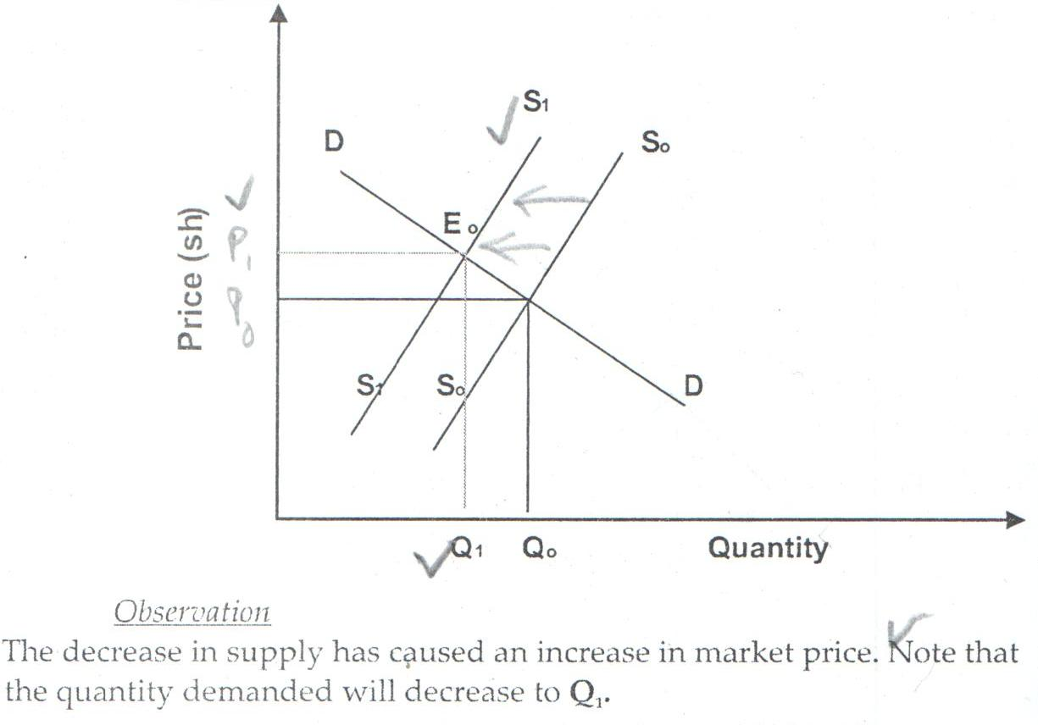
- Highlight 4 dangers of locating firms in a central place (4marks)
- High population in an area will cause congestion
- Causes rural-urban migration
- Contributes to escalation of crime in urban areas
- May lead to development of slums
- Health hazards will come up due to poor living conditions
- Leads to unbalanced regional development
- Leads to pollution in the area
- Provide good target by enemy during war and terrorism
1X4=4

- Outline 4 characteristics of a perfect competition market structure (4marks)
- Made up of many unorganized buyers
- Made up of many unorganized sellers
- All products are similar/homogenizes
- Buyer/seller have perfect knowledge of the market
- No price control
- Perfect mobility of factors of production
- No government interference by way of subsidies or price fixing
- No transport cost involved in accessing goods from different seller
- No excess demand or supply
- No discrimination of seller or buyers
- Free entry & exist of firms in the industry
1X4=4
- Outline 4 channels that can be used to distribute locally manufactured goods (4marks)
- Manufacturers Wholesalers Retailers Consumers
- Manufacturer Government agency Retailer Consumer
- Manufacturer Wholesaler Consumer
- Manufacturer Retailer Consumer
- Manufacturer Manufacture outlet Retailer Consumer
- Manufacturer Consumer
1X4=4
- Give 4 assumptions in a two sector economy circular flow of income (4marks)
- Household spend all their incomes on buying goods and services i.e. No saving
- Firms do not make any further investments
- No foreign trade
- No government participation in production
- No surplus or shortage
- Economy is made up of firms and household only
- There is no variation in the money supply in the economy
- A person or firm cannot be a consumer and producer at the same time
1X4=4

