NAME………………………………............…………………… INDEX NO. ……….…………………….
SCHOOL ………………………………………………………... DATE…………………………………….
SET……………..CLASS……………..
565/1
BUSINESS STUDIES
Paper 1
September, 2021
Time: 2 Hours

PRE-MOCK JOINT EXAMINATION – 2021
Kenya Certificate of Secondary Education (KCSE)

INSTRUCTIONS TO CANDIDATES

- Answer all the questions in the spaces provided.

For Examiner’s Use Only
Question | 1 | 2 | 3 | 4 | 5 | 6 | 7 | 8 | 9 | 10 | 11 | 12 | 13 | 14
Marks

Questions | 15 | 16 | 17 | 18 | 19 | 20 | 21 | 22 | 23 | 24 | 25
Marks

Total Marks

- Outline four internal environment factors that may negatively influence the operations of a business. (4 marks)
i)______________________________________________________________________
ii)______________________________________________________________________
iii)_____________________________________________________________________
iv)_____________________________________________________________________

- State the characteristic of human wants that match the descriptions given below: (4 marks)
Description | Characteristics
a)Satisfaction of one want automatically leads to creation of another
b)Some human wants are experienced by all human beings
c) Human wants can never be fully satisfied
d) After some wants are satisfied, they recur

- Give for reasons why direct production is undesirable in a country. (4 marks)
i)______________________________________________________________________
ii)______________________________________________________________________
iii)_____________________________________________________________________
iv)_____________________________________________________________________

- Highlight four reasons why the Kenyan government encourages entrepreneurship in the country. (4 marks)
i)______________________________________________________________________
ii)______________________________________________________________________
iii)_____________________________________________________________________
iv)_____________________________________________________________________

- State four modern developments in office management. (4 marks)
i)______________________________________________________________________
ii)______________________________________________________________________
iii)_____________________________________________________________________
iv)_____________________________________________________________________

- Give four differences between a Public Limited Company and a Public Corporation. (4 mks)

Public Limited Company | Public Corporation
i)  ii)  iii)  iv) | i)  ii)  iii)  iv)

- Highlight four advantages of mail-order business. (4 marks)
i)______________________________________________________________________
ii)______________________________________________________________________
iii)_____________________________________________________________________
iv)_____________________________________________________________________

- Give four reasons for the popularity of Mpesa as a means of payment in Kenya.(4 marks)
i)______________________________________________________________________
ii)______________________________________________________________________
iii)_____________________________________________________________________
iv)_____________________________________________________________________

- The following balances were extracted from books Hussein trades on 30th October 2019.
Cash 20,000
Bank 160,000
Premises 200,000
Debtors 40,000
Creditors 95,000
2 years loan 258,000
Stock 210,000

Prepare the balance sheet for Hussein Traders as at 30th October 2019. (5 mks)

- State four reasons for government involvement in business activities. (4 marks)
i)______________________________________________________________________
ii)______________________________________________________________________
iii)_____________________________________________________________________
iv)_____________________________________________________________________

- Outline four problems associated with boda boda (motor cycle) as a means of transport. (4 marks)
i)______________________________________________________________________
ii)______________________________________________________________________
iii)_____________________________________________________________________
iv)_____________________________________________________________________

- For each of the statements below, state the appropriate term as used in insurance. (4 marks)
Statement
a)Specified amount of money paid at regular intervals by the insured to the insurer for coverage against losses
b)People employed by an insurance company to compute expected losses and value of premiums
c)Amount of money refundable to the insured by the insurer in case the former terminates contract before it matures
d) Loss incurred by a business as a result of disruption of business in the event of the insured risk occurring

- Highlight four problems that would be experienced by consumers in the absence of warehousing. (4 markS)
i)______________________________________________________________________
ii)______________________________________________________________________
iii)_____________________________________________________________________
iv)_____________________________________________________________________
- State four benefits of advertising to a consumer. (4 marks)
i)______________________________________________________________________
ii)______________________________________________________________________
iii)_____________________________________________________________________
iv)_____________________________________________________________________
- Identify the source documents used to record the following transactions in the books of original entry. (4 marks)
Transaction | Source Document
- Credit purchases
- Sales returns
- Cash sales
- Cash purchases

- Outline four circumstances that may make a producer to bypass the wholesaler when distributing his goods. (4 marks)
i)______________________________________________________________________
ii)______________________________________________________________________
iii)_____________________________________________________________________
iv)_____________________________________________________________________

- Highlight four external economies of scale that a firm may get as a result of growth in the industry. (4 marks)
i)______________________________________________________________________
ii)______________________________________________________________________
iii)_____________________________________________________________________
iv)_____________________________________________________________________

- Highlight four characteristics of oligopoly market structure. (4 marks)
i)______________________________________________________________________
ii)______________________________________________________________________
iii)_____________________________________________________________________
iv)_____________________________________________________________________
- State the type of unemployment relating to each of the following descriptions: (4 marks)
- Caused by alternating trading patterns occurring at similar times _____________________________
- Arises where workers have more skills and higher qualifications than the job requirements ______________________________
- Arises out of a mismatch between the skills possessed by potential employees and the location of the jobs available ____________________________________
- Arises when people are unwilling to take up jobs due to low pay _______________________

- The diagram below shows a change in the supply of a product. Outline four factors which may have caused such a change. (4 marks)
Price
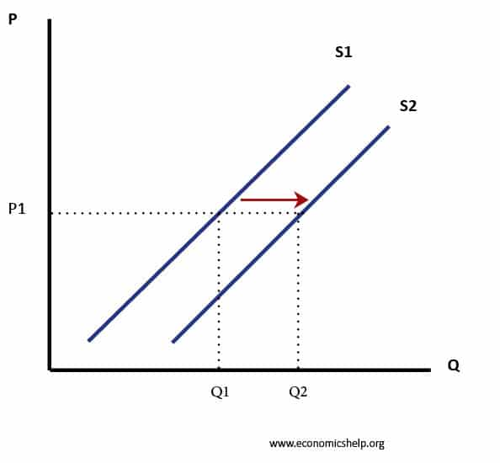Quantity
i)______________________________________________________________________
ii)______________________________________________________________________
iii)_____________________________________________________________________
iv)_____________________________________________________________________

- The following information relates to Jumbo Traders on 31/12/2020
Details Shs
Capital (31/12/2020) 940,000
Net loss 20,000
Additional Investments 420,000
Monthly drawings 5,000
Determine the capital as at 1/01/2021 (3 marks)

- Outline four roles played by the Nairobi Securities Exchange in the Kenyan economy. (4 marks)
i)______________________________________________________________________
ii)______________________________________________________________________
iii)_____________________________________________________________________
iv)_____________________________________________________________________

- Listed below is a set of transaction. In each case state whether the transaction will increase, decrease or have no effect on capital. (4 marks)
 | Transaction | Effect
 | Additional cash invested by the owner
 | Receiving cash from a debtor
 | Losses incurred by a business
 | Owner takes some stock for own use

- Mention four disadvantages of an ageing population to a country. (4 marks)
i)______________________________________________________________________
ii)______________________________________________________________________
iii)_____________________________________________________________________
iv)_____________________________________________________________________

- Given below is a cash book extract from the books of accounts of Patel Enterprises.

Dr Cr
Date | Details | F | Discount allowed | Cash | Bank | Date | Details | F | Discount received | Cash | Bank
2009 |  |  |  |  |  | 2009
1/12 | Bal b/d |  |  | 1,500 | 90,000 | 14/12 | Bank | C |  | 30,000
2/12 | Rono |  | 2,000 | 36,000 |  | 20/12 | Equipment |  |  |  | 80,000
14/12 | Cash | C |  |  | 30,000 | 30/12 | Drawings |  |  | 7,000

In relation to the entries appearing in the cash book extract, state the transactions that took place on each of the following dates. (4 marks)

- 2nd December 2009

- 14th December 2009

- 20th December 2009

- 30th December 2009

