**FORM THREE JOINT EXAMS**

**233/1**

**CHEMISTRY**

**Paper 1**

**(THEORY)**

**July 2015**

**TIME: 2 HOURS**

**NAME:………………………………………………………….……. ADM NO:……………………**

**SCHOOL ……………………………….SIGNATURE …………… DATE ……………………………**

**INSTRUCTIONS**

* Write your name and admission number in the space provided above.
* Sign and write the date of examination in the spaces provided above.
* Answer **ALL** questions in the spaces provided.
* All working **MUST** be clearly shown where necessary.
* Students should answer all questions in English.

**For Examiners’ use only**

|  |  |  |
| --- | --- | --- |
| Questions | Maximum Score | Candidates Score |
| 1 - 31 | 80 |  |

1. Name the apparatus used for measuring;
2. Time (1 mk)
3. Temperature (1 mk)
4. State three ways of preventing drug abuse. (3 mks)
5. (a) Define the term flame (1 mk)

(b)Which kind of flame is produced when the air hole of a Bunsen burner is open? (1 mk)

1. Imagine that a new element, tarium, has been recently discovered in Msambweni. It is a solid but easily cut with a knife. When added to water it reacts vigorously and takes fire, forming an alkaline solution.
2. Is tarium a metal or non-metal? Give a reason for your answer. (1 mk)
3. What is the valency of tarium? (1 mk)
4. Using the symbol T for tarium, write the equation for its reaction with water. (1 mk)
5. Use the information given below to answer the questions that follow.

|  |  |
| --- | --- |
| Solution | PH |
| L | 1.5 |
| M | 6.5 |
| N | 13.0 |
| O | 7.0 |
| P | 8.0 |

1. Which of the solution may be used to relieve stomach upset caused by indigestion? (1 mk)
2. Which solution:
3. Will have no effect on litmus paper? (1 mk)
4. Is likely to be dilute sulphuric (vi) acid? (1 mk)
5. Is likely to be ammonium hydroxide solution? (1 mk)
6. A mixture, M has two solid components, C and D. Component C is soluble in solvent X but not in solvent Y while component D is soluble in solvent Y but not in X. Explain how you would separate the two components of M. (2 mks)
7. The diagram below shows an incomplete chromatogram of dyes. X Y, Z and mixture W.

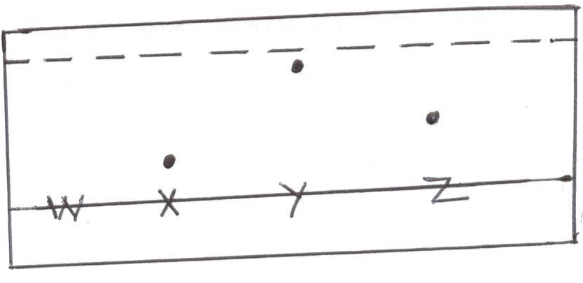

1. Mixture W contains dyes Y and Z only. Complete the chromatogram to show how mixture W separates. (2 mks)
2. Which dye is the most soluble in the solvent (1 mk)
3. When a piece of burning magnesium is put in carbon (iv) oxide gas, it continues to burn to form a white solid and black specks.
4. Name:

The white solid (1 mk)

The black specks (1 mk)

1. Why does magnesium continue to burn despite the fact that carbon (iv) oxide does not support burning? (1 mk)
2. An element R has two isotopes 207R and 208Rin the proportion 3: 1respectively. Determine the R.A.M. of element R (2 mks)
3. A compound of carbon, hydrogen and oxygen contains 71.12 by mass of oxygen, 2.2 hydrogen and the rest is carbon.It has relative molecular mass of 90.
4. Determine the empirical formula of the compound. (2 mks)
5. Determine the molecular formula of the compound. (1 mk)
6. Explain why the following combination of reagents is unsuitable for the laboratory preparation of hydrogen.
7. Zinc + dilute nitric (v) acid (1 mk)
8. Lead + dilute hydrochloric acid (1 mk)
9. State two uses of Argon. (2 mks)
10. Write the electronic configuration of the following:
11. N3- (1 mk)
12. Al3+ (1 mk)
13. Calcium metal reacts vigorously with cold water with effervescence of a gas.
14. What is the gas given off? (1 mk)
15. Write the equation for this reaction. (1 mk)
16. Under the same conditions, gaseous neon was found to diffuse faster than gaseous fluorine. Explain this observation. (F=19.0:Ne=20.0) (2 mks)
17. Name two pieces of apparatus that can be used to accurately measure 25.0cm3 of a liquid. (2m)
18. Write equations to show the effect of heat on each of the following:
19. Sodium nitrate (1 mk)
20. Potassium hydrogen carbonate (1 mk)
21. Anhydrous iron(ii) sulphate (1 mk)
22. Draw a well labeled diagram for the arrangement you would use to prepare and collect a dry sample of hydrogen gas. (3 mks)
23. In terms of structure and bonding, explain why the melting point of oxygen is much lower than that of sodium. (3 mks)
24. Using dots (**.**) and crosses (**X**) show bonding in:

(a) the compound formed when nitrogen reacts with chlorine.

(N =7,Cl =17) (1 ½ mk)

1. Potassium oxide

(K = 19, O = 8) (1 ½ mk)

1. The ionization energies for three elements D, E and F are shown in the table below

|  |  |  |  |
| --- | --- | --- | --- |
| Element | D | E | F |
| Ionisation energy (KJmol-1) | 519 | 418 | 494 |

1. What is meant by ionization energy? (1 mk)
2. Which element is the strongest reducing agent? Give a reason (2 mks)
3. Explain why a mixture of copper (ii) oxide and magnesium reacts when heated while there is no reaction when a mixture of copper and magnesium oxide is heated. (2 mks)
4. The chemical equations below are the main reactions in large scale manufacture of sodium carbonate

NH3 (g) + CO2(g) + H2O (l) NH4HCO3(aq)

NH4HCO3(aq) + NaCl(aq) NaHCO3(s) + NH4Cl (aq)

1. Explain how the two products, NaHCO3 and NH4Cl are separated. (1 mk)
2. (i) How is sodium carbonate finally obtained? (1 mk)

(ii)Write the equation for the reaction in (b) (i) above (1 mk)

1. An evacuated flask has a mass of 90.050 g when filled with gas X at S.T.P, the flask weighs 90.121g. If the volume of the flask was 22.2 cm3, calculate the relative molecular mass of gas X and suggestits identity. (3 mks)
2. Name the following compounds
3. CH3 – CH2 – CH – CH2– CH3

CH3

1. CH3 – C = CH2

CH3

1. CH3 – CH2 – CH2

CH3

1. An isotope of element F has 34 neutrons and its mass number is 64. F forms a cation with 28 electrons. Write the formula of the cation indicating the mass and atomic numbers. (1 ½ mk)
2. An experiment was set up as shown in the diagram



1. Identify substance D. (1 mk)
2. Describe how the other product of the burning candle could be prevented from getting into the environment. (2 mks)
3. Starting with 50cm3 of 2.8 M sodium hydroxide, describe how a sample of pure sodium sulphate crystals can be prepared. (3 mks)
4. (a) Give an equation showing that nitrogen (ii) oxide may be obtained from nitric (v) acid and copper. (1 mk)

(b)How would you distinguish between nitrogen (ii) oxide and nitrogen (iv) oxide (1 mk)

1. When 8.53g of sodium nitrate were heated in an open test tube, the mass of oxygen gas produced was 0.83g. Given the equation of the reaction as:

2NaNO3(s) 2NaNO2(s) + O2(g)

Calculate the percentage of sodium nitrate that was converted to sodium nitrite. (3 mks)

(Na = 23, O, N = 14.0, O = 16.0)

1. Bottles of sodium carbonate, sugar and sodium chloride have lost their labels. A student prepares and tests an aqueous solution of a sample from each bottle.

The results obtained are as shown in the table below. (1 ½ mk)

|  |  |  |  |
| --- | --- | --- | --- |
| Bottle | PH | Electrical Conductivity | Correct label |
| 1 | 7 | Does not conduct |  |
| 2 | 10 | Conduct |  |
| 3 | 7 | Conduct |  |

**END**