GATITU MIXED SECONDARY SCHOOL
FORM 3 CHEMISTRY AUGUST HOME ASSIGNMENT
INSTRUCTIONS: All questions and answers should be written at the back of the exercise book. (No question should be left unanswered)
- (a) The table below shows some properties of chlorine, bromine and iodine
Elements | Formula | Colour and state at room temperature | Solubility in water
Chlorine | Cl₂ | i……………. | Soluble
Bromine | Br₂ | Brown liquid | ii…………..
Iodine | L₂ | iii…………….. | Slightly soluble
Complete the table by giving the missing information in (i) (ii) and (iii)
( 3 mks)
(b) Chlorine gas is prepared by reacting concentrated hydrochloric acid with manganese (IV) oxide
(i) Write the equation for the reaction between concentrated hydrochloric acid and manganese (IV) oxide ( 1 mk)
(ii) What is the role of manganese (IV) oxide in this reaction ( 1 mk)
(c) (i) Iron (III) chloride react with chlorine gas to form substance “E”
identify substance “E” ( 1 mk)
(ii) During the reaction in C (i) above 6.30g of iron (II) chloride were converted to 8.06g of substance “E” Calculate the volume of chlorine gas used. (CL= 35.5) Molar gas volume a room temperature = 24000 cm3 (Fe = 56) ( 3 mks)
(d) Draw and name the structure of the compound formed when excess chlorine gas is reached with ethane gas ( 3 mks)
(e) Give one industrial use of chlorine ( 1 mk)

The diagram below shows the set up used in an experiment to prepare chlorine gas and react it with aluminium foil. Study it and answer the questions that follow

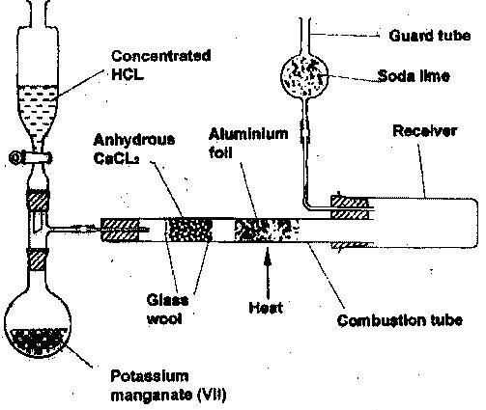

(a) In the experiment, concentrated hydrochloric acid and potassium manganate (VII) were used to prepare chlorine gas. State two precautions that should be taken in carrying out this experiment. ( 2 mks)
(b) Write the formula of another compound that could be used instead of potassium manganate (VII) ( 1 mk)
(c) Explain why is necessary to allow the acid to drip slowly onto potassium manganate (VII) before the aluminium foil is heated. (2 mks)
(d) State the property of the product formed in the combustion tube that makes it possible for it to be collected in the receiver. ( 1 mk)
(e) When 1.08g of aluminium foil were heated in a stream of chlorine gas, the mass of the product formed was 3.47g. Calculate the:
(i) Maximum mass of the product formed if chlorine was in excess
(AL = 27; Cl = 35.5) ( 3 mks)
(ii) Percentage yield of the product formed ( 1 mk)
(f) Phosphorous trichloride is a liquid at room temperature what modification should be made to the set up if it is to be used to prepare phosphorous trichloride ( 1 mk)
- (i) What is the action of chlorine on cold dilute sodium hydroxide ( 1 mk)
(ii) Write down the equation for the above reaction ( 1 mk)
- If chlorine gas is passed over heated iron fillings and the products dissolved in water, a yellow solution is formed
(i) Identify the yellow solution ( 1 mk)
(ii) What would be observed if aqueous sodium hydroxide solution was added to the yellow solution ( 1 mk)
(iii) Write an equation for the reaction between the yellow solution and sodium hydroxide ( 1 mk)
- A solution of hydrogen chloride in methylbenzene (toluene) has no effect on limestone. A solution of hydrogen chloride in water reacts with limestone to produce a gas explain ( 1 mk)
- The diagram below represents the industrial manufacturer of hydrochloric acid. Study it and answer the questions that follow.

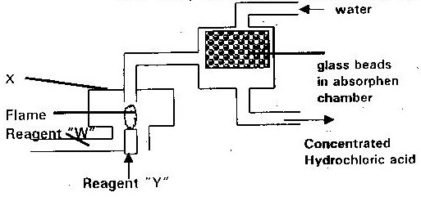

(a) Name the reagents “W” and “Y” ( 1 mk)
(b) Explain the role of the glass beads in the absorption chamber ( 1 mk)
(c) Write an equation for the reaction in chamber “X” ( 1 mk)
(d) Explain why hydrochloric acid formed appears yellow in colour ( 1 mk)
- The diagram below shows preparation of hydrochloric acid
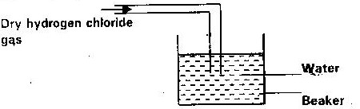

(i) State one mistake in the diagram
(ii) Hydrogen chloride does not have any effect on litmus paper unlike hydrochloric acid. Explain ( 1 mk)
- The flowchart below summarizes the results of series of chemical reactions; study it and answer the questions that flows
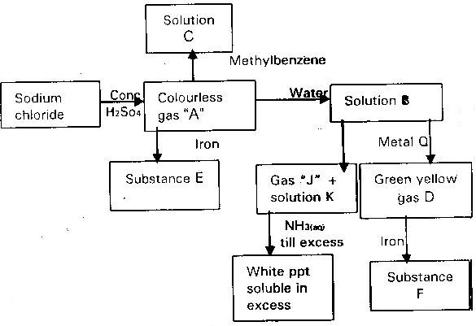

(a) Identify gas “A” gas “D” substance E and F, Gas J solution K and metal Q
( 4 mks)
(b) What is the effect of solution “B” and a solution “C” on dry blue litmus paper? Explain ( 2 mks)
(c) What would you observe if excess ammonia solution is added to the solutions of substance “E” and “F” separately, explain your observations ( 2 mks)
(d) What reagent would you use to convert?
(i) Substance “E” to substance “F” ( 1 mk)
(ii) B to gas D ( 1 mk)
(e) State the condition required in the formation of substance E or F which is not given in the diagram ( 1 mk)
- Below is a set up of the apparatus used to prepare a dry sample of chlorine gas in the laboratory?
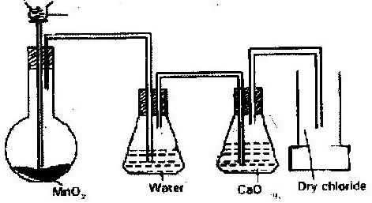

(a) State two observation that were made in the reaction ( 2 mks)
(b) Suggest two collection that should be made on the above set up so that experiment is successful ( 2 mks)
(c) What is the role of water in this set up? ( 1 mk)
(d) (i) Write an equation for the reaction which produces chlorine ( 1 mk)
(ii) What is the role of water of MNO₂ in this reaction ( 1 mk)
(e) Determine the mass of chlorine gas formed if 40 cm³ of 11.0 m hydrochloric acid was used in this reaction (Cl= 35.5) ( 3 mks)
(f) 0.53g of chlorine gas was reacted with iron to form 0.81 of product. Determine the molecular formula of the products given that its relative molecular mass is 162.5 (Fe = 56) (Cl = 35.5) ( 4 mks)
(g) Name two raw materials that are used with chlorine to produce hydrochloric acid on the large scale ( 1 mk)
- The experiment below was set up to prepare iron (iii) chloride tram chlorine

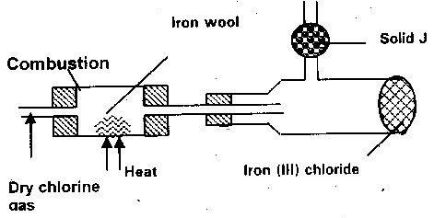

(a) Name two reagents that could be used to prepare chlorine gas in the laboratory ( 1 mk)
(b) Why is it necessary to dry chlorine gas before using it here? ( 1 mk)
(c) What property of iron (III) chloride makes it possible to collect it as shown? ( 1 mk)
(d) Give the names of solid J and state its functions ( 1 mk)
(e) Where should this experiment be carried out and why ( 1 mk)
(f) Give the equation for the reaction that takes place in the combustion tube
(g) What would be observed if some chlorine water is shaken in gas jar of hydrogen sulphate gas ( 1 mk)
- A student set up the apparatus below in the school laboratory to prepare and study the properties of a certain gas A.
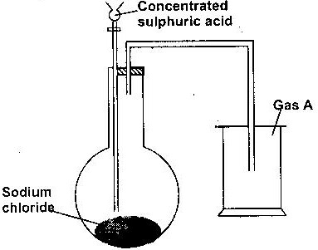

(a) Name gas A ( 1 mk)
(b) Write down a chemical equation for the reaction taking place to produces gas “A”
(c) What major property of “gas” enables the student to collect the gas above as shown in the diagram ( 1 mk)
(d) Suggest a possible drying agent if the student want to collect dry sample of the gas ( 1 mk)
(e) Large qualities of the gas were bubbled into the same amount of water by passing the gas through an inverted filter funned placed on the surface of the water to prepare a solution “Q”
(i) Give a reason why a filter funned is necessary in (e) above (1 mk)
(ii) Some of the resulting solution Ce was mixed with silver nitrate- solution a white precipitate was observed. Name the white precipitate ( 1 mk)
(iii) Write down an ionic equation for the formation of the white precipitate in e (ii) above
(iv) Suggest the identity of solution Q. ( 1 mk)

