GATITU MIXED SECONDARY SCHOOL
FORM 3 CHEMISTRY END-TERM EXAM 2015
2ND TERM
1. Ethanol and pentane are miscible liquids. Explain how water can be used to separate a mixture of ethanol and pentane. (2mks)

2. A warm red phosphorous was lowered to a gas jar of chlorine using a deflagrating spoon.
(i) State one observation made in the experiment. (1mk)

(ii) Identify the substance formed in the above reaction. (1mk)

3 (a) Give the structural formula of 3, 3-dimethly pent-l-yne (1mk)

(b) Name the following compounds using the IUPAC system.

CH₃ CH₂ CH C= CH₂ (1mk)
| |
Br CH₃

4. Use the chart below to answer the questions that follow.
Magnesium
Gas P
Solid R
Copper (II) oxide heat
Solid T
Liquid S
Steam
+
+

Identify:
Gas P ……………………………. ( 1 mk)
Solid R ……………………………. ( 1 mk)
Solid T ……………………………. ( 1 mk)
Liquid S ……………………………. ( 1 mk)

5. The apparatus below was a set up to show the catalytic oxidation of ammonia. Study the diagram and answer the questions that follow.
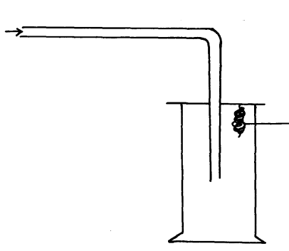
Dry NH_{3 (g)}
Hot nichrome wire

(i) Write an equation for the reaction that takes place in the gas jar. (1mk)

(ii) Why is it necessary to have a hot nichrome wire in the gas jar. (1mk)

6. Given the equation for reaction 2Al_{(s)} + 3Cl_{2(g)} 2AlCl_{3(s)} Calculate
(i) Volume of chlorine at (r.t.p) required to react with 3g of Aluminium (Molar gas volume at r.t.p = 24litres, Al = 27, Cl = 35.5) (3mks)

(ii) Mass of Aluminium chloride formed. (3mks)

7. Using reagents provided only, explain by means of balanced chemical equations how you could prepare a salt of Zinc carbonate solid. (3mks)
- Zinc powder
- Nitric (V) acid (dilute)
- Water
- Solid sodium carbonate

8. Explain the following observations.
(a) When lead (II) carbonate reacts with dilute hydrochloric acid, very little carbon (IV) oxide is produced (2mks)

(b) When hydrogen chloride gas is dissolved in water the solution formed turns blue litmus paper red but there is no effect on blue litmus paper when the gas is dissolved in carbon tetra chloride. (CCl₄) (2mks)

9. Element A has atomic mass 23 and element B atomic mass 7 and also has 12 neutrons and 4 neutrons respectively.
a) Write the electron arrangement of A and B (2mks)
A……………………………
B……………………………

b) Which element has higher ionization energy? Explain (2mks)

10. D grams of potassium hydroxide were dissolved in distilled water to make 100cm³ of solution 50cm³ of the solution required 50cm³ of 2.0M nitric acid for complete neutralization.
Calculate the mass D of potassium hydroxide.
KOH_{(aq)} + HNO_{3(l)} KNO_{3(aq)} + H₂O_{(l)} (relative formula of KOH=56) (3mks)

11. Painting, Oiling, galvanizing and or tin plating are methods of rust prevention.

a) Explain the similarity of these methods in the ways they prevent rusting. (1mk)

b) Explain why galvanized iron objects are better protected even when scratched. (1mk)

12. Solutions can be classified as acids bases or neutral. The table below shows solutions and their pH
values.
Solution  K  L  M | pH values  1.5  7.0  14.0

(i) Select any pair that would react to form a solution of pH 7 (1mk)

(ii) Identify two solutions that would react with Aluminium hydroxide. Explain. (2mks)

13. State two uses of Argon. (1mk)

14. The peaks below show the mass spectrum of element X
9.1
8.1
82.8
Intensity (% abundance)

Isotopic mass
24
25
26

Calculate the relative atomic mass of X (2mks)

15. The chemical equations below are the main reactions in large scale manufacture of sodium carbonate.
NH_{3 (g)} + CO_{2 (g)} + H₂O _{(l)} NH₄HCO₃ _{(aq)}

NH₄HCO₃ _{(aq)} + NaCl_{(aq)} NaHCO_{3(s)} + NH₄Cl_{(aq)}

a) Explain how the two products, NaHCO₃ and NH₄Cl are separated. (1mk)

b) (i) How is sodium carbonate finally obtained? (1mk)

(ii) Explain how ammonia is recovered and recycled? (1mk)

16. Name two allotropes of sulphur. (2mks)

A  B  C | Water | Alcohol | Ether
 | Soluble | Insoluble | Insoluble
 | Insoluble | Soluble | Very Soluble
 | Soluble | Soluble | Insoluble
17. Study the information below and answer the following questions. A mixture contains three solid A,B and C. the solubility of these solids in different liquids is as shown below

Explain how you will obtain sample C from the mixture. (3mks)

18. 20cm³ of an unknown gas Q takes 12.6 seconds to pass through small orifice.10cm³ of oxygen gas takes 11.2 seconds to diffuse through the same orifice under the same conditions of temperature and pressure .Calculate the molecular mass of unknown gas Q ( O=16) (3mks)

19. Using dot (•) and cross (x) diagram, show the bonding in the compound phosphonium ion PH⁺₄ ( P=15.0, H=1.0). (2mks)

20. A compound of carbon, hydrogen and oxygen contains 71.12 by mass of oxygen, 2.2 hydrogen and the rest is carbon. It has relative molecular mass of 90.

a) Determine the empirical formula of the compound. (2mks)

b) Determine the molecular formula of the compound. (2mks)

21. The diagram below shows an incomplete set up of the laboratory preparation of carbon (IV) oxide gas. Complete it. (3mks)

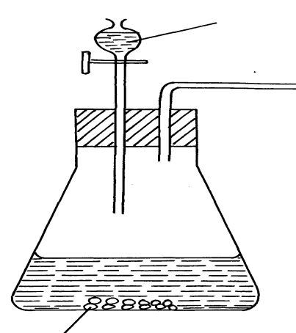
Dilute HCl

Calcium carbonate

Marking scheme( 60MKS)

1. Add water to the mixture. Water mixes with ethanol and forms the lower layer while the upper layer is pentane. Use separating funnel √ ½ to separate pentane and use fractional distillation √ ½ to obtain ethanol from water. √ (2mks)

2. (i) white fumes √
(ii) Phosphorus (V) chlorite //Phosphorous (III) chloride

H H C

H C C C C ≡ C H √1

H H C
H - - H

H
H

H - - H

3. (a)

b) 3-Bromo-2-methylpent-1-ene √1

4. Gas P - Hydrogen √½
Solid R – Magnesium oxide √
Solid T – Copper metal √½
Liquid S – water √½ (total 2mks)
Pt/Ni
5. (i) 4NH_{3(g)} + 5O_{2(g)} 4NO_{(g)} + 6H₂O_{(l)} (penalize ½mk for wrong or missing state symbol)
(ii) Provide activation energy for the reaction √1mk
6. (a) 54g of Al react with 7200cm³
3g = ? √½
= 3 x 7200
54 √½ = 4000cm³ √½ (1½mks)
(b) 54g produce 267g of AlCl₃ √½
3g = 3 x 267
54 √½
= 14.83g √½ (1½mks)

7. Add excess Zinc powder to Nitric (V) acid
Zn_{(s)} + 2HNO_{3(aq)} Zn(NO₃)_{2(aq}) + H₂O_{(l)} √1
Na₂CO_{3(s)} Na₂CO_{3(aq)} √1
Na₂CO_{3(aq)} + Zn(NO₃)_{2(aq)} ZnCO_{3(s)} + 2NaNO_{3(aq)} √1
Or Zn²⁺_{(aq)} + CO_{3(aq)} ZNCO_{3(s)} √ (max 3mks)
8. (a) Insoluble Lead (II) chloride formed coats Lead (II) Carbonate preventing further reaction.
(b) Hydrogen chloride ionizes in water to form acidic solution (H⁺ions) while it remains in molecular
form in carbon tetra chloride.

9. (a) Atomic No. of A 23 – 12 = 11
A = 2. 8 . 1 √
B = 2 . 1 √1 (2mks)
(b) B√1, Its outermost electron√1 experience stronger nuclear attraction / B has smaller atomic
radius/ has fewer energy levels.

10. If 1000cm³ of HNO³ = 2moles
50cm³ of HNO³ = (2 x 50)
1000 = 0.1moles √½
1:1
0.1: 0.1
If 50cm³ of KOH = 0.1mole √½
100cm³ of KHO = (0.1 x 100) √½
50
= 0.2moles √½
D = 0.2
56
D = (0.2 x 56) √½ = 11.2g √½ (3mks)
11. (a) Coat or cover √1the metal surfaces to avoid contact of air and water with the metal(1mk)
(b) Zinc is more reactive than iron hence reacts with an oxygen available √1mk (sacrificial method)

12. K and M
K and M – Aluminium hydroxide is amphoteric (reacts with both acids and bases) √1mk)

13. - Arch welding √1
- Bulbs to prevent oxidation of the filament √1 (2mks)

14. 24 x 82.8 + 25 x 8.1 + 26 x 9.1
100
= 1987.2 + 202.5 + 236.6 √1
100
= 2426.3
100 = 24.263 √1

15. (a) Filtration √1–NaHCO₃ residue and NH₄Cl as filtrate
(b) Decomposition of NaHCO₃ √1
(c) Slaking– mixture of Ammonium is heated to give CaCl₂, water and Ammonia//
NH₄Cl + Ca(OH)₂

16. - Monoclinic (β) prismatic
- Rhombic (α), octahedral

17. - Add ethen √1 to the mixture and stir B dissolves
- Filter √½to obtain A and C as a residue
- Add alcohol √½to the residue C dissolves
- Filter √½and evaporate √½the filtrate to dryness. (3mks)

18. TQ = MQ
TQ = 12.6sec
TO₂ = 22.4sec √½
MO₂ = 2 x 16 = 32
12.6 √½= MQ
22.4 32
M₂ = 12.6 ² x 32
22.4

TO₂ MO₂

MQ = 0.3164063 x 32 √½
10.125002
= 10.13 √ (3mks)
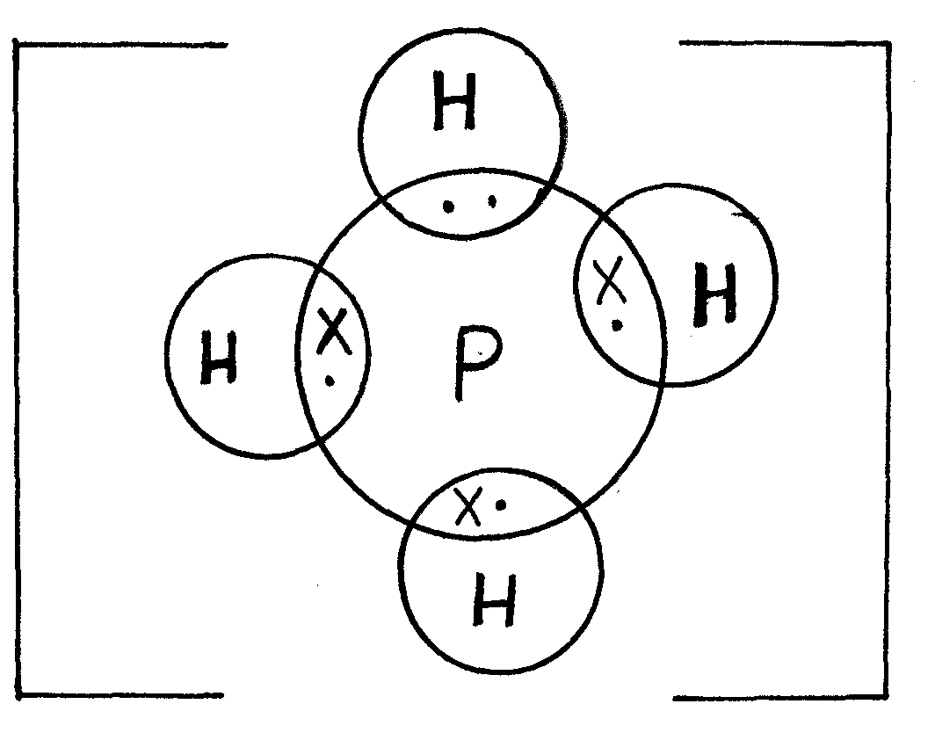19. Let an e of P = .
+
Let an e of H = x
√ (2mks)

20.
Elements | C | H | O
% mass  No. of moles  Ratio of moles  No. of atoms | 26.7 √½  ^{26.7}/₁₂ = 2.225  ^{2.225}/_{2.2} =1  1 | 2.2  ^{22.2}/₁ = 2.1  ^{2.2}/_{2.2} = 1  1 | 71.1 √½  ^{71.1}/₁₆ = 4.44375  ^{4.44375}/_{2.2} = 2  2 √½  (2mks)
Empirical formula CHO₂ √½
21.

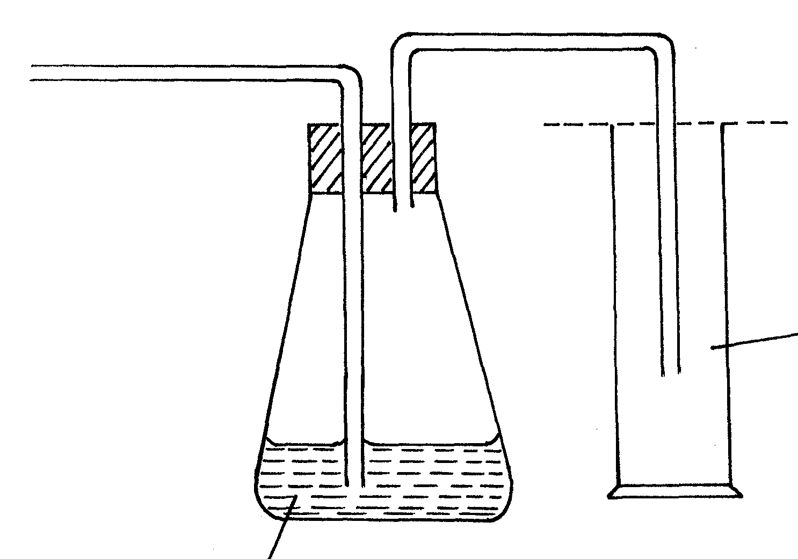
Conc. Sulphuric acid
Carbon (IV) oxide
(workable neat diagram (1mk)
(3mks)
√
√

