GATITU MIXED SECONDARY SCHOOL
THIRD TERM 2015
FORM 3 CHEMISTRY ENDTERM EXAMS

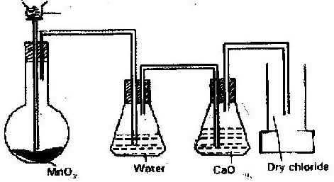
- Below is a set up of the apparatus used to prepare a dry sample of chlorine gas in the laboratory?
HCl

2
(a) State two observations that were made in the reaction (2 mks)
(b) Suggest two corrections that should be made on the above set up so that experiment is successful (2 mks)

(c) What is the role of water in this set up? ( 1 mk)
(d) (i) Write an equation for the reaction which produces chlorine ( 1 mk)

(ii) What is the role of MnO₂ in this reaction ( 1 mk)

(e) Determine the mass of chlorine gas formed if 40 cm³ of 11.0M hydrochloric acid was used in this reaction (Cl= 35.5) (3 mks)

(f) 0.53g of chlorine gas was reacted with iron to form 0.81g of product. Determine the molecular formula of the products given that its relative molecular mass is 162.5 (Fe = 56) (Cl = 35.5) (3 mks)

(g) Name two raw materials that are used with chlorine to produce hydrochloric acid on the large scale (1 mk)

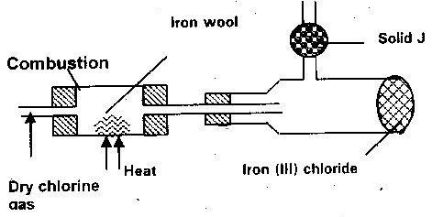
- The experiment below was set up to prepare iron (III) chloride from chlorine

(a) Name two reagents that could be used to prepare chlorine gas in the laboratory (1 mk)

(b) Why is it necessary to dry chlorine gas before using it here? (1 mk)

(c) What property of iron (III) chloride makes it possible to collect it as shown? (1 mk)

(d) Give the name of solid J and state its functions (1 mk)

(e) Where should this experiment be carried out and why (1 mk)

(f) Give the equation for the reaction that takes place in the combustion tube (1mk)
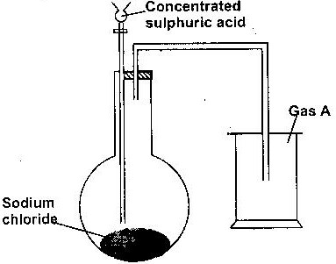
- A student set up the apparatus below in the school laboratory to prepare and study the properties of a certain gas A.

(a) Name gas A (1 mk)

(b) Write down a chemical equation for the reaction taking place to produces gas “A” (1mk)

(c) What major property of “gas” enables the student to collect the gas above as shown in the diagram (1 mk)

(d) Suggest a possible drying agent if the student want to collect dry sample of the gas (1 mk)

(e) Large quantities of the gas were bubbled into the same amount of water by passing the gas through an inverted filter funned placed on the surface of the water to prepare a solution “Q”
(i) Give a reason why a filter funnel is necessary in (e) above (1 mk)

(ii) Some of the resulting solution (e) was mixed with silver nitrate solution and a white precipitate was
observed. Name the white precipitate (1 mk)

(iii) Write down an ionic equation for the formation of the white precipitate in e (ii) above (2mks)

(iv) Suggest the identity of solution Q. (1 mk)

- A compound where structure is shown below is found in detergent
O
CH₃ (CH₂)_{n}CH OSO⁻₃ Na⁺
With reference to the structure, explain how the detergent removes grease during washing (3mks)

- The structure below represent five cleaning agents
o
R – COO Na⁺ R - OSO₃Na⁺
^{A} ^{B}
Which cleansing agent would be more suitable for washing in water containing magnesium sulphate? Explain (2mks)

6. (a) Draw the structure of ethanol and propanoic acid (2mks)

(b) Give the name of the organic compound formed when ethanol and propanoic acid react in presence of concentrated sulphuric acid (2mk)
 | Relative molecular mass | Boiling point (⁰ C)
Pentane | 72 | 36
Propan – 1-ol | 60 | 97

- The table below shows the relative molecular masses and the boiling points of pentane and propane -1- ol

Explain using a structure why the boiling point of propan –l –ol is higher than that of pentane (2mk)

8. The table below gives the information of some carboxylic acids and then draw points
Acid | Boiling point (⁰C)
HCOOH | 101
CH₃COOH | 118
CH₃CH₂COOH | 141
CH₃CH₂CH₂CH₂COOH | 187
CH₃CH₂CH₂CH₂CH₂COOH | 205

(a) Give the name of the acid whose formula is
CH₃CH₂CH₂CH₂COOH (2 mk)

(c) Calculate the volume of 0.2M sodium hydroxide solution which would be required to react completely with a solution containing 3.0 g of CH₃COOH. (C= 12) (H= 1.0) (O= 16) (3mks)

Marking scheme (50MKS)
1. i) lack of inverted tunnel/ dissolution through a delivery tube.
ii) HCL_{(g)} is a molecular / covalent compound lacking free ions while hydrochloric acid is ion; the free ions facilitate the reaction.
2. a) A Hydrogen chloride
D Chloride gas
B Hydrochloric acid
E Iron (ii) Chloride
F Iron(iii) chloride
J Hydrogen gas
Q Zinc
K Zinc (ii) Chloride
b) Solution B: Turns blue litmus paper to red.
Solution C: No effect on the litmus paper
c) E Gree precipitate
F Brown precipitate
d) i. - Excess chlorine
- Chlorine is an oxidizing agent
ii. Potassium margent VII or Manganese (IV) Oxide.

e) Heat
3. a) - Effervescence
- Green yellow gas

b) - Use concentrated sulphuric acid as a drying agent
- Heat the reactant

c) To remove HCL_{(g)} sprays
d) i) 4HCL_{(aq)} + MNO₂ CL_{2(g)} + MNCL_{2(aq)} + 2H₂O_{(l)}
ii) To oxidize HCL to form chlorine

e) Mole of HCL = 40 x 11 = 0.44 modes
1000
Moles of CL₂ = .44 x 1 ₌₌ 0.11 modes
1000
RMM of CL₂ = 71
Mass = 71x 0.11 = 7.81g
f) Fe Cl
0.28 0.53
56 35.5

0.005 0.0149
0.005 0.005
1 3
FeCl₃ Empirical formula
g) Hydrogen and water
2. a) Concentrated Hydrochloric acid and potassium manganate (VII) or
manganese (IV) oxide.

b) Prevent formation of tri-iron oxide (Fe₂O₄) which will coat the iron
preventing reaction with chlorine.

c) It sublimes

d) Calcium oxide; to absorb excess chlorine gas and water vapour.

e) Fume cupboard/open field; chlorine is poisonous
f) 2Fe_{(s)} + 3CL_{2(g)} 2FeCL_{3(s)}

g) Yellow solid / sulphur.
3. a) hydrogen chloride
b) NaCL_{(s)} + H₂SO_{4 (aq)} NaHSO_{4 (aq)} + HCl _{(g)}
c) Dense than air.

d) Concentrated sulphuric acid
e) i) -Increase the surface area for dissolution of gas
- Prevent water sucking back
ii) Silver chloride
iii) Ag⁺_{(aq)} + CL_{(aq)} AgCL_{(s)}
iv) Hydrochloric acid
4. The ionic “head” lowers the surface tension of water faciliatating mixing of water and grease. The non polar “tail” mix with grease, dislodging it from the fabric.

5. “B”: “B” does not form scum
6. a) Ethanol H H
│ │
H — C — C — OH
│ │
H H

H H O
│ │

Propanoic acid H — C — C — C — OH
│ │
H H
b) Alkanols / alcohols
7. Penten -1-al is polar. There are two forces, vanderwaals and hydrogen bonds holding its molecule together. Pentane is none polar.
8. pentanoic acid

