Name: …………………………………………………………… Adm. No. ……………………………
KISIRIRI SECONDARY SCHOOL
END OF TERM TWO, 2014 EXAMINATIONS
FORM THREE CHEMISTRY
233/1
CHEMISTRY
PAPER 1

TIME: 2 HOURS

INSTRUCTIONS TO THE CANDIDATES:-

- Answer all the questions in the spaces provided.
- Write your name and admission number in the spaces provided.
- Mathematical tables and electronic calculators may be used for calculation.
- All workings must be clearly shown where necessary

1. The table below shows the pH values of five solutions B, C, D and E. Study it and answer the questions that follow:
Solution | B | C | D | E | F
pH | 2.0 | 7.0 | 8.5 | 6.2 | 12.0

(a) Name the indicator used in the determination of pH values and justify its choice (2mks)
…………………………………………………………………………………………………
…………………………………………………………………………………………………
(b) Suggest the pH of solution obtained by mixing
(i) B and F (1mk)
………………………………………………………………………………………………………
(ii) C and E (1mk)
…………………………………………………………………………………………………………
(c) Which solution is most likely to be ammonia? Explain (1mk)
…………………………………………………………………………………………………
…………………………………………………………………………………………………

2. Study the set-up below and answer the questions that follow;
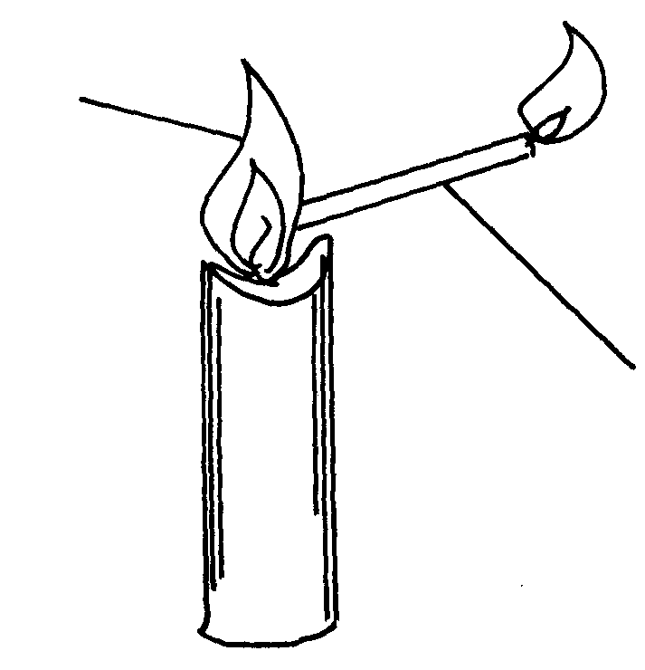
Flame
Bunsen burner flame

Delivery tube

(a) What does the experiment demonstrate? (1mk)
…………………………………………………………………………………………………..
(b) When is this type of Bunsen burner flame produced? (1mk)
…………………………………………………………………………………………………..
(c) Give two characteristics of the type of flame used in the set-up (1mk)
…………………………………………………………………………………………………..
…………………………………………………………………………………………………..

3. The following are atomic and ionic radii (nm) of a number of elements in the same group of
periodic table.
Elements | Atomic radii(nm) | Ionic radii (nm)
X | 0.064 | 0.136
Y | 0.099 | 0.181
W | 0.114 | 0.195
Z | 0.133 | 0.216
The letters do not represent the actual symbols of the elements.
(a) Is this group metallic or non-metallic? Explain. (2mks)
…………………………………………………………………………………………………
…………………………………………………………………………………………………
(b) Which of the elements is most electronegative? (1mk)
…………………………………………………………………………………………………

4. It takes 10 seconds for 50cm³ of gas Q to diffuse through a porous material, and 20 seconds
for 150cm³ of gas A. If the vapour density of gas A is 16, determine the molecular mass of Q. (3mks)

5. Use the scheme below to answer the questions that follow:
Solid X
Gas Y
Moist red litmus paper
Turns blue
Carbon (IV) oxide
Colourless liquid L
Na₂O₂
Gas Z + colourless solution
Heat

(a) Identify; (i) Solid X …………………………………………………………………….
(ii) Gas Y………………………………………………………………….. (2mks)
(b) State the chemical test for liquid L (1mk)
…………………………………………………………………………………………………

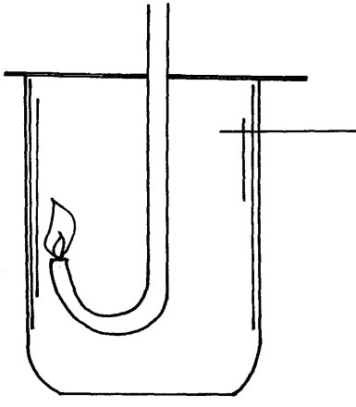
6. Hydrogen gas was lighted in a gas jar of air using the arrangement shown below:

Hydrogen gas

(i) Write an equation for the combustion of hydrogen gas. (1mk)
…………………………………………………………………………………………………
(ii) State and explain what is observed if a glowing splint is lowed into the gas jar of hydrogen. (2mk)
…………………………………………………………………………………………………

7. When excess dilute hydrochloric acid was added to sodium carbonate, 960cm³ of carbon
(IV) Oxide was produced. Determine the mass of sodium carbonate that was used in the reaction.
(Molar gas volume = 24.0dm³, Na=23, C=12, O=16) (3mks)

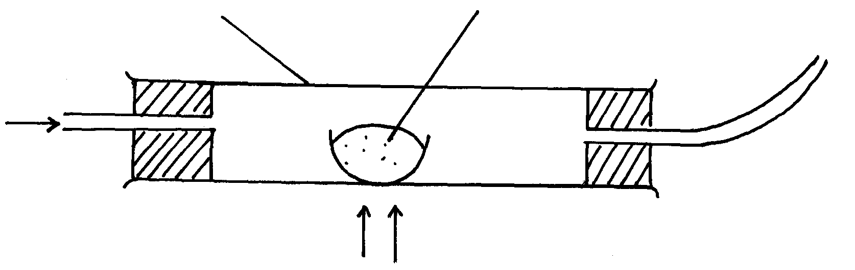
8. Steam was passed over heated charcoal as shown below:
Combustion tube
Charcoal
Mixture of gases
Heat
Steam

(a) Name the two gases in the mixture (1mk)
……………………………………… …………………………………………………
(b) Write the equation for the reaction which takes place in the combustion tube. (1mk)
…………………………………………………………………………………………………
(c) Identify the reducing and the oxidizing agent in the above reaction (1mks)
…………………………………………………………………………………………………
…………………………………………………………………………………………………

9. An hydrocarbon W has the structure CH₃-CH=CH₂, and it undergoes hydrogenation reaction to form substance X :
(a) Identify; (i) Substance X …………………………………………………………… (1mk)
(ii) Conditions A …………………………………………………………. .
B …………………………………………………………. .(1mk)
(b) What general name is given to such kind a reaction? (1mk)
…………………………………………………………………………………………………

10. The set-up below was used to investigate the properties of hydrogen
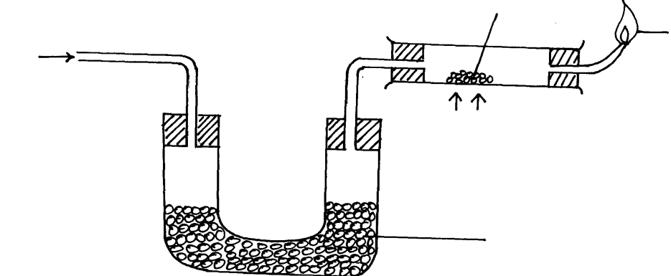
Dry hydrogen
Heat
Anhydrous Calcium Chloride
Blue flame
Lead (II) oxide

(i) State the observations that was made in the combustion tube as the reaction progressed
to completion (1mk)
…………………………………………………………………………………………………
…………………………………………………………………………………………………
(ii) Write equations for the reactions ;
I) In the combustion tube (1mk)
…………………………………………………………………………………………………
II) State the properties of hydrogen that were investigated (1mks)
…………………………………………………………………………………………………

11. The set-up below was used by a form three student to prepare a dry sample of gas M. Study
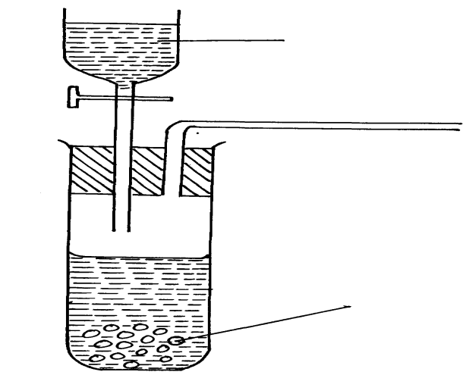
it and use it to answer the questions that follow:-
Calcium carbide_{(s)}
Water

(a) Complete the diagram to show how a dry sample of gas M can be collected (1mks)
(b) State the identity of gas M ……………………………………………………………(1mk)

12. The table below shows the compounds of period three element and their properties. Study
it and answer the questions that follow:
Element | Na | Mg | Al | Si | P | S | Cl
Formula of Oxide | Na₂O  Na₂O₂ | MgO | ----------- | SiO₂ | ----------- | SO₂  SO₃ | Cl₂O₇ Cl₂O
Formula of Chloride | NaCl | MgCl₂ | AlCl₃ | ----------- | PCl₃  PCl₅ | -------------
Bonding in chloride | Ionic | Ionic | ---------- | Covalent | ------------ | Covalent
(a) Complete the table by filling in the blank spaces (3mks)
(b) Solid aluminium chloride vapourizes when heated to form a molecule whose formula
is Al₂Cl₆. Draw a well displayed formula of Al₂Cl₆ indicating clearly the two different
types of bonds present in the molecule. (2mks)
13. Two solids A and B were heated and their melting points noted and recorded as shown in
the table below:
Solid | Melting point (ºC)
A | 105 – 107
B | 220 – 220.2
- With a reason, identify the solid that was not pure (2mks)
…………………………………………………………………………………………………
…………………………………………………………………………………………………
(b) State the criteria for purity (1mk)
……………………………………………………………………………………………………

14. Explain the following:
Group O elements are generally unreactive (1mk)
…………………………………………………………………………………………………
…………………………………………………………………………………………………

15. A mmonia and chlorine react according to the equation ;

3Cl_{2(g)} + 2NH_{3(g)} N_{2(g)} + 6HCl_{(g)}
Which species undergoes reduction? Explain your answer (2mks)
…………………………………………………………………………………………………
…………………………………………………………………………………………………
…………………………………………………………………………………………………
16. You are provided Lead (II) Oxide, dilute nitric acid, Sodium Carbonate and distilled water.
Describe briefly how you can prepare Lead (II) Carbonate from these reagents (3mks)
…………………………………………………………………………………………………
…………………………………………………………………………………………………
…………………………………………………………………………………………………
…………………………………………………………………………………………………
…………………………………………………………………………………………………

17. The melting points and boiling points of the alkali metals decrease down the group but for halogens, they increase down the group. Explain these trends. (2mks)
…………………………………………………………………………………………………
…………………………………………………………………………………………………
…………………………………………………………………………………………………

18. A hydrocarbon M was found to decolorize bromine water. When two moles of M were burnt completely, six moles of Carbon (IV) Oxide and two moles of water are formed.
(i) Write the molecular and structural formulae of M (1mk)
…………………………………………………………………………………………………
(ii) Name of the homologous series to which M belongs (1mk)
…………………………………………………………………………………………………
(iii) name the product formed when M is reacted with hydrogen chloride gas (1mk)
…………………………………………………………………………………………………

19. What chemical test would you use to distinguish the following substances:
(i) Oxygen and carbon (Iv) Oxide (1mk)
…………………………………………………………………………………………………
(ii) Hydrogen and steam (1mk)
…………………………………………………………………………………………………
(iii) CH₂= CH₂ and HC ≡ CH (1mk)
…………………………………………………………………………………………………

20. Study the flow chart below and answer the questions that follow:
Solid X
Heat
Brown gas Y
Yellow solid
Colourless solution
Dilute HNO₃
White precipitate
Dilute hydrochloric acid

(i) Name Solid X …………………………………………………………..…………. (1mk)
(ii) Which anion is present in solid X?............................................................................... (1mk)
(iii) Write a chemical equation for the reaction that leads to the formation of brown gas and
the yellow solid (1mk)
…………………………………………………………………………………………………

21. The diagram below is part of the periodic table with the elements shown. The letters do not
represent the actual symbols. Study the diagram then respond to the questions that follow.
A
F

G

H

B

C
D

E

(i) Identify the elements that will form;
I. A monovalent cation ……………………………………………………………. (1mk)
II. A divalent anion ………………………………………………………………..…. (½mk)
(ii) Write the formula of the compound formed when element G and D react. (1mk)
…………………………………………………………………………………………………
…………………………………………………………………………………………………
(iii) What name is given to the family element to which G belongs? (½mk)
…………………………………………………………………………………………………

22. How many electrons are lost when 3.6g of Magnesium are converted to magnesium ions?
(Mg = 24, L = 6.02 x 10²³) (2mks)

23. Classify the process below as chemical or physical changes (2mks
Process | Physical or chemical change
(a) Fractional distillation
(b) Displacement reaction
(c) Sublimation
(d) Neutralization

24. (a) State the role of the following part during fractional distillation of a mixture of water and ethanol.
Glass beads in the fractionating column (1mk)
…………………………………………………………………………………………………..
(b) State any two applications of fractional distillation process. (1mks)
…………………………………………………………………………………………………..
25. Use the scheme below to answer the questions that follow:-
Substance L
Brine
Step I
Step II
NH₄Cl and NaHCO₃
NH₄Cl
NaHCO₃
Na₂CO₃
Step III

(i) Name substance L …………………………………………………………………… (1mk)
(ii) What process takes place in Step III ………………………………………………………………………….(1mk)
(iii) Write a chemical equation for the reaction that takes place in step III (1mk)
…………………………………………………………………………………………………

26. In an experiment, 25cm³ of 0.1M anhydrous Sodium Carbonate were titrated against
sulphuric acid. 37.5cm³ of the acid neutralized the carbonate completely. Determine
the concentration of sulphuric acid in moles per litre. (2mks)

27. Explain why burning magnesium continues to burn in a gas jar full of carbon IV oxide while a burning splint would be extinguished (2mks)

28. . A certain carbonate WCO3 reacts with dilute hydrochloric acid, If 1g of the carbonate reacts completely with 20cm3 of 1M hydrochloric acid
Calculate the relative atomic mass of W ( C=12, O =16) ( 3mks)

