NAME…………………………………ADM NO…………DATE…………………
KISIRIRI SECONDARY SCHOOL
P.O. BOX 93-20500 TEL 0721-451-691
CAT ONE OF 3ND TERM 2013
FORM THREE
CHEMISTRY
ONE HOUR
1. The following are atomic and ionic radii (nm) of a number of elements in the same group of
periodic table.
Elements | Atomic radii(nm) | Ionic radii (nm)
X | 0.064 | 0.136
Y | 0.099 | 0.181
W | 0.114 | 0.195
Z | 0.133 | 0.216
The letters do not represent the actual symbols of the elements.
(a) Is this group metallic to non-metallic elements? Explain (2mks)
…………………………………………………………………………………………………
(b) Which element is the strongest oxidizing agent? (1mk)

2. Use the scheme below to answer the questions that follow:
Solid X
Gas Y
Moist red litmus paper
Turns blue
Carbon (IV) oxide
Colourless liquid L
Na₂O₂
Gas Z + colourless solution
Heat

(a) Identify; (i) Solid X …………………………………………………………………….
(ii) Gas Z…………………………………………………………………….
(iii) Gas Y………………………………………………………………….. (3mks)
(b) State the chemical test for liquid L (1mk)
………………………………………………………………………………………………………………
…………………………………………………………………………………………………

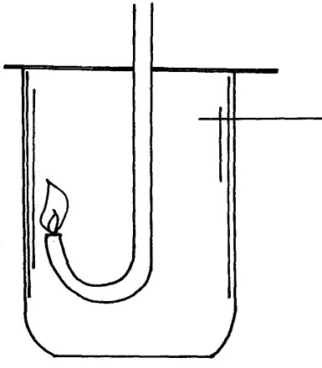
3. Hydrogen sulphide was lighted in a gas jar of enriched air with oxygen using the arrangement shown below:

Hydrogen sulphide

(i) Write an equation for the combustion of hydrogen sulphide. (1mk)
…………………………………………………………………………………………………
(ii) State what is observed if the product is passed through acidified potassium dichromate (1mk)
…………………………………………………………………………………………………

4. When excess dilute hydrochloric acid was added to sodium sulphite, 960cm³ of sulphur
(IV) Oxide was produced. Determine the mass of sodium sulphite that was used in the reaction.
(Molar gas volume = 24.0dm³, Na=23, S=32, O=16) (3mks)

5. You are provided Lead (II) Oxide, dilute nitric acid, Sodium Carbonate and distilled water.
Describe briefly how you can prepare Lead (II) Carbonate from these reagents (3mks)
…………………………………………………………………………………………………
…………………………………………………………………………………………………
…………………………………………………………………………………………………
…………………………………………………………………………………………………
…………………………………………………………………………………………………

6. Study the flow chart below and answer the questions that follow:
Solid X
Heat
Brown gas Y
Yellow solid
Colourless solution
Dilute HNO₃
White precipitate
Dilute hydrochloric acid

(i) Name I.. Solid X …………………………………………………………..…………. (1mk)

II. Brown gas Y ……………………………………………………………… (1mk)

(ii) What anion is present in solid X?............................................................................... (1mk)

(iii) Write a chemical equation for the reaction that leads to the formation of brown gas and
the yellow solid (1mk)
…………………………………………………………………………………………………

(iv) identify the white precipitate in the above flow chart. (1mk)

7. How many electrons are lost when 3.6g of Magnesium are converted to magnesium ions?
(Mg = 24, L = 6.02 x 10²³) (3mks)
…………………………………………………………………………………………………
…………………………………………………………………………………………………

8. Moist/damp/wet blue and red litmus papers were put in a gas jar containing air/oxygen. Burning sulphur was then lowered into the gas jar. State and explain the observation made. ………………………………………………………………………………………………………………………………………………………………………………………………………………………………………………………………………………………………. .(2mks)

9. Iron filings were put in a test tube containing powdered sulphur then heated on a Bunsen flame. Stop heating when reaction starts. State and explain the observations made. (2mks) ………………………………………………………………………………………………………………………………………………………………………………………………………………………………………………………………………………………………………………………………………………………………………………………………………….

10.Dry litmus papers and wet/damp/moist litmus papers were put in a gas jar containing sulphur(IV) oxide gas. State and explain the observations made (2mks).
..…………………………………………………………………………………………………………..……………………………………………………………………………………………………………………………………………………………………………………….

11. Study the chart below and answer the questions that follows:
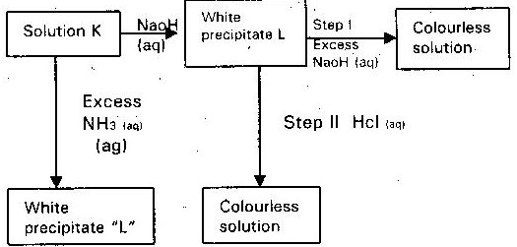

a) Identify:-
i) The cation in the solution K (1mk)
ii) The white precipitate “L” (1mk)
b) What property of white precipitate L is illustrated in steps I and II. (1mk)

c) write an equation for the reaction of the white precipitate L and dilute HCl (1mk)

- A,B,C are three homologous series of organic compounds
Series | General formula
A | C_{n}H_{2n}-2
B | C_{n}H_{2n}
C | C_{n}H_{2n} + 2
(i) What is the name given to series C ( 1 mk)

(ii) Write down the name and structural formula of the second member of series “B” (2mks)

(iii) Write down an equation and name of the products of reaction between HBr with second member of series “B” ( 2 mks)
(iv) state a chemical test thaty can be used to distinquish a member of A and B. (2mks)

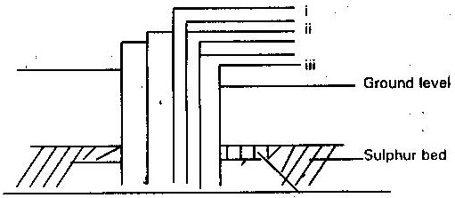
- The diagram below illustrates how sulphur is extracted by frasch process

(a) (i) Label the pipe through which superheated water is pumped in ( 1 mk)

(ii) What is the purpose of hot compressed air in this process? (1mk)

(b) The equation below shows the oxidation of sulphur (IV) oxide to sulphur (VI) oxide in the contact process
2SO₂ (g) + O₂ (g) →2 SO₃(g) ∆H = - 196KJ
(i) Name the catalyst used in this process ( 1 mk)

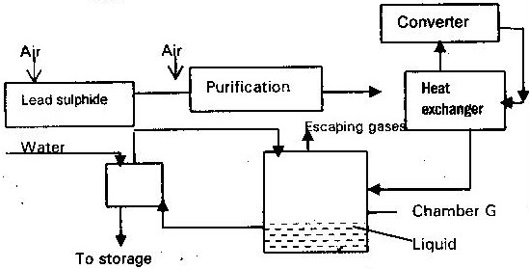
14. (a) The diagram below shows some processes that takes place during the industrial manufacture of sulphuric acid.

(i) Write the equation for the reaction in which sulphur (IV) Oxide is produced (1mk)

(ii) Why is it necessary to keep the gas pure and dry? ( 1 mk)

(iii) Describe the process that takes place in chamber G ( 1 mk)

(iv) Name the gases that escape into the environment ( 1 mk)

(v) State and explain the harmful effect on the environment of one of the gases (1mk)

(vi) state two uses of sulphuric(vi) acid. (1mk)

