## PERFECT STEPS PUBLISHERS

0721745374/0721707626

Nairobi

## END OF YEAR EXAMS 2015

CHEMISTRY FORM 1

1. Wooden splints **F** and **G** were placed in different zones of a Bunsen burner flame. The diagram below gives the observations that were made

**G**

**F**

Burnt parts

Burnt part

(a)Explain the difference between **F** and **G** (2marks)

**………………………………………………………………………………………………………**

**…………………………………………………………………………………………………**

(b) Name the type of flame that was used in the above experiment (1mark)

**………………………………………………………………………………………………………**

**………………………………………………………………………………………………………**

C. Name the other type of flame produced by a Bunsen burner and state one of its characteristic (2marks)

**………………………………………………………………………………………………………**

**………………………………………………………………………………………………………**

2.The diagram below shows a Bunsen burner when in use.



1. Name the region labelled A and B (2 marks)

A………………………………………………………………………………………………………

B…………………………………………………………………………………………………

1. State the function of the part labelled C (1 mark)

………………………………………………………………………………………………

3. (a) What is a drug? (1mark)

**………………………………………………………………………………………………………**

(b) Give **two** drugs that are commonly abused by the youth. (2marks)

**………………………………………………………………………………………………………**

4. A mixture of oil and water was shaken and left to separate as shown in the diagram below:

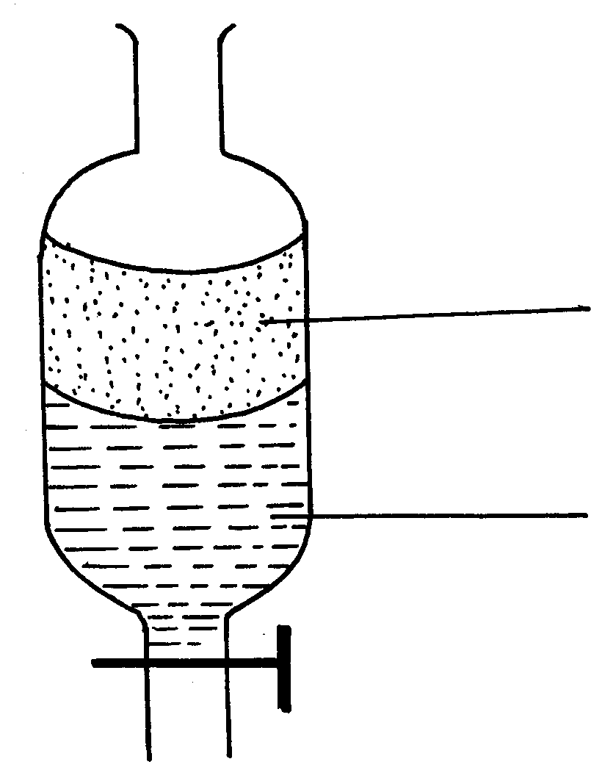

**P**

**W**

State the identity of; (2marks)

1. **P** ………………………………..……………………………………………………..
2. **W ……………………………………………………………………………………..**

5. The diagrams below are some common laboratory apparatus. Name each apparatus and state its use

|  |  |  |
| --- | --- | --- |
| **Diagram** | **Name** | **Use** |
|  | (1mk ) | (1mk) |

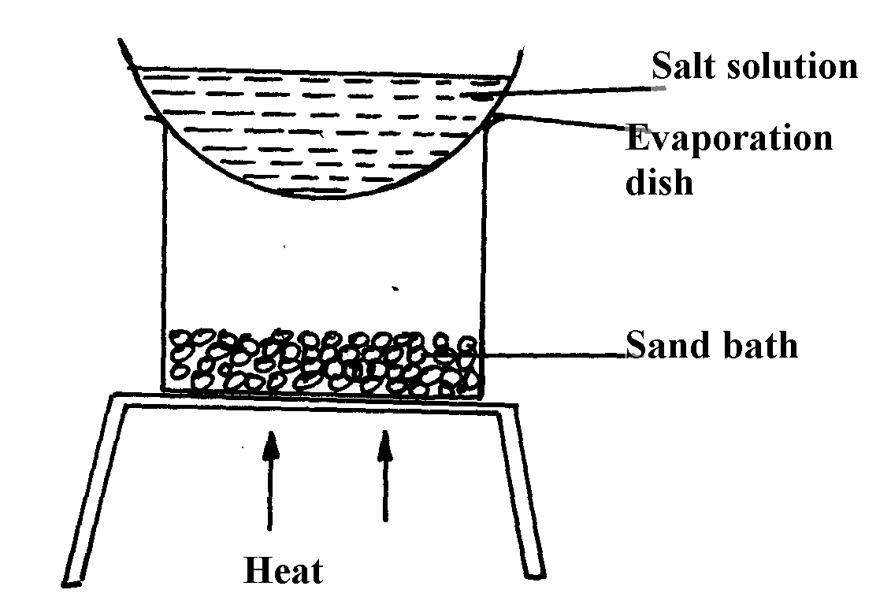6. A form 1 student carried out the separation as shown in the set-up below:-

i)Identify the method above

…………………………………………………………………………………………(1mark)

ii) Give **one** of its disadvantages (1mark)

**………………………………………………………………………………………………………**

iii)State one application of the above method (1mark)

**………………………………………………………………………………………………………**

7. What is effect of impurities on:

(i) Melting point (1mark)

**………………………………………………………………………………………………………**

(ii) Boiling point of a substance? (1mark)

**………………………………………………………………………………………………………**

8. The apparatus below were used by a student to study the effect of heat on hydrated

Copper II sulphate

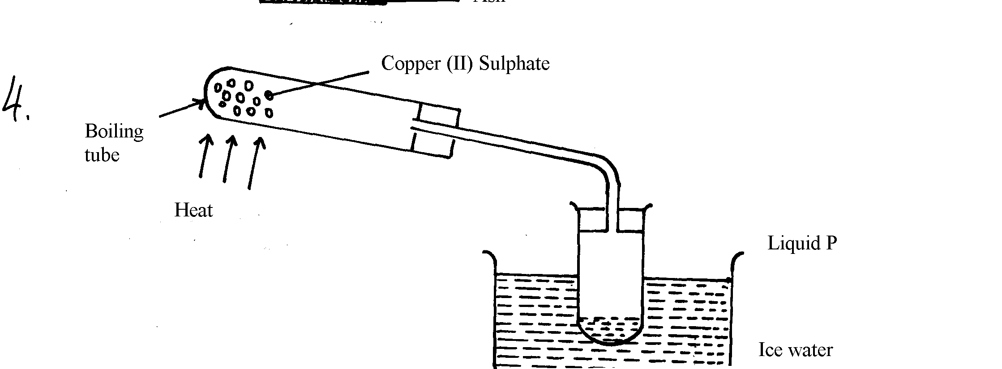

1. What is the role of the ice cold water (1mark)

**………………………………………………………………………………………………………**

b) Name liquid P (1mark)

………………………………………………………………………………………………………

(c) What observation is made in the boiling tube (1mark)

**………………………………………………………………………………………………………**

9. a)i) The diagram below show spots of a pure substance **A, B,** and **C** on a chromatography paper. Spot **D** is that of a mixture

●

●

●

●

A

B

C

D

After development **A, B**, and **C** were found to have moved 3cm, 2cm and 1cm respectively. **D** had separated into two spots which had moved 3cm and 2cm

On the diagram above;

I. Label the baseline (origin) (1mark)

**………………………………………………………………………………………………………**

II. Show the positions of all the spots after development (2marks)

III. Identify the substances present in mixture **D** (1mark)

**………………………………………………………………………………………………………**

b) Describe how solid ammonium chloride can be separated from a solid mixture of ammonium chloride and sodium chloride (3marks)

**………………………………………………………………………………………………………**

**………………………………………………………………………………………………………**

10. A student left some crushed fruit mixture with water for some days. He found the mixture had fermented. He concluded that the mixture was contaminated with water and ethanol with boiling point of 100oC and 78oC respectively. The set-up of apparatus below is used to separate the mixture.

**A**

Thermometer

**B**

Mixture

Conical

flask

Distillate

Apparatus **W**

(i) Name the piece of apparatus labeled **W** (1mark)

**……………………………………………………………………………………………………**

(ii) What is the purpose of the thermometer in the set-up? (1mark)

**………………………………………………………………………………………………………**

(iii) At which end of the apparatus **W** should tap water be connected? (1mark)

**……………………………………………………………………………………………………**

(iv) Which liquid was collected as the first distillate? Explain (2mark)

**………………………………………………………………………………………………………**

(v) What is the name given to the above method of separating mixture? (1mark) **………………………………………………………………………………………………………**

(vi) State **two** applications of the above method of separating mixtures (2mark) **………………………………………………………………………………………………………**

**………………………………………………………………………………………………………**

**………………………………………………………………………………………………………**

(vii) What properties of the mixture make it possible for the component to be separated by the above methods? (1mark)

**………………………………………………………………………………………………………**

11. The information below gives PH values of solutions **V, W, X, Y Z**

|  |  |
| --- | --- |
| **Solution** | **PH values** |
| V  W  X  Y  Z | 2  6.5  11  14  4.5 |

(a) Which solution is likely to be?

(i) Calcium hydroxide (1mark)

**………………………………………………………………………………………………………**

(ii) Rain water? (1mark)

**………………………………………………………………………………………………………**

(b)Which solution would react most vigorously with magnesium metal (1mark)

**………………………………………………………………………………………………………**

12. (a) What is rust? (1mark)

**………………………………………………………………………………………………………**

(b) Give **two** methods that can be used to prevent rusting (2marks)

**………………………………………………………………………………………………………**

(c) Name **one** substance which speeds up the rusting process (1mark)

**………………………………………………………………………………………………………**

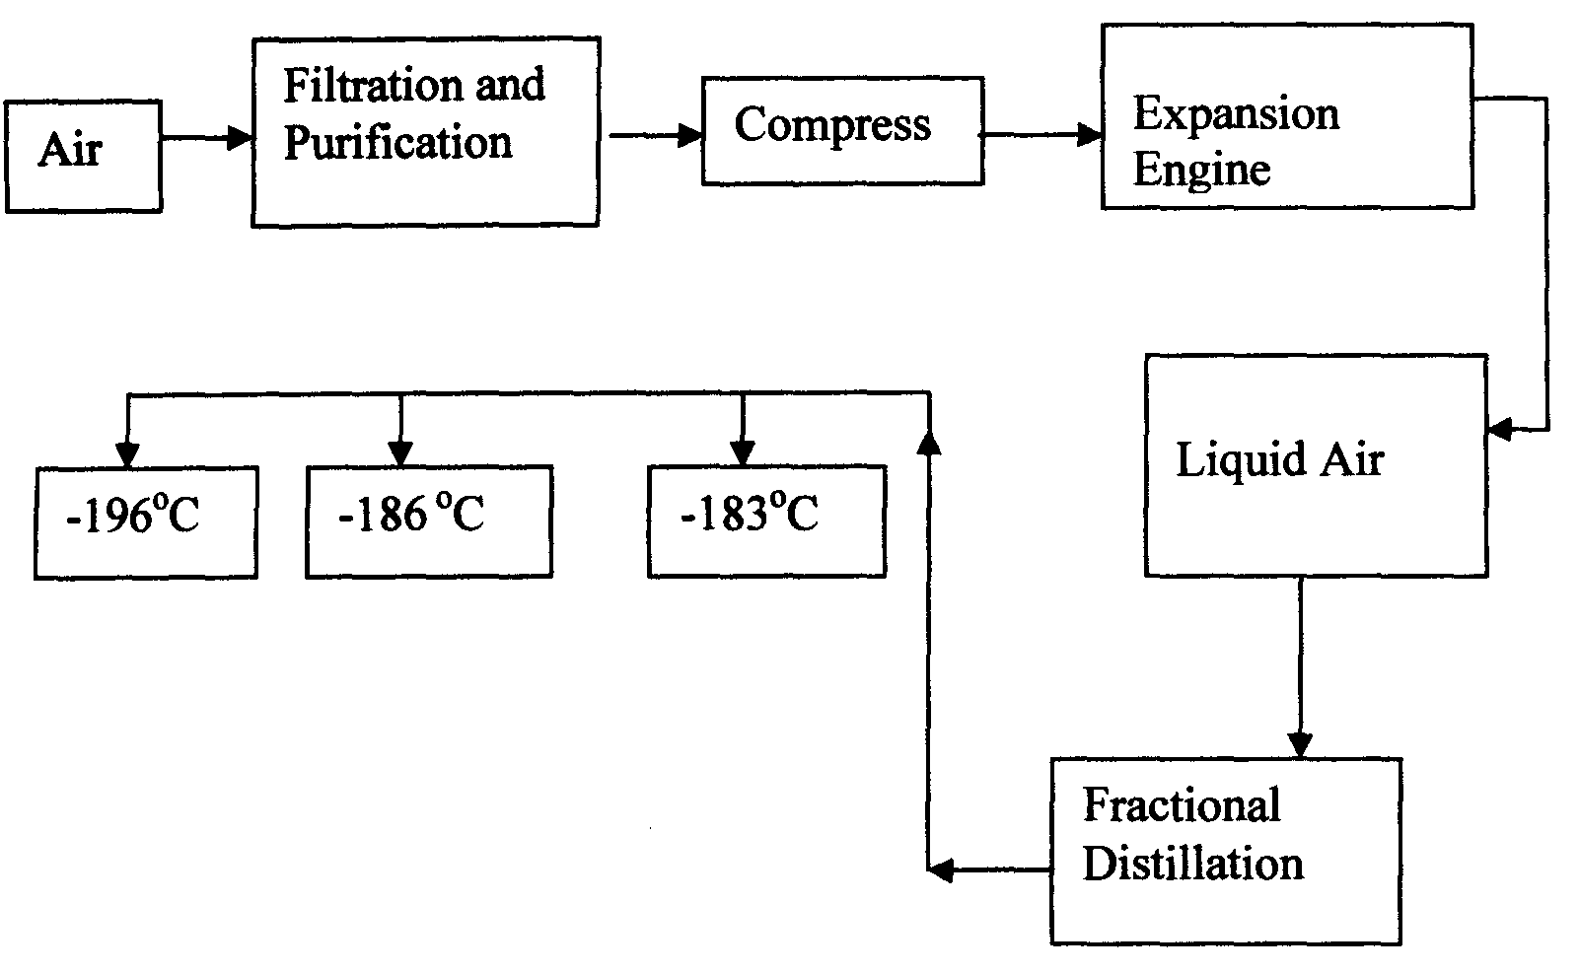13. Oxygen is obtained on large scale by the fractional distillation of air as shown on the flow chart below.

a) Identify the substance that is removed at the filtration stage (1mark)

**………………………………………………………………………………………………………**

b) Explain why Carbon (IV) oxide and water are removed before liquefaction of air. (2marks)

**………………………………………………………………………………………………………**

c) Identify the component that is collected at -186°. (1mark)

**………………………………………………………………………………………………………**

d) Name one step that is missing and state its significance. (2marks)

**………………………………………………………………………………………………………**

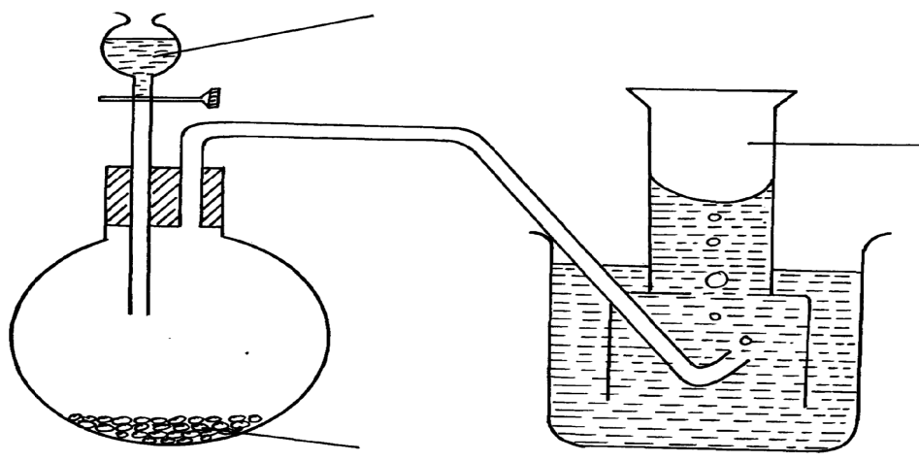14. The diagram below shows students set-up for the preparation and collection of oxygen gas

X

Oxygen gas

Sodium peroxide

(a) Name substance **X** used (1mark) **………………………………………………………………………………………………………**

(b) Write a word equation to show the reaction of sodium peroxide with the substance named in **14(a)** (1mark)

**………………………………………………………………………………………………………**

c) State the property that makes it possible to collect oxygen as shown in the diagram. (1mark)

**………………………………………………………………………………………………………**

d) State two uses of oxygen (2marks)

**……………………………………………………………………………………………………**

15. a) Complete the table below to show the color of the given indicator in acidic and basic solutions. (2marks)

|  |  |  |
| --- | --- | --- |
| Indicator | Color in | |
| Methyl Orange | Acidic Solution | Basic Solution |
|  |  |
| Phenolphthalein |  |  |

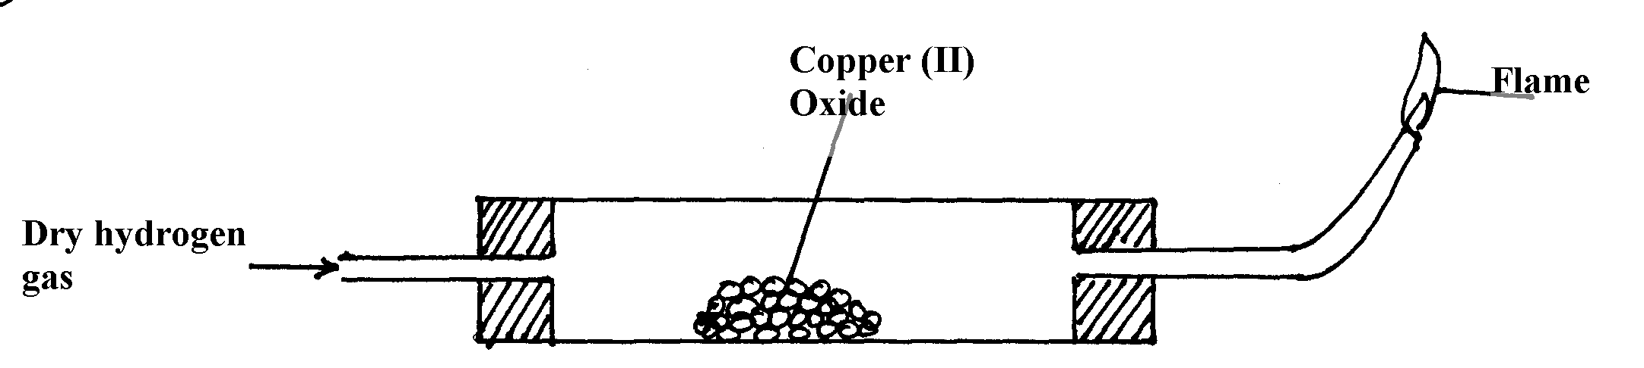16) The set-up below is used to investigate the properties of hydrogen.

1. On the diagram, indicate what should be done for the reaction to occur (1mark)
2. Hydrogen gas is allowed to pass through the tube for some time before it is lit. Explain (1mark)

**………………………………………………………………………………………………………**

Write a word equation for the reaction that occurs in the combustion tube (1mark)

**………………………………………………………………………………………………………**

When the reaction is complete, hydrogen gas is passed through the apparatus until the cool down. Explain (1mark)

………………………………………………………………………………………………………

What property of hydrogen is being investigated? (1mark)

**………………………………………………………………………………………………………**

What observation is made in the combustion tube? Expain (2mark)

**………………………………………………………………………………………………………**

Why is zinc oxide not used to investigate this property of hydrogen gas? (1mark)

**………………………………………………………………………………………………………**

b) State two uses of hydrogen (2marks)

**………………………………………………………………………………………………………**

**………………………………………………………………………………………………………**

17. A form one class carried out an experiment to determine the active part of air. The diagram below shows the set-up of the experiment and also the observation made.

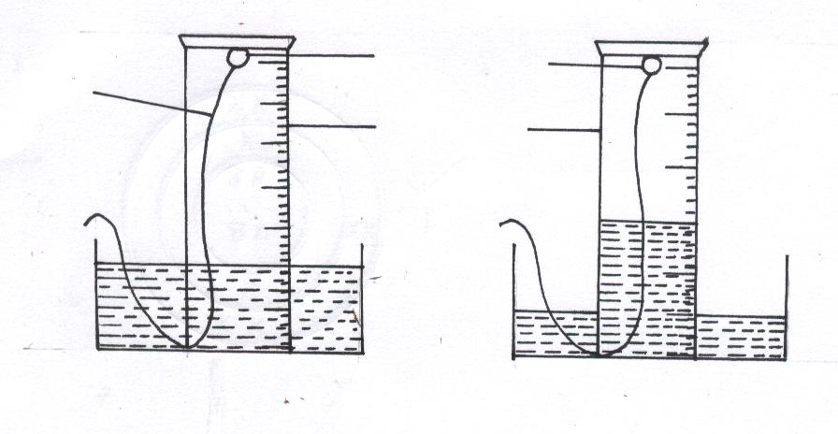

White phosphorous

Measuring cylinder

Wire

Beginning of the Expt

End of Expt

a) What is observed when white phosphorus is exposed to air? (1marks) …….………………………………………………………………………………………………

b)Write equations for the reactions which occurs (2marks)

…….………………………………………………………………………………………………

…….………………………………………………………………………………………………

c) How is phosphorus stored in the laboratory (1mark)

……………………………………………………………………………………………………

…….………………………………………………………………………………………………

18. The graph below shows the changes which take place when a solid is heated.

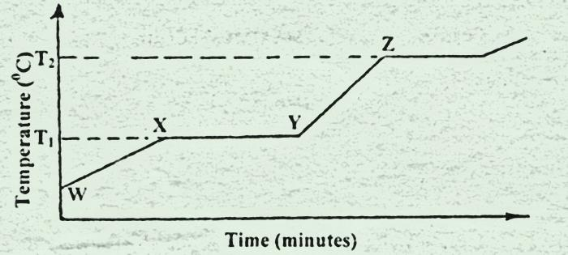

(a) What happens to the molecules between Wand X? (1mark)

…….………………………………………………………………………………………….……

(b) What is the significance of the temperatures T1and T2? (1mark)

…….………………………………………………………………………………………….……

(c) Explain why the temperature does not rise between X and Y. (1mark)

…….………………………………………………………………………………………….……

19. The diagram below shows a set up used to investigate the process of rusting. Study it and answer the questions that follow.

Tube A

Tube A

Tube C

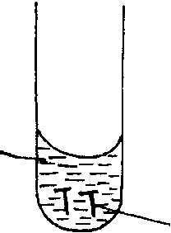 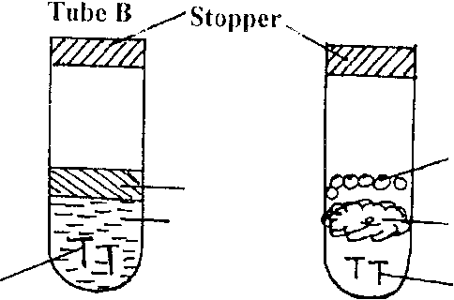

Anhydrous Calcium Chloride

Cotton wool

Iron nails

Boiled water

oil

Iron nails

Distilled water

State and explain the observation made on the iron nails in tubes A and B at the end of the experiment.

Tube A (2marks)

…….………………………………………………………………………………………….……

Tube B (2marks)

…….………………………………………………………………………………………….……

b) What is the role of anhydrous calcium chloride in tube C (1mark)

…….………………………………………………………………………………………….……

20. Study the diagram of the set-up below and answer the questions that follow.

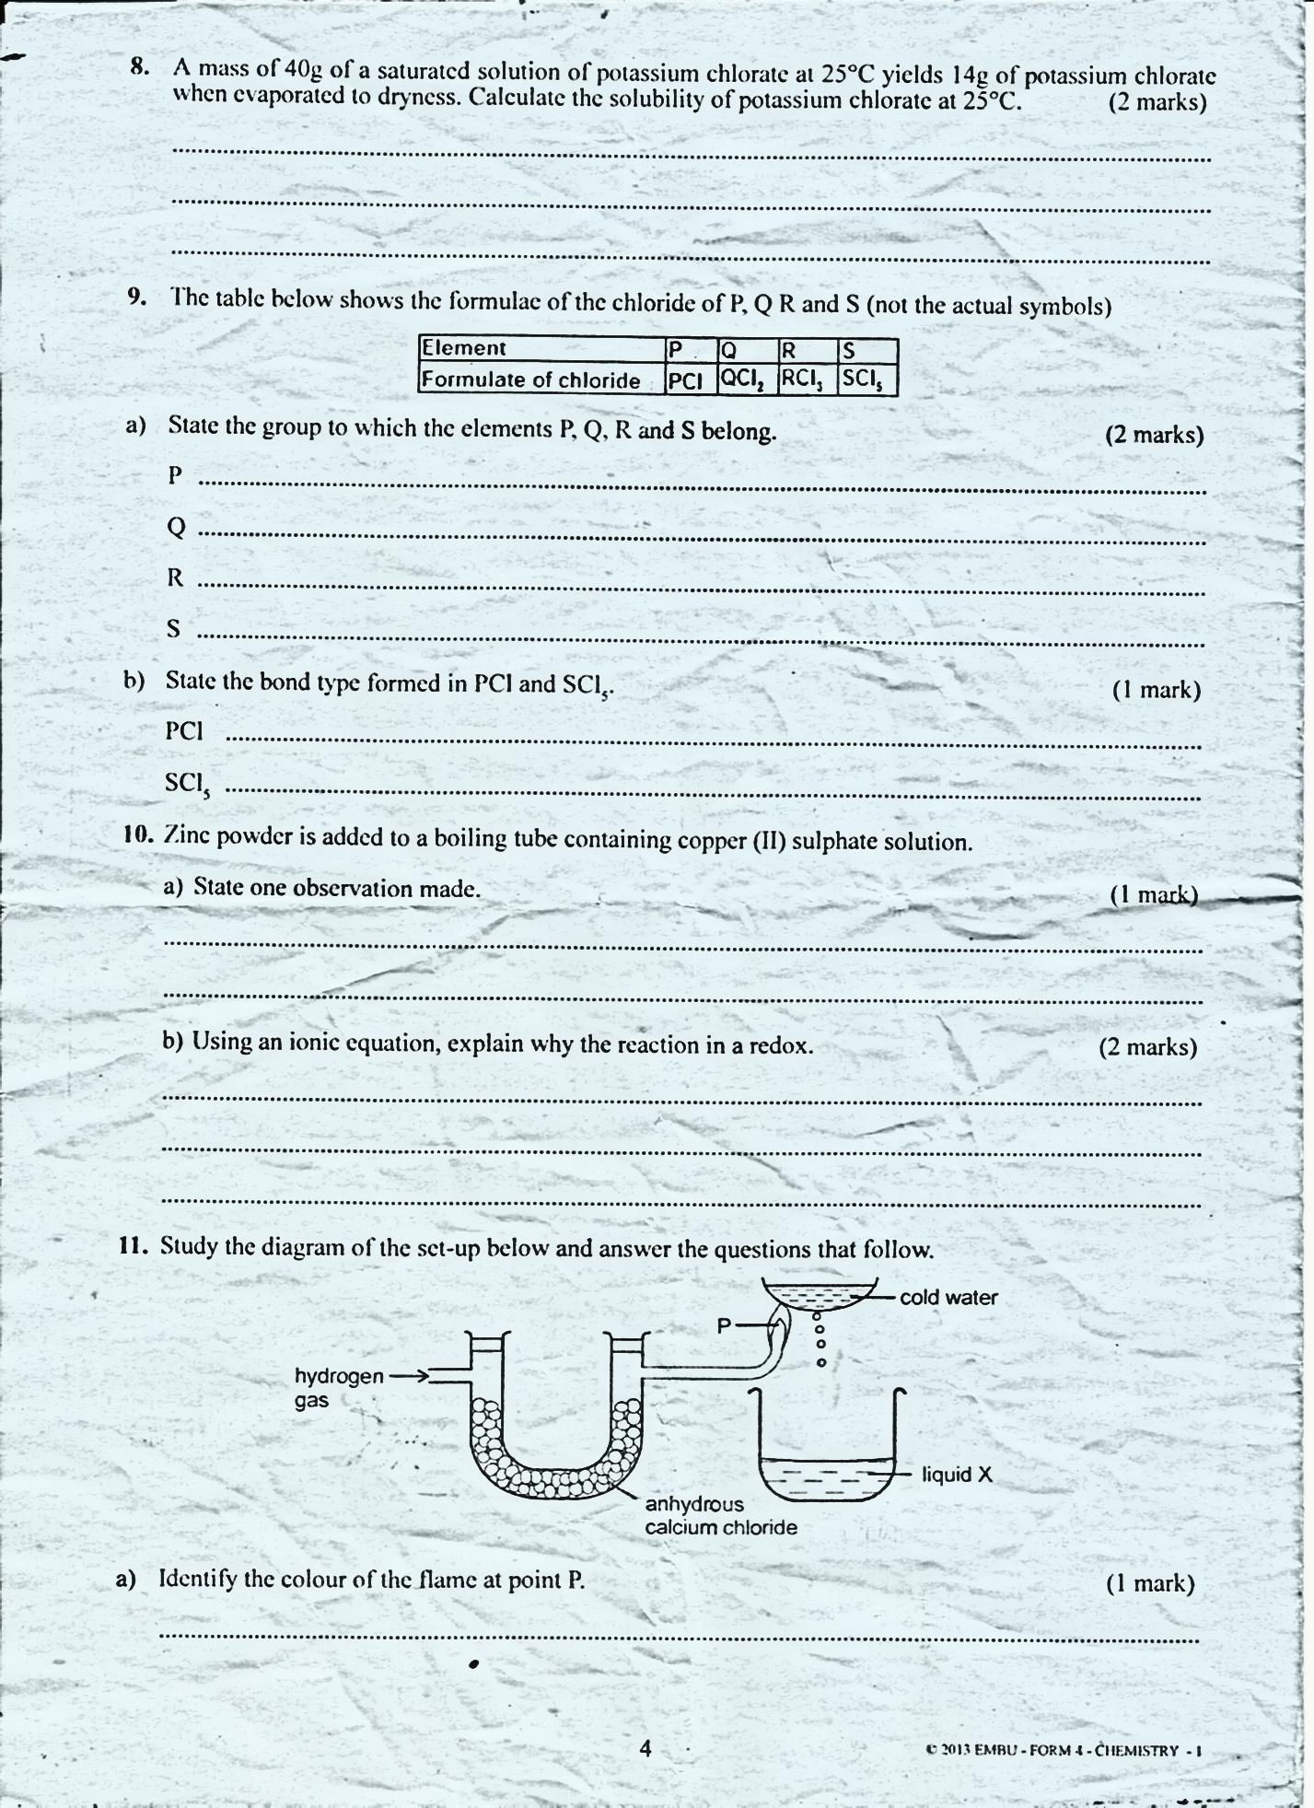

a) Identify the color of the flame at point P. (1mark)

…….………………………………………………………………………………………….……

b) Describe a chemical test for liquid X. (2marks)

…….………………………………………………………………………………………….……

…….…………………………………………………………………………………………….…

c) Write a word equation to show formation of liquid x (1mark)

…….………………………………………………………………………………………….……

…….…………………………………………………………………………………………….

21. The following diagram shows the effects of heat on the physical states of substances.



(a) Identify the processes represented by the letters A, C, D, and F (2marks)

…A….………………………………………………………………………………………….

…C….…………………………………………………………………………………………….

…D.………………………………………………………………………………………….…

…F….……………………………………………………………………………………………

(b) Name two substances that undergo the process labelled E and F. (2marks)

…….………………………………………………………………………………………….……

…….…………………………………………………………………………………………….…

c)Name a method that can be used to extract the following:-

(i) Common salt from a salt solution. (1mark)

…….………………………………………………………………………………………….……

(ii) Oil from cashew nuts. (1mark)

…….………………………………………………………………………………………….……

22. a) State the type of change in the following (3marks)

i) Burning a candle

…….………………………………………………………………………………………….……

ii) Heating anhydrous copper(II) sulphate

…….……………………………………………………………………..…………………….……

iii) Heating copper(II) nitrate

…….………………………………………………………………………………………….……

State three characteristics of a temporary chemical change (3marks)

…….………………………………………………………………………………………….……

23) Describe how to prepare a simple acid-base indicator using flower petals (3marks)

…….………………………………………………………………………………………….………….…………………………………………………………………………………………….…

…….………………………………………………………………………………………….……

…….…………………………………………………………………………………………….…