FORM ONE CHEMISTRY DECEMBER HOLIDAY ASSIGNIMENT-2015
1a) State the chemical test for presence of water. (1mk)
b) State the test, which is used to show that water is pure. (1mk) 2. Describe an experiment to show that water is an oxide of hydrogen. (3mks) 3. State the precautions that must be taken when carrying out experiments with hydrogen gas. (2mks) 4. Why is it not advisable to use iron in making steam boilers. (2mks)
5. Write a word equation in which hydrogen acts as a reducing agent. (1mk)
6. Name the products formed when kerosene/a candle is burned in air. (2mks)
7. Write down the observations and equation made when a small piece of potassium is placed in water. (4mks)

8. Some moist iron wool was placed in a test tube and the tube was inverted and set up as shown below.

y cm
x cm

The apparatus was left for one week. The water level rose and iron wool turned red-brown.

(i) Write a word equation to show the rusting of iron. (1 mk)
(ii) Write the expression for an approximate percentage. (1 mk)
(iii) State two similarities between rusting and combustion. (1 mk)
(iv) What is the chemical name for rust? (1mk)
9. Paper chromatography is a method of separating colors or dyes.
What two properties should the components of a mixture have that would make the separation possible. (2 mks)

10. Study the diagram below and answer the questions that follow. (3 mks)
Gas jar

Dilute
Hydrochloric acid

Clamp

Zinc granules
Liquid Z

(a) Write a word equation for the reaction between zinc granules and dilute hydrochloric acid. (1 mk)
(b) What property of hydrogen is demonstrated by the method of collection shown on the diagram? (1 mk)
- Hydrogen gas passed through liquid Z. What is the name of liquid Z and what is the purpose of liquid Z? (1 mk)
- Name industrial uses of hydrogen. ( 2mks)
11. The diagrams below represent two iron nails with some parts wrapped tightly with zinc strips, respectively.

A Zinc strip Iron nail B Copper strip Iron nail

What observations would be made at the exposed points A and B if the wrapped nails are left in the open for several months? Explain.
Observation at A. ( 1mk)
Explanation: ( 1 mk)
Observation at B.( 1 mk)
Explanation :( 1mk)
12. Study the diagram below and answer the questions that follow.
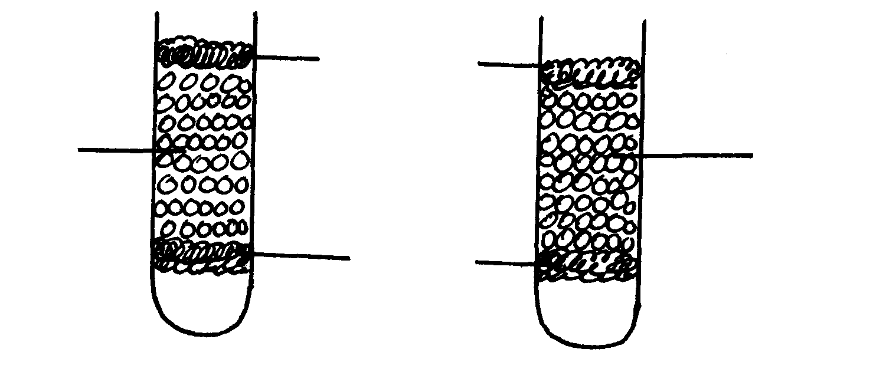
Cotton wool
Dry sodium chloride
Anhydrous calcium chloride

Cotton wool
a)State and explain the observations made after two weeks. (2mks)
b) Give one reason for Silver plating an Iron spoon (1mk)
13(a) What is a flame (1mk)
(b)Name the type of a flame produced by the Bunsen burner when the air hole is closed. (1mk)
14.The diagram below shows an iron bar which supports a bridge the iron bar is connected to a piece of magnesium metal.
Iron bar

Soil Magnesium

Connecting wire
Explain why it is necessary to connect the piece of magnesium to the iron bar. (3mks )
15. Pentane and ethanol are miscible. Describe how water can be used to separate a mixture of pentane and ethanol. (3mks)
16. Phosphorus element smoulders in air to form two oxides
(a) Name the two oxides. (2mks)
(b) State the nature of the solution when the above mentioned oxides are dissolved in water.1 mk)
17 Classify the following processes as either chemical or physical. (3mks )
Process Type of change
(a) Heating of lead (II) oxide
(b) Obtaining kerosene from crude oil
(c ) Souring of milk
18. (a) What are acid-base indicators?(1mk)
(b) Give two acid-base indicators and state the colour changes in acid and base solutions. (2 mks )
Name of indicator Colour in acid Colour in base

(i) ________________________ _______________________ _____________

(ii) _______________________ _______________________ ____________________
19. In the industrial preparation of oxygen, state:
- How dust particles are removed from air. (1 mk)
- Why carbon (IV) oxide is removed before the mixture is cooled to -25⁰C. (1 mk)
20.A mixture contains sodium chloride, sugar and camphor. The table below shows the solubility of these solids in different liquids.

Liquid  Solid | Water | Ethanol | Ether
Sodium chloride | Soluble | Insoluble | Insoluble
Camphor | Soluble | Insoluble | Very soluble
Sugar | Soluble | Soluble | Insoluble

Explain how sugar can be obtained from a mixture of sodium chloride, camphor and
Sugar. (3mks)

THIS THE LAST PRINTED PAGE.

