GATITU SECONDARY SCHOOL P.O BOX 327-01030, GATUNDU

233/1/2

CHEMISTRY FORM 1 END OF YEAR EXAMINATION -2015

NAME…………………………………….ADM……………CLASS…………….

**ANSWER ALL QUESTIONS.**

1. Study the figure below and answer questions that follow.

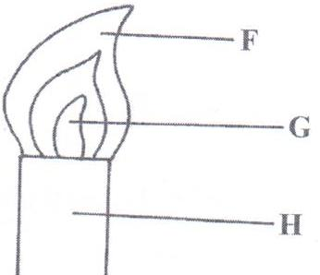

Name the parts labeled **F** and **G**. (2mks)

………………………………………………………………………………………………………………………………………………………………………………………………………………………………………………………………………………………………………

2. Samples of urine from three participants F, G and H at an international sports meeting were spotted onto chromatography paper alongside two from illegal drugs A1 and A2. A chromatogram was run using methanol. The figure below shows the chromatogram.

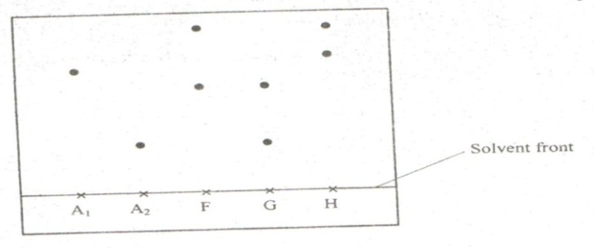

1. Identify the athlete who had used an illegal drug. (1mk)

…………………………………………………………………………………………….

1. Which drug is more soluble in methanol? (1mk)

………………………………………………………………………………………………

3. The diagram below is a set up for the laboratory preparation of dry oxygen gas.

Sodium peroxide

Liquid X

Liquid Y

1. Name:
2. Liquid Y (1mk)

…………………………………………………………………

1. Liquid X (1mk)

…………………………………………………………………….

1. Write a word equation for the reaction that took place in the flask.(1mk)

……………………………………………………………………………………………………………………………………………………………………………………………………………..

(c) Outline **three** uses of oxygen gas. (3mks)

…………………………………………………………………………………………………………………………………………………………………………………………………………………………………………………………………………………………………………………………………………………………………………………………………………………………………………………………………………………………………………………………………………………………………………………………………………………………………………......

4. The following diagram shows the effects of heat on the physical states of substances.

(a) Identify the processes represented by the letters A, B, C, D, E and F (3mks)

....................................................................................................................................................................................................................................................................................................................................................................................................................................................................................................................................................................................................................

  (b) Name two substances that undergo the process labelled E and F. (2mks)

……………………………………………………………………………………………………

(c) Name a method that can be used to extract the following:-

 (i) Common salt from a salt solution. (1mk)

…………………………………………………………………………………………

(ii) Paraffin from crude oil. (1mk)

………………………………………………………………………………………..

(d) A student separated liquid P (B.P 78°C) and liquid Q (B.P 100°C) wring the apparatus shown below.



  (i) Name the apparatus labelled

(a) M .......................................................................................................(1mk)

  (b) R.........................................................................................................(1mk)

  (ii) State one function of the glass bead in apparatus labelled R (1mk)

……………………………………………………………………………………………………

(iii) What is the reading on the thermometer when the first jar drops of the distillate appeared in the beaker. (1 mark)

…………………………………………………………………………………………………..

  (iv) Which of the liquids remains in the flask. (1mark)

…………………………………………………………………………………………………..

5. The pH of a sample of soil was found to be 5.5. An agricultural officer recommended the addition of lime (calcium oxide).State the function of lime in the soil. (2mks)

………………………………………………………………………………………………………………………………………………………………………………………………………………………………………………………………………………………………………………………………………………………………………………………………………………………………

6. In an experiment to investigate the percentage of oxygen in air, 200cm3 of air was passed over heated copper turnings repeatedly until a constant volume of air remained.160 cm3 of air remained at the end of the experiment.

i) Name four gases remaining in the 160 cm3 of air. (2mks)

………………………………………………………………………………………………………………………………………………………………………………………………………………………………………………………………………………………………………………………

ii) Determine the percentage of air used up during the experiment. (2mks)

………………………………………………………………………………………………………………………………………………………………………………………………………………………………………………………………………………………………………………………

7. Solutions may be classified as strongly basic, weakly basic, neutral, strongly acidic or weakly acidic. The information below gives some solutions and their pH values. Study it and answer the questions that follow.

|  |  |
| --- | --- |
| Solution | pH |
| P | 0.5 |
| Q | 7 |
| R | 14 |
| S | 9 |

Classify the solution in the table using the stated classifications. (4mks)

P…………………………………….. Q……………………………………

R…………………………………….. S…………………………………….

8. State and explain the changes in mass that occur when the following are heated separately in open crucibles. Write a word equation for each reaction. (3mks)

a) Zinc metal.

b) Zinc carbonates.

………………………………………………………………………………………………………………………………………………………………………………………………………………………………………………………………………………………………………………………………………………………………………………………………………………………………

9. Sodium chloride (common table salt) is contaminated with copper (II) oxide. Explain how pure sodium chloride can be obtained from the mixture. NB: sodium chloride is soluble in water while copper (II) oxide is not. (2mks)

………………………………………………………………………………………………………………………………………………………………………………………………………………………………………………………………………………………………………………………

10. Nitrogen and oxygen are among the gases in the air. Nitrogen boils at -196oC and oxygen at -183oC respectively. Explain how pure nitrogen gas can be obtained from a mixture of nitrogen and oxygen. (3mks)

……………………………………………………………………………………………………………………………………………………………………………………………………………………………………………………………………………………………………………………………………………………………………………………………………………………………..

11. Complete the following word equations. (10mks)

a) Copper (II) oxide + Dil. Sulphuric acid

b) Calcium oxide + Dil. Hydrochloric acid

c) Sodium carbonate + Dil. Nitric acid

d) Zinc + Dil. Hydrochloric acid

e) Sodium hydroxide + Dil. Nitric acid

**END.**