GATITU MIXED SECONDARY SCHOOL
CHEMISTRY FORM 1 END OF TERM 3 2015
- The diagram below shows a piece of apparatus used in laboratory.

- Give the;
- Name of apparatus 1mk

- Use of the apparatus. 1mk

- Label the part of apparatus marked A,B,C and D. 4mks

- Give one reason why laboratory apparatus are made of glass. 1mk

- Name a method that would be used to separate the following mixture into pure substances. 3mks
- iodine + and lead II sulphate

- sulphur + iron powder

- Some sulphur powder was burnt in air the product obtained was shaken with a small amount of warm water to make a few solution. State and explain the observation made when a few drops of methyl orange indicator were added to the solution.3mks

- Give the chemical name for rust. 1mk

- Complete the following 3mks
Element latin name symbol

Plumbum
Copper cu

Kalium k

- Fractional distillation of liquid air is used to separate various gaseous component in air. Explain how to 3mks
- Remove carbon iv oxide

- Remove moisture

- Obtain nitrogen

- The experiment below was set by student

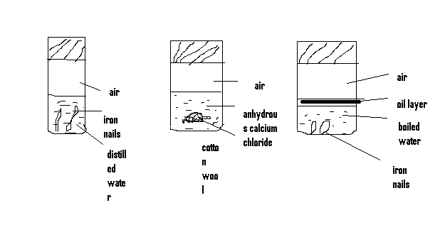
- Explain the purpose of boiling water before putting tube 3 1mk

- What is the role of anhydrous calcium chloride in test tube 2 1mk

- In which test tube did rusting take place? Explain 2mks

- Give two condition that may speed up the rate of rusting. 2mks

- State four methods which can be used to prevent rusting on iron. 4mks

- Impurities have an effect on both melting and boiling point on substance.
- State the effect of an impurity to
- Boiling point of a substance 1mk

- Melting point 1mk

- State one criteria for determining the purity of a substance 1mk

- Identify a method that can be used to separate ethanol and water. 1mk

- What is a compound? 1mk

- Metal s removes oxygen combined with R . Q react with an oxide of R but not with an oxide of P. p react cold water but Q does not
- Arrange the metals in order of reactivity starting with the most reactive to the least reactive. 2mks

- What is air pollution? 1mk

- Name four gases found in air and their percentage composition. 4mks

- Explain the change in mass that occurs when the following substances are separately heated in oxygen
- Copper metal 2mks

- Copper II nitrate 2mks

- Complete the following equations 6mks
- Lead + oxygen →

- Copper II oxide + aluminium →

- Magnesium oxide + copper →

- Classify the following process either chemical or physical 3mks
- Heating copper II sulphate crystals

- Heating zinc oxide

- Evaporation

- Complete the following table to show to colour of the given indicator in the indicator solution. 2mks

indicator | Colour in acid solution | Basic solution
Methyl orange |  | Red
phenolphthalein | colourless

- In laboratory preparation of oxygen
- Identify two substances that can be used to prepare oxygen. 1mk

- Identify a method which is used to collect dry oxygen gas. explain 2mks

- Why the first few bubbles are not collect. 2mks

- .The students set up the experiment below to collect gas v.the wet sand and
Was heated before heating zinc powder
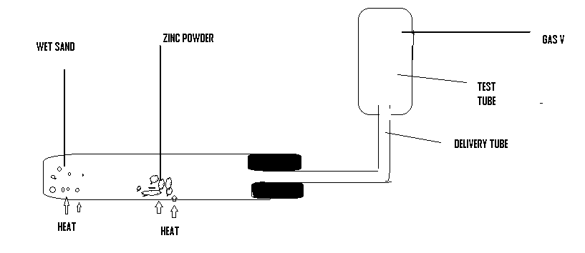

- why was it necessary toheat wet sand before heating zinc powder (2mks)

ii) What would happen if zinc powder was heated before heating sand (2mks?)

iii) During the experiment the delivery tubeis removed before heating stops…explain (2mks)

iv) Identify another substance that can be used inplace of wet sand (1mk)

v) When copper metal was used in place of zinc, there was no gas produced. Explain (2mks)

vi) Identify another metal that can give the same result as copper Metal (1mk

