NAME --------------------------------------------- CLASS ---------------------------ADM NO ---------------------
GATITU MIXED SECONDARY SCHOOL
CHEMISTRY FORM 1
3RD TERM 2013
2 HRS
- Give two harmful effects of drug abuse. 2mks

- Give two ways that chemistry has helped to boost food production. 2mks

- Indicate whether the following substances are conductors or non conductors. 4mks
copper | Conductor
Rubber
Glass
Graphite

- Name the piece of apparatus used for the following function in the laboratory.
- measuring accurate volumes of liquids and solutions. 1mk

- scoping solid reagents from container. 1mk

- supporting beakers and flasks during heating 1mk

- Give two properties of glass that makes it suitable for the manufacture of laboratory apparatus. 2mks

- The diagram below shows what is observed when paraffin is added to water in a beaker.
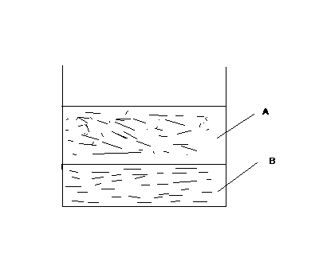

- On the diagram label the water and paraffin layer 1mk
A
B
- What type of a mixture is the paraffin water mixture? 1mk

- Name the method of separation that can be used to separate the liquids. 1mk

- The diagram below represents chromatogram obtained when a plant extract was introduced on a piece of chromatographic paper.
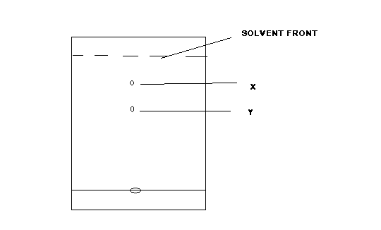

- What is solvent front? 1mk

- Give two reasons why Y is formed near the solvent front. 2mks

- What is meant by the following terms? 2mk
- melting point

- mixture

- Give three differences between permanent and non permanent changes. 3mks
permanent | Non permanent

- Write a word equation for the reaction between the following.
- Write a word equation for the reaction between the following. 1mk

- sodium hydroxide and hydrochloric acid 1mk

- Classify the following substances as elements, compounds or mixtures
Air | Mixture
Water
Soil
Iron

- In an experiment, a form one student inverted a gas jar over a burning candle placed on a cork floating on a sodium hydroxide solution as shown in the diagram below.
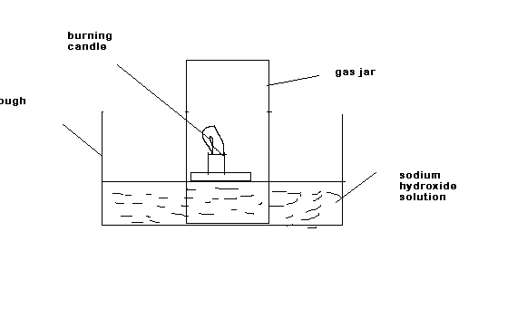
- What observation was made? 2mks

- what was the student investigating in the experiment? 1mk

- Why did the student use sodium hydroxide solution instead of water? 1mk

- What is meant by water pollution? 1mk

- Give one possible water pollutant that comes from your home. 1mk

- When a metal M was placed in a beaker of cold water it melts into a silvery white ball that reacts on surface producing a hissing sound as shown below.

- Identify metal M 1mk

- State and explain the observation made when a blue and red litmus paper were placed in the water after the reaction. 2mks

- The word equation below is for a redox reaction
Lead (II) oxide + hydrogen gas → lead + water
- what is a redox reaction? 1mk

- Identify the
reducing agent 1mk

Oxidizing agent 1mk

- Name the elements present in the following compounds
- sodium nitrate 1 ½ mk

- water 1 mk

- Give two ways of preventing fire accidents in the laboratory while using the Bunsen burner in the laboratory 2mks

- What is the function of fume chamber in the laboratory? 1mk

- Explain why it is extremely dangerous to use a charcoal Jiko in a room that is not well ventilated. 2mks

- The table below gives some properties of gases V1,V2 and V3
Gas | Density to air | Effect of water
V1 | Lighter than air | Dissolves easily
V2 | Heavier than air | Dissolves fairly
V3 | Slightly less dense than air | Almost insoluble
- Name the most suitable method of collecting 1mk
- v1 1mk

- v2 1mk

- v3 1mk

- Name the method of separation used to separate crude oil into components. 1mk

- Name one compound obtained from separation of crude oil and give its use. 1mk

- The diagram below represents a set up of apparatus used in experiment to determine mass of oxygen gas that reacted with a given mass of magnesium ribbon.
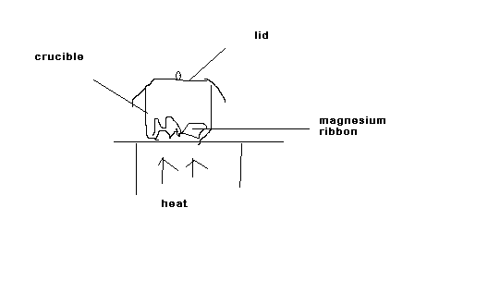
The following masses were measured during the experiment
mass of crucible + lid =13.6 g
mass of crucible + lid + magnesium ribbon =14.8g
mass of crucible + lid + residue after heating =16.4 g
- Give a reason for the following
- the magnesium ribbon was polished with solid paper before being used in the experiment. 1mk

- the lid was opened occassionary during heating. 1mk

- State the observation made in the crucible at the end of experiment. 1mk

- Write a word equation for the reaction that took place. 1mk

- calculate the
- mass of magnesium ribbon used 1 ½ mk

- mass of oxygen that reacted with the magnesium ribbon 1 ½ mk

- total mass of the compound formed when magnesium reacts with oxygen 1 ½ mk

- In an experiment to determine the composition of candle wax, candle wax was burnt in air and the products collected were a colourless liquid and a colourless gas that formed a white precipitate in calcium hydroxide solution.
- State how the courless liquid obtained could be identified. 1mk

- name the colourless gas 1mk

- From the experiment, what elements compose candle wax. 2mks

- During the large scale isolation of oxygen, air is passed through the following stages
stage i: passed through filters
stage ii: bubbled through sodium hydroxide solution
stage iii: cooled to -25 c
stage iv: compressed and expanded repeatedly
stage v: fractional distillation
- state the purpose of the following stages 4mks
stage i

stage ii

stage iii

stage iv

- which components of air are separated in stage v 1 ½ mk

- Give one advantage of universal indicators over acid –base indicators 2mks

- Give two examples of each of the following
- A strong base 2mks

- An acidic oxide 2mks

- laboratory acid –base indicators 2mks

- study the diagram below and answer the questions that follow
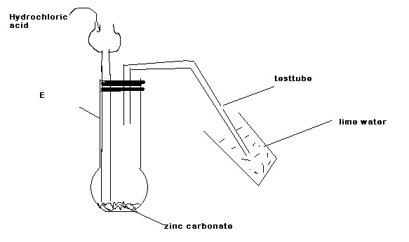

- Name apparatus E 1mk

- state the observation made in the
Apparatus E 1mk

Test tube 1mk

- Name the compounds formed in the reaction 1 ½ mk

- study the diagram below and answer the questions that follow
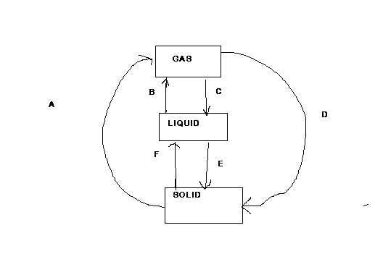

a. Identify process A,C and F 3mks

b. Give an example of a substance that undergoes process A 1mk
c. On the axis below draw the heating curve of pure water showing all the process it undergoes and three states of matter.
3mks

a. i.Name the regions of a non luminous flame 3mks

ii. Which is the hottest region 1mk

b. Under what condition can the non – luminous flame are obtained from a Bunsen burner. 1mk

c. What type of reaction takes place when the laboratory gas burns in air? 1mk

