NAME………………………………………………ADM.NO………………………

OLMARIKO SECONDARY SCHOOL

END OF TERM ONE, 2016 EXAMINATION
CHEMISTRY
Form ONE

INSTRUCTION

- Answer all the questions in the spaces provided
- All working must be shown where nnecessary
1. A well labeled diagram of a Bunsen burner is given below.
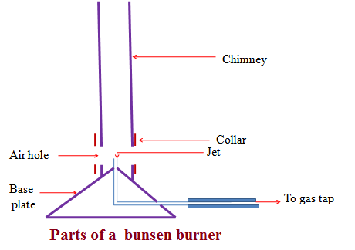
a) State the functions of;
I) chimney(2mks)

I I) collar(2 mks)

III) air hole(2 mks)

IV) base plate(2 mks)

b) draw a well labeled diagram of a non-luminous flame (4mks)

c) Describe how you will light the Bunsen burner with the non-luminous flame. (4mks)

d) state four differences between the luminous and non-luminous flames. (8mks)
 | luminous flame | non-luminous flame
1
2
3
4

2. a) What is Chemistry (2mks)

b) list four importances of Chemistry (4mks)
1
2
3
4
5

3. a) What is a Chemistry laboratory (1mk)

b) State two reasons why most laboratory apparatus are made up of glass. (2mks)

c) Draw a diagram of a volumetric flask (2mks)

d) Write any five laboratory safety rules. (10mks)

4. a) What is a drug? (1mk)

b) Name any five drugs commonly abused. (5mks)

c) State any two negative health effects of drug abuse.(2mks)

5. Study the set up below and answer the questions that follow.
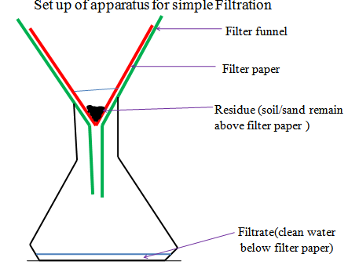
a) Describe how sodium chloride crystals can be separated from a mixture of common salt(sodium chloride) and sand using filtration and any other techniques. (5mks)

b) State the method that can be used to separate the components of the following mixtures (5mks)
 | mixture | method
1 | common salt and iodine
2 | iron fillings and zinc granules
3 | petrol from crude oil
4 | kerosene and water
5 | muddy water
6. a) Define the following terms
I) solution
II) matter
III) pure substance
IV) boiling point.
b) Draw a simple diagram to illustrate how distillation takes place (3mks)

END
WISHING YOU THE BEST IN THIS EXAMINATION; MR OMWANDO.

