GATITU MIXED SECONDARY SCHOOL
CHEMISTRY FORM 2 OPENER EXAM TERM 2 2015
- Element A has atomic mass 23 and element B has atomic mass 7 and also have 12 neutrons and 4 neutrons respectively.
- Write the electronic arrangement of A and B 1mk

- Which element has higher ionization energy? Explain 2mks

- An element M has two isotopes, m1 with 63 atomic mass and 65 for M₂. The relative atomic mass of the naturally occurring is 63.55. Calculate the percentage of each isotope. 3mks

- An oxide of element G has the formula as G₂O₃
- state the valency of element G 1mk

- In which group of the periodic table is element G? 1mk

- The table below gives information about the ions T and Z²⁻
ION | T | Z²⁻
Electron arrangement | 2.8 | 2.8.8
Number of neutrons | 12 | 16
- How many protons are there in the nucleus of:
- Element T? 1mk

- Element Z? 1mk

- Element X is found in period III and group IV. It consists of two isotopes 28_{X} and Q_{X}. a sample of x was found to consist of 90% of 28^{x}. if the relative atomic mass of x is 28.3, work out the number of neutrons in Q^{X}. 2mks

- Use the information in the table below to answer the questions that follow. (the letters do not represent the actual symbols of the elements .
element | Q | P | R | S | T
ATOMIC NUMBER | 18 | 5 | 3 | 5 | 20
MASS NUMBER | 40 | 0 | 7 | 11 | 40
- Which two letters represent the same elements? Give a reason 1mk

- Give the number of neutrons in an atom of element R. 1mk

- The number of protons, neutrons and electrons in atoms A to F are given in the table below the letters do not represent the actual symbol of the elements:
atoms | protons | neutrons | electrons
A | 3 | 4 | 2
B | 9 | 10 | 10
C | 12 | 12 | 12
D | 17 | 18 | 17
E | 17 | 20 | 17
F | 18 | 22 | 18
- Choose from the table the letters that represent:
- An atom of a metal 1mk

- A neutral atom of non metal 1mk

- An atom of a noble gas 1mk

- A pair of isotopes 1mk

- A cation 1mk

- The grid below shows a part of the periodic table. The letters do not represent the act symbol. Use it to answer the questions that follow:
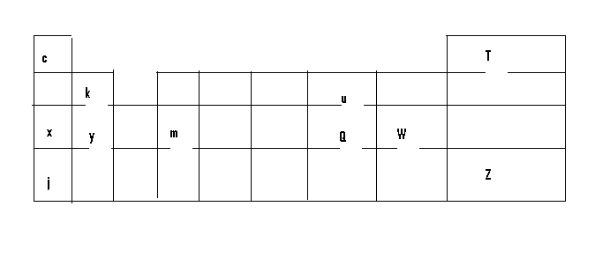
- How does the atomic radius of element X and Y compare 1mk

- Using crosses(x) to represent electrons draw the atomic structure of element Q. 2mks

ii.state the period and the group to which element Q belong. 1mk

- The ionic configuration of element G is 2.8 G forms an ion of the type G⁻¹. indicate on the grid the position of element G 1mk

- To which chemical family does element G belong? 1mk

- State one use of element U 1mk

- What is the nature of the compound formed between K and U? 1mk

