COUNTY MULTILATERAL EXAM
END OF TERM II EXAM
JULY / AUGUST 2016
CHEMISTRY
FORM 2
QUESTION PAPER
TIME: 2 ½ HOURS
END OF TERM 2 2016 CHEMISTRY FORM 2

1. Identify the particles responsible for electric conductivity in the following substances. (2 mks)
a) Magnesium metal

b) Molten lead (II) bromide

c) Sodium Chloride solution

d) Graphite

2. Balance the following chemical equations.
(a) (2 mks)

b) (2 mks)

3. The equation below illustrates a certain method used to prepare salts.
(1mk)
a) Name the method of salt preparation. (1 mk)

b) Starting with copper (II) oxide and dilute sulphuric acid, explain how copper (II) sulphate crystals can be prepared. (3mks)

4. An element x has atomic number 17. It consists of of x – 35 and ¼ of x – 37 isotopes.
a) Define
(i) Atomic number. (1 mk)

(ii) Isotopes (1 mk)

b) Calculate the relative atomic mass of x. (3mks)

c) What is the mass of the more abundant isotope. Explain. (2 mks)

d) Write down the electron configuration of x. (1 mk)

5(a) Differentiate between the following terms as used in chemistry. (2mks)
- Anode and cathode (2 mks)

- Cation and anion (2 mks)

- Electrode and electrolyte (2 mks)

b) Define electrolysis. (1 mk)

c) The diagram below represents a set up of apparatus used to investigate the effect of electric current on Lead (II) Chloride.
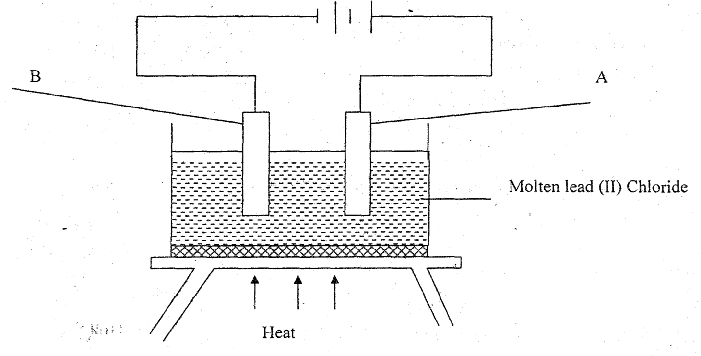

(i) Identify
A _________________(1 mk)
B _________________( 1mk)
(ii) Write a balanced equation to show the reaction taking place at. (1 mk)
A

B

(iii) Write the overall equation for the reaction (1 mk)

(iv) Lead (II) bromide is a binary electrolyte. What is meant by the term binary electrolyte? (1mk)

6.(a) What is rusting? (1 mk)

(b) Identify the conditions necessary for rusting to take place. (2 mks)

c) State and explain three methods used to prevent rusting. (3mks)

d) Explain why cars in Mombasa rust faster than those in Nairobi. (1mk)

7(a) State four differences between a physical ad a chemical change. (4mks)

b) Categorize the following processes as either temporary or permanent changes.
2 mks)
- Sublimation of iodine
- Burning of charcoal
- Dissolving salt in water
- Heating a mixture of sulphur and iron

8. Study the flow chart below and answer the questions that follow;

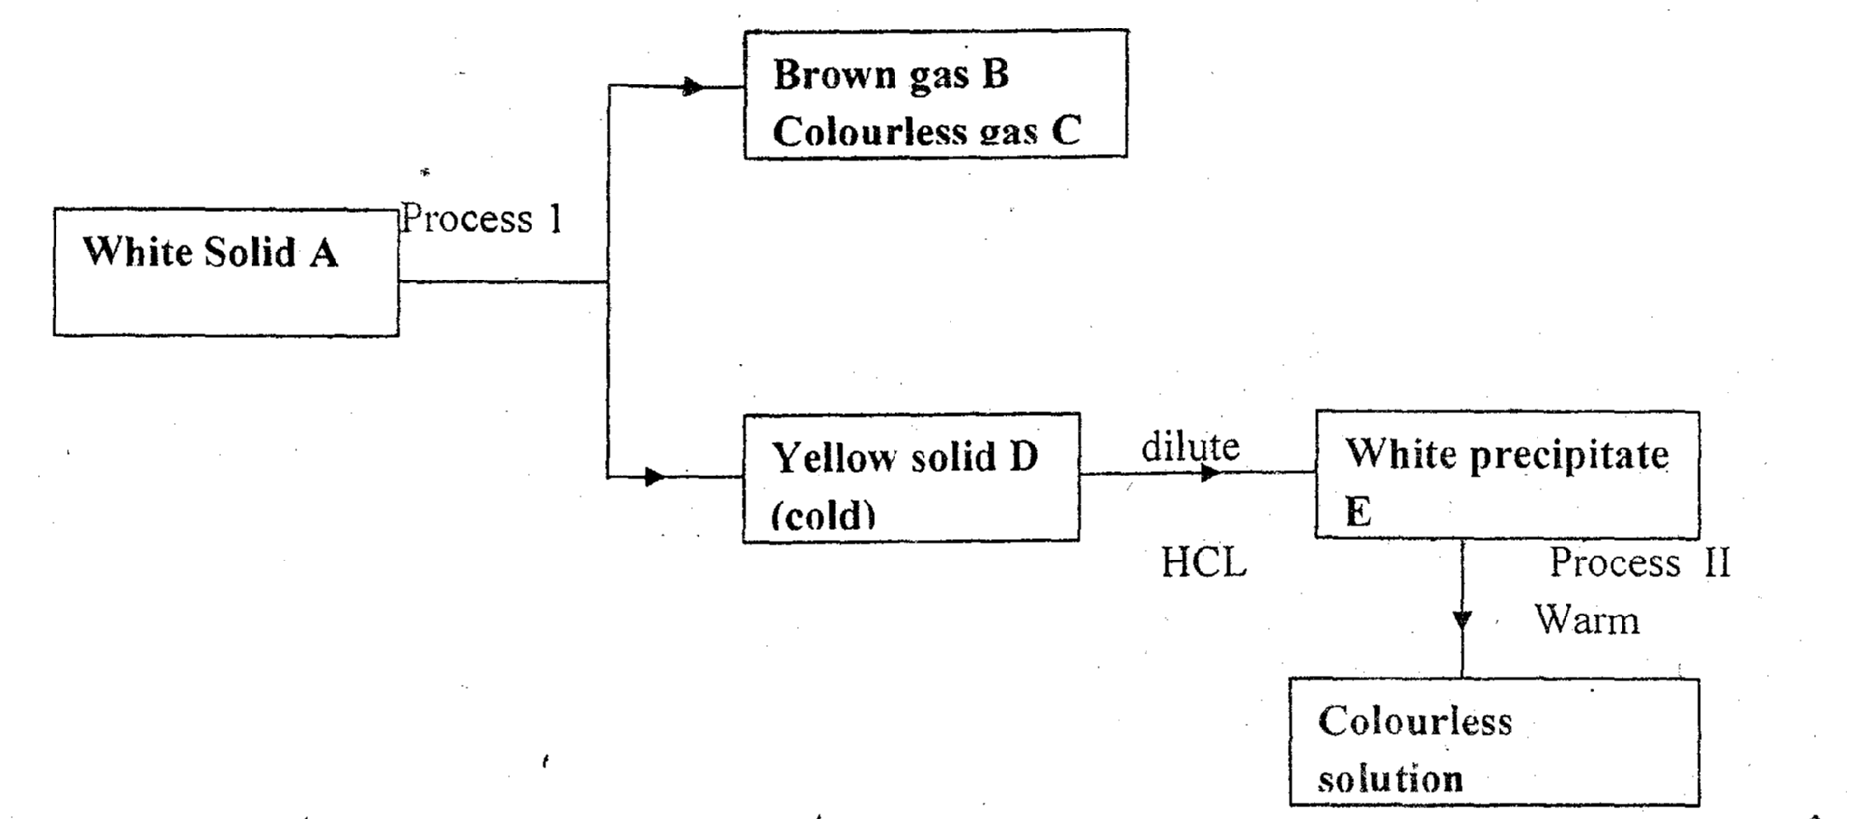
(a) Identify substances. (5 mks)
A

B

C

D

E

(b) Name process I (1 mk)

c) Write a balanced equation to show formation of B,C and D. (2 mks)

d) Describe a test for the colourless gas C. (1 mk)

e) What does process II indicate about the solubility of E? (1 mk)

f) Write a chemical equation to show formation of precipitate E. (1 mk)
9. Explain the following.
a) Atomic radius of elements decreases across a period but increases down the group. (2 mks)

b) Though aluminum is a reactive metal, it is used to make cooking pans. (1 mk)

c) Potassium and sodium metals are stored in paraffin. (1mk)

d) The ionic radius of halogens is larger than their respective atomic radius. (1 mk)

10. Write down the formula of the following compounds. (1mk)
a) Sodium hydrogen carbonate. (1 mk)

b) Calcium chloride (1 mk)

c) Iron (III) oxide (1 mk)
d) Potassium chloride (1 mk)

11. Hydrogen carbonates of metal x and y were heated over a blue Bunsen burner flame. The table below shows the products of formed… study it and answer the questions that follow. The letters do not represent the actual symbols of the elements.
Metal nitrate | Product
X | Metal carbonate, carbon (iv) oxide and water
Y | Metal oxide, carbon (iv) oxide and water
a) What is the name given to the blue flame? (1mk)

b) Name the other type of flame produced by a Bunsen burner. (1 mk)

c) Which of the metals is more reactive? Explain. (2 mks)
d) Identify one metal that would possible be:
X _______________________ (1 mk)
Y _______________________ (1 mk)

12. The table below gives a summary of some properties of elements P,Q,R and S. Study it and answer the questions that follow. The letters do not represent the actual symbols of the elements.
Element | Electron arrangement | Valency
P | 2.2 | 2
Q | 2.7 | 1
R | 2.8.2 | 2
S | 2.8.8.1 | 1

a) Define the term valency. (1 mk)

b) To which group and period does element S belong? (2 mks)
Group _________________
Period__________________
c) What is the name given to the family to which element Q belongs? (1 mk)
d) Identify an element which is likely to be;
i) A metal (1 mk)
ii) A non-metal (1 mk)
iii) A poor conductor of electricity (1 mk)
e)(i) Which two elements have similar chemical properties? (1mk)

ii) What is the family name of elements mentioned in e(i) above (1 mk)

f) Which is the most likely formula of a carbonate of R. (1 mk)

g)(i) Using a dot (.) and cross (x) diagram, illustrate the type of bonding between Q and R. (2 mks)

ii) Identify the name of the bonding illustrated in g (i) above. ( 1mk)

13.(a) Define allotropy. (1 mk)
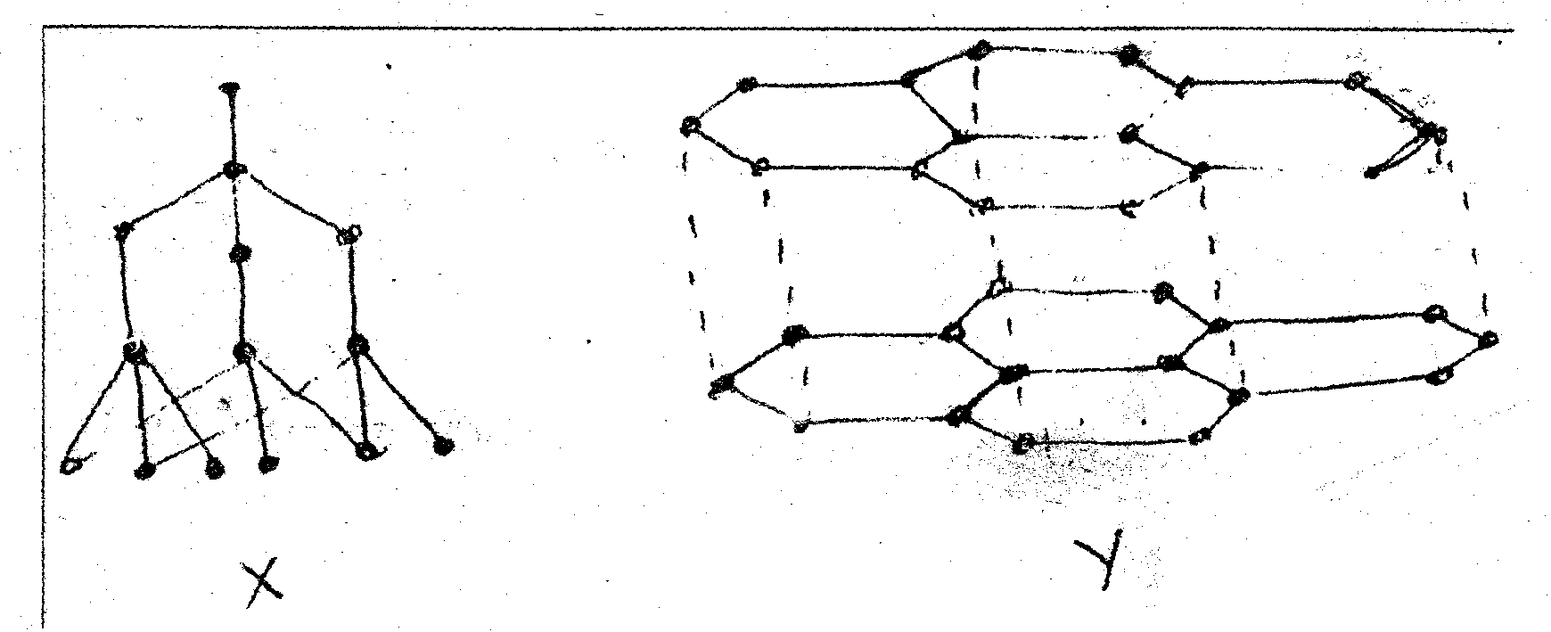
(i) Identify allotropes X and Y. (2mks)

(ii) Give one use of each of the allotropes mentioned above. (2 mks)

X_______________________
Y_______________________

- Which of the above allotropes conducts electricity? Explain (2 mks)
14. An experiment was set up as shown in the diagram below.
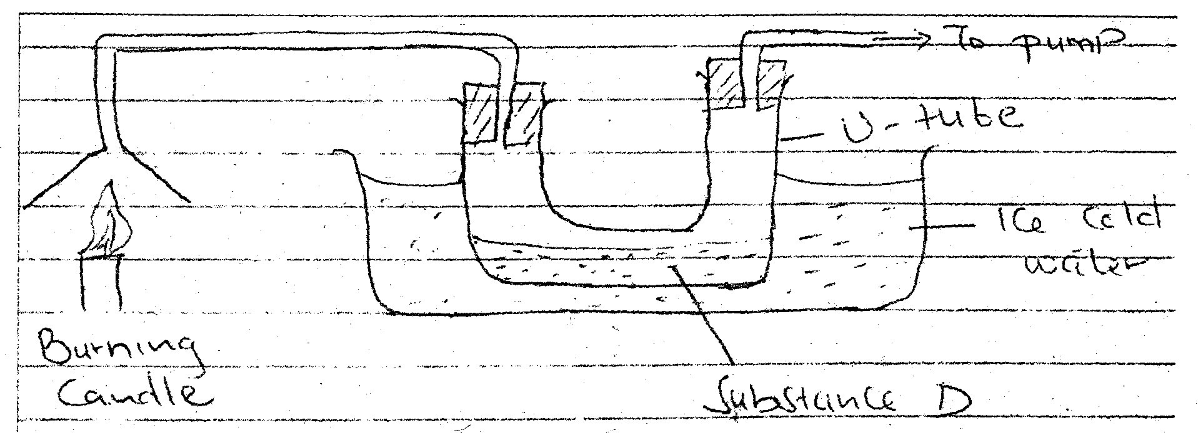
a) Candle is a compound consisting of two elemments.
Name the two elements. (2 mks)

b) Identify substance D. (1 mk)

c) Describe how the other product of a burning candle could be prevented from getting to the environment. (2 mks)

15. State and explain three observations made when sodium metal is placed in a pool of water. (3 mks)

