GATITU DAY MIXED SECONDARY SCHOL
CHEM FORM 2
END OF TERM 2 2012 EXAM
- Give 2 differences between luminous and non luminous flames. (2mks)

- Describe how one can obtain sodium chloride from a mixture of sodium chloride and sand. (3mks)

- The spots in the diagram below represents a a paper chromatogram for three brands of soda suspectrul to contain unwanted food additives.

T he results showed the presence of unwanted food additives in N and P only. On the chromatogram
a) Circle the spots which show unwanted food additives (2mks)

b) Label the solvent front and baseline on the chromatogram. (2mks)

4. The diagram below shows a method used by a form two student to separate ethanol from water.

a) What is the name of the metal of separation above? (1mk)

b) Why is it possible to separate ethanol from water? (2mks)

c) State the role of the glass beads in the fractionating column? (2mks)

d) What would happen if the inlet and outlet were exchanged? (2mks)

e) Name the apparatus A and B. (2mks)

5. The diagrams below represent two iron nails with some parts covered tightly with zinc and tin respectively. What observations would be made at the exposed points R and Z if the wrapped nails are left in the open for several days? Explain. (3mks)

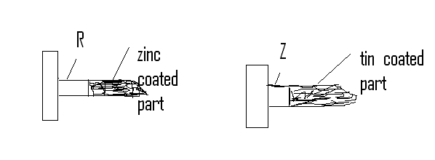
6. A student was supplied with a colorless liquid. Describe one chemical test that could be carried out to show that the liquid was water. (2mks)

ii. How could it have been shown that the liquid was pure water. (2mks)

7. a) Atoms are said to be electrically neutral. Explain (1mk)

b) Distinguish between the following:
i. Atomic number and mass number (2mks)

ii. Mass number and relative atomic mass (2mks)

8. a) An isotope Q has mass number of 34 and 18 neutrons.
i. Draw the atomic structure of Q (2mks)

ii. State its electronic arrangement (1mk)

9. a) Determine thje relative atomic mass of the potassium whose isotopic composition occurs in proportions given. (3mks)
Potassium: 38 39 40
K O.001% K 93.1% K 6.84%
19 19 19

b) Write chemical equation and balance off for the reaction between
i. lead and sulphuric acid (1mk)

ii. Aluminium and hydrochloric acid (1mk)

c) Give the formula of the following compounds:
i. zinc carbonate (1mk)

ii. Copper chloride (1mk)

10. The table below shows some elements in the periodic use it to answer questions that follow. The letters are not the actual symbols of the elements.
P |  |  |  |  |  |  | Q | R
 |  |  |  |  |  | S | T
V

i) An element K has an atomic number of 20. Indicate on the grid its position. (1mk)

ii) Write formula of the compound formed between V and T (2mks)

iii) Which element belongs to period i2 and group VIII? (2mks)

11. a) Give the results of the reactions below and balance them

i. mg (s) + HCL (aq) → (2mks)

ii. CuCO3 (aq) +HNO3 ()aq) → (2mks)

b) Write a balanced equation for each of the following reactions:
i. Magnesium metal with steam (2mks)

ii. Action of dilute hydrochloric acid calcium carbonate (2mks)

12. The grid below represents part of the periodic table. Study and answer the questions that follow. The letters given do not represent the actual symbols of the elements.
 |  |  |  |  |  | A
 | B |  | C |  | D |  | E
F | G
 |  |  |  |  |  |  | H

i) Select the element that can form an ion with a charge of -2. Explain your answer (2mks)

ii) What type of structure would the oxide C have? Explain (1mk)

iii. How does reactivity of H compare with of E ? Explain your answer. (1mk)

iv. Using dots(.) and crosses (x), draw the structure of the following molecules (1mk)
carbon (IV) oxide(co2)

GOOD LUCK AND NICE HOLIDAY

