NAME ………………………………………………………ADM NO. ……………………….
GATITU MIXED SECONDARY SCHOOL
CHEMISTRY FORM 2 TERM 3 2014 END TERM EXAM

- 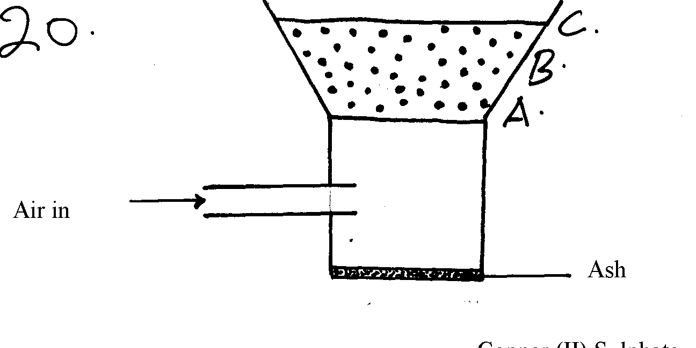The diagram below shows a charcoal jiko (stove). Write the equations to show combustion in region A, B and C. Explain your answers fully. 6mks

- Explain why charcoal is used in making gas mask. 1mk

- Explain why amorphous forms of carbon do not conduct heat and electricity. 2mks

- Give four examples of amorphous form of carbon. 4mks

- Explain why diamond is used in drilling of metal . 1mk

- Apart from drilling of metals give two uses of diamond. 2mks

- Graphite is a good electrode explain . 1mk

- Apart from being an electrode. Give other 3 uses of graphite. 3mks

- Give reasons why lead carbonate and sulphuric acid are not suitable reagent in preparation of carbon Iv oxide. 2mks

- Give a reason why carbon IV oxide is collected using downward delivery. 1mk

- Carbon IV oxide does not support combustion. However Magnesium continues to burn in carbon IV oxide. Explain 3mks

- The equation below show a certain property as carbon II oxide
CO_{(g)} + CUO_{(s)} → CU_{(s)} + CO_{2(g)}
- Which is the reducing agent 1mk

- What is oxidation? 1mk

- State the observation made during the above reaction. 2mks

- Give two physical property of carbon II oxide. 2mks

- The set up below show preparation and collection of carbon iv oxide.

- Write a balanced chemical equation for the reaction that took place flaskA 2mks

- What is the role of sodium hydrogen carbonate? 1mk

- Name another reagent that can be used in place of sodium hydrogen carbonate. 1mk

- What is the role of concentrated sulphuric acid? 1mk

- State another substance that can be used instead of calcium sulphuric acid. 1mk

- Explain why lead carbonate cannot be used in place of calcium carbonate 2mks

- Write a balanced chemical equation. Support your answer in (d) above. 2mks

