NAME ………………………………………………………ADM NO. ……………………….
GATITU MIXED SECONDARY SCHOOL
CHEMISTRY FORM 2 TERM 3 2014 MID TERM EXAM
- Study the flow chart below and answer the questions that follows

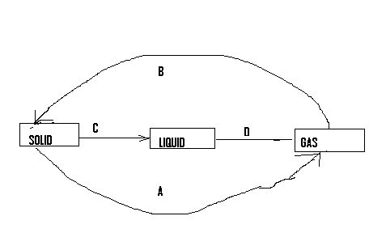

- Name process 4mks
A
B
C
D
- Give an example of a substance that undergo Nprocess A when heated. 1mk

- Graphite is an allotrope of carbon. Explain why graphite is soft and slippery. 2mks

- Sodium chloride do not conduct electricity in solid state but only in molten state. Explain.2mks

- Define a salt and give two examples of salt. 2mks

- Explain the following types of salts 4mks
- Normal salt

- Acidic salt

- Double salt

- Basic salt

- Explain the following terms 3mks
- Deliquence

- Efflorescence

- Hygroscopy

- State two properties of the following
Ionic compounds 2mks

Covalent compounds 2mks

- State four differences between luminous and non luminous flames. 4mks

- Giving two reasons non –luminous flame is best to be used in laboratory heating.2mks

- Most laboratory apparatus are made of glass. State two reasons why they are not made of plastic. 2mks

- The grid below show a part of a periodic table. The letter does not represent the actual symbol. Use it to answer the questions that follow..
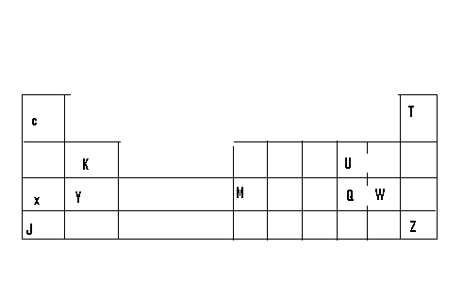
- Compare the atomic atomic radius of element X and Y and give a reason for your answer. 2mks

- Using crosses (x) to represent electrons draw the atomic structure of element Q 1mk
- State the period and the group to which element Q belongs. 1mk

- The ionic configuration of element A is 2.8 , A forms an ion of the type A⁻ indicate on the grid the position of element A 1mk

- During preparation of lead II chloride salt , lead II nitrate and sodium chloride were reacted in the laboratory using the equation below Pb(NO₃)₂ + NaCL → Pb cl₂ + NaNo₃
- Name the insoluble salt that was formed 1mk

- Balance the chemical reaction between lead II nitrate and sodium chloride. 2mks

- Write an ionic equation to show how this salt was formed. 2mks

- Name the type of reaction during formation of the above salt. 1mk

- Name another salt that can be prepared by the similar method. 1mk

- Which is the name given to ions that remain unchanged during a chemical reaction. 1mk

- Identify the ions which didn’t take place in the above chemical reaction 1mk

- The diagram below show a set up for preparation of oxygen gas.

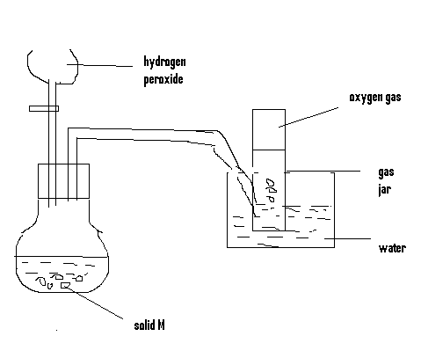

- Name solid M 1mk

- Write a chemical reaction in the flask. 2mks

- Why is oxygen collected by the above method? 2mks

- Give two uses of oxygen gas. 2mks

- Name a non metal that conduct electricity. 1mk

- Explain why non metals do not conduct electricity. 2mks

- Differentiate between conductors and electrolytes. 2mks

