233/1
CHEMISTRY Paper 1
1. The table below gives information about ions of P and Y
Ion | P⁺ | Y²⁻
Electron arrangement | 2.8 | 2.8.8
Number of Neutrons | 12 | 16

- Write the electrons arrangement for the atom of Y (1mk)

- How many protons are there in the nucleus of (2mks)
- P…………………………………………………………………..
- Y……………………………………………………………………
- Write the formula of the compound formed when P and Y reacts (1mk)

2. When hydrated sample of calcium sulphate was heated until all the water was lost. The following data was recorded.
Mass of crucible = 30.296g
Mass of crucible + Hydrated salt = 33.111g
Mass of crucible + Anhydrous salt = 32.781g
Determine the empirical formula of the hydrated salt
(RMM of CuSO₄ = 136 and that of H₂0= 18) (3mks)
…………………………………………………………………………………………………………………………………………………………………………………………………………………………………………………………………………………………………………………………………………………………………………………………………………………………………………
3. When iron and steam are heated in a closed container, a dynamic equilibrium is reached.
3Fe_{(s)} + 4H₂O Fe₃O₄ _{(s)} + 4H₂ _{(g)}
  - Define the term dynamic equilibrium? (1mk)
………………………………………………………………………………………………………………………………………………………………………………………………………………
  - What is the effect on equilibrium if magnesium is added? Explain (2mks)
………………………………………………………………………………………………………………………………………………………………………………………………………………
4. The structure below represents a sweet smelling compound
CH₃ –CH₂ – CH₂ – C – O - CH₂ - CH₂ - CH₃
O
Give the name of the two compounds that can be used to prepare this compound in the laboratory (2mks)
……………………………………………………………………………………………………………………………………………………………………………………………………………………
5. Starting with copper metal describe how a sample of crystals of copper (ii) chloride may be prepared in the laboratory (3mks)
………………………………………………………………………………………………………………………………………………………………………………………………………………………………………………………………………………………………………………………………
6. (a) State the Grahams law of diffusion (1mk)
……………………………………………………………………………………………………………
(b) The molar masses of gases W and X are 16.0 and 44.0 respectively. If the rate of diffusion of W through a porous material is 12cm³ s⁻¹
Calculate the rate of diffusion of X through the same material. (2mks)

7. The following are half- cell reactions and their reduction potentials
E^{θ}(volts)
A²⁺ _{(aq)} + 2ē A (s) -0.76
B²⁺ _{(aq)} + 2ē B (s) -0.13
C⁺ _{(aq)} +ē C (s) +0.80
D²⁺ _{(aq)} + 2ē D (s) + 0.30
The letters used do not represent the actual symbols of elements
(a)Write the cell representation for the electrochemical cell that would give the highest e.m.f (1mk)
………………………………………………………………………………………………….
(b)State and explain the observation made when a copper rod is placed in a beaker containing silver nitrate solution (2mks)
……………………………………………………………………………………………………..
……………………………………………………………………………………………………...
8. (a) Name the type of artificial radioactivity represented by each of the following nuclear equations
(i) ³₁H + ²₁H ⁴₁He + ¹_{o} n + Energy (1mk)
…………………………………………………………………………………………………………
141
92
235
(ii) U + ¹₀ n Ba + K + 3¹₀ n + Energy (1mk)
56
36
92
…………………………………………………………………………………………………………

(b) Give two differences between nuclear reactions and chemical reactions (2mks)
……………………………………………………………………………………………………………………………………………………………………………………………………………………
9. When SO₂ (g) is bubbled through acidified KMnO₄ solution, the reaction takes place according to the following equation.
2MnO₄⁻ _{(aq)} + 5SO₃²⁻ _{(aq)} + 6H⁺ _{(aq)} 2M_{n}O₄ _{(aq)} + 3SO₄²⁻ _{(aq)} + 3H₂O _{(l)}
  - Calculate the oxidation numbers of manganese in
(i) MnO₄⁻ (1mk)

(ii) MnSO₄ (1mk)

(b) During the reaction was manganese oxidized or reduced? Explain. (1mk)
…………………………………………………………………………………………………………
10. The diagram below is part of a set up used in the laboratory for thepreparation of a gas.
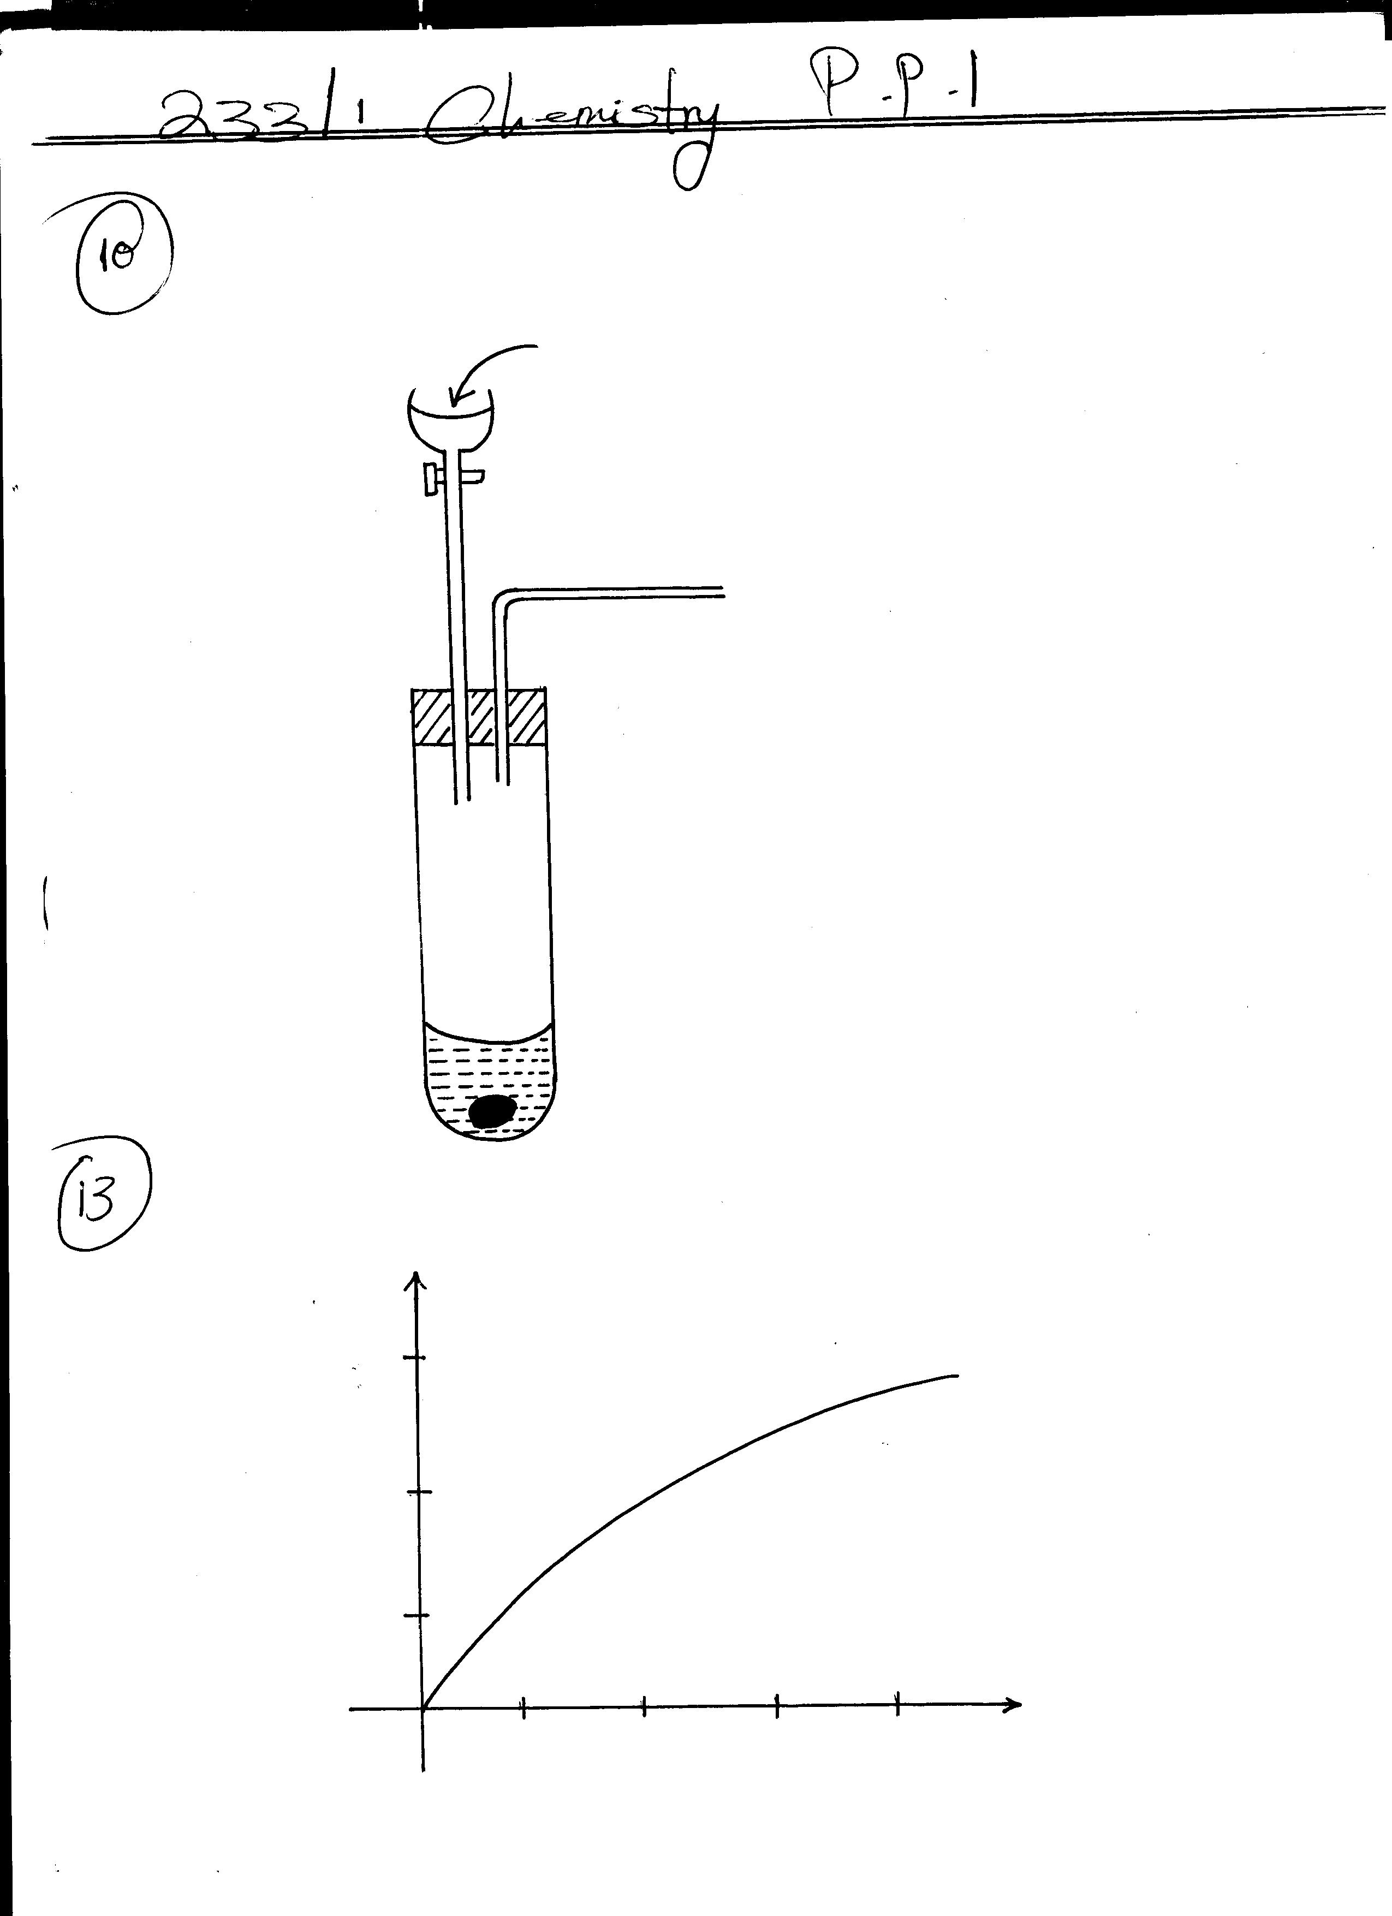
Dilute Hcl (aq)
Iron (ii)sulphate

Complete the diagram to show how a dry sample of the gas can be collected (3mks)

11. 15.cm³ of ethanoic acid was dissolved in water to make 500cm³ of solution.
Calculate the concentration of the solution in moles per litre (C=12, H= 1, O= 16, density of ehanoic acid is 1.05g/ cm³) (3mks)

12. A compound whose general formula is Y (OH)₃ reacts as shown by the equations below.
(i) Y(OH)₃ _{(s)} + OH⁻ _{(aq)} [Y(OH)₄]⁻ _{(aq)}
(ii) Y(OH)₃ _{(s)} + 3H⁺ _{(aq)} Y3⁺ _{(aq)} + 3H₂O _{(l)}
- What name is given to compounds which behave like Y(OH)₃ in the two reactions? (1mk)
……………………………………………………………………………………………………………………………………………………………………………………………………………………
- Name two elements whose hydroxides behave like that of Y (2mks)
……………………………………………………………………………………………………………………………………………………………………………………………………………………
13. A Certain mass of a metal reacted with excess dilute hydrochloric acid at 25⁰C. The volume was recorded after every 30secs. The results were presented as shown below.
30
20
10
0
30
60
90
120

(a) Name one piece of apparatus that may be used to measure the volume of the gas liberated. 1mk)
…………………………………………………………………………………………………………
(b)(i) On the same axis, sketch the curve that would be obtained if the experiment was repeated at 35⁰C (1mk)
…………………………………………………………………………………………………………
(ii) Explain the shape of your curve in b(i) above (1mk)
……………………………………………………………………………………………………………………………………………………………………………………………………………………

14. A piece of cover slip was weighed before and after a student made a circle on it using a pencil lid of pure graphite. The masses were as shown below;
Mass of cover slip before - 1.804g
Mass after drawing the circle – 1.9053g
Determine the number of carbon atoms used to draw the circle. ( C =12, L=6.00 x 10²³) (3mks)
………………………………………………………………………………………………………………………………………………………………………………………………………………………………………………………………………………………………………………………………
15. Dacron is a synthetic fibre formed by polymerization reaction between a dicarboxylic acid and a diol (alcohol with two functional groups) HOOC – C₆H₄ – COOH HO(CH₂)₂OH
Dicarboxylic Acid, ethan -1, 2- diol
(a)Show how polymerization between the two occur. (2mks)
…………………………………………………………………………………………………………
…………………………………………………………………………………………………………
(b) Name the type of polymerization involved in forming Dacron (1mk)
…………………………………………………………………………………………………………
16. Use the table below to answer the questions that follow. (The letters are not the actual symbols of the elements)
Element Atomic number M.P⁰c
A 19 63.7
B 11 97.8
C 17 - 101
D 13 660
J 14 1410
(i). Identify an element that exist as a gas at room temperature .Explain. (2mks)
……………………………………………………………………………………………………………………………………………………………………………………………………………………
(ii) Using dots (.) and crosses(x) draw the bonding formed when element T and C react to form a compound. (2mks)
………………………………………………………………………………………………………………………………………………………………………………………………………………………………………………………………………………………………………………………………

17. In the equation below, identify the species that act as an acid. Explain
NH₄⁺ _{(aq)} + H₂O _{(l)} NH₃ _{(aq)} + H₃O⁺ _{(aq)} (3mks)
……………………………………………………………………………………………………………………………………………………………………………………………………………………………………………………………………………………….………………………………………
18. Chlorine and iodine are elements in the same periodic table. Chlorine gas is yellow while aqueous iodine is brown.
(a) What observation would be made if chlorine gas were bubbled through aqueous sodium iodide?
Explain using an ionic equation (2mks)
……………………………………………………………………………………………………………………………………………………………………………………………………………………
(b) Under certain conditions, chlorine and iodine react to give iodinetrichloride. (ICl₃ _{(s)}). What type of bonding exist in iodinetrichloride? Explain (2mks)
……………………………………………………………………………………………………………………………………………………………………………………………………………………
19. When a few drops of ammonia solution ware added to a colourless solution W, a white precipitate was observed. On addition of more ammonia solution, the white precipitate dissolved,
(a) Name the white precipitate. (1mk)
…………………………………………………………………………………………………………
(b) Write an ionic equation for the formation of the white precipitate. (1mk)
…………………………………………………………………………………………………………
(c) Write the fomular of the complex compound formed when the white precipitate dissolves. (1mk)
…………………………………………………………………………………………………………
20. Draw the structure of the following organic compounds
(a) pent – 2 - yne (1mk)

(b) Propylmethanoate (1mk)

(c) Ethanedioic acid (1mk)

21. Study the flow chart below and answer the questions that follow
Solid A

Brown Gas B

Solid k (Yellow when hot, white when cold)
))
Colourless gas C

HNO₃ _{(aq)}
Colourless solution M
Dilute

- Identify gases (2mks)
- B………………………………………………………………………
- C…………………………………………………………………….
(b) Identify ions likely to be present in solid A (1mks)
……………………………………………………………………………………………………………………………………………………………………………………………………………………
22. (a) Name any two substances recycled in solvey process. (2mks)
……………………………………………………………………………………………………………………………………………………………………………………………………………………
(b) Using an equation, explain how sodium carbonate is used to soften hard water. (1mk)
……………………………………………………………………………………………………………………………………………………………………………………………………………………
23. Hydrogen peroxide decomposes according to the equation given below;
H₂O_{2(aq)} H₂O_{(l)} + ½ O₂ (g): ∆H = - 98kj/mol
8.5g of hydrogen peroxide contained in 100cm³ of solution with water were completely decomposed.

Determine the rise in temperature due to this decomposition. (specific heat capacity of water = 4.2Jg⁻¹k⁻¹, density of water = 1g/cm³, O= 16, H=1) (3mks)
………………………………………………………………………………………………………………………………………………………………………………………………………………………………………………………………………………………………………………………………
24. The flow chart below shows some of the processes involved in large scale production of sulphuric (vi) acid. Use it to answer the questions that follow.
oxygen
Reaction
chamber
Absorption
chamber
Sulphur (iv)oxide
Sulphur (iv) oxide
Substance A
Oleum

(a)Describe how oxygen is obtained from air on large scale. (3mks)
………………………………………………………………………………………………………………………………………………………………………………………………………………………………………………………………………………………………………………………………
(b) Name substance A . (1mk)
……………………………………………………………………………………………………………………………………………………………………………………………………………………

25. Carbon (ii)oxide gas was passed over heated iron (iii) oxide as shown below
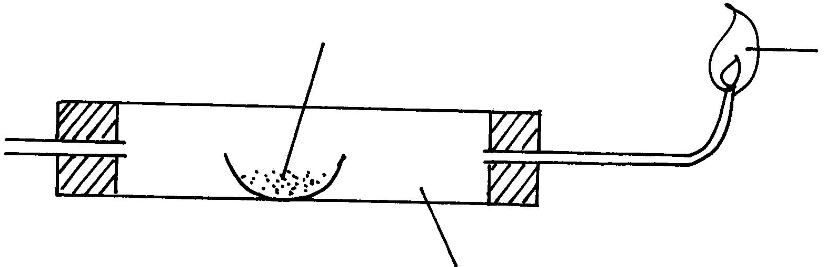
Flame
Tube P
Iron (iii)oxide
HEAT
Carbon (ii)
oxide

  - Give one observation made in tube P (1mk)
……………………………………………………………………………………………………………………………………………………………………………………………………………………
  - Write an equation for the reaction which takes place in test tube P (1mk)
……………………………………………………………………………………………………………………………………………………………………………………………………………………
26. (a) Define a flame (1mk)
……………………………………………………………………………………………………………………………………………………………………………………………………………………
(b) Name the type of a flame produced by the Bunsen burner when the air hole is closed. (1mk)
…………………………………………………………………………………………………………
…………………………………………………………………………………………………………

MARKING SCHEME
1.(a) 2.86
(b) (i) p - 11
(ii) y - 16
(c) p₂ y
2. Mass of hydrated salt 33.111g
- 30.296g
2.815
Mass of anhydrous salt 32.781
- 30.296
2.485
Mass of water 2.815 - 2.485 = 0.33
CaSo₄ | H₂O
2.485  136  0.01827  0.01827  1:1 | 0.33  18  0.01833  0.01827
Ca SO₄. H₂O
3(a) Dynamic equilibrium is a state in reaction where both the forward and the backward reaction occur at the same rate.
- Backward reaction will be favoured/reaction will shift towards the reactants side/left hand side.
This is because addition of magnesium will lead to reaction between magnesium and water hence production of more hydrogen.
4. – Butanoic acid.
- propanol
5. Burn copper in oxygen to form copper (II) oxide.
- Add the oxide in dilute hydrochloric acid in excess.
- Filter to obtain filtrate
- Evaporate the filtrate not to dryness.
6.(a) The rate of diffusion is inversely proportional to the square root of density provided the physical conditions is kept constant.
(b) Rw = mx
Rx mw

12 = 16
Rx 44

Rx = 19.8997 cms³⁻¹

7. (a) A_{(s)}/A²⁺_{(aq)} // 2C⁺_{(aq)} / 2 C_{(s)}

- The colour of solution turns to blue.
There is silver deposit
Copper is oxidized to copper (II) ions while silver ion is reduced to silver.
8. (a) I Nuclear fusion
II Nuclear fission
(b) Chemical Reaction Nuclear Reaction
- involves valency electron - involves the proton and neutron
- Little amount of energy released - Involves large amount of energy
9.(a) (i) Mn + 4 (-2) = 1
Mn = 1 + 8
Mn = + 7
(ii) Mn + ( -2) = 0
Mn = + 2
(b) Mn⁺⁷ Mn⁺⁸
Oxidized
Manganese has lost an electron to be oxidized to manganese of positive +8
10.
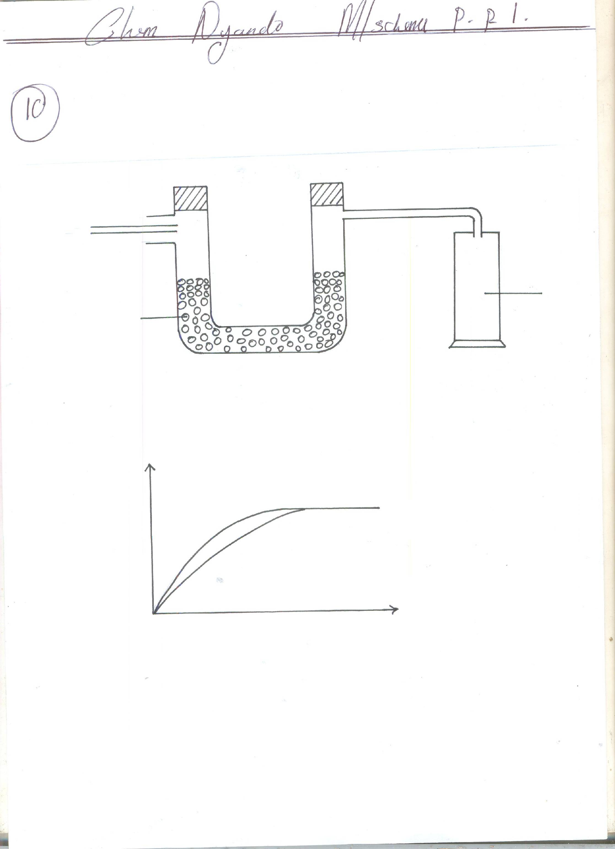
H2S _{(g)}
Anhydrous
calcium chloride

11. Mass CH₃ COOH used = 15 x 1.05
= 15.75g
Moles of CH₃ COOH = 15.75 = 0.2625 moles
60
500cm³ = 0.2625 moles
1000 = 1000 x 0.2625
500
= 0.525MCH₃COOH
12. (a) Amphoteric hydroxide
(b) Aluminium hydroxide
- zinc hydroxide
- lead hydroxide
35ºC
25ºC
13 (a) Syringe
(b) (i)

(ii)Temperature increases the kinetic energy of particles hence increasing the collision between the reactants and this Makes the rate of reaction to increase.
14. Mass of carbon used = 1.9053g - 1.804
= 0.1013g
Number of moles of carbon used = 0.1013
12
= 0.008442 moles
Number of atoms used = 0.008442 x 6.00 x 10²³
= 5.0652 x 10²¹ atoms
15. (a) HOOC - C₆H₄ - COOH + HO (CH₂) 2OH
HO –c - C₆H₄ – C-O – CH₂ CH₂ OH + H₂O

(b) Condensation polymensation
16 (i) C
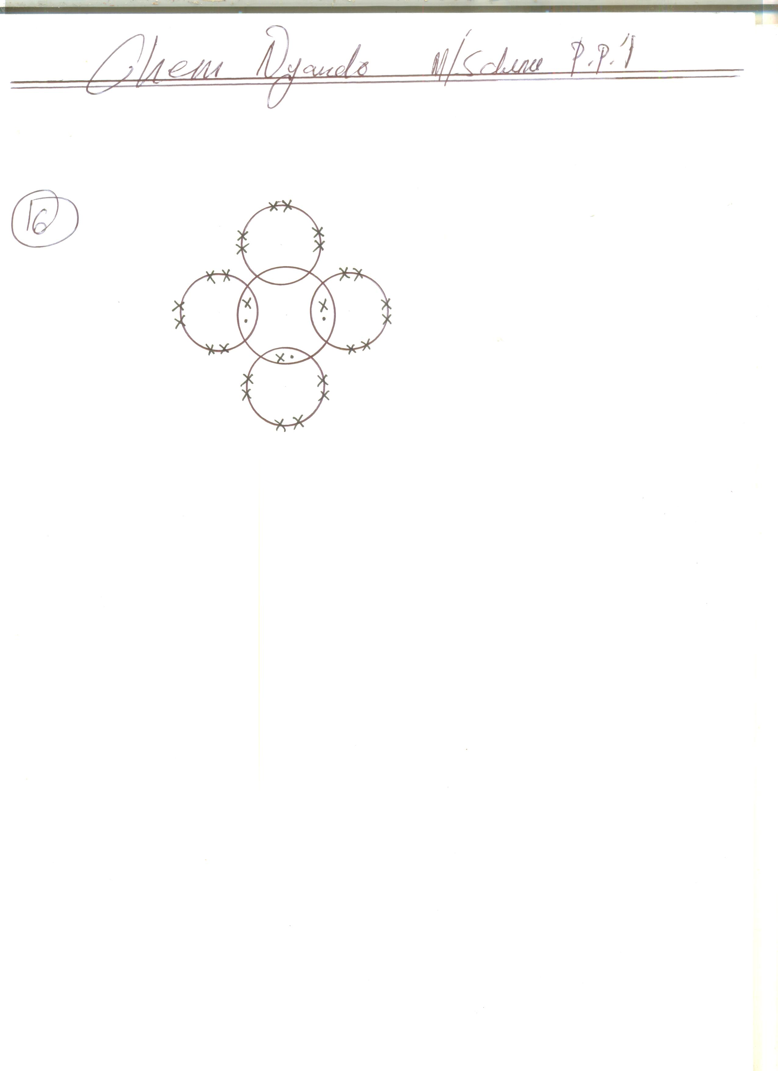
Because its melting point is below won temperature
C
T
C
C
C
(ii)

17. NH₄⁺/H₃O⁺
NH₄⁺ donates proton in forward reaction
H₃O⁺ donates proton in backward reaction.
18. (a) The a colour of sodium Iodide changes to brown
CL_{2 (g)} + 2 I _{(aq)} + I ₂⁽¹⁾
(b) Covalent
Both are non metals
19. (a) Zinc hydroxide
(b) Zn²⁺ (aq + 2OH (aq) Zn (OH)₂ (s)
(c) [ Zn (NH₃)₄]²⁺

20. H

(i) H₃C - C - C = C - CH₃

H

(ii) O H H H

H - C - O - C - C - C - H

H H H

O O

(iii) HO - C - C - OH

21. (a) (i) NO_{2 (g)}
(ii) O_{2 (g)}

(b) Zn²⁺ _{(aq)} and NO⁻_{3 (aq)}

22. (a) Water, Ammonia, carbon (iv) oxide
(b) Ca²⁺ (aq) + CO₃²⁻ (aq) CaCO₃ (aq)
Mg²⁺(aq) + CO₃² (aq) MgCO_{3 (s)}

23. Number of moles = 8.5 = 0.25 moles
34
Amount of heat = 0.25 x 92
= 24.5KJ

Heat = MC∆θ
∆θ = Heat = 24500 = 58.3K
Mc 100 x 4.2

24.(a) The air is compressed to a pressure of 200 atmosphere
- cooled to a temperature of -200⁰C
- Fractional distillation of liquidfied air is done and oxygen is obtained at -86⁰C
(b) Concentrated sulphuric (VI) acid

25.(a) The brown solid turns to grew solid.
(b) Fe₂O_{3 (s)} + 3CO_{(g)} 2 Fe_{(s)} + 3CO_{2 ( g)}

26.(a) Mass of burning gases
(b) Non-luminous flame

