NAME………………………………………………ADM.NO………………………

OLMARIKO SECONDARY SCHOOL

END OF TERM ONE, 2016 EXAMINATION
CHEMISTRY
Form Two

INSTRUCTION

- Answer all the questions in the spaces provided
- All working must be shown where necessary
1. The diagram below represents a paper chromatogram of pure w, X, and Y. A mixture K contains W and Y only.
(I) Indicate on the diagram the chromatogram of K. (1mk) (1mk)
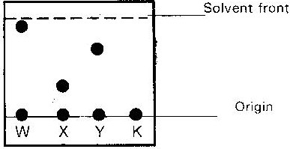

(II) state one use of chromatography. (1mk)
(III) State two properties which makes chromatography possible. (2mks)
2. In an experiment to separate a mixture of organic liquid “m” (B.P. 56⁰C) and liquid “n” (B.P. 118⁰C) a student set up the apparatus shown below.
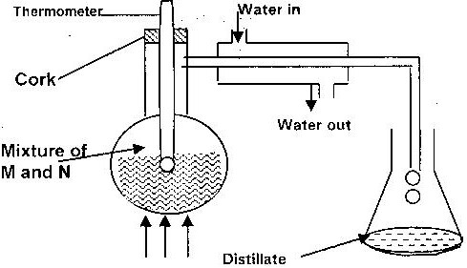

a) Identify two mistakes in the set up. (2mks)
b) How would the student test for the purity of the distillates? (1mk)
c) state one industrial use of fractional distillation. (1mk)

3. Some sodium Chloride was found to be contaminated with Copper (II) Oxide which is insoluble in water. Describe how a sample of sodium chloride can be separated from the mixture. (3mks)

4. Air was passed through several reagents as shown in the flow chart below.
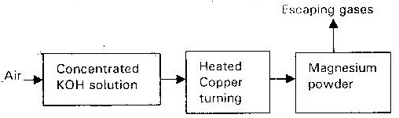

- Write the equation s for the two possible reactions which take place in the chamber with magnesium powder. (2mks)

b) Name one gas which escapes from the chamber containing magnesium. Give a reason for your answer. (2mks)
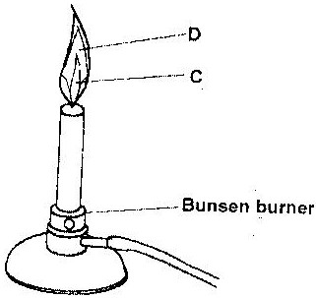
5. The diagram below shows a Bunsen burner when in use.
a) Name the region labelled C and D. (1mk)
b) state the name of the above flame. (1mk)
c) when is this type of flame produced by the Bunsen burner? (1mk)
6. The graph below is a cooling curve of a substance from gaseous state to solid state.
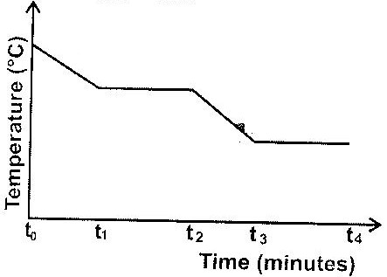

Give the name of the:
a) Process taking place between t0 and t1; (1mk)
b) Energy change that occurs between t3 and t4 (1mk)
7. For each of the following experiments give the observation, the type of change that occurs (physical, chemical or temporary chemical change) and the formula of any substance(s) formed. If no new compound (substance) is formed write no new compound formed. (6mks)

Experiment | Observation | Type of change | Formulae
Add few drops of water to small amount of anhydrous copper II sulphate.
A few crystals of Iodine I₂ are heated gently in a test tube.
A small piece of sodium metal is dropped onto water in a beaker.
A lighted wooden splint is lowered into a test tube with hydrogen gas
8. Name the methods by which the following substances could be separated.
a) Kerosene from crude oil (1mk)
b) Coloured extract from grass dissolved in ethanol. (1mk)
c) Aluminium chloride from sodium chloride. (1mk)
d) Iron fillings from sulphur powder. (1mk)
9. Explain why potassium is kept under paraffin while phosphorous under water. (2mks)
10. Solutions may be classified as strong basic, weakly acidic, strong acidic. The information below gives solutions and their PH values. Study it and answer the questions that follow.

Solutions | PH values
B | 1.5
C | 6
D | 14
Classify the solutions in the table above using the stated classification (3mks)
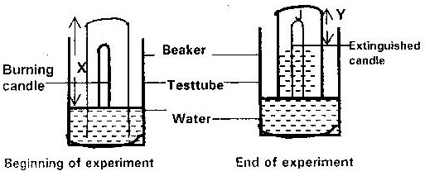
11. Study the experiment set up represented by the diagram below and answer the question that follows.

a) Explain what would be observed if red and blue litmus papers were dipped into the water at the end of experiment. (2mks)
b) Write an expression in terms of X and Y to show the (%) percentage of the gas used by the burning candle. (1mk)
12.Oygen reacts with the elements phosphorous and sulphur to form oxides in which the elements is in its highest oxidation number. The table below gives the oxide of sulphur and its highest oxidation number. Complete the table for phosphorous. (1mk) (Atomic number p=15, s=16)
Elements | Oxides | Highest oxidation number
P |  | +5
S | SO₃ | +6
Cl |  | +7
.
13. The diagram below is a set up for the laboratory preparation of oxygen gas.
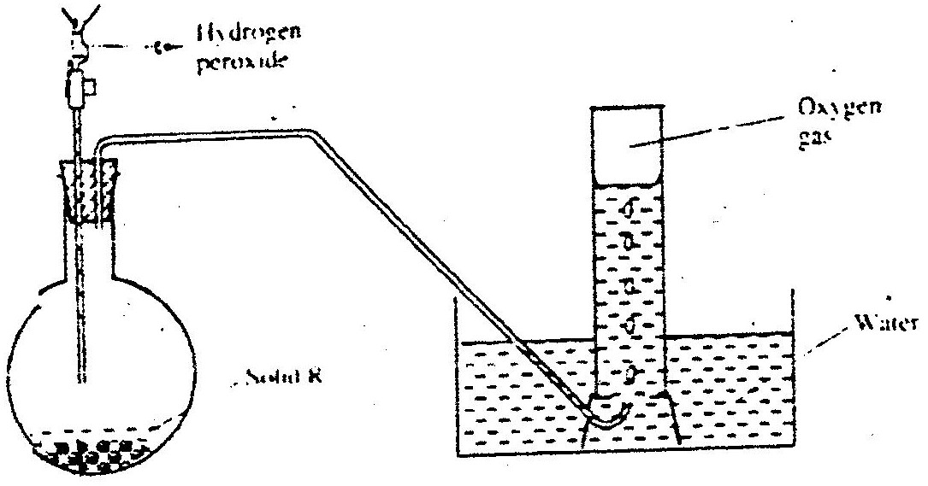

a) Name solid R. (1mk)
b) Write an equation for the reaction that takes place in the flask. (1mk)
c) Give one commercial use of oxygen.
15. The diagram below shows a student’s set up for the preparation and collection of hydrogen gas.
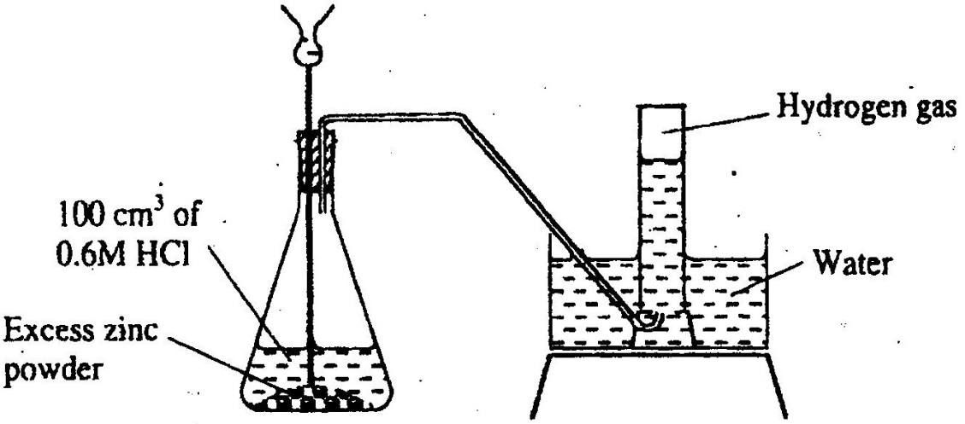

a) why is this gas collected over water? (1mk)
b) Give a reason why helium is increasingly being preferred to hydrogen in weather balloons. (1mk)

 |  |  |  |  | G
 |  |  |  |  | H |  |  | I
F

Elements | Electronic configuration | Ionization energy kj mol ⁻¹
P | 2,1 | 519
C | 2,8,1 | 494
R | 2,8,8,1 | 418

16. Using dots (.) and crosses(x) to represent electrons. Draw a diagram to show bonding in carbon (IV) oxide. (C= 6, O = 8) (2mks)
17. The molecular mass of hydrogen sulphide is 34 while that of water is “18”.
Explain why the boiling of water is higher than that of hydrogen sulphide. (2mks)
compound formed between N and Ca.
18.
The following diagrams show the structures of two allotropes of carbon. Study them and answer the questions that follow:-

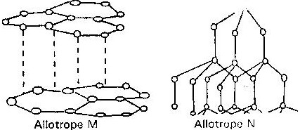

i) Name the allotrope
M (1mk)
N (1mk)
ii) Give one use of N (1mk)
iii) Which allotrope conducts electricity? Explain (2mks)
19.8. The table below shows some properties of element A-H. The letters do not represent the actual symbols of the elements:
Element | Atomic No. | M.PoC
A | 11 | 98
B | 12 | 650
C | 13 | 660
D | 14 | 1410
E | 15 | 44.2  590.0
F | 16 | 113  -1.19
G | 17 | -101
H | 18 | 189
(a) Which period do these elements belong? Give a reason (1mk)
…………………………………………………………………………………………………….
…………………………………………………………………………………………………….
…………………………………………………………………………………………………….
(b) Write the electron arrangement for the stable ions of
(i) F …………………………………………………………………………… (½mk)(ii) C……………………………………………………………………………. (½mk)
(c) Write a chemical equation which takes place between A and water (1mk) …………………………………………………………………………………………………….
…………………………………………………………………………………………………….
(d) Draw a dot (●) and cross (X) diagram to show the bond in a compound formed between
A and G (2mks)

(e) Why do elements E and F have two values of melting point? (1mk)
…………………………………………………………………………………………………….
…………………………………………………………………………………………………….
(f) In terms of structure and bonding explain the following;
(i) There is an increase in melting point from A to C (2mks)
…………………………………………………………………………………………………….
…………………………………………………………………………………………………….
…………………………………………………………………………………………………….
…………………………………………………………………………………………………….

