NAME …………………………….. INDEX NO. ……..…
DATE ……………………………. CLASS ……………..

MUKINDURI SECONDARY SCHOOL MID TERM 1 EXAMS 2018
CHEMISTRY FORM THREE
2 ¼ HRS

INSTRUCTIONS TO CANDIDATES
(a) Answer your name and index number in the spaces provided above.
(b) Answer all the questions in the spaces provided in the question paper.
(c) Mathematical tables and silent electronic calculators may be used.
(d) All working must be clearly shown where necessary.

1. Both ions y²⁻ and z²⁺ have an electron configuration 2.8.8.
(i) Write the electron arrangement for

Y ……………… (½ mk)

Z ………………. (½ mk)

(ii) Draw the structure of atom Z given that it has 20 neutrons. (1 mk)

2. The table below indicates the PH values of solutions labeled A, B, C, D and E.
Solution | A | B | C | D | E
PH value | 5 | 13 | 2 | 10 | 7
Identify the solution

(i) Containing the highest concentration of hydrogen ions. (1 mk)

(ii) Which solution is likely to be ethanoic acid. Give a reason. (1 mk)

(iii) Which is likely to be common salt solution. (1 mk)

3. Study the experiment set up of apparatus shown below.
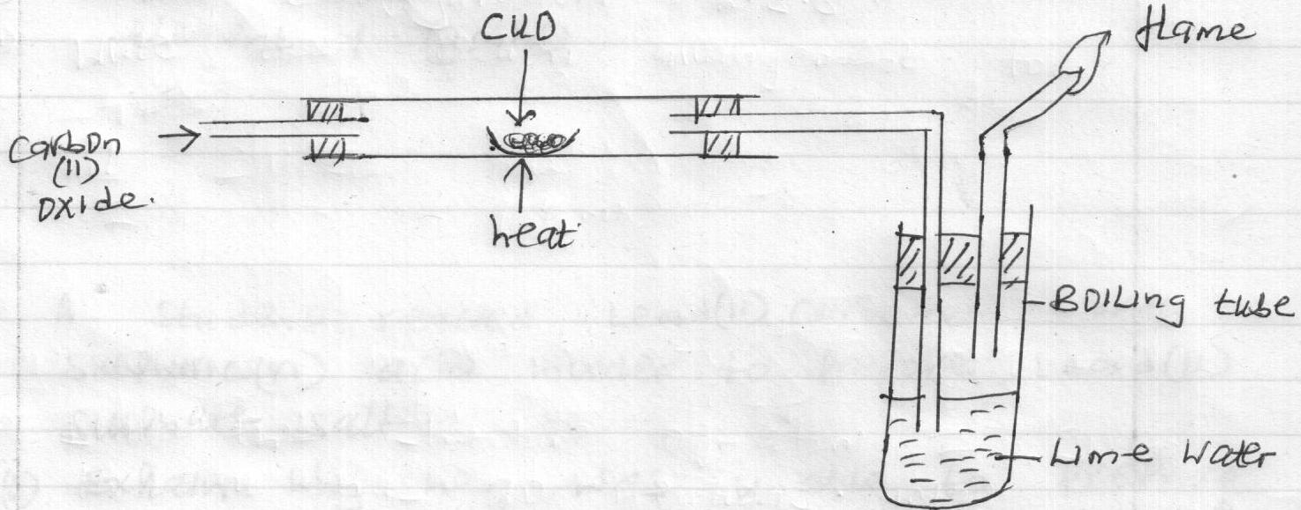

(i) State two observations made in the set up as the experiment progressed. (2 mks)

(ii) Write an equation to explain the change that occurred in the boiling tube. (1 mk)

4. The following data refers to element Y
Isotope | A | B | C
Isotope mass | 54 | 56 | 57
Percentage abundance % | 6.0 | 92.0 | 2.0

(a) Given that isotope C contains 31 neutrons in its nucleus find the number of protons in isotope A. (1 mk)

(b) Calculate the relative atomic mass of element Y. (2 mks)

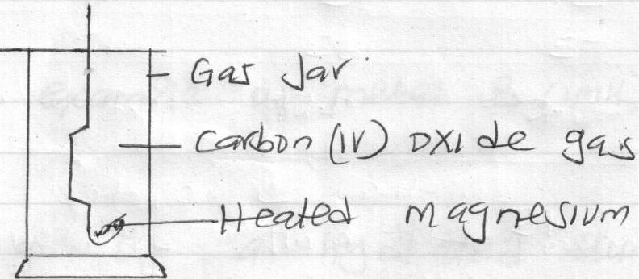
6. The diagram below shows a heated magnesium metal lowered inside a gas jar of carbon (iv) oxide.

Study it and answer the questions that follow
(i) State two observations that can be made during and after the experiment. (2 mks)

(ii) Write an equation for the reaction. (1 mk)

7. The products formed by action of heat on nitrates of element A, B and C are shown below.
Nitrate | Products formed
A | Metal oxide + Nitrogen (iv) oxide + oxygen
B | Metal + oxygen + Nitrogen (iv) oxide
C | Metal nitrite + oxygen

(a) Arrange the metals inorder of increasing reactivity. (1 mk)

(b) Which element forms a soluble carbonate. (1 mk)

(c) Give an example of metal B. (1 mk)

8. When 31.2g of hydrated Aluminium oxide (Al₂O₃ x H₂O) were heated, 20.6g of unhydrous Aluminium oxide were obtained. Determine the value of X.
Al = 27, O = 6, H = 1. (3 mks)

9. A few crystals of hydrated copper (ii) sulphate were carefully placed into water in a beaker at one spot. The beaker was left undisturbed for two hours. State and explain the observation that was made. (2 mks)

11. Using dots and crosses to represent electrons show the bonding in
(a) NH⁺₄ (N = 7, H = 1) (2 mks)

(b) Methane (CH₄) (C = 6, H = 1). (1 mk)

12. Element X has atomic number 15. In which group and period does X belong?
(i) Group - (1 mk)

(ii) Period - (1 mk)

13. State the particles that conduct electricity in each of the following
(i) Graphite (1 mk

(ii) Aqueous sodium chloride solution. (1 mk)

14. A compound of carbon, hydrogen and oxygen contains 40% carbon, 6.67% hydrogen and the rest oxygen. What is its molecular formula given that its relative molecular mass is 180. (C = 12, H = 1, O = 16. (3 mks)

16. Dry carbon (ii) oxide reacted with heated lead (ii) oxide as shown in the equation below.
PbO_{(s)} + CO_{(g)} CO_{2(g)} + Pb_{(s)}

(a) Name the process undergone by lead (ii) oxide. (1 mk)

(b) Name another gas that can be used to perform the same function as carbon (ii) oxide in the above reaction.

(1 mk)
17. Give the name of each of the processes described below which takes place when salts are exposed to the air for sometime.
(i) Anhydrous copper (ii) sulphate becomes wet. (1 mk)

(ii) Magnesium chloride forms aqueous solution. (1 mk)

(iii) Fresh crystals of hydrated sodium carbonate (Na₂Co₃. 10H₂O) become covered with a white powder. (1 mk)

18. A certain volume of carbon (iv) oxide takes 200 seconds to diffuse through a porous plug. How long would it take the same volume of Hydrogen chloride gas to diffuse through the same plug under the same conditions? (C = 12, O = 16, H = 1, Cl = 35.5). (3 mks)

19. Molten lead (ii) bromide was electrolysed using graphite electrodes.
(a) State the observation made at the cathode. (1 mk)

(b) Write half equations for the reaction occurring at each of the electrode.
(i) Cathode (1 mk)

(ii) Anode (1 mk)

````````````````````````````````````````````````````````````````````````````

21. A sample of a gas occupies a volume of 120cm³ at 40⁰C under a pressure of 110Kpa. What would its temperature be if it occupied 105cm³ under a pressure of 125Kpa? (3 mks)

23. (a) The electronic arrangement of ion of element Q is 2.8.8. If the formula of the ion is Q³⁻, state the group and period to which Q belongs.
Group – (½ mk)

Period - (½ mk)

(b) Helium, neon and argon belong to group 8 of the periodic table. Give
(i) The general name of those elements. (1 mk)

(ii) Name one property of Argon that makes it possible to be used in electric lamps. (1 mk)

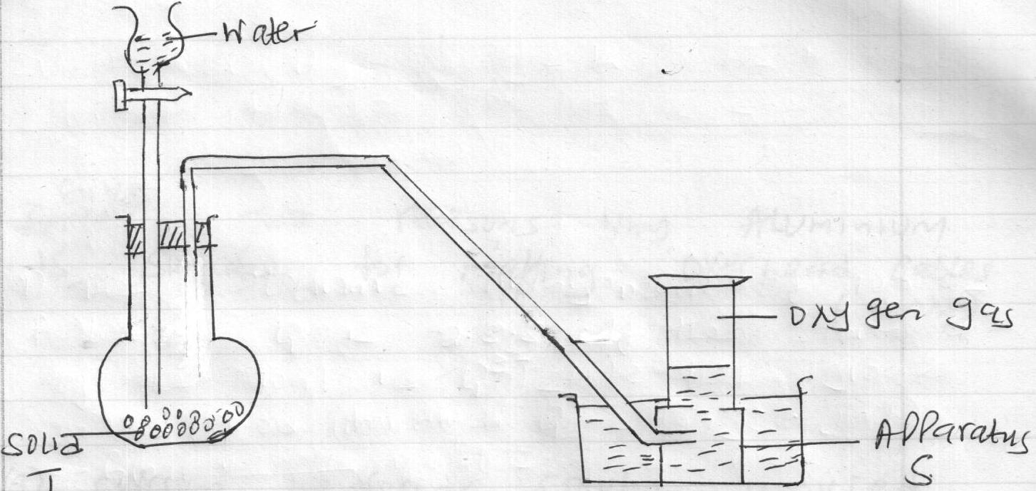
24. (a) The following diagram shows how oxygen can be prepared and collected in the laboratory.

(i) Name
(a) Apparatus S (1 mk)

(b) Solid T (1 mk)

(c) Write an equation for the reaction taking place. (1 mk)

25. An element X (not the actual chemical symbols) has an atomic number of 17.
(a) Give the name of the group to which the element belongs. (1 mk)

(b) Which has a larger radius an atom of X or an ion of X? Explain. (2 mks)

26. Give two reasons why Aluminium is suitable for making overhead cables. (2 mks)

27. (a) Calcium hydroxide solution is used to test for the presence of carbon (iv) oxide but sodium hydroxide solution is not used for the same purpose. Explain. (1 mk)

(b) Lead (ii) nitrate solution was mixed with sodium sulphate solution in a test tube. Write an ionic equation for the reaction that occurred. (1 mk)
(c) State one use of salts. (1 mk)

28. The diagrams below shows the allotropes of carbon. Study them and answer the questions that follow.
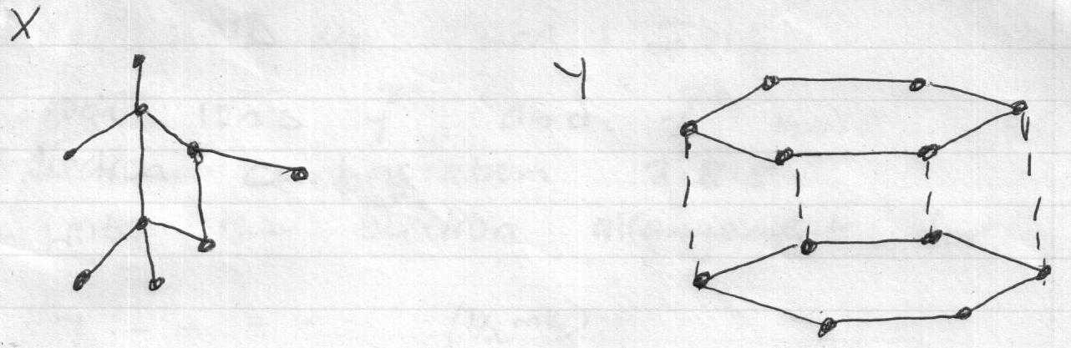

(a) Name the allotropes represented by the letters X and Y.
X - (½ mk)

Y - (½ mk)

(b) Which of the two allotropes is a good conductor of electricity? Explain. (2 mks)

29. When potassium nitrate is heated, it produces potassium nitrite and gas B.
(a) Identify gas B. (1 mk)

(b) Name the type of reaction undergone by the potassium nitrate. (1 mk)

30. Charcoal is a fuel that is commonly used in cooking. When it burns it forms two oxides.
(a) Name the two oxides. (2 mks)

(b) State one use of one of the oxides mentioned in (a) above. (1 mk)

