GATITU MIXED SECONDARY SCHOOL
OPENER EXAM 2015
TERM I
CHEMISTRY FORM 3
INSTRUCTIONS
- Answer ALL the questions in the spaces provided.
- Remember to write your name and admission number.

- State two differences between luminous and non-luminous flames. (2 marks)

- Explain how you would obtain pure ammonium chloride from a mixture of lead sulphate and ammonium chloride. (2 marks)

- Sodium chloride (common table salt) is contaminated with copper (II) oxide. Explain how pure sodium chloride can be obtained from the mixture. (2 marks)

- State and explain the changes in mass that occurs when the following are heated in separate open crucibles. Write a word equation for each reaction.
- Zinc metal (2 marks)

- Zinc carbonates (2 marks)

- The setup below was used to study some properties of air.
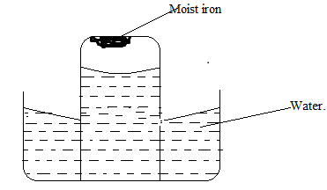

- Draw another diagram to show the level of water in the test tube after 24 hours. Explain the observation made. ( 2 marks)

- State and explain the observation made on moist iron after 24 hours. ( 2 marks)

- State the disadvantage of what was observed in (ii) ( 1 mark)

- Write a word equation for the reaction between magnesium with; ( 3 marks)
- Oxygen

- Chlorine

- Sulphur (IV) acid.

- The diagram below represents a set up for the laboratory preparation of oxygen gas.

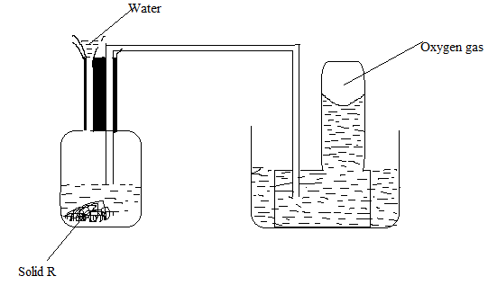
- Name solid R ( 1 mark)

- Write a word equation for the reaction in the flask. (1 mark)

- Give two commercial uses of oxygen gas. (2 marks)

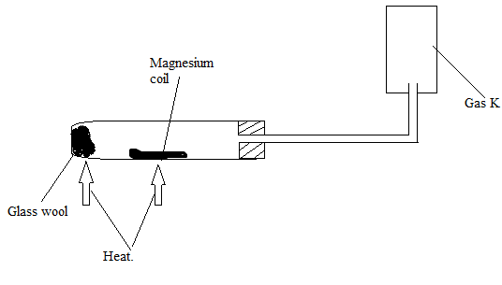
- A student set up the experiment below to collect gas K. The glass wool was heated before heating the magnesium coil.

- Explain why it is necessary to heat the moist glass wool before heating the magnesium. (1 mark)

- Identify gas K (1 mark)

- What property of gas K makes it possible to be collected as shown. (1 mark)

- From the following list of compounds; zinc oxide, solid carbon (IV) oxide, sodium carbonate, nitric acid, iron (III) chloride;
- Identify two that sublime (1 mark)

- Identify two that reacts and form salt and water only ( 1 mark)

- Write word equations for the reaction between; ( 3 marks)
- Sodium carbonate and nitric acid

- Calcium metal and steam

- Oxygen gas and hydrogen gas

“Hope is waking your Dream.” Mahatma Gandhi……………………………… Success. Mr. Chihi.

