**Name**…………………………………… …………………………..………… Index No:………………………….

**233/2**  Candidate’s Signature …………..……………

**CHEMISTRY** Date: …………………………

**PAPER 2**

**(THEORY)**

**AUGUST 2017 ASSIGNMENT.**

**TIME: 2 HOURS**

ST CLARE GIRLS HIGH SCHOOL.

***Kenya Certificate of Secondary Education (K.C.S.E.)***

**233/2**

**Chemistry**

**Paper 2**

**2 hours**

**INSTRUCTIONS TO CANDIDATES**

* Write your name and Index number in spaces provided above.
* Sign and write the date of examination in the spaces provided above
* Answer all the questions in the spaces provided above.
* KNEC Mathematical tables and silent electronic calculators may be used.
* All working must be clearly shown where necessary.
* Candidates should answer the questions in English.

**FOR EXAMINERS USE ONLY**

|  |  |  |
| --- | --- | --- |
| **Question** | **Maximum score** | **Candidate’s score** |
| 1 | 13 |  |
| 2 | 10 |  |
| 3 | 9 |  |
| 4 | 14 |  |
| 5 | 14 |  |
| 6 | 09 |  |
| **7** | 11 |  |
| **Total score** | **80** |  |

*This paper consists of 10 printed pages. Candidates should check to ascertain that all pages are printed as indicated and that no questions are missing.*

1. Section below represents part of a periodic table. Study it and answer the follow. The letters are not the actual symbols of the elements.

|  |  |  |  |  |  |  |  |  |
| --- | --- | --- | --- | --- | --- | --- | --- | --- |
|  |  | | | | | | |  |
|  |  |  |  | **Q** |  |  |  |  |
| **X** |  |  |  | **H** |  | **O** | **T** | **W** |
| **Y** |  | **A** |  |  |  |  | **V** |  |
| **Z** |  |  |  |  |  |  | **S** |  |

1. Which element will require the largest amount of energy to remove one of the outermost electrons in group I. ( 1mk)

……………………………………………………………………………………………….

1. Select the least reactive non-metal (1mk)

……………………………………………………………………………………………….

(iii) Which of the elements has the largest tendency of forming covalent bonds in nature?

Explain your answer. (lmk)

……………………………………………………………………………………………….

……………………………………………………………………………………………….

1. Ions of element M (M2) have an electronic configuration of 2.8.8. Place element M onthe above

grid. (lmk)

(v) Write the electronic arrangement of element W hence give**one** use. (2mks)

……………………………………………………………………………………………….

……………………………………………………………………………………………….

(b) Study the table below and answer questions that follow.

|  |  |  |  |  |  |  |  |
| --- | --- | --- | --- | --- | --- | --- | --- |
| Formula of Chlorides | NaC1 | MgC12 | A1C13 | SiCI4 | PC13 | SC12 |  |
| M.P (°C) | 801 | 714 |  |  |  | -80 |  |
| Formula of oxides | Na2O | MgO | A12O3 | SiO2 | P4O10 | SO2 | Cl2O7 |
| M.P(°C) | 1190 | 3080 | 2050 | 1730 | 560 | -73 | -90 |

1. Using dots(.) and crosses (x) to represent electrons, draw a diagram to show bonding in the following compounds.

(I) PCl3 (2mks)

(II) NaC1 (2mks)

1. Why is the melting point of A1C13 not indicated in the tube above? (lmk)

……………………………………………………………………………………………….

……………………………………………………………………………………………….

1. Explain the large difference in the melting points of the compounds of formula MgO and

P4O10. (2mks)

……………………………………………………………………………………………….

……………………………………………………………………………………………….

4. Use the information below on standard electrode potentials to answer the questions that follow:

Electrode reaction Eθvolts

C2+(aq) + 2e- C(s) + 0.34

D2+(aq) + 2e- D(s)+ 0.44

E+(aq) + e- E(s)- 2.92

Fe2+ +2 e- F(s) - 2.71

G2++ 2 e-G (s) - 0.14

½ H2(g) + e- H-(aq)+ 2.87

½ K2(g) + e-K(aq)+ 1.09

L+(aq) + e-½ L20.00

a) (i) Identify the strongest reducing agent and the strongest oxidizing agent. Give reasons. (2mks)

…………………………………………………………………………………………………….

………………………………………………………………………………..…………………….

(ii) Calculate the e.m.f of the cell formed by connecting half cells C and D. (lmk)

…………………………………………………………………………………………………….

………………………………………………………………………………..…………………….

b) Draw and label a diagram of a cell formed by - connecting half cells of E and D. On the

diagram indicate the flow of electrons. (3mks)

…………………………………………………………………………………………………….

………………………………………………………………………………..…………………….

…………………………………………………………………………………………………….

………………………………………………………………………………..…………………….

…………………………………………………………………………………………………….

………………………………………………………………………………..…………………….

An aqueous solution of Copper (II) Sulphate was electrolysed using platinum electrodes. When a current was passed a gas that relights a glowing splint was produced.

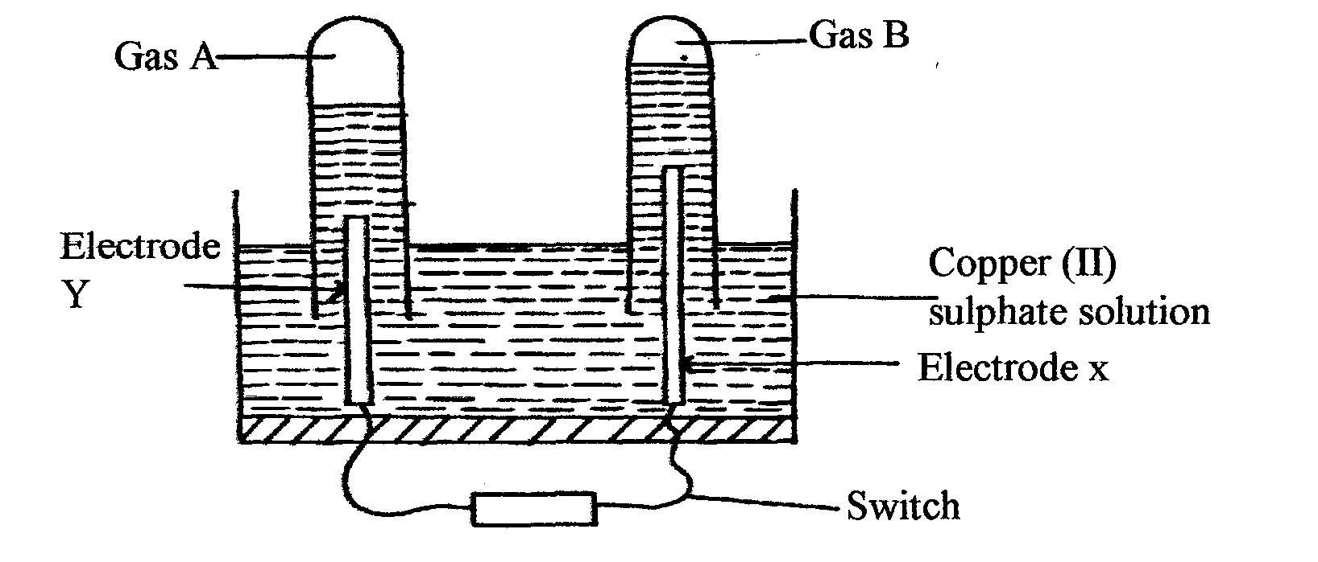

(i) Name the electrode which acts as cathode. Give a reason. (lmk)

…………………………………………………………………………………………………….

………………………………………………………………………………..…………………….

(ii) Write an equation for the reaction at the anode. (lmk)

…………………………………………………………………………………………………….

………………………………………………………………………………..…………………….

d) 0.11 g of metal R is deposited by electrolysis when a current of 0.03 amperes flow for 99minutes.

(R =92.) ,( 1 Faraday = 96500 C)

(i) Find the number of moles of metal deposited. (2mks)

…………………………………………………………………………………………………….

………………………………………………………………………………..…………………….

…………………………………………………………………………………………………….

………………………………………………………………………………..…………………….

(ii) Find the number of moles of electrons passed. (2mks)

…………………………………………………………………………………………………….

………………………………………………………………………………..…………………….

…………………………………………………………………………………………………….

………………………………………………………………………………..…………………….

(iii) Determine the value of n in the metallic ion Rn+ (2mks)

…………………………………………………………………………………………………….

………………………………………………………………………………..…………………….

…………………………………………………………………………………………………….

………………………………………………………………………………..…………………….

2 (a) Study the flow chart below and answer the questions that follow

CH3CH2COOCH2CH3

Step II

HOCH2CH2OH

Step VII

Step VI

Step I

CH3CH2ONa

CH3CH2OH

CH2CH2

Polymerisation Step VIII Cr2O2-7/H+ Step III

CH3COOH

Compound T

Step IV NaOH (aq)

CH4

Compound S

1. Name compounds (lmk)

S…………………………………………………………………………………

T …………………………………………………………………………………

(ii) State the conditions and reagents necessary f r the following steps to take place. (2mks)

|  |  |  |
| --- | --- | --- |
| Step | condition | reagents |
| I |  |  |
| II |  |  |

(iii) Name processes II and IV (2mks)

II………………………………………………………………………………..…………

IV………………………………………………………………………………..…………

iv) Write the equation for the formation of compound S (lrnk)

………………………………………………………………………………..…………………….

v) Give **one** use of T (1mk)

………………………………………………………………………………..…………………….

vi) Write an equation for the complete combustion of CH4 (lmk)

………………………………………………………………………………..…………………….

(b) Natural rubber is made from the monomer isoprene whose structure is

CH2 C CCH2

| |

CH3 H

i) Give the IUPAC name of Isoprene (lmk)

………………………………………………………………………………..…………………….

………………………………………………………………………………..…………………….

(ii)Draw polymer unit of natural rubber showing (1mk)

3. Study the scheme below and answer the questions that follow.

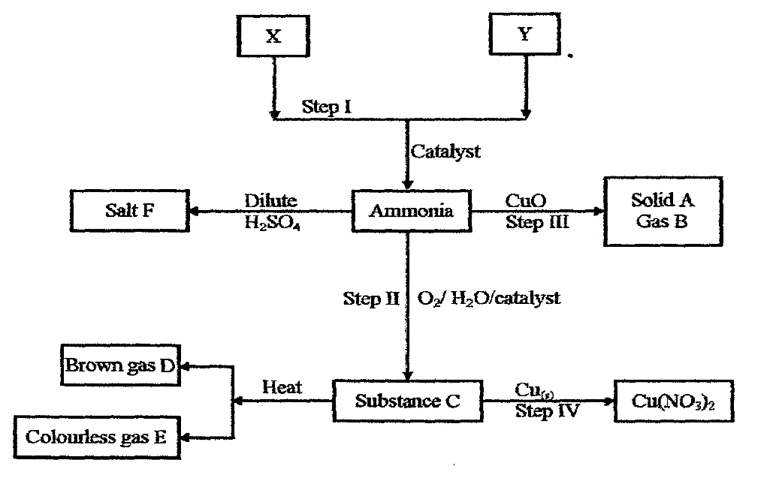

(a) State the sources of the substance X and Y. (2mks)

………………………………………………………………………………..…………………….

………………………………………………………………………………..…………………….

(b) Identify the catalyst used in step I and how it is made to be effective. (lmk)

………………………………………………………………………………..…………………….

………………………………………………………………………………..…………………….

(c) Name the substance A, B, C and E. (2mks)

A………………………………………………………………………………..……………

B………………………………………………………………………………..……………

C………………………………………………………………………………..……………

E………………………………………………………………………………..……………

(d) Write the chemical equations that shows

(i) The formation of substance C. (lmk)

………………………………………………………………………………..…………………….

………………………………………………………………………………..…………………….

(ii) The reaction between substance C and copper metal. (lmk)

………………………………………………………………………………..…………………….

………………………………………………………………………………..…………………….

(e) Describe a chemical test for gas E. (lmk)

………………………………………………………………………………..…………………….

(f) (i) State **one** economic use of substance F. (lmk)

………………………………………………………………………………..…………………….

5 (a) A student carried out an experiment in order to find out the effect of varying the molarity of Sodium

thiosuiphate, on the time it took to react fully with hydrochloric acid. She carried out the experiment at a temperature of 26.0°C. using 50.0cm3 portions of sodium thiosuiphate in each case.

Results obtained were tabulated as shown below.

|  |  |  |  |  |  |  |
| --- | --- | --- | --- | --- | --- | --- |
| Molarity of the Sodium thiosulphate portions used | 1.2 | 1.0 | 0.8 | 0.6 | 0.4 | 0.2 |
| Time (seconds) taken for the reaction to be completed | 16 | 22 | 33 | 51 | 76 | 170 |

1. State **one** observation likely to have been noted in the set up during this experiment. (1mk)

………………………………………………………………………………..…………………….

1. On the grid provided below draw a graph of the results (Molarity of thiosulphate on X-axis)

(3 mks)



1. State and explain the effect of varying the molarity of sodium thiosulphate on time taken to - complete reaction. (2 mks)

………………………………………………………………………………..…………………….

………………………………………………………………………………..…………………

1. I. Using the graph to determine the molarity of sodium thiosulphate whose reaction with the acid

would take 42 seconds to be completed. (1 mrk)

II. Determine the number of moles of hydrochloric acid required to react fully with sodium

Thiosulphate of the above molarity in (iv), I

Na2S2O3(aq) + 2HClaq  S(s) + SO2(g) + 2NaC1(aq) + H2O(l) (2 mks)

( v) On the same grid above sketch a curve that is likely to be obtained. If the experiment was repeated

using the same reagents but whose temperature is at 30°C. Label this curve as “curve X” (2 mks)

(b) (i) Below is an equilibrium that is normally established in the Haber process

 N2(g) + 3H2(g) 2NH3(g)ΔH = - 92KJ mol-1

Explain what would happen to the position of equilibrium if some water was introduced into the

equilibrium mixture (2mks)

………………………………………………………………………………..…………………….

………………………………………….………………………………………..…………………

1. Give **one** major use of the product of haber process in agrochemical industry. (1mk)

………………………………………………………………………………..…………………….

………………………………………….………………………………………..…………………

6. In the preparation of magnesium carbonate magnesium was burnt in air and the product collected. Dilute

sulphuric acid was added and the mixture filtered and cooled. Sodium carbonate was added to the filtrate and the content filtered. The residue was washed and dried to give a white powder.

a) Give the chemical name of the productformed when magnesium burns in air (lmk)

………………………………………………………………………………..…………………….

………………………………………….………………………………………..…………………

b) Write a chemical equation for the above reactions (lmk)

………………………………………………………………………………..…………………….

………………………………………….………………………………………..…………………

c) (i) Name filtrate collected after sodium carbonate was added (lmk)

………………………………………………………………………………..…………………….

………………………………………….………………………………………..…………………

(ii) Name the white powder. (lmk)

………………………………………………………………………………..…………………….

………………………………………….………………………………………..…………………

d) Write chemical equation for the reaction between product in (a) and acid. (lmk)

………………………………………………………………………………..…………………….

………………………………………….………………………………………..…………………

e) Name the ions present in the filtrate after addition of sodium carbonate. (1mk)

………………………………………………………………………………..…………………….

………………………………………….………………………………………..…………………

f) Write an ionic equation to show the formation of the white powder. (lmk)

………………………………………………………………………………..…………………….

………………………………………….………………………………………..…………………

g) Write an equation to show what happened when white powder is strongly heated. (lmk)

………………………………………………………………………………..…………………….

………………………………………….………………………………………..…………………

7. The flow chart below shows industrial extraction,.4luminium metal. Study it and answer the questions

that follow.

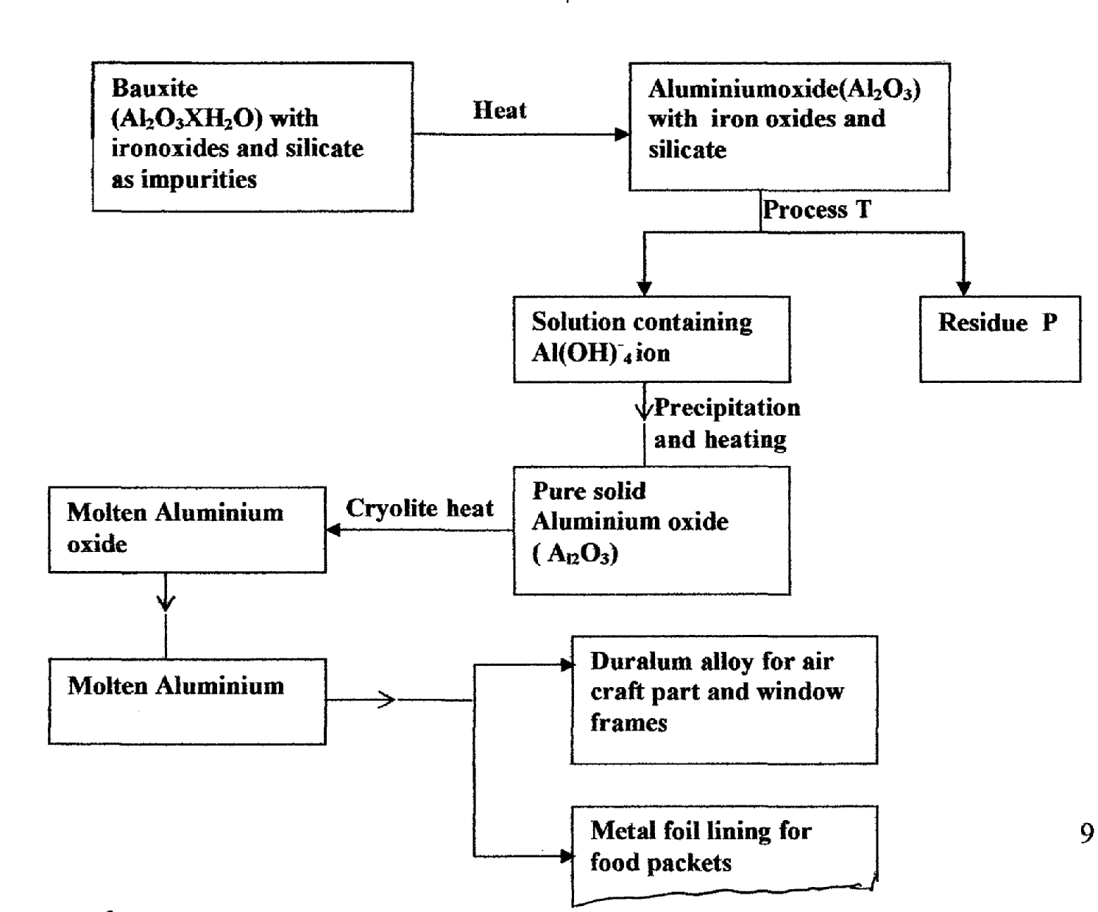

a) (i) Explain how process **T** is carried out. (2mks)

………………………………………………………………………………..…………………….

(ii) Name residue **P**, give a reason. (2mks)

………………………………………………………………………………..…………………….

………………………………………….………………………………………..…………………

(iii) Explain why it is necessary to heat Aluminium oxide in presence of cryolite before

electrolysis is carried out. (1 mk)

………………………………………………………………………………..…………………….

………………………………………….………………………………………..…………………

b) Suggest a reason why:

(i) Aluminium is not used for marine purpose. (lmk)

………………………………………………………………………………..…………………….

………………………………………….………………………………………..…………………

(ii) Carbon is not used for the reduction of Alumimum oxides. (lmk)

………………………………………………………………………………..…………………….

………………………………………….………………………………………..…………………

c) What properties of Aluminium and its alloys make them suitable for the uses indicated? (1 mk)

………………………………………………………………………………..…………………….

………………………………………….………………………………………..…………………

d) When 31 .2g of hydrated. Aluminium oxide ( A12O3XH2O) was heated to a constant mass of 2O.6g of

Aluminium oxide ( A12O3) was obtained. Determine the value of x in hydrated oxide. (3mks)

(A1= 27.0, 016.0, H1.0)