Name____________________________________Class_______________AdmNo:_____________
Date__________________________________________Sign_______________

END OF TERM ONE EXAMINATION

FORM TWO

CHEMISTRY

2 HOURS

Instructions to candidates:
- Answer all questions in both section A and B.

- All working must be clearly shown and, in the spaces, provided.

FOR EXAMINER’S USE ONLY
Section | Maximum  Score | Candidate’s  Score
A | 40
B | 40
Grand Score | 80

1[a] what is an atom? [1mk]
…………………………………………………………………………………………………………..…………………………………………………………………………………………………………. [b]Distinguish between atomic number and mass number [1mk]
…………………………………………………………………………………………………………………………………………………………………………………………………………………….2. Name two sub-atomic particles [2mks]
……………………………………………………………………………………………………………………………………………………………………………………………………………………

3. Element P has two isotopes P⁶⁰ and P⁶¹ which occur in the ratio X:2. Given that its R.A.M is 60.4. ³⁰ ³⁰
Calculate the value of X [3mks]

4. A patient went to the hospital and was diagnosed to have cold flu. The patient was prescribed to take drugs 1 x 3

[i]How and what hours in interval will the drugs be taken [2mks]
………………………………………………………………………………………………………………………………………………………………………………………………………………………………………………………………………………………………………………………………
[ii]Supposing the patient took the drugs at 7.00a.m in the morning. What other hours of the day will the patient take the drugs [2mks]
………………………………………………………………………………………………………………………………………………………………………………………………………………………………………………………………………………………………………………………………
5. Identify a suitable method that would be used to separate mixture of the following substances
[a]Iodine and potassium chloride [1mk]
……………………………………………………………………………………………………………………………………………………………………………………………………………………
[b]Water and ethanol [1mk]
……………………………………………………………………………………………………………………………………………………………………………………………………………………
[c]Table salt dissolved in water [1mk]

……………………………………………………………………………………………………………………………………………………………………………………………………………… …..
6. Fill the table below
compound | Chemical formulae
[i]sodium chloride
[ii]Iron{III}oxide
[iii] | Al{OH}₃

7.Chemistry is a science subject that involves practicals that are done in the laboratory. Safety rules are given in order for the student to take precaution while in the laboratory
{i} State three such rules to be observed [3mks]
…………………………………………………………………………………………………………………………………………………………………………………………………………………… ………………………………………………………………………………………………………………………………………………………………………………………………………………………………………………………………………………………………………………………………
{ii} Most of the laboratory apparatus are made of glass. Give two reasons [2mks]
………………………………………………………………………………………………………………………………………………………………………………………………………………………………………………………………………………………………………………………..……..
8.Njoki a form 2 student, was given a colourless liquid suspected to be water.
[a]Describe one chemical test she could use to identify the liquid. [2mks]
………………………………………………………………………………………………………………………………………………………………………………………………………………………………………………………………………………………………………………………………

{b}Describe an experiment she could perform to ascertain its purity [2mks]
………………………………………………………………………………………………………………………………………………………………………………………………………………………………………………………………………………………………………………………………
9.Two ions X²⁺ and Y²⁻ forms ions with ionic configurations 2.8.8 each
[a]Which of the ions is of an element in
[i]period 3
……………………………………………………………………………………………………… [ii]Group 2
………………………………………………………………………………………………………
[b]Given that element Y has a mass number of 32, draw the structure of its ions [2mks]

10. The form two students were given solutions P, Q and R in three different beakers. They put in red and blue litmus papers and recorded the results as shown below

Solution | P | Q | R
Effect on blue litmus paper | Turns red | Remains blue | Remains blue
Effects on red litmus paper | Remains red | Turns red | Turns blue

Which of the solutions was most likely to be;
[i]Distilled water [1mk]
…………………………………………………………………………………………………………
[ii]of an oxide of sodium. Explain your answer [2mks]
………………………………………………………………………………………………………………………………………………………………………………………………………………….…

[iii]An oxide of sulphur. Explain your answer [2mks]
………………………………………………………………………………………………………………………………………………………………………………………………………………………………………………………………………………………………………………………………
11.[a]Differentiate between prescription drugs and over the counter drugs [2mks]
………………………………………………………………………………………………………………………………………………………………………………………………………………………………………………………………………………………………………………………………
[b]Name two commonly abused drugs in Kenya [1mk]
……………………………………………………………………………………………………………………………………………………………………………………………………………………
[c]State two physiological effects of drug abuse to the human body [2mks]
………………………………………………………………………………………………………………………………………………………………………………………………………………………………………………………………………………………………………………………………
SECTION B
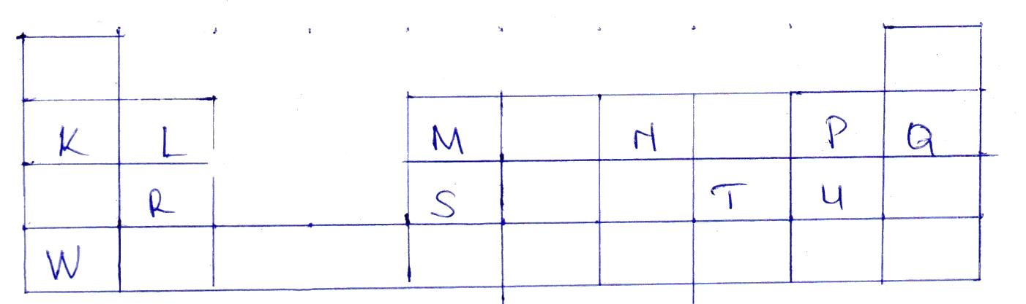
12.Study the grid below showing a section of the periodic table. The letters are not the actual chemical symbols of the elements

[a]State the letter that represents an element that
[i]Belongs to period 3 [2mks]
……………………………………………………………………………………………………
[ii]Belongs to group 2 [1mk]
……………………………………………………………………………………………………
[iii]Forms ions with a charge of +3 [1mk]
……………………………………………………………………………………………………
[iv]forms ions with a charge of +1 [1mk]
……………………………………………………………………………………………………
[v]Forms ions with a charge of -1 [1mk]
……………………………………………………………………………………………………
[b]What name is given the family to which elements K and W belong [2mks]
……………………………………………………………………………………………………………………………………………………………………………………………………………………
[c]How does the following compare? Explain your answer
[i]Atomic radius P and U [2mks]
…………………………………………………………………………………………………………………………………………………………………………………………………………………………………………………………………………………………………………………………………………………………………………………………………………………………………………
[ii]Ionic and atomic radius of L [2mks]
…………………………………………………………………………………………………………………………………………………………………………………………………………………………………………………………………………………………………………………………………………………………………………………………………………………………………………
[iii]ionic and atomic radius of U [2mks]
…………………………………………………………………………………………………………………………………………………………………………………………………………………………………………………………………………………………………………………………………………………………………………………………………………………………………………

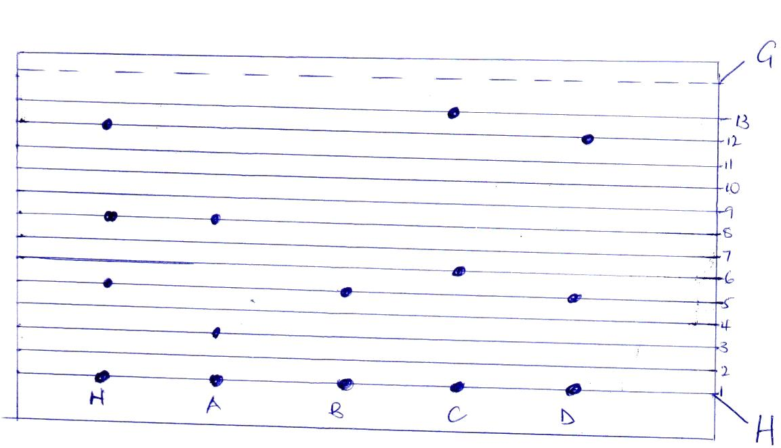
13.Form two students carried out paper chromatogram for mixture of K and substances A,B,C and D. study it and answer the questions that follow

[a]Label [2mks]
[i]G…………………………………………………………………………………………………….
[ii]H……………………………………………………………………………………………………
[b]What is the suitable solvent to use in this paper chromatogram [1mk]
………………………………………………………………………………………………………….
[c]Identify the substances present in mixture N [3mks]
……………………………………………………………………………………………………………………………………………………………………………………………………………………
[d]Which of the pure substance was a compound of N [1mk]
…………………………………………………………………………………………………………
[e]State two factors that determine the speed by which a substance in a solution moves up the absorption paper [2mks]
………………………………………………………………………………………………………………………………………………………………………………………………………………………………………………………………………………………………………………………………

[f]State two application of paper chromatogram [2mks]
………………………………………………………………………………………………………………………………………………………………………………………………………………………………………………………………………………………………………………………………
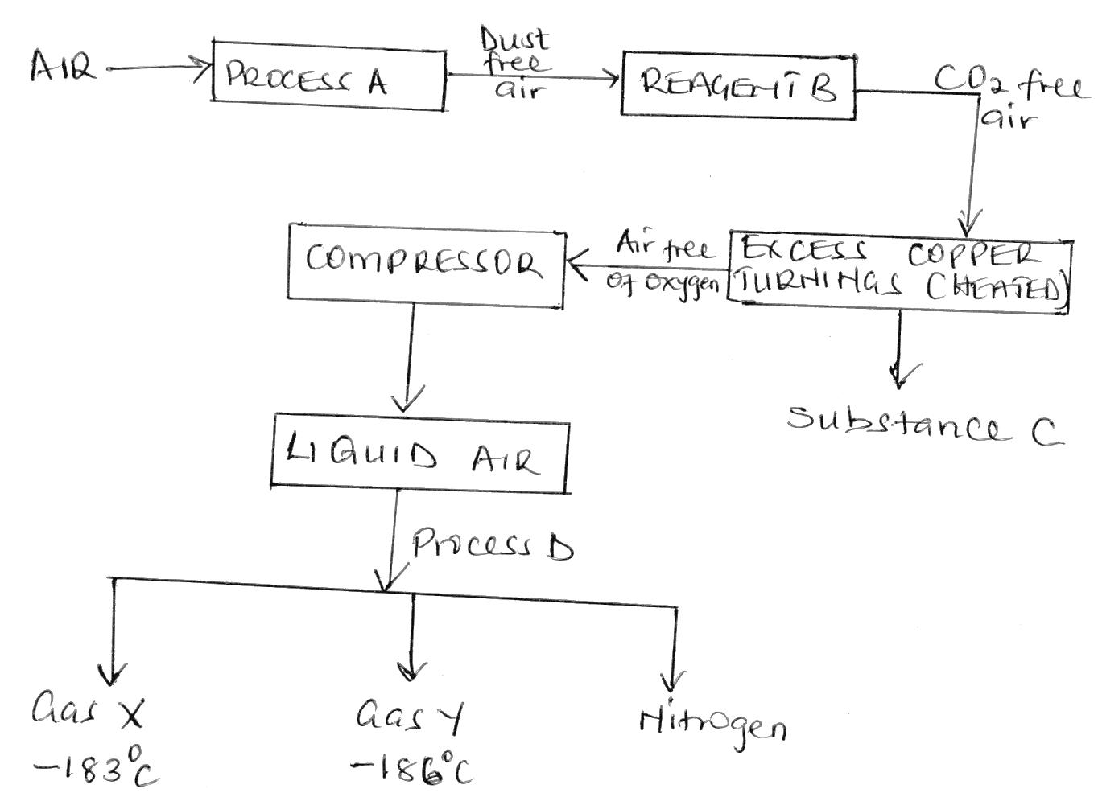
14.The chart below shows how the main components of air are separated. Study it and answer the questions that follow

[a]Identify
[i]Gas x ……………………………………………………………………………… [1mk]
[ii]Gas y ………………………………………………………………………………. [1mk]
[iii]The temperature at which Nitrogen is distilled out
………………………………………………………………………………………… [1mk]
[b]Name
- Process A …………………………………………………………………….. [1mk]
- Reagent B ……………………………………………………………………… [1mk]
- Substance C …………………………………………………………………… [1mk]
- Process D ……………………………………………………………………… [1mk]
[c]What is the purpose of passing the air through compressor [1mk]
……………………………………………………………………………………………………………………………………………………………………………………………………………………
[d]Write the chemical equation of the reaction taking place when copper turnings are heated [1mk]
…………………………………………………………………………………………………………
15.Study the table below and answer the questions that follow
ELEMENT | A | B | C | D | E | F | G
Atomic radius [nm] | 0.156 | 0.136 | 0.125 | 0.110 | 0.110 | 0.104 | 0.099
Ionic radius[nm] | 0.095 | 0.065 | 0.050 |  |  | 0.184 | 0.181
1st ionization energy KJ/mol | 492 | 743 | 790 | 791 | 1060 | 1063 | 1254
Melting point ⁰C | 97.8 | 650 | 660 | 1410 | 442 | 119 | -101
Atomic number | 11 | 12 | 13 | 14 | 15 | 16 | 17

[i]Explain why;
[a]A has a larger atomic radius than ionic radius [1mk]
……………………………………………………………………………………………………………………………………………………………………………………………………………………………………………………………………………………………………………………………….
[b]G has a smaller atomic radius than its ionic radius [1mk]
……………………………………………………………………………………………………………………………………………………………………………………………………………………………………………………………………………………………………………………………….
[c]Explain on the trend of melting point from A to C [2mks]
………………………………………………………………………………………………………………………………………………………………………………………………………………………………………………………………………………………………………………………………

[d]Explain why D has the highest melting point [1mk]
………………………………………………………………………………………………………………………………………………………………………………………………………………………………………………………………………………………………………………………………
[e]Why is G having smallest atomic size [1mk]
……………………………………………………………………………………………………………………………………………………………………………………………………………………

