**NYATIKE SUB-COUNTY JOINT EVALUATION EXAMS**

**CHEMISTRY 1**

**JULY/AUGUST 2014**

**MARKING SCHEME**

1. (a) Cooking vessels _Its a good conductor for heat √

Over head cables- Its light/low density does not rust /conducts electricity –any correction

(b) Solution of wood ash contains KOH which reacts with aluminium oxide layer became its amphoteric √

2. (a) Gas K is hydrogen gas √

(b) Calcium hydroxide was formed, which is a weak base √

(c) Ca(s) +2H2O Ca(OH)2(aq)+H2(g)

Penalize ½ mark for wrong state symbols if not balanced give (O)

3. (a) K-ammonium chloride √

(b) Sublimation √

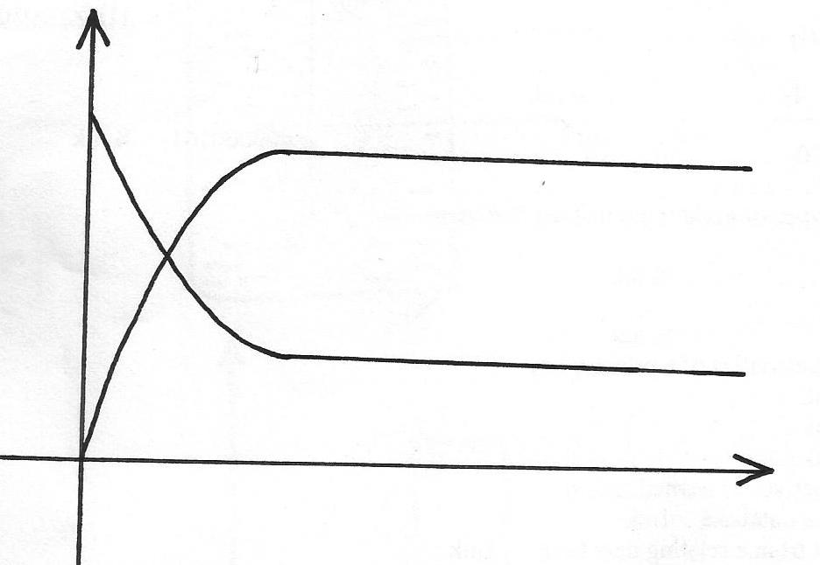4. Atomic number is the number of protons in an atom √ while mass number is the total number of protons and neutrons √

5. (i)

**Concentration**

**Time**

**F(g) √ ½**

**E(g) √ ½**

(ii) Concetration of F increases with time because it’s a product, it is being formed √. While concentration of E decreases with time because it’s a reactant, its being used up √

6. An insoluble lead (II) Sulphate is formed, which hinders further reaction

7. The solution turns blue, because the crystal dissolves and the blue colour spreads through √ ½ diffusion

8. (a) B+ has more energy levels than A+, hence electrons in A+ are attracted more strongly by nucleus √

(b) C2+ has greater nucleus charge than A+ hence electrons in C2+ are attracted more strongly √

9. (a) Grahams law of diffusion states the rate of diffusion of a gas is inversely proportional to the square root of its density at constant temperature and pressure √







10. (a) Water vapour acts as a catalyst √

(b) 2H2S(g) + SO2(g)  2H2O(l) +3S(s)

(c) H2S/Hydrogen sulphide √

11. Colour of sugar turns brown √ ½ to black Conc. Sulphuric (VI) acid dehydrates sugar forming carbon and water √

12. (i) Soap detergent √

(ii) Soapless detergent √

(iii) B √

(iv)B √

13. (i) 2N2O(g) + C(s) CO2(g) +2N2(g)

(ii) Ammonium nitrate when heated directly may explode √ ½ while a mixture of ammonium chloride and sodium nitrate when heated does not explode √ ½

(iii) Nitrogen (I) Oxide has a characteristic sweet, sickly smell √

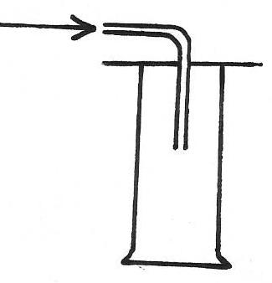14. (a)(i)

**H2S**

(ii) Iron (II) sulphide/FeS √ ½

Solid J: Fused calcium chloride /CaCl2 √ ½

(b) 2HCl(aq) + FeS(s) H2S(g) + FeCl2(s)

15. (a) Nuclear fusion is a process whereby smaller nuclide combine to from a larger one at high temperatures. While nuclear fission is whereby a larger nuclide splits to form smaller one when hit by neutron √

230

90

230

Th Pa + e

-1

0

91

(c) Tracing up take of nutrients e.g Phosphorous by plants

Production of new variety of crops with higher yield/more resistant to pests and diseases/with early maturity (any correct one)

16. (a) Polystyrene √

H

H

H

O

׀ ׀

(b) C = C

׀ ׀

17. Hydrogen chloride is highly soluble √

18. (a) CH3CH2OH(aq)+ 3O2(g) 2CO2(g) + 3H2(l) √

(b) 

RMM of CH3CH2OH=46

0.92g produced =27.3kJ

46g=

=-1365KJ/mol

19. (a) Haematite/siderite √

(b) CaCO3(s)  CaO(s) + CO2(g) √

CaO(s) + SiO2(s)  CaSiO3(l) √

20. Zn(s) + 2HCl(aq) ZnCl2(aq) +H2(g)

Moles of HCl= 100x0.2

1000

=0.02moles √ ½

Mole ratio 1:2 √ ½

Moles of Zinc that reacted

=0.02x ½ =0.01 √ ½

Mass of zinc that reacted =0.01x65

=0.65g √ ½

∴Excess Zinc =1.96-0.65 √ ½

=1.31g

21. To magnesium oxide, add excess HNO3 √ ½ HCl or H2SO4. Add NaOH or KOH or NH4OH to the mixture √ ½ filter √ ½ and dry √ ½ the residue between two filter papers

22. 2x-10=0

2x=10

x=+5 √

23. (a) Dynamic equilibrium is an equilibrium whereby the rate of forward reaction is equal to the rate of backward reaction √

24. Q = It=

0.5x(32x60+10) √ ½

=0.5x1930

=965C √ ½

0.22g=965C

∴44g = 44x965

0.22 √ ½

=193000C √ ½

No of F= 195000 √ ½

96500

=2F

Charge =2+ √

25. (a) Thermal cracking is the breaking down of long chain hydrocarbons by means of heating. White catalytic cracking is whereby long chain hydrocarbons are broken down by catalysis process. √

(b) CFC-Chlorofluorocarbons causes global warming by depleting the ozone layer √

26. (a) Frasch Process √1

(b) Melt the solid sulphur √

©(i) Insoluble in water √1

(ii) Unreactive in water √1

27. (a) It is the amount of heat required to convert one mole of a substance into vapour at a constant temperature

(b) I mole of H2O=2+16=18g

If 18g=41.1KJ

∴1g = 1 x 41.1

18

=+2.283KJ √1

Without a sign penalize ½ mk

28. (a) Reference electrode √ ½

Eθ=0.00volts

(b)(i) I.At electrode Q:

Q(s) Q2+(aq) +2e- √ ½

II. At electrode T:

T+(aq) +e- T(s)

Or

2T++2e 2T(s) √ ½

(ii) Emf=Eθ reduction-Eθ oxidation

=(-0.83)-(-1.37) √ ½

=-0.83+1.37

=+0.54volts √ ½