MWAKICAN EXAM
CHEMISTRY FORM TWO
END OF TERM TWO 2015
1.a)( Describe how to light and obtain a non- luminous flame from a Bunsen burner.(3 mks)

b) State one disadvantage of the flame obtained above.(1 mk)

2. State the type of changes undergone by the following substance,
a) Obtaining kerosene from crude oil.(1 mk)

b) Souring of milk.(1 mk)

3. The table below shows liquids that are miscible and those that are immiscible
liquid | L3 | L4
L1 | Miscible | Miscible
L2 | miscible | immiscible
Use the information given to answer the question that follow
1. Name the method that can be used to separate L1 and L2 from a mixture of two.(1 mk)

II) Describe how a mixture of L2 and L4 can be separated.(2mks)

4. A beekeeper found that when stung by a bee application of a little solution of sodium hydroxide helped to relieve irritation from the affected area. Explain.(2 mks)

5. The set up below was used to collect gas F produced by the reaction between water and calcium metal

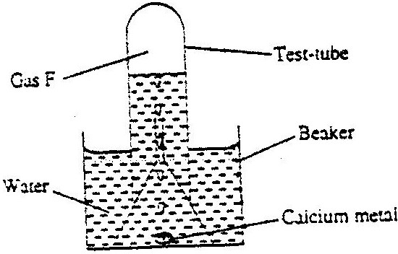

i) Name gas F.(1 mk)

ii) At the end of the experiment the solution in the beaker was found to be a weak base. Explain why the solution is a weak base.(2 mks)

III) Give one laboratory use of the solution formed in a beaker.(1 mk)

6. Write the formula for the oxide of
A) Magnesium

b) Chlorine

7. The following set-ups were used to investigate the rusting of iron. Study it and answer the question that follow.
A) Give a reason why rusting did not occur in test tube c.(1 mk)

b) Aluminum is used to protect iron sheets from rusting. Explain two ways in which aluminum protects iron from rusting.(2 mks)

8. When hydrogen gas is passed over heated lead (ii) oxide, a reaction occurs as shown in the set-up below.

State what happens inside the combustion tube (1 mk)

9. The set-up below was used to prepare hydrogen gas

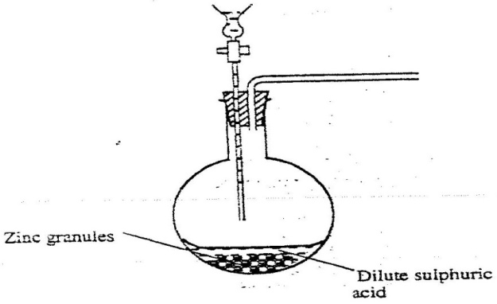

A) Complete the diagram to show how a dry sample of hydrogen gas can be collected.(3 mks)

b) Write an equation for the reaction which take place when hydrogen gas burns in air.(1 mk)

10. Both graphite and molten lead (ii) chloride conducts electricity. State the substance that conducts electricity in:
A) Graphite.(1 ½ mks)

b) Molten lead (ii) chloride.(1 mk)

11. The diagram below represents a charcoal burner. Study it and answer the question that follows

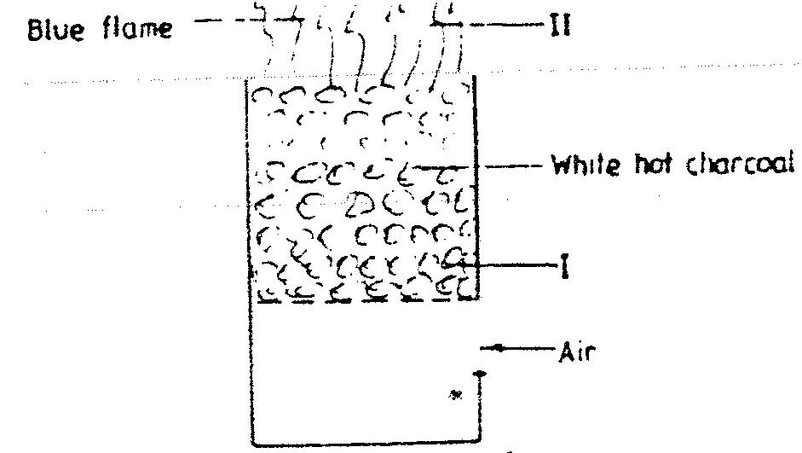

A) Write equations for the reactions taking place at (i) and (ii) above.(2 mks)
i)

ii)
b) At region marked y an oxide of carbon forms. This oxide is often referred to as a “silent killer”
i) Identify the oxide.(1 mk)

ii) Why is this oxide described as a silent killer.(2 mks)

12. Study the flow chart below and answer the questions that follow
Substance F1
Step 1 step 2
Colourless solution
Calcium oxide
Dilute hydrochloric heat to dryness
acid

step 3 filter+ excess carbon(iv) oxide
Substance G1

A) Give the name of the process that take place in step 1.(1 mk)

b) Give
i) The name of substance G.(1 mk)

ii) Suggest one use of carbon (iv) oxide.(1 mk)

13. The table below shows some of the elements of the periodic table and their atomic numbers, atomic masses and melting point. The letters are not the actual symbols of the elements
Element | B | C | D | E | F | G | H | I | J | K
Atomic no | 7 | 8 | 19 | 15 | 2 | 9 | 6 | 16 | 12 | 11
Atomic mass | 14 | 16 | 39 | 31 | 4 | 19 | 12 | 32 | 40 | 23
Melting point oc | -209 | -218 | 63 | 44 | -272 | 223 | VARY | 113 | 669 | 98
a) Select two elements with oxidation state of -3.(2 mks)
b) Which elements represent the most powerful reducing agent.(1 mk)

c) How does the atomic radii of D compare with that of K. Explain.(2 mks)

d) How do you compare the electrical conductivity of element J and K. Give your reason.(2 mks)

e) Select two elements which when reacted with element G forms a compound that conducts electricity both in molten and aqueous state.(2 mks)

f) Select two elements that have a common valency. State the elements.(2 mks)
g) In which group and period do D and G belong?
(D) Group period. (1 mk)
(G) Group period. (1 mk)
h) Select one element stored in
a) Water-
b) paraffin.- (2 mks)
14. a) Define the term “salt”(1 mk)

b) Describe how you can prepare crystals of sodium chloride under laboratory conditions starting with 100cm³ of a solution of dilute hydrochloric acid.(3 mks)

c) State at least two uses of salts.(2 mks)

15. State term(s) used to describe the processes below when salts are exposed to air for some time
i) Anhydrous copper ii sulphate becomes wet.(1 mk)

ii) Fresh crystals of sodium carbonate Na₂Co₃.10H2o become powdery.(1 mk)
16. Using dots (.) and crosses(x) draw a diagram to show bonding in ammonia.(2 mks)

17. In terms of structure and bonding explain why graphite
A) Conducts electricity

b) Has a higher melting point.(2 mks)

18. a) What is a radical as used in chemistry.(1 mk)

b) State the formula of the compound formed when the following radicals combine
i) Ammonium, NH₄⁺ and sulphate, SO₄^{2-.(}1 mk)

ii) Calcium ion Ca²⁺ and phosphate, PO₄³⁻ ion.(1 mk)

19. Study the structure below which represents an allotrope of carbon

A) Identify the allotrope. (1 mk)

b) State one of its uses, giving reasons for your answer. (2 mks)
20. Ethanol,C₂H₅OH has a boiling point of 78⁰c while dimethylether,(CH₃)₂O has a boiling point of only ⁻33ºc, yet dimethyl either has a higher molecular mass than ethanol. Explain the observation in terms of structure and bonding.(2 mks)

21. The table below gives information about element in period three of the periodic table
element | Atomic no | Atomic radius | Ionization energy
Sodium | 11 | 0.002nm | 50kj
Magnesium | 12 | 0.001nm | 70kj
Aluminum | 13 | 0.0005nm | 93kj
Silicon | 14 | 0.0001nm | 107kj
a) State and explain the changes in atomic radius across the period.(2 mks)

b) Give reason(s) for increases ionization energy across the period.(2 mks)

22. The grid below represents parts of the periodic table. Study it and answer the questions that follow letter do not represent actual symbols of elements-draw the grid

A
 |  |  |  |  |  | m |  | q | w
C |  |  |  |  | d |  |  | r
 |  |  |  |  |  |  |  | s | p

i) Select two element with a charge of -2.(2 mks)

ii) Which is the most reactive non metal above.(1 mk)

iii) Give the formula of the oxide of D.(1 mk)

iv) Show on the grid an element which is mono atomic.(1 mk)
v) On the grid provided assign and indicate the position of iron metal.(1 mk)
vi) Compare the atomic radii of element d and r. Explain.(2 mks)

vii) Element m forms 2 isotopes whose isotopic composition is as given below
¹²₆M(75%) and ¹⁴₆m(25%). Calculate its relative atomic mass.(3 mks)

23. Name a property of neon that makes it suitable for use in electric lamps.(1 mk)

24. Four metals F,G,H and J were each separately added to cold water and steam. Metal F and H reacted with cold water and very explosively with steam Metals G and J showed no reaction with cold water.
A) Suggest the identify of metal H.(1 mk)

b) Write an equation for the reaction between metal F and steam.(1 mk)

c) Metal J forms a hydroxide whose formula is J(OH)₂
Suggest the chemical family of metal.(1 mk)

d) Suggest a metal above which forms a monovalent ion.(1 mk)

