**MWAKICAN JOINT EXAMINATION**

**FORM 3 CHEMISTRY PAPER 2 MARKING SCHEME**

1. a) i) C gains electrons to🗸½ form ions, innermost electrons🗸½ repels incoming electrons hence larger ionic radius.

ii) It has giant atomic🗸½ structures revealed by strong covalent🗸½ bonds hence require higher 🗸energy to melt.

iii) BCl2 🗸1

b) U – 2,6🗸1

V – 2,8,3 🗸1

c) i) Heating of cotton🗸½ wool and magnesium🗸½

ii) Wet cotton produced🗸½ steam when heated 🗸½

Steam reacted with hot🗸½ magnesium forming gas C🗸½

iii) Potassium is more reactive🗸1

2. a) i) A mixture of brine // conc NaCl and ammonia gas🗸1

ii) NaCl (aq) + NH3 (aq) + CO2 (g) + H2O (l) NaHCO3 (s) + NH4Cl (aq) 🗸1

iii) Filtration 🗸1

Fractional crystallization 🗸1

b) Manufacture of glass🗸1

Cattle licks🗸1

Softening of water🗸1 *(Any two @ 1mk Total = 2mks)*

c) i) CaO / Calcium oxide🗸1

ii) Heating of calcium carbonate to produce CO2(g)🗸1

Heating of carbon to CO2 (g)🗸 *(Any one)*

d) 2NaHCO3(s)  Na2CO3 (s) + CO2 (g) + H2O (l)🗸1

e) Ammonia🗸½ and carbon (IV) oxide🗸½

f) Allows slow movement of ammonical brine🗸1 inorder for the reaction to occur effectively//

increase surface area for reaction🗸1

g) NaCl(aq) + NH3 (g) + CO2 (g) + H2O (l) NaHCO3 (s) + NH4Cl (aq)

2NaHCO3 (s) Na2CO3 (s) + CO2 (g)  + H2O(l) 🗸1

63.6 tonnes.

Mass of Na2CO3  = 106g

Moles of Na2CO3 = 🗸½

= 600000 moles🗸½

Moles of NaHCO3 = 600000 x 2

= 1200000 moles🗸½

1 mol of NaCl produces 1 mol of NaHCO3

Mass of NaCl = 58.5g🗸½

58.5g = 1 mol of NaHCO3

1200000 mol 🗸½



🗸½

**or**

Mass of NaHCO3 = 23 + 1 + 12 + 48

= 84g🗸½

2 x 84g NaHCO3 = 106g Na2CO3

63.6 tonnes🗸½



100.8 tonnes🗸½

Mass of NaCl = 58.5🗸 ½ mass of NaHCO3 = 84🗸½

58.5g NaCl = 84g NaHCO3

100.8 tonnes



= 70.2🗸½

3. a) I: The outlet delivery tube should not dip into the Zinc/dilute Sulphuric acid mixture in the round

buttoned flask. ✓ 1mk

II: The use of heat is not required ✓ 1mk

b)

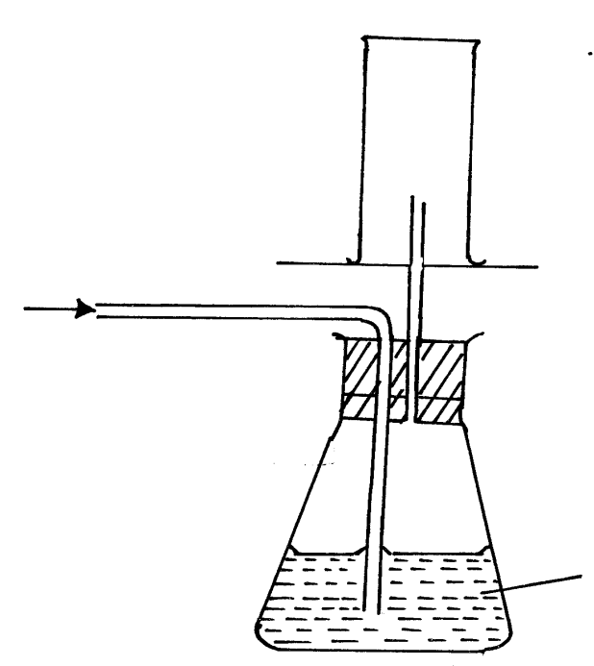

Dry H2 (g)

✓ (way of collection) 1mk

Card board

Wet H2 (g)

Conc H2SO4

✓ 1mk

c) i) It does not react with conc. H2SO4 ✓1 mk

ii) H2(g) + ½ O2 (g) ht H2O(g) ✓ balancing½ mark

states ½ mark

d) Zn2(s) + H2SO4 (aq) ZnSO4 (aq) + H2(g) balancing ½ mk

states ½ mk

1vol 1 vol 1vol

 

Therefore, ✓1mk 



Or R = 65.4 ✓ 1mk

e) - H2(g) is used in balloons by meteorologists ✓1mk

- It is used as rocket fuel ✓ 1mk

Note: Allow other correct answers.

|  |  |  |  |
| --- | --- | --- | --- |
| 4 | a) (i) 2 – bromobutane 🗸½  (ii) Sulphuric (VI) acid 🗸  b) (i) X – Concentrated sulphuric (VI) acid🗸½  Y – Concentrated sodium hydroxide / potassium hydroxide🗸½  (ii) To absorb CO2 / SO2 formed during the reaction🗸½  (iii) Heating 🗸  (iv) Its density is almost the same as that of air🗸  (v) C2H5OH  C2H4 (g) + H2O(l)  c) (i) Nickel🗸  (ii) A – Ethane 🗸  B – Chloroethene 🗸  (iii) - Not biodegradable hence pollutants🗸  - Produce toxic gases when burnt🗸  (iv) III – Polymerisation🗸  IV – Substitution 🗸  (v) By hydration of K🗸 at 9000C using phosphorous (V) acid as🗸 a catalyst  OR  Hydrolysis of K by adding 🗸conc H2SO4 followed by water and then warmed 🗸  d) C3H6🗸 | 1  1  1  1  1  1  1  1  1  1  1  2  1 |  |

5(a) Allotropy is the existence of an element in more than one form without a change of state (

(b) (i) D – Graphite (1)

(ii) E _ Diamond (1)

(ii) In electrolysis as an electrode or used as a lubricant Lead pencils or Atomic piles (any one) (1)

(iii) E or Diamond (1); all its 4 outermost electrons are involved in bonding ( ½ )

Thus it has no free/mobile electron to conduct electricity. ( ½ )

(c) (i) CO2(g) is denser than air (1)

CO2(g) does not support combustion (1)

CO2(g) does not burn (1) (any two)

(d) (i) CO2(g) + C(s) 2CO(g) (1)

(ii) Sodium hydroxide (1)

(iii) pass a sample of each gas (CO2(g) and CO(g) )in a boiling tube containing Ca(OH)2(aq). Carbon(IV) Oxide (1) forms a white precipitate with Calcium Hydroxide (lime water. Carbon(II) Oxide has no reaction with Calcium Hydroxide solution (1) (2mks)

OR

Carbon(IV) Oxide turns litmus paper pale red while Carbon(II) Oxide has no effect on litmus paper (any other correct description)

(iv) Reduction of metal oxides

6. a) I isolation of nitrogen from air

ii)concentrated sodium hydroxide or KOH(aq)

iii)Burns to produce white residue or solid

iv)to remove the water vapour or to dry the gas

v)rare gases – neon and argon

b)it is hygroscopic and absorbs water from air, the water reacts explosively with concentrated sulphuric acid

ii)Nitric(vi) acid decomposes to form NO2 and O2 on heating the NO2  is the brown gas.

c) % of acid can be increased through fractional distillation.

7a) 2NaNO3 (s) heat NaNO2 (s) + 02 (g)

b) Slightly soluble in water

c) No effect on the litmus paper because the gas produced is neutral.

7B)when the circuit is completed the bulb lights(1/2) brown substance(1/2)formed grey(1/2)substance formed on cathode:because pbBr2 acts as an electrolyte(1/2):lead ions gain electrons to form pb(1/2) and loses electrons to form (Br) ½mk

A-- cathode

B—anode

8. i) 2NaHCO3 Na2CO 3 + CO2 + H20

(s) (s) (g) (g) (2mks)

ii)168 g of NaHCO3  yield 106g of Na2CO3

8.4g……………………………….106x8.4

168 =5.3g of Na2CO3(2mks)

iii)22.4 liters at s.t.p 168 g of NaHCO3 evolve 22.4 liters at s.t.p 8.4g  of NaHCO3 evolve 22.4x8.4

168 =1.12 litres(2mks)

b)

|  |  |  |
| --- | --- | --- |
| Element | Cu | O |
| Composition | 3.2 | 0.8 |
| Reacting moles | 3.2/64=0.05 | 0.8/16=0.05 |
| Mole ratio | 0.05/0.05=1 | 0.05/0.05=1 |

Emphirical formula CuO 1:1 (4mks)

c)boyles law 20x375 =15xv2

p1v1 =p2v2 v2 = 20*375

p1=20 atm 15

v1=375cm3

p2 = 15 atm v2= 500cm3 (3mks)

v2 =?