NAME…………………………………………CLASS………ADM……………

233/2
FORM 3 CHEMISTRY PAPER 2 THEORY

TIME 2HRS

TERM 2 2016

MWAKICAN JOINT EXAM TEAM (MJET) TERM 2 2016
Instructions to candidates.
- Write your name and index number in spaces provided in the question paper.
- Answer all the questions in the spaces provided in question paper.
- Mathematical tables and silent calculators may be used.
- All working must be clearly shown where necessary.
QUESTIONS | STUDENT SCORE
1
2
3
4
5
6
7
8

1.a) Study the table below which shows properties of elements across period three and answer
the question that follow.

Element | A | B | C | D | E | F | G | H
Atomic radius (nm) | 0.156 | 0.136 | 0.125 | 0.118 | 0.110 | 0.104 | 0.099 | -
Ionic r Radius (nm) | 0.095 | 0.065 | 0.050 | - | - | 0.184 | 0.181 | -
Melting points (⁰C) | 97.8 | 650 | 660 | 1410 | 44.2 | 119 | -101 | -186

i)Explain why the atomic radius of G is smaller than its ionic radius. (1mk)
……………………………………………………………………………….
……………………………………………………………………………….
ii) Explain why the melting point of D is higher than the other elements (2mks)
……………………………………………………………………………….
……………………………………………………………………………….
iiiGive the formula of the chlorides of element B (1mk)
……………………………………………………………………………….…………… ……………………………………………………………………………………………

b) The ions of V³⁺ and U²⁻ have identical electronic configuration 2.8.
Write down the electron arrangement of the elements U and V (2mks)
U ………………………………………………………………………………………
V ………………………………………………………………………………………
c) The diagram below shows how magnesium reacts with steam
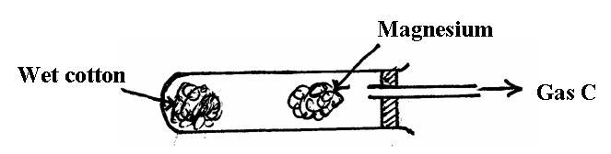

i) Gas C would not be produced as is in the set-up but when certain condition is introduced gas C is produced. Identify the condition which was omitted in the set-up (1mk)
……………………………………………………………………………
ii) Describe how gas C is produced after the mistake was corrected in the
above set-up (2mk)
………………………………………………………………………………
………………………………………………………………………………

iii) Why is it not advisable to use potassium in place of magnesium? (1mk)
…………………………………………………………………………………..
………………………………………………………………………………….
2. The flow chart below shows the manufacture of sodium carbonate. Study it carefully and
answer the questions that follow.
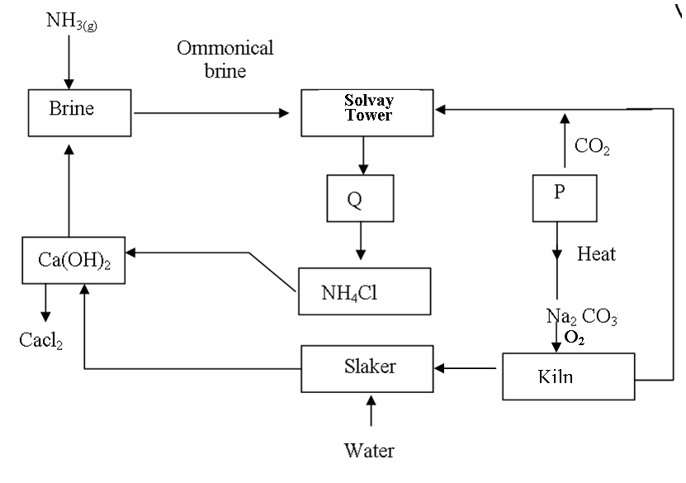
Ammonical brine
CaCl₂
a) i) What is ammonical brine? (1mk)
……………………………………………………………………………..
ii) Ammonical brine reacts with carbon (IV) oxide to form a mixture of two salts which produce Q. Write an equation to show formation of Q (1mk)
……………………………………………………………………………..
……………………………………………………………………………..
iiiName two processes that are used to separate Q into NH₄Cl and P(2mks)
……………………………………………………………………………..
…………………………………………………………………………….
b) Give two uses of sodium carbonate produced in the process (2mks)
……………………………………………………………………………………..
…………………………………………………………………………………….
c) i) Name the substance that reacts with water that comes into the slaker (1mk)
………………………………………………………………………………
ii) What happens at the kiln? (1mk)
………………………………………………………………………………
………………………………………………………………………………

d) Write an equation for the reaction that occurs when P is heated to form solid
Na₂ CO₃ (1mk)
………………………………………………………………………………………
………………………………………………………………………………………
e) Name two substances that are recycled in the process. (1mk)
………………………………………………………………………………………
………………………………………………………………………………………
f) Solvay tower is as shown below. Study the diagram and answer the question below
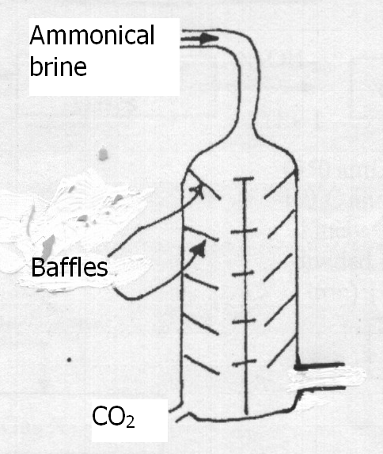
Give two reasons why the baffles are used in the solvay (2mks)
………………………………………………………………………………………….
………………………………………………………………………………………….
g) A factory produces 63.6 tonnes of anhydrous Na₂CO₃ on a certain day by this
process.
Calculate the number of tonnes of sodium chloride used upon on this particular
Day.
Assume the plant is working at 100% efficiency.
(C = 12, H = 1, Cl = 35.5, Ca = 40, Na = 23) (3mks)

3. A student set-up the arrangement below to prepare and collect dry hydrogen gas
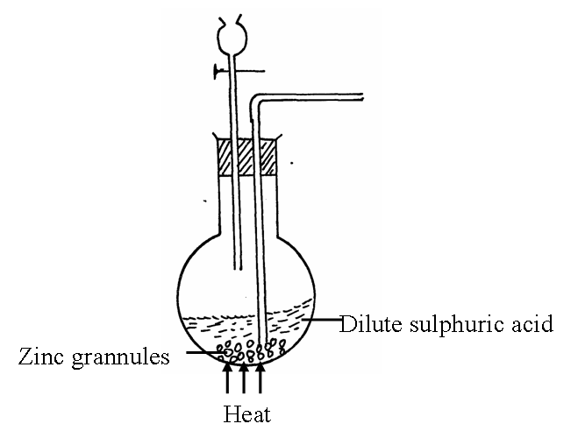

(a) Identify two errors from the section of the arrangement shown above(2mks)
I:
II:
(b) Complete the diagram to show how dry hydrogen gas can be collected.(2mks)

(c) (i) Explain the effect of hydrogen gas on a wet red litmus paper(1mk)
………………………………………………………………………………………………………………………………………………………………………………………………………………

(ii) Write a balanced chemical equation for the reaction that takes place when hydrogen gas is burnt in air. (1mk)
………………………………………………………………………………………………………………………………………………………………………………………………………………
(d) determine the relative atomic mass of zinc, given that when 6.54g of zinc was used, 2.4litres of hydrogen gas was produced. (molar gas volume = 24 litres) (3mks)

e) State any two non-industrial uses of hydrogen gas (1mk)

4 a) Name the following compounds(1mk)
(i)
……………………………………………………………………………………………….
(ii) H₂SO₄
……………………………………………………………………………………………….

- The diagram below is for the preparation of ethene gas in the school laboratory.

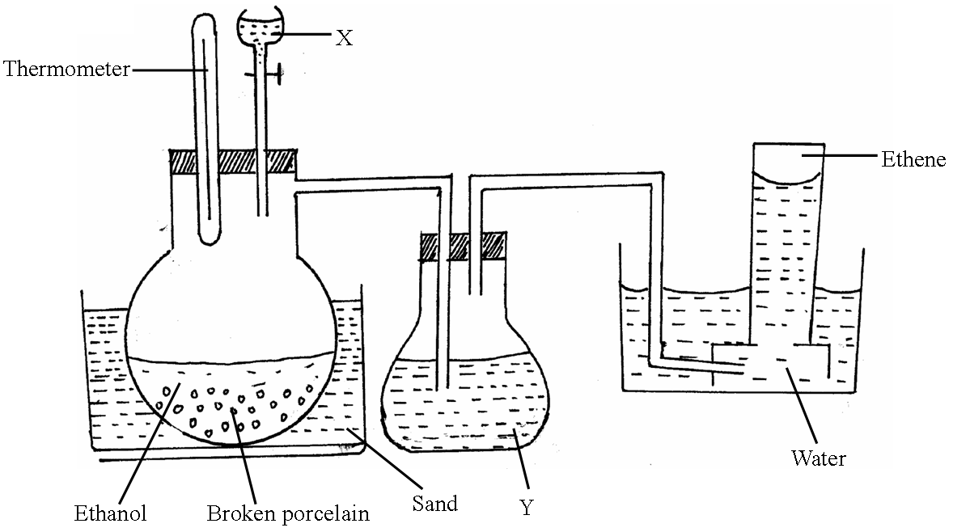

(i) Name substance (1mk)
X_____________________________
Y_____________________________
(ii) What is the use of substance Y?
……………………………………………………………………………………………………………………………………………………………………………………………….
(iii) State one condition missing in the set up (1mk)
……………………………………………………………………………………………………………………………………………………………………………………………….

(iv) Explain why ethene can’t be collected by either upward or downward
delivery.
(1mk)
……………………………………………………………………………………………………………………………………………………………………………………………….
(v) Write down an equation for the production of ethene in the above set up
(1mk)
……………………………………………………………………………………………………………………………………………………………………………………………….
c) Study the scheme below and answer the questions that follow.

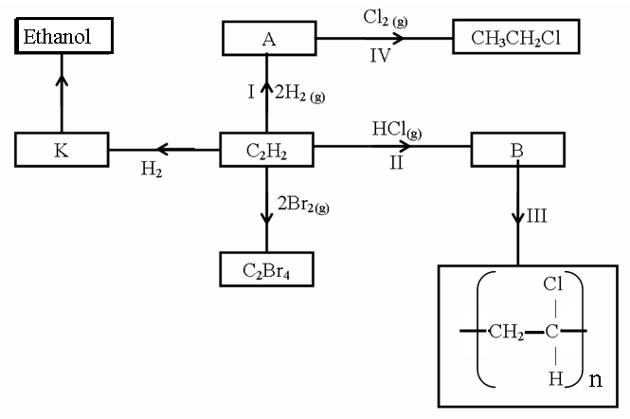

(i) Identify the catalyst used in step I (1mk)
……………………………………………………………………………………………………………………………………………………………………………………………….

(ii) Name the compounds A and B (1mk)
A_____________________________
B_____________________________
(iii) Give one disadvantage of compound formed in step III (1mk)
……………………………………………………………………………………………………………………………………………………………………………………………….
(iv) Name the reactions taking place at steps: (1mk)
III______________________________
IV______________________________
(v) Describe how substance K is converted to ethanol (2mks)
……………………………………………………………………………………………………………………………………………………………………………………………….
……………………………………………………………………………………………….……………………………………………………………………………………………….
d) Under certain conditions, heptane can be converted to two products. The formula of one of the products is C₄H₁₀. Write down the structural formula of the other products. (1mk)

5. (a) Carbon has two allotropes. What is meant by the term allotropy? (1mk)
…………………………………………………………………………………………………………………………………………
…………………………………………………………………………………………………………………………………………

(b) The following diagrams show the structures of two allotropes of carbon. Study
them and answer the questions that follow.
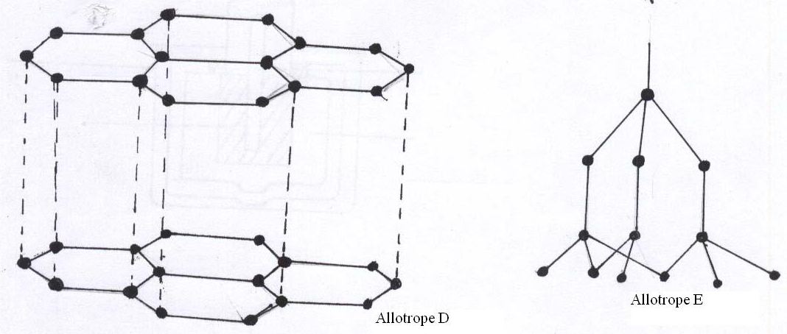
- Name the allotrope (2mks)
D
…………………………………………………………………………………………………………………………………………
E
…………………………………………………………………………………………………………………………………………

- Give one use of D (1mk)
…………………………………………………………………………………………………………………………………………
…………………………………………………………………………………………………………………………………………

- Which allotrope does not conduct electricity. Explain (2mks)
…………………………………………………………………………………………………………………………………………
…………………………………………………………………………………………………………………………………………

(c) State two properties of Carbon (IV) Oxide that make it suitable for use in fire extinguishers. (2mks)
…………………………………………………………………………………………………………………………………………
…………………………………………………………………………………………………………………………………………
(d) In an experiment, Carbon (IV) Oxide gas was passed over heated coke and the gas produced collected as shown in the diagram below.
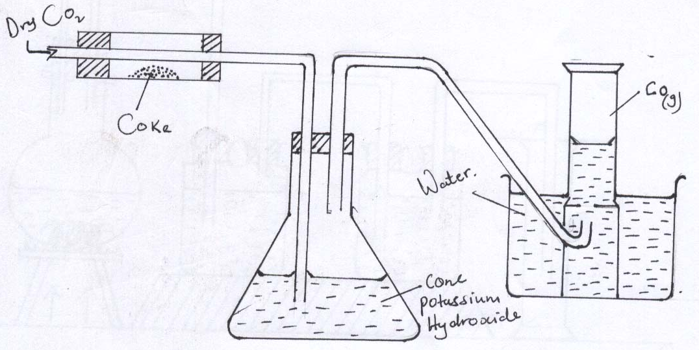
- Write an equation for the reaction that took place in the combustion tube. (1mk)

- Name another substance that can be used instead of Potassium Hydroxide. (1mk)
…………………………………………………………………………………………………………………………………………

- Describe a simple chemical test that can be used to distinguish Carbon (II) oxide. (2mks)
…………………………………………………………………………………………………………………………………………
…………………………………………………………………………………………………………………………………………
…………………………………………………………………………………………………………………………………………

- Give one use of carbon(II) Oxide (1mk)
…………………………………………………………………………………………………………………………………………
…………………………………………………………………………………………………………………………………………

6. The set up below was used to obtain dry nitrogen gas from air .study it and answer the questions that follows.

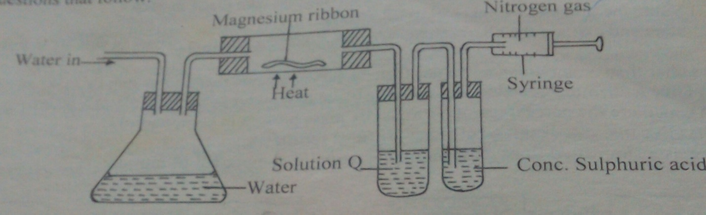

i)name the method used above.(1mks)
……………………………………………………………………………………………………..
ii)identify solution q.(1mks)
………………………………………………………………………………………………………………………………………………………………………………………………………………
iii)state the observation made in the combustion tube .(1mks)
………………………………………………………………………………………………………………………………………………………………………………………………………………
iv)What is the function of concentrated sulphuric acid in the set up above.(1mks)
………………………………………………………………………………………………………………………………………………………………………………………………………………
v)Name 1 impurity in the nitrogen gas collected by this method.(1mks)

………………………………………………………………………………………………………
b)the set up below was used to prepare Nitric(v)acid in the laboratory using concentrated sulphuric acid on potassium nitrate crystals.study it and answer the questions that follows.

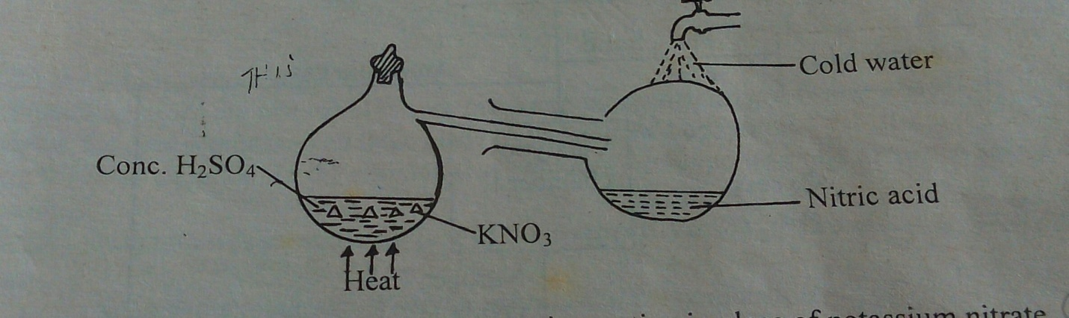

i)Explain why sodium nitrate is not appropriate option in place of potassium nitrate.(1mk)

………………………………………………………………………………………………………………………………………………………………………………………………………………………………………………………………………………………………………………………
ii)A reddish brown gas was observed in the retort.explain.(1mk)

…………………………………………………………………………………………………………………………………………………………………………………………………………
c)60-50 % Nitric(V) acid is produced from the absorption chamber in the industrial manufacture of the nitric acid.Describe how the percentage of the acid can be increased.(2mks).,……………………………………………………………………………………………………………………………………………………………………………………………………………………………………………………………………………………………………………………………………………………………………………………………………………

7a.The diagram below represents a set up used by a student to investigate the effect of heat on sodium nitrate.use it to answer the questions that follow.
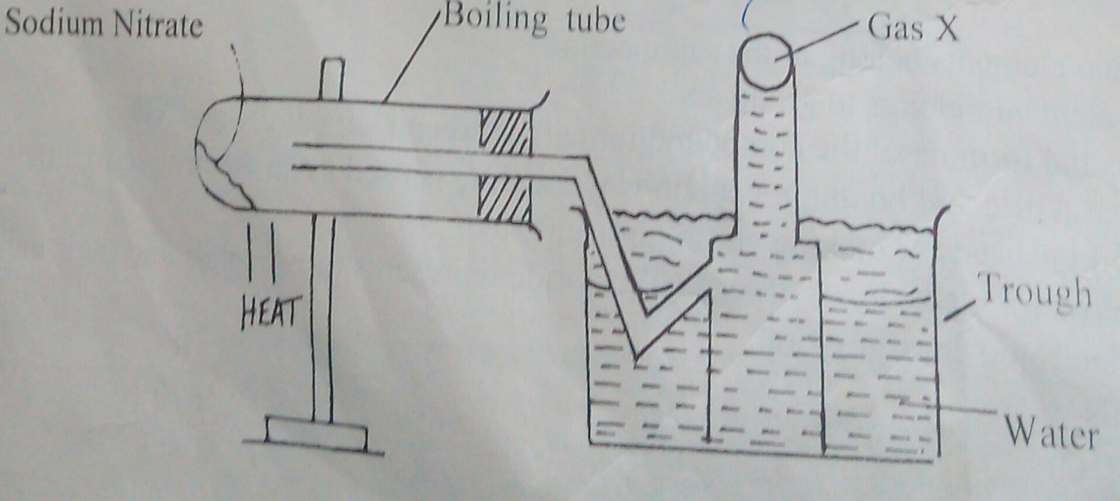

a)Write the chemical equation of the reaction in the boiling tube(2mks)

………………………………………………………………………………………………………………………………………………………………………………………………………………………………………………………………………………………………………………..

b)state the property of the gas that makes it to be collected by the method shown.(1mk)

…………………………………………………………………………………………..

c)predict the effect of water in the trough on the litmus paper after the experiment(2mks)

…………………………………………………………………………………………………………………………………………………………………………………………………………….
……………………………..

B)study the set up below and answer the questions that follows .

switch
bulb
A carbon electrodes
B
- - - - - molten lead (ii) bromide
--- - - - - -

heat
I)State and explain the observations that would be made when the circuit is completed.(3mks)
………………………………………………………………………………………………………………………………………………………………………………………………………………………………………………………………………………………………………………………………………………………………………………………………………………………………
ii)Name the electrodes A and B

A…………………………
B………………………………….
8 . 8.4g of sodium hydrogen carbonate are completely decomposed by heating.calculate the mass of the resulting solid and the volume in litres of the gas produced at s.t.p.(molar gas volume 22.4litres)
a) (i) write a balanced chemical equation(2mks)
………………………………………………………………………………………………………………………………………………………………………………………………………………………………………………………………………………………………………………………

ii) calculate the mass of solid formed(2mks)
…………………………………………………………………………………………………………………………………………………………………………………………
iii) calculate the volume of the gas produced in litres at s.t.p(2mks)
……………………………………………………………………………………………………………………………………………………………………………………………………………………………………………………………………………………………………………………………………………………………………………………………………………………………………………………………………………………………………………………………………
b)During an experiment on the reduction of an oxide of copper the following data was obtained.
Mass of empty boat…………………………………25.0g
Mass of empty boat + oxide of copper………………..29.0g
Mass of boat+copper(after reaction)……………………28.2g
(cu=64.0 0=16)
Find the emphirical formula of copper oxide.(4mks)
………………………………………………………………………………………………………………………………………………………………………………………………………………………………………………………………………………………………………………………………………………………………………………………………………………………………………………………………………………………………………………………………………………………………………………………………………………………………………………………………………………………………………………………………………………………………………………………………………………………………………………………………………………………………………………………………………………………………………
(c) A volume of 375cm³ of a gas has a pressure of 20 atmospheres.what will be its volume if pressure is reduced to 15 atmospheres?(3mks)

