Name………………………………………………………. Class…………….
Adm. No………………………………………….Date ………………
Candidate’s Signature………………………..
233/1
CHEMISTRY
Paper 1
Time: 2 Hours
END OF TERM TWO FORM 4 EXAMINATION 2019

INSTRUCTIONS TO CANDIDATES

- Write your name and ADM. number in the spaces provided above
- Sign and write the date of examination in the spaces provided.
- Answer all the questions in the spaces provided.
- Mathematical table and silent electronic calculators may be used.
- All working must be clearly shown where necessary.

FOR EXAMINERS USE ONLY
Question | Maximum score | Candidate’s score
1-30 | 80

This paper consists of 9 printed pages. Candidates should check to ascertain that all pages are printed as indicated and that no questions are missing.

1. State two reasons why most apparatus in the laboratory are made of glass (2mks)
……………………………………………………………………………………………………..
……………………………………………………………………………………………………..
2. The following is an organic compound represented as CH₃CH₂COOCH₂CH₃
(i) Name the organic acid and the alkanol used in making the compound (2mks)
……………………………………………………………………………………………………..
……………………………………………………………………………………………………..
(ii) Name the organic compound and the gas formed when the alkanol in (i) above is reacted
with Potassium (1mk)
……………………………………………………………………………………………………..
……………………………………………………………………………………………………..
3. Use the information below to answer the question that follows
Ca_{(s)} + ½ O_{2(g)} CaO_{(s)} ; ΔH=-635KJmol⁻

C_{(s)} + O_{2(g)} CO_{2(g)}; Δ H= -394KJmol⁻

Ca_{(s)} + C_{(s)} + ³/₂O_{2(g)} CaCO_{3(s)}ΔH= -1207 KJmol⁻

Calculate the enthalpy change for the reaction

4. (a) What is the role of the following parts during fractional distillation of a mixture of water
and ethanol
(i) Fractionating column (1mk)
……………………………………………………………………………………………………..
……………………………………………………………………………………………………..
(ii) Glass beads in the fractionating column (1mk)
……………………………………………………………………………………………………..
……………………………………………………………………………………………………..
(b) State any one application of fractional distillation process (1mk)
……………………………………………………………………………………………………..
……………………………………………………………………………………………………..
5. Name the process which takes place when:
(i) Iodine changes directly from solid to gas (1mk)
……………………………………………………………………………………………………..
(ii) Fe²⁺_{(aq)} changes to Fe³⁺_{(aq)} (1mk)
……………………………………………………………………………………………………..
(iii) White sugar changes to black solid when mixed with excess concentrated sulphuric (VI) acid
(1mk)
……………………………………………………………………………………………………..
6. The melting point of phosphorous trichloride is -91ºC while that of sodium chloride is 801ºC.
In terms of structure and bonding. Explain the difference in their melting point (3mks)
……………………………………………………………………………………………………..
……………………………………………………………………………………………………..
……………………………………………………………………………………………………..
7. (a) Name a suitable drying agent to be used to dry chlorine gas (1mk)
……………………………………………………………………………………………………..
(b) Chlorine reacts with red hot powder to give iron (III) chloride but not iron (II) chloride.
Explain? (1mk)
……………………………………………………………………………………………………..
……………………………………………………………………………………………………..
(c) Sodium hydroxide reacts with chlorine to form bleaching powder. Write a balanced equation
for the reaction (1mk)
……………………………………………………………………………………………………..
……………………………………………………………………………………………………..
8. The electronic arrangement of elements are represented by letters A to D are as follows
A:2.8.6 B:2.8.2 C:2,8,1 D2:8.8
(a) Select the element which forms
(i)Double charged cation (1mk)
……………………………………………………………………………………………………..
(ii) A soluble carbonate. (1mk)
……………………………………………………………………………………………………..
(b) Which element has the shortest atomic radius? (1mk)
……………………………………………………………………………………………………..
……………………………………………………………………………………………………..
9. Describe how a sample of Lead (II) chloride can be prepared using the following reagents dilute nitric (V) acid; dilute hydrochloric acid and lead carbonate (3mks)
……………………………………………………………………………………………………..
……………………………………………………………………………………………………..
10. A radioactive element of mass 50g has a half-life of 10 seconds
(a) Sketch a graph of mass against time to show how the element mass varies with time (2mks)
0
10
20
30
40
10
20
30
40
50
Time (sec)
Mass (g)

(b) Give one use of radioactive in industries (1mk)
……………………………………………………………………………………………………..
11. State and explain one disadvantage of using hard water in boilers (2mks)
……………………………………………………………………………………………………..
……………………………………………………………………………………………………..
……………………………………………………………………………………………………..
12. Hydrogen sulphide gas was passed through a solution of iron(III) chloride
(i) State and explain the observations made (2mks)
……………………………………………………………………………………………………..
……………………………………………………………………………………………………..
(ii) Write an ionic equation for the reaction taking place in (i) above (1mk)
……………………………………………………………………………………………………..
……………………………………………………………………………………………………..
……………………………………………………………………………………………………..
13. The apparatus below was set up to show the catalytic oxidation of ammonia. Study the diagram and answer the questions that follow
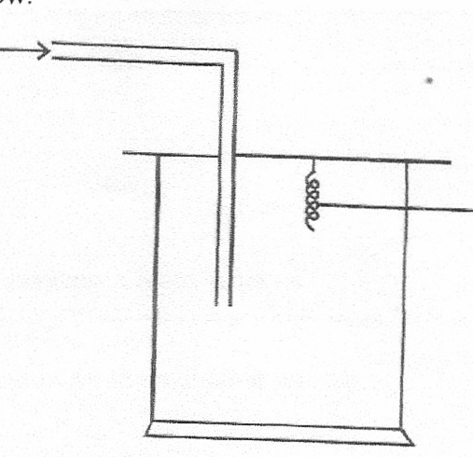
Dry NH_{3(g)}

Hot platinum wire

(i) Write an equation for the reaction that takes place in the gas jar (1mk)
……………………………………………………………………………………………………..
……………………………………………………………………………………………………..
(ii) What is the role of hot platinum wire? (1mk)
……………………………………………………………………………………………………..
……………………………………………………………………………………………………..
(iii) Write the formula of the complex ion formed when excess ammonia gas is passed
through a solution containing Zn²⁺ ions. (1mk)
……………………………………………………………………………………………………..
……………………………………………………………………………………………………..
14. A solution of silver nitrate was put in a container made of metal Q for 1 day. Given that:
Q²⁺_{(aq)+}2e- Q_{(s)} :E^{θ}=0.130v
Ag⁺_{(aq)}+e Ag_{(s)} :E^{θ}=+0.80v
Determine whether or not a reaction occurred between silver nitrate and metal Q (2mks)
……………………………………………………………………………………………………..
……………………………………………………………………………………………………..
15. The table below shows the solubility of salt at various temperatures

Temperature | Solubility g/100g of water
0 | 36
40 | 30
80 | 25
110 | 20
What would happen if a sample of a saturated solution of the salt 40ºC is heated to 80ºC?
Explain (2mks)
……………………………………………………………………………………………………..
……………………………………………………………………………………………………..
16. The equation given below represents a redox reaction
Mg_{(s)}+2HCl_{(aq)} MgCl_{2(aq)} +H_{2(g)}

(i) Write the equation of the reduction process (1mk)
……………………………………………………………………………………………………..
(ii) Which substances is oxidized? (1mk)
……………………………………………………………………………………………………..
……………………………………………………………………………………………………..
17. When a current of 1.5 amperes was passed through cell containing M²⁺ ions on metal M for 15 minutes the mass of the cathode increased by 0.26g. (1F=96500C)
(i) Calculate the quantity of electricity used (1mk)

(ii) Determined the relative atomic mass of metal M (2mks)

18. State any two differences between luminous and non-luminous flames (2mks)
……………………………………………………………………………………………………..
……………………………………………………………………………………………………..
………………………………………………………………………………………………………
……………………………………………………………………………………………………..
19. (a) State Graham’s law of diffusion (1mk)
……………………………………………………………………………………………………..
……………………………………………………………………………………………………..
(b) The molar masses of gas U and V are 16.0 and 44.0 respectively. If the rate of diffusion of
U through the porous materials is 12cm³⁻¹ . Calculate the rate of diffusion of V through the
same materials (2mks)

20. The set up below was used to collect a dry sample of a gas

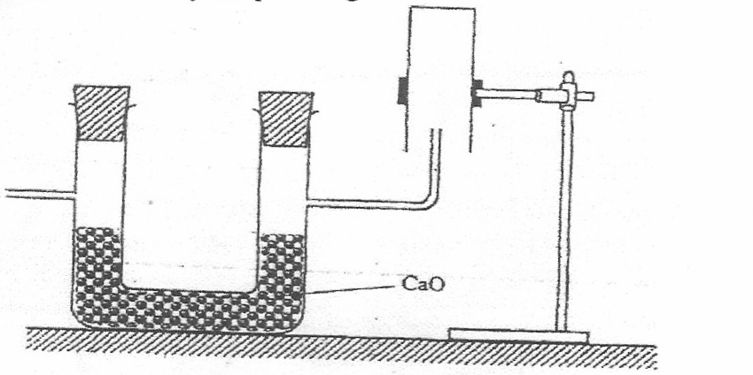

CaO

Give two reasons why the set-up cannot be used to collect carbon (IV) oxide gas (2mks)
……………………………………………………………………………………………………..
……………………………………………………………………………………………………..
21. Dilute sulphuric (VI) acid does not react fully with calcium carbonate while dilute hydrochloric acid reacts fully with calcium carbonate liberating carbon (IV) oxide. Explain (2mks)
……………………………………………………………………………………………………..
……………………………………………………………………………………………………..
22. On complete combustion of 0.5g of a hydro carbon; 1.257g of carbon (IV) oxide and 0.514g of water were produced. If the relative molecular mass of the hydrocarbon is 84, determine the molecular formula (C=12,H=1,O=16) (3mks)

21. The conversion of SO₂ to SO₃ in the contact process is shown by the equation
2SO_{2(g)} + O_{2(g)} 2SO_{3(g)} ΔH=⁻197KJ
(a) What would be the effect of?
(i) Increasing the concentration of Oxygen (1mk)
……………………………………………………………………………………………………..
……………………………………………………………………………………………………..
(ii) Increasing the temperature (1mk)
……………………………………………………………………………………………………..
……………………………………………………………………………………………………..
(b) Write an equation for the sulphuric (VI) acid from Oleum (1mk)
……………………………………………………………………………………………………..
……………………………………………………………………………………………………..
24. Sulphur burns in air to form sulpur (IV) oxide. A simple energy level energy level diagram for the reaction is given below. Study the diagram and answer the questions that follow:
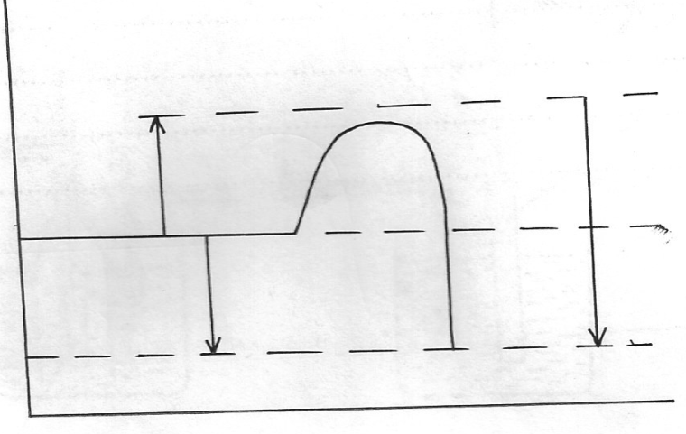

SO_{2(g)}
ΔH₂
ΔH₃
ΔH₁
S_{(g)} + O_{2(g)}
Reaction co-ordinate
Energy

(a) What do the following represents?ΔH₁ and ΔH₃ (2mks)
……………………………………………………………………………………………………..
……………………………………………………………………………………………………..
(b) Write an expression for ΔH₃in terms of ΔH₁and ΔH₂ (1mk)
……………………………………………………………………………………………………..
……………………………………………………………………………………………………..
25. Given the reaction below
Zn_{(s)} +2HCl_{(aq)} ZnCl_{2(aq)} +H_{2(g)}
State how the following factors affect the rate of reaction giving explanation (1mk)
……………………………………………………………………………………………………..
……………………………………………………………………………………………………..
(a) Using Zinc powder instead of granules (1mk)
……………………………………………………………………………………………………..
……………………………………………………………………………………………………..
(b) Heating the reactants (1mk)
……………………………………………………………………………………………………..
……………………………………………………………………………………………………..
26. The flow chart below shows steps used in the extraction of zinc from one of its ores
Zinc carbonate
Powder Zinc Carbonate ore
Concentrated Zinc Carbonate ore
Zinc oxide
Zinc metal
Crushing
Step 1
Step 2
Step 3
Heat
Gas
Step 4
Coke

(a) Name the process that is used in step 2 to concentrated concentrated zinc carbonate ore. (1mk)
……………………………………………………………………………………………………..
……………………………………………………………………………………………………..
(b) Write an equation for the reaction which takes place in step 3 (1mk)
……………………………………………………………………………………………………..
……………………………………………………………………………………………………..
(c) Name one use of zinc other than galvanizing (1mk)
……………………………………………………………………………………………………..
……………………………………………………………………………………………………..
27. The set up below used to obtain a sample of iron
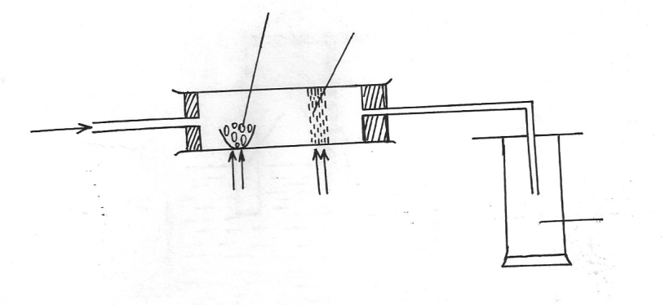
Excess Iron (III) oxide
Carbon
Heat
Heat
Gas
Oxygen

(a) Identify the gas collected ( ½ mk)
……………………………………………………………………………………………………..
(b) What observation is made on the excess iron (III) oxide? ( ½ mk)
……………………………………………………………………………………………………..
……………………………………………………………………………………………………..
(c) Write equations for the two reactions that take place in the combustion tube (2mks)
……………………………………………………………………………………………………..
……………………………………………………………………………………………………..
28. The table below shows PH values of some solutions

Solution | A | B | C | D
PH values | 13 | 7 | 1 | 6.5
(a) What solution reacts vigorously with Magnesium metal? (1mk)
……………………………………………………………………………………………………..
……………………………………………………………………………………………………..
(b) Which solution is likely to be that of Lemon juice? (1mk)
……………………………………………………………………………………………………..
……………………………………………………………………………………………………..
(c) Which solution forms complex ions with zinc (II) oxide? (1mk)
……………………………………………………………………………………………………..
……………………………………………………………………………………………………..
29. When a few drops of aqueous ammonia were added to Copper (II) Nitrate solution a light blue precipitate was formed. On addition of more aqueous ammonia a deep blue solution was formed. Identify the substances responsible for the:
(a) Light blue precipitate (1mk)
……………………………………………………………………………………………………..
……………………………………………………………………………………………………..
(b) Deep blue solution (1mk)
……………………………………………………………………………………………………..
……………………………………………………………………………………………………..
30. Explain why there is general increase in the first ionization energies of the elements in period 3 of the periodic table from left to right (2mks)
……………………………………………………………………………………………………..
……………………………………………………………………………………………………..
……………………………………………………………………………………………………..

