NAME.......................................................................................ADM NO..........
DATE............................. SIGN.............................................
233/2
Chemistry paper 2
2 HRS
July/August 2019.

Kenya Certificate of Secondary Education 2019

233/2
Chemistry Paper 2
TIME: 2 HRS
July/August 2019.

INSTRUCTIONS TO CANDIDATES
- Write your name and index number in the spaces provided at the top of this page.
- Answer all the questions in the spaces provided.

1. a) In which homologous series do the following compounds belong
i) CH₃CCH (1mk)

ii) CH₃CH₂COOH (1mk)

b) Raw rubber is heated with sulphur in the manufacture of natural rubber.
i) What is the name given to the process? (1mk)

ii) Why is the process necessary? (1mk)

c) Study the scheme given below and answer the questions that follow.

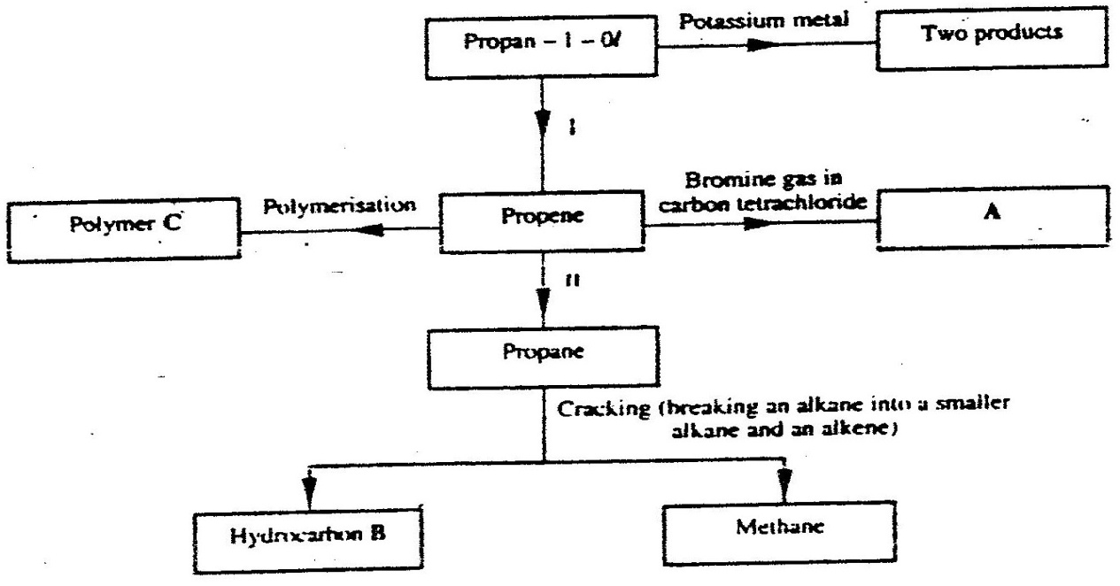

i) Write an equation for the reaction between propan – 1 –ol and potassium metal. (1mk)

ii) Name processes I and II (2mks)
I

II

iii) Identify the products A and B (2mks)
A

B

iv) Name one catalyst used in process II (1mk)

v) Draw the structural formula of the repeating unit in the polymer C. (1mk)

vi) State two industrial uses of methane. (2mk)

2. (a) The following diagrams show the structures of two allotropes of carbon. Study them and answer the questions that follow

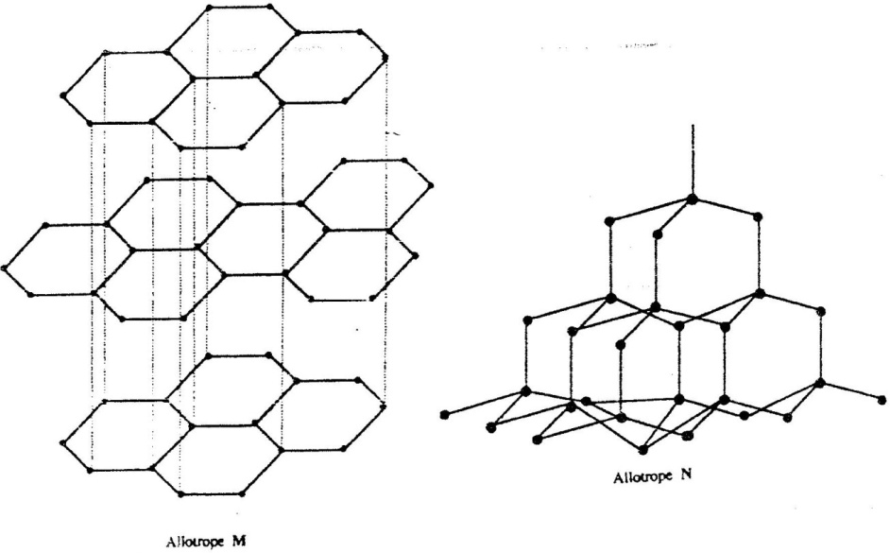

- What is meant by the term allotropy? (1mk)

ii) Name allotrope (2mk)
M

N

(iii) Give one use of N (1mk)

(iv) Which allotrope conducts electricity? Explain (2mk)

(b) In an experiment, carbon (IV) oxide gas was passed over heated charcoal and the gas produced collected as shown in the diagram below

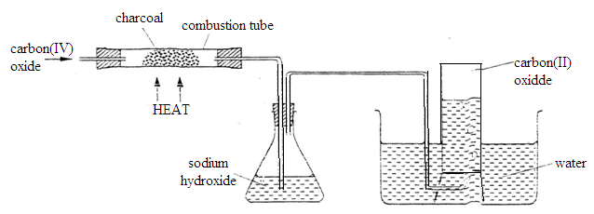

(i) Write an equation for the reaction that took place in the combustion tube (1mk)

(ii) Name another substance that can be used instead of sodium hydroxide ((1mk)

(iii) Describe a simple chemical test that can be used to distinguish between carbon (IV) oxide and carbon (II) oxide (3mk)

(iv) Give one use of carbon (II) oxide (1mk)

3. a) Fraction distillation of liquid air usually produces nitrogen and oxygen as the major products.
- Name one substance that is used to remove carbon (IV) oxide from the air before it is changed into liquid. (1mk)

ii) Describe how nitrogen gas is obtained from the liquid air. (2mk)
(Boiling points nitrogen = - 196ºC, oxygen = -183ºC)

(b)Study the flow chart below and answer the questions that follow.
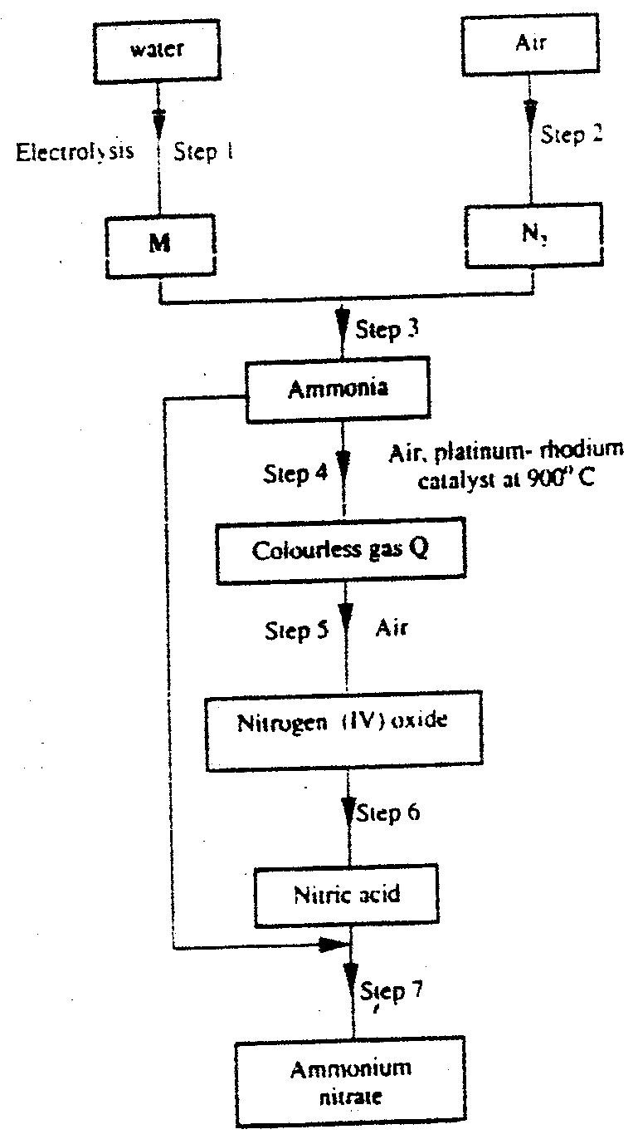

i) Name element M. (1mk)

ii) Why is it necessary to use excess air in step 4? (1mk)

iii) Identify gas Q. (1mk)

iv) Write an equation for the reaction in step 7. (1mk)

v) Give one use of ammonia nitrate. (1mk)

c) State and explain the observations that would be made if a sample of
sulphur is heated with concentrated nitric acid. (2mks)

4. (a) An atom Q can be represented as ⁵²Q .
₂₄

What does the number 52 represent? (1mk)

(b) Study the information in the table below and answer the equations that follow. (Letters are not the actual symbols of the elements)

Element | Electronic arrangement of stable ion | Atomic  Radius  (nm) | Ionic  Radius  (nm)
N | 2.8.8 | 0.197 | 0.099
P | 2.8.8 | 0.099 | 0.181
R | 2.8 | 0.160 | 0.065
S | 2.8 | 0.186 | 0.095
T | 2 | 0.152 | 0.068
U | 2.8 | 0.072 | 0.136

(i) Write the formula of the compound formed when N reacts with P.
(Atomic numbers are N = 20; P = 17) (1mk)

(ii) Identify the elements which belong to the third period of the periodic table. Explain (2mks)

(iii) Which of the element identified in b (ii) above comes last in the third period? Explain (2mks)

(iv) Select two elements which are non- metals (1mk)

(c) The table below gives some properties of substances I, II, III, and IV. Study it and answer the questions that follow

Substance | Electrical conductivity |  | M.P (⁰C) | B.P (⁰C)
 | Solid | Molten
I | Does not conduct | Conducts | 801 | 1420
II | Conducts | Conducts | 650 | 1107
III | Does not conduct | Does not conduct | 1700 | 2200
IV | Does not conduct | Does not conduct | 113 | 440

(i) What type of bonding exists in substances I and II (1mk)
I

II

(ii) Which substances is likely to be sulphur? Explain (2mks)

5. (a) Below is a simplified diagram of the Downs Cell used for the manufacture of sodium. Study it and answer the questions that follow

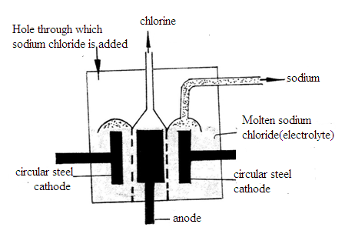

(i) What material is the anode made of? Give a reason (2mks)

- What precaution is taken to prevent chlorine and sodium from re- combination? ( 1mks)

(iii) Write an ionic equation for the reaction in which chlorine gas is formed (1mk)

(b) In the Downs process, (used for manufacture of sodium), a certain salt is added to lower the melting point of sodium chloride from about 800⁰C to about 600⁰C.
(i) Name the salt that is added (1mk)

(ii) State why it is necessary to lower the temperature (1mk)

(c) Explain why aqueous sodium chloride is not suitable as an electrolyte for the manufacture of sodium in the Downs process (2mk)

(d) Sodium metal reacts with air to form two oxides. Give the formulae of two oxides (1mk)

(e) State two uses of sodium (2mk)

6. (a) A student was supplied with a colourless liquid suspected to be water.
(i) Describe one chemical test that could have been used to show that the liquid was water (2mk)

- How could it have been shown that the liquid was pure water? (1mk)

(b) The flow chart below shows the various stages of water treatment. Study it and answer the questions that follow

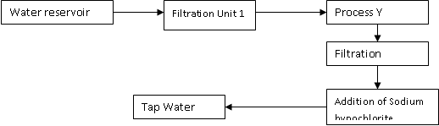

(i) Which substances are likely to be removed in filtration unit I? (1mk)

(ii) What is the purpose?
- Process Y (1mk)

II Addition of sodium hypochlorite (1mk)

(c) It was confirmed that magnesium sulphate was present in the tap water
(i) What type of hardness was present in the water? (1mk)

(ii) Explain one method that can be used to remove the water hardness. (2mks)

d. The set-up below was used to collect gas F, produced by the reaction between water and calcium metal.
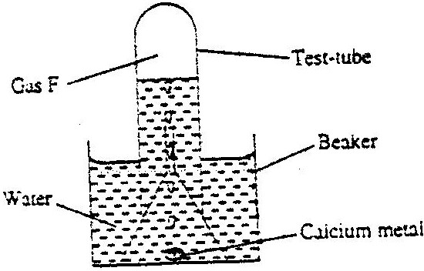

(i) Name gas F (1mk)

(ii) At the end of the experiment, the solution in the beaker was found to be a weak base. Explain why the solution is a weak base. (2 marks)

(iii) Give one laboratory use of the solution formed in a beaker. (1 mark)

(e) The scheme below shows some reactions starting with calcium oxide. Study it and answer the questions that follow.
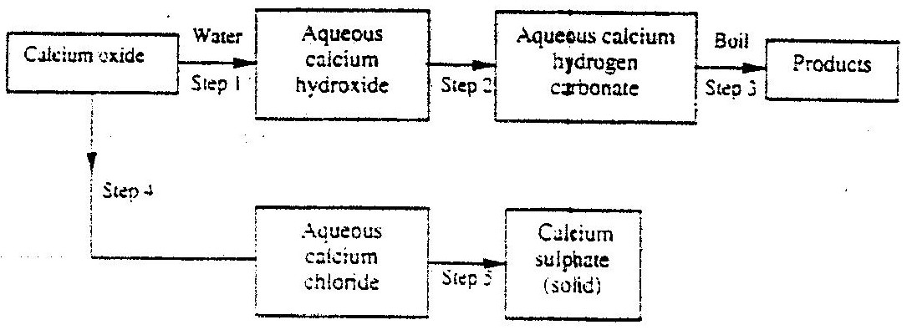

- Name the reagents used in steps 2 and 4 (1mk)
Step 2

Step 4

- Write an equation for the reaction in step 3. (1mk)

7. a) State two differences between chemical and nuclear reactions (2mks)

(b) The table below gives the percentages of a radioactive isotope of Bismuth that remains after decaying at different times.

Time (min) | 0 | 6 | 12 | 22 | 38 | 62 | 100
Percentage of Bismuth | 100 | 81 | 65 | 46 | 29 | 12 | 3

i) On the grid provided, plot a graph of the percentage of Bismuth remaining
(Vertical axis) against time. (3mks)

ii) Using the graph, determine the:
- Half – life of the Bismuth isotope (1mk)

II. Original mass of the Bismuth isotope given that the mass that remained
after 70 minutes was 0.16g (2mks)

c) Give one use of radioactive isotopes in medicine (1mk)

