SCHOOL BASED EXAMINATION 2019
CHEMISTRY 233/1
MARKING SCHEME
JULY/AUGUST 2019

- a) Exothermic reaction - heat energy is given out (lost) to the surrounding.
Endothermic reaction - heat energy is absorbed from the surrounding.

b) Heat change = Heat required + Heat given out
to break bonds during bond formation

CH _{4(g)} + 2O _{2(g)} CO _{2(g)} + 2H₂O_{(l)}

Heat required to break bonds = 4 x 413 = 652
= 2 x 497 = 994
2646 ¹/₂

Heat given out = -804 x 2 = -1608
= -464 x 5 = -1856
-3464 ¹/₂

Heat change = 2646 + - 3464 ¹/₂
= -818 kJ/mol ¹/₂

- Test I ¹/₂ and II ¹/₂
- Dilute sulphuric (VI) acid is not an oxidizing agent 1 hence cannot oxidize carbon to carbon (IV) oxide. 1
- Iron is above hydrogen in the reactivity series hence it displaces hydrogen. 1

- – Add excess lead (II) oxide to dilute Nitric (V) acid. Filter the mixture.
- Add sodium carbonate /potassium carbonate/ammonium carbonate to the filtrate.
- to precipitate lead (II) carbonate. Filter the residue and wash it with distilled water. Dry between filter paper.

- a) Zinc sulphide / Iron (II) sulphide
b) FeS_{(s)} + 2 HCl _{(aq)} FeCl _{2(aq)} + H₂S _{(g)}
c) Has a smell of rotten eggs. Colourless gas.

- KOH = 39 + 1 + 16 = 56 ¹/₂
Concentration of KOH = 7 = 0.125 moles/dm³ ¹/₂
56
2KOH_{(aq)} + H₂X _{(aq)} K₂X _{(aq)} + 2H₂O_{(l)}
2 : 1
Moles of H₂X = 0.125 = 0.0625 Moles /dm³ ¹/₂
2
RFM of the acid = 0.18 ¹/₂
0.0625
= 288 ¹/₂ (3 marks)
- a) G and K
b) HL₂
c) F

- Yellow colour intensifies 1
Addition of NaOH increases the concentration ion of hydroxide ¹/₂ in the system therefore equilibrium shifts to the right. ¹/₂

- O = 16 x 2 = 32
- a)
H H H
H C C C OH
H H H
b) i) dehydration
ii) Propane
c) 70

- Mass of oxygen = 2.75 – 195
= 0.8 ¹/₂
K O
1.95 0.8
39 16 ¹/₂

0.05 0.05
0.05 0.05 ¹/₂
1 1

(KO)_{n} = 110
(39 + 16) n = 11
55n = 110 2
55 55
n = 2 ¹/₂ M.F. = (KO)₂
= K₂O₂ ¹/₂

- a) Period 3 – Has 3 occupied energy levels.
b) R has more number of protons/nuclear charge than Q. Hence electrons of R are more strongly attracted.

Hydrogen gas
from generator
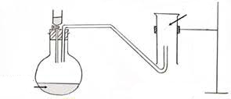

1
1
Workability – 10mk
Dry hydrogen gas
Conc. H₂SO₄ acid

- i) Heat evolved = 400 x 4.2 x 9 ¹/₂
= 15120J or 15.12kJ ¹/₂

ii) Mass of methanol burnt = 125 – 124.5
RFM of methanol = 32 ^{½} = 0.5g ¹/₂
0.5g of methanol = 15.12kJ
32g of methanol = 15.12 x 32 ¹/₂
0.5
= -967.68kJ/mole ¹/₂

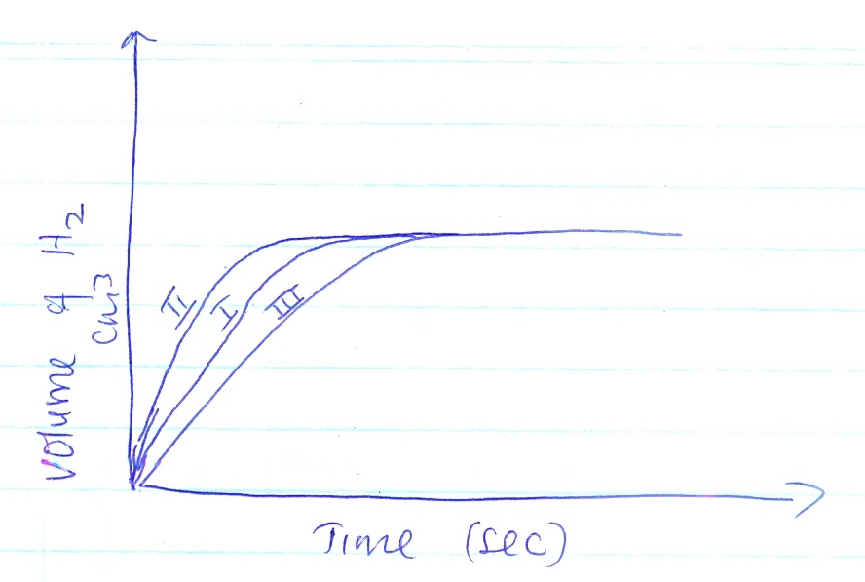

- The solid dissolved to form a solution. (1mk)
This is because calcium chloride formed is deliquescent. 1
- i) Cation – Zinc /Zn ²⁺
Anion – Chloride / Cl⁻
b) Ag ⁺ _{(aq)} + Cl ⁻ _{(aq)} AgCl_{(s)}
t ¹/₂
5600yrs
t ¹/₂
5600yrs
t ¹/₂
5600yrs
- 1 ¹/₂ ¹/₄ ¹/₈

Age of the wood = 3 x 5600
= 16800 yrs

- a) Sodium nitrate or Potassium nitrate
b) H₂SO_{4(aq)} + NaNO _{3 (s)} NaHSO _{4 (aq)} + HNO _{3(g)}
c) To prevent it from decomposing

- a) Temporary
b) Temporary
c) Permanent

20. a) U – NaHCO₃ or KHCO₃
V – Na₂CO₃ or K₂CO₃
b) Na₂CO _{3(s)} + 2HCl _{(aq)} 2 NaCl _{(aq)} + H₂O _{(l)} + CO _{2(g)}
or
K₂CO _{3(s)} + 2HCl_{(aq)} 2KCl_{(aq)} + CO _{2(g)} + H₂O _{(l)}

21. a) Copper (II) Sulphate
b) 36 – 27 = 9g
c) Fractional Crystallization

22. i) L_{(s)} L ²⁺ _{(aq)} + 2e⁻
ii) Q ²⁺ _{(aq)} + 2e⁻ Q(s)
b) E = +0.34 - - 0.13
= 0.47v
23. i) t
ii) P
24. a) RFM of BaSO₄ = 56 + 32 + 64
= 152
Moles of BaSO₄ = 4.66 = 0.031 moles
152

BaSO₄ Ba ²⁺ + SO₄ ⁻²
Mole 1 : 1 : 1 ∴ Moles of SO₄ ²⁻ = 0.31

b) 152 → 4.66g N₂SO₄ = 174
? → 5.34g SO₄ = 96
RFM of N₂SO₄ = 152 x 5.34 = 174 2N + 96 = 174
4.66 2N = 174 – 96
2N = 78 39
2 2
N = 39

25. i) Propanoic acid
- Methanol
ii) Esters
iii) 2CO₃OH + 2K 2CH₃OK + H₂
26. a) Because concentration of ions is high 1 at the beginning and decreases as the ions are discharged
during electrolysis 1 (2mks)

b) CU ²⁺ _{(aq)} + 2e Cu_{(s)} 1

27. T = (18 x 60) + 5
= 1085 seconds
Q = 0.5 x 1085
= 542.5 C
0.22g of Z = 542.5 C
44g of Z = 542.5 x 44
0.22
= 108500C

Charge = 108500 = 1.12
Or 96500
No. of Faradays
+1
Or
Charge = 0.5 x 1085 x 44
0.22 x 96500
= + 1
28. a) Sublimation
b) Oxidation
c) Dehydration

