SCHOOL BASED EXAMINATION 2019
CHEMISTRY 233/2
MARKING SCHEME
JULY/AUGUST 2019

- a) Q 1 – has the highest number of occupied energy levels. 1 (2mks)

b) Q – has the largest atomic radius thus valency electron loosely held. (2mks)
c) Alkali metals 1 (1mk)
d) S has large atomic radius than U because U 1 has high nuclear charge/More protons
than S 1 (2mks)
e) V/W ¹/₂ is stable ¹/₂ (1mk)
f) Q⁺¹ (1mk)
g)

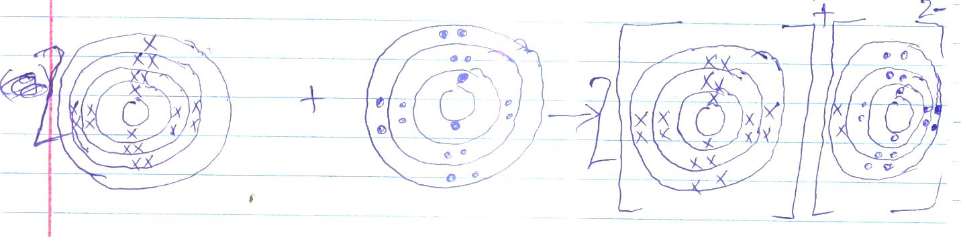
2
2

(2mk)
- a) i) III – Polymerisation 1
IV – Fermentation 1
ii) I – Hydrogen gas ¹/₂
}
Nickel/Platinum Both conditions to be stated
¹/₂
Temperature 150-250⁰C - Accept any temperature between
150-250⁰C
II – Concentrated Sulphuric acid ¹/₂
Temperature 180⁰C ¹/₂

b) CH₃CH₂OH + CH₃CH₂COO H CH₃CH₂COO CH₂CH₃ + H₂O 1 - Ignore state symbols
c) N – Sodium Propanoxide 1
M – Hydrogen 1
d) – Using KMnO₄/H⁺ 1 - C₃H₆ decolourises Accept burning a sample of each
while C₃H₈ does not 1
or – using Br₂/H₂O – C₃H₆ decolourises
while C₃H₈ does not
or Burn each C₃H₈ burns with a blue flame
while C₃H₆ burns with a yellow flame

e) i) (CH₃CH-CH₂ )_{n} = 42000 1
42n = 42000
n = ⁴²⁰⁰⁰/₄₂ 1 = 100
f) ii) Causes environmental pollution 1
Since it is non-biodegradable
Total 12 marks
3. a) i) Zn_{(s)} + H₂SO _{4(aq)} ZnSO _{4(aq)} + H _{2(g)} 1 - Penalise ¹/₂ mk for wrong
Missing/incorrect symbol
ii) This is causes by the escaping hydrogen gas 1

b)
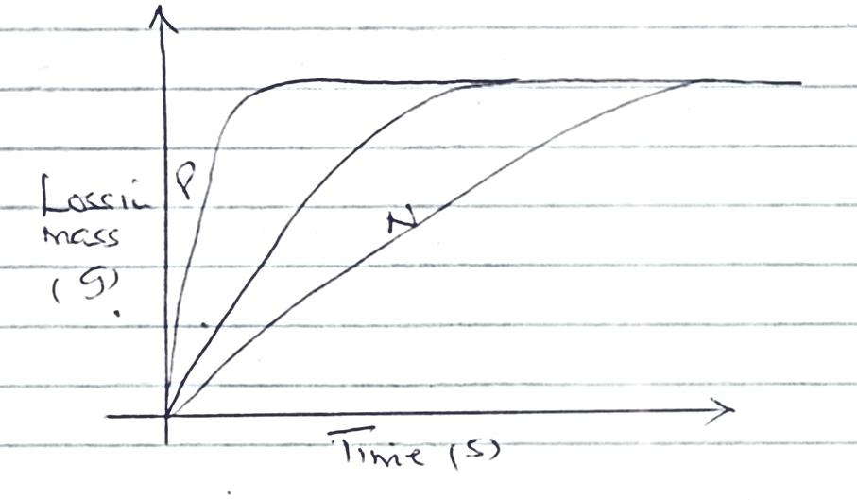
The curves should level similarly

c) i) Dynamic equilibrium – A reaction 1 where the rate of the Reject forward reaction is equal
forward reaction is equal to the rate of the backward reaction to the backward reaction

ii) Decrease in pressure causes, equilibrium to shift to the left 1 as
this favours the direction that results to increased 1 volume // Accept alternative words
increased number of moles of gases. Implying suggested response

II – Decrease in temperature causes the equilibrium to shift to ,,
the right 1 as this favours the direction that results in
production of heat. 1

d) Aqueous NaOH reacts with the H⁺ ions lowering their concentration ,,
hence yellow colour becomes dorminant as equilibrium shifts to the left.

4. a) i) C ¹/₂ : because it E^{θ} ¹/₂ is 0.00 (1mk)
ii) E ¹/₂ – has the highest positive standard electrode potential. ¹/₂ (1mk)
b) i) K and E 1 (1mk)

ii)
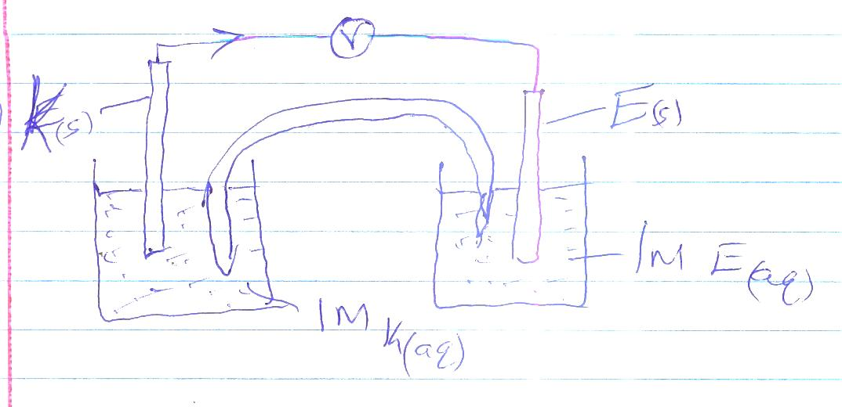 (3 mks)
c) E.M.F. = E_{red} – E_{ox}
= -292 - ⁻0.44 ¹/₂ = -2.48 ¹/₂
Overall e.m.f is negative, ¹/₂ the rection does not take place. ¹/₂ (2mks)

d) i) H – Anode ¹/₂
J – Cathode ¹/₂ (1mk)

ii) A burning splint is introduced in the mouth of a test tube containing gas F. It extinguishes with a pop sound,
iii) 4OH⁻ _{(aq)} 2H₂O + O ₂ + 4e 1
= 4 x 96500 = 386000C ¹/₂
5 x 201 = 1005C ¹/₂
386000 – 24000
1005 + 24000 x 10005 ^{½} = 62.49cm³ ¹/₂
386000

5. a) i) Zinc blende / Zinc Sulphide 1
II
ii) Q – Sulphur (IV) oxide / SO₂ 1

iii) I R – Calcium oxide and carbon 1
S – Zinc oxide 1
P – Coke / Carbon 1
b) ZnO_{(s)} + C_{(s)} Zn_{(s)} + CO_{(g)} 1

ZnO_{(s)} + CO_{(g)} Zn_{(s)} + CO₂ _{(g)} 1

c) To provide CaO ¹/₂ that remove impurities ¹/₂ and CO₂ which is reduced by C to
produce CO ¹/₂ which is used in the reduction. ¹/₂

d) To galvanise iron 1
To make brass 1
Making outer casing in dry batteries

e) Contact Process 1 // Manufacture of Sulphuric (VI) acid
Total 12 marks

6. a)
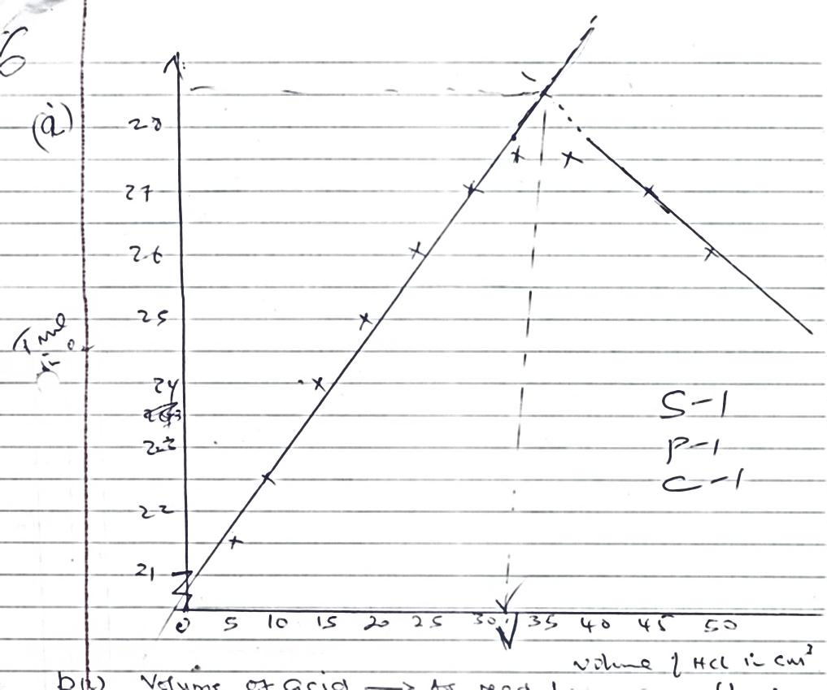
Temp (⁰0C)

b) i) Volume of acid As read from graph. (1mk)
ii) Write balance equation
NaOH + HCl NaCl + H₂O 1
Moles of NaOH = 50 x 1 = 0.005 ¹/₂
1000
Moles of HCl = 0.005 moles mole ratio 1 : 1 (2mks)
Value of the graph x 1000 = Ans ¹/₂
0.005
1
iii) Volume of the acid + 50m³ of NaOH x 4.2 x ΔT (value from the graph) = Ans 1
1000

Then continue consequentially. 1

7. a) i) X – hydrogen / Nitrogen ¹/₂ State correct source ¹/₂ (2mks)
Y – hydrogen / Nitrogen ¹/₂ State correct source ¹/₂

b) N _{2(g)} + 3H _{2(g)} 2 NH _{3(g)} 1 (1mk)

c) F – Ammonium Sulphate
A – Copper ¹/₂ each
B – Nitrogen
E – Water (2mks)

d) 2NH _{3(aq)} + H₂SO _{4(aq)} (NH₄)₂SO _{4 (aq)} 1

e) i) Redox 1
ii) I – CuO 1 / Copper (II) oxide
II – Nitrogen /NH₃ 1 /ammonia
f) Used as a fertilizer 1
Total 10 mks

