Name: ……………………………………………………… Index No: …………….….…….Class ..…..……
School: …………………………………………………….. Candidate’s Signature………….………………
Date: ……………….…………………………..
233/2
Paper 2 (Theory)
July/August 2019
Time: 2 Hours

SCHOOL BASED FORM 4 EXMINATION 2019

Kenya Certificate of Secondary Education (K.C.S.E.)

CHEMISTRY
PAPER 2 (THEORY)
2 HOURS

Instructions to candidates:
• Write your Name and Index number and School in the spaces provided above.
• Sign and write the date of examination in the spaces provided above.
• Answer ALL the questions in the spaces provided in the question paper.
• Mathematical tables and silent Scientific electronic calculators may be used.
• All workings MUST be clearly shown where necessary.

FOR EXAMINER’S USE ONLY
QUESTIONS | MAXIMUM  SCORE | CANDIDATE’S  SCORE
1 | 11
2 | 12
3 | 12
4 | 13
5 | 12
6 | 10
7 | 10
Total Score | 80

- The grid below shows part of the periodic table. Use it to answer the questions that follow.

 |  |  |  |  |  |  | S | U | V
P | R |  |  | X |  |  | T |  | W
Q

- Which of the elements has the largest atomic radius? (2 marks)
____________________________________________________________________________________________________________________________________________________________
- Identify the most reactive metal.
Explain. ( 2 mark)
____________________________________________________________________________________________________________________________________________________________
- Name the chemical family to which P and Q belong (1 mark)
______________________________________________________________________________
- Compare the atomic radius of S and U.
Explain (2 marks)
____________________________________________________________________________________________________________________________________________________________
- Select an element that does not form ion.
Explain (1 mark)
____________________________________________________________________________________________________________________________________________________________
- Give the formula of one stable cation with an electron arrangement of 2.8.8. (1 mark)
______________________________________________________________________________
- Draw the dot ( ) and cross ( X ) diagram to show bonding between Q and T. (2 marks)

- Study the flow chart below and answer questions that follow.

C₃H₈

Step 1
Step III CH₃
CH₃CH = CH₂ CH– CH₂

Step II

Step V
Step VII/ Na_{(s)}
Propanoic acid CH₃CH₂CH₂OH Liquid N
and gas M

Step VI Step IV
Ethanol conc
Sulphuric acid
Warm

Substance L Sugars

- i) Name the type of reaction in step marked III and IV. (2 marks)
____________________________________________________________________________________________________________________________________________________________
ii) Name the important reagents and conditions in steps marked I and II.
Step I _____________________________________________________________ (1 mark)
Step II ____________________________________________________________ (1 mark)
- Write balanced equation for the reaction taking place in step (VI). (1 mark)
_____________________________________________________________________________
- Identify liquid N and gas M. (2 marks)
______________________________________________________________________________
______________________________________________________________________________
- Describe a chemical test that can be used to distinguish between C₃H₈ and C₃H₆. (2 marks)
______________________________________________________________________________
______________________________________________________________________________
- i) If the relative molecular mass of the compound formed in step III is 42000, determine the value
of n in the compound. (C = 12, O = 16, H = 1) (2 marks)

ii) State one disadvantage of the continued use of items made from the compound formed in
e(i) above. (1 mark)
___________________________________________________________________________
- a) The sketch below represents a graph obtained when zinc granules were reacted with excess
0.2M sulphuric acid in the presence of a catalyst in a conical flask placed on an electronic
balance.
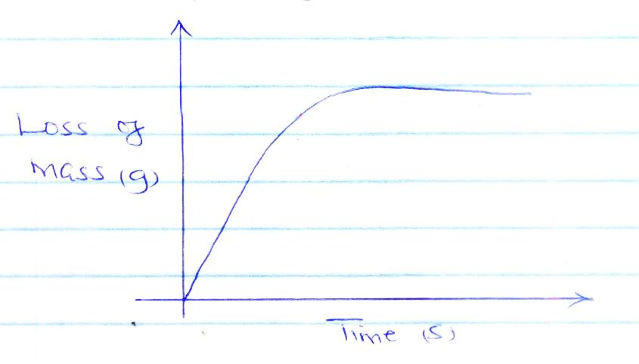
Write an equation for the reaction that took place. (1 mark)
___________________________________________________________________________
___________________________________________________________________________

ii) Explain why there is loss in mass. (1 mark)
___________________________________________________________________________
___________________________________________________________________________
b) Sketch on the same axes, the curve obtained when:
I: Same mass of zinc powder was used under the same conditions. Label it P. (1 mark)
II: No catalyst was used. Label it N. (1 mark)
c) In the contact process, sulphur (IV) oxide is converted to sulphur (VI) oxide in the catalytic chamber in which a dynamic equilibrium is reached.

2SO _{2(g)} + O _{2(g)} 2SO _{3(g)} ; ΔH = -97 kJ/Mol.

i) What is meant by dynamic equilibrium? (2 marks)
__________________________________________________________________________
__________________________________________________________________________
ii) State and explain how each of the following would affect the position of the equilibrium.
- Decrease in pressure (2 marks)
__________________________________________________________________
__________________________________________________________________
__________________________________________________________________

- Decrease in temperature (2 marks)
__________________________________________________________________
__________________________________________________________________
__________________________________________________________________

d) An equilibrium exists between chromate and dichromate ions as shown below.

2CrO₄ ²⁻ _{(aq)} + 2H⁺ _{(aq)} Cr₂O₇ ²⁻ _{(aq)} + H₂O _{(l)}
(Yellow) (Orange)
State and explain the observation made when aqueous sodium hydroxide is added to the above mixture. (2 marks)
__________________________________________________________________________
__________________________________________________________________________
- a) Study the standard electrode potentials for the half cells given below and answer the
questions that follow.
K⁺ _{(aq)} + e K _{(s)} -2.92
L⁺ _{(aq)} + e L _{(s)} +0.52
C⁺ _{(aq)} + e C₂ _{(g)} 0.00
D⁺ _{(aq)} + e D _{(s)} -0.44
E⁺ ₂ _{(aq)} + e E _{(aq)} + 1.36
i) Which element is likely to be hydrogen? Explain. (1 mark)
________________________________________________________________________
________________________________________________________________________
ii) Identify the strongest oxidizing agent. Explain. (1 mark)
________________________________________________________________________
________________________________________________________________________
b) i) Which two half cells would produce the highest potential difference when combined?
(1 mark)
________________________________________________________________________
________________________________________________________________________
ii) Draw the electrochemical cell of b(i) above.

c) Explain whether reaction represented by the equation below can take place. (2 marks)

2A⁺ _{(aq)} + D _{(s)} 2A_{(s)} + D ²⁺ _{(aq)}
___________________________________________________________________________ ___________________________________________________________________________ ___________________________________________________________________________

d) 90cm³ of acidified water was electrolyzed using the set up below.
Gas F
Gas G

H
J

i) Identify electrodes H and J. (1 mark)
H - _______________________________________________________________________
J - ________________________________________________________________________
ii) Describe how gas F can be identified. (2 marks)
___________________________________________________________________________ ___________________________________________________________________________ ___________________________________________________________________________
iii) In the above experiment 5A of electricity was passed through the acidified water for 3 minutes 21 seconds. Calculate the volume of gas G produced at room temperature and pressure. (Molar gas at r.t.p = 24000cm³, 1F = 96500c ) (3 marks)

- The flow chart below shows the extraction of zinc ore. Study it and answer the questions that follow.
Gas Q Solid P

ZnS Roaster Roaster CaCO₃
S R

Oxygen

Slag Reduction
Chamber

Molten zinc
- i) Give the common names of the ore. (1 mark)
- ZnS - ________________________________________________________________
(ii) Name the gas (2 marks)
Q - __________________________________________________________________
(iii) Name the solids
- R - ____________________________________________________________
- S - ____________________________________________________________
- P - ____________________________________________________________
- Write the chemical equation for the reaction that produces zinc metal. (1 mark)
___________________________________________________________________________
___________________________________________________________________________
- What is the purpose of adding Calcium carbonate in the reaction chamber? (1 mark)
______________________________________________________________________________________________________________________________________________________
- Give two uses of zinc metal. (2 marks)
______________________________________________________________________________________________________________________________________________________
- Name one other industries that can be established alongside the zinc extraction plant.
(2 marks)

- In an experiment, 50cm³ of 1.0M sodium hydroxide solution was placed in a suitable apparatus and 5.0cm³ portions of hydrochloric acid were added. The resulting mixture was stirred with a thermometer and the temperature recorded after each addition.

Volume of HCl (cm³) | 5 | 10 | 15 | 20 | 25 | 30 | 35 | 40 | 45 | 50
Temperature (⁰C) | 21.5 | 22.5 | 24.0 | 25.0 | 26.0 | 27.0 | 27.5 | 27.5 | 27 | 20

- Plot a graph of temperature against volume of the acid added. (3 marks)

- i) From the graph determine volume of HCl used to neutralize 50cm³ of 1M NaOH. (1 mark)
ii) Hence determine concentration of the HCl in moles per litre. (3 marks)

- i) Calculate the amount of heat produced in the reaction.
(Specific heat capacity = 4.2 kJKg⁻¹k⁻¹ and density of the solution 1g/cm³) (2 marks)

ii) Hence calculate the enthalpy of neutralization. (1 mark)

7. Study the scheme below and answer the questions that follow.

X Y

Step 1

Catalyst
CuO

Dilute H₂SO₄
Salt F Ammonia Solid A
Step 3
Gas B
Step 2 O₂/H₂O/Catalyst

Brown gas D
Heat
CU
Substance C Cu(NO₃)₂
Step 4

Colourless liquid E

- Identify X and Y. (2 marks)
i) X - ________________________________________________________________________
ii) Y - ________________________________________________________________________
- Write the reaction between X and Y. (1 mark)
______________________________________________________________________________
______________________________________________________________________________
- Name the following substances. (2 marks)
i) F - ________________________________________________________________________
ii) A - ________________________________________________________________________
iii) B - ________________________________________________________________________
iv) E - ________________________________________________________________________
- Write chemical equation for the formation of salt F. (1 mark)
______________________________________________________________________________
- Name the type of reaction that takes :-
i) Place between Ammonia and CuO (1 mark)

- In the reaction in e (i) above which of the species undergo
- Reduction (1 mark)
________________________________________________________________________
- Oxidation (1 mark)
________________________________________________________________________
- State one economic use of substance F. (1 mark)
______________________________________________________________________________

______________________________________________________________________________

