Name…………………………………… …………………………………..…Adm No:………

233/2 Candidate’s Signature …………..……………
CHEMISTRY Date: …………………………
PAPER2
THEORY
MARCH/APRIL, 2019
TIME: 2 HOURS

MOMALICHE JOINT EVALUATION TEST-2019

Kenya Certificate of Secondary Education (K.C.S.E.)
233/2
Chemistry
Paper 2
2 Hours

INSTRUCTIONS TO CANDIDATES

- Write your name and Index number in spaces provided above.
- Sign and write the date of examination in the spaces provided above
- Answer all the questions in the spaces provided above.
- KNEC Mathematical tables and silent electronic calculators may be used.
- All working must be clearly shown where necessary.
- Candidates should answer the questions in English.

For Examiners Use Only
Question | Maximum score | Candidate’s score
1 | 13
2 | 10
3 | 11
4 | 11
5 | 10
6 | 12
7 | 13
Total score | 80

This paper consists of 11printed pages. Candidates should check to ascertain that all pages are printed as indicated and that no questions are missing.

- a) The set up below was used to prepare hydrogen gas.
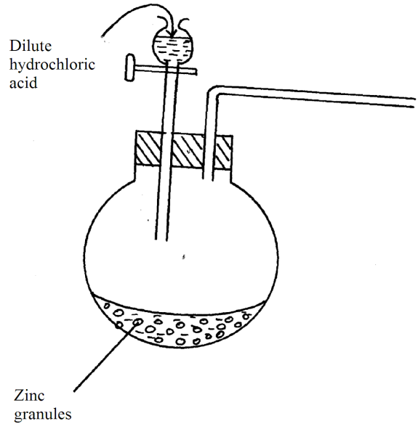
i) Complete the diagram to show how dry sample of hydrogen gas can be collected. (2mks)
ii) An oxide of hydrogen of mass 0.5g was found to contain 0.03g of hydrogen. Determine the molecular formula of the oxide. (Molecular mass of the oxide = 34, O = 16, H = 1) (3mks)

iii) Other than hardening of oils, state one other use of hydrogen. (1mk) ……………………………………………………………………………………………………………………………………………………………………………………………………………………
b) In an experiment to determine the proportion of oxygen in air, copper turnings were packed in excess along a combustion tube connected to two syringes of 120cm³ each in volume. Syringe R contained 120cm³ of air while syringe S was empty as shown.
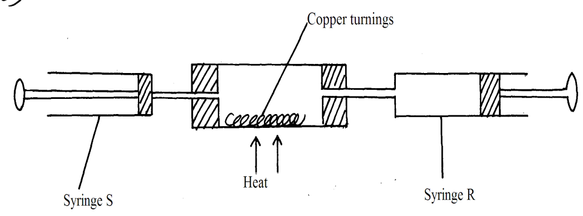

Air was passed over the heated turnings slowly and repeatedly until there was no further change in volume. 95.5cm³ of air remained in syringe R.
- Why was air passed over heated copper
- slowly (1mk)
……………………………………………………………………………………………………………………………………………………………………………………………………
II) repeatedly. (1mk) ……………………………………………………………………………………………………………………………………………………………………………………………………………………
ii) State one observation made in the combustion tube during the experiment. (1mk) ……………………………………………………………………………………………………………………………………………………………………………………………………....……………
iii) Determine the percentage of oxygen used during the experiment. (1mk)

c) Describe how a sample of sodium carbonate crystals can be obtained from a mixture containing ammonium chloride, sodium carbonate and calcium sulphate. (3mks) ……………………………………………………………………………………………………………………………………………………………………………………………………………………………………………………………………………………………………………………………………………………………………………………………………………………………………………………………………………………………………………………………………………………………………………………………………………………………………………………………………………………………………………………………………………………………………………………………………………………………………………………………………………………
2. Study the information below and answer the questions that follow:
Formula of the chloride | Nacl | MgCl₂ | AlCl₃ | SiCI₄ | PCI₃ | SCI₂
M.P(⁰C) | 801 | 714 | - | -70 | -91 | -80
Formula of the oxide | Na₂0 | MgO | A1₂0₃ | Si0₂ | P₄0₁₀ | SO₂ | Cl₂0₇
M.P(⁰C) | 1190 | 3080 | 2050 | 1730 | 560 | -73 | -90

(a) Aluminium chloride AlCl₃ has an unexpected bond type and structure.
(i) State the type of bond and the structure in AlCl₃.
Bond type..................................................................................................................................... (lmk)
Structure...................................................................................................................................... (lmk)
(ii) What type of bonding would AlCI₃ be expected to have and why? (lmk)
……………………………………………………………………………………………………………… ………………………………………………………………………………………………………………..
(iii) Why is the melting point of AlCI₃ not indicated in the table above? (1mk
…………………………………………………………………………………………………………
(b) A piece of blue litmus paper is placed in a solution of sodium chloride and a solution of aluminium chloride. Explain what would be observed in each case.
(i) Sodium chloride solution (lmk)
…………………………………………………………………………………………………………
(ii) Aluminium chloride solution (1mk)
…………………………………………………………………………………………………………
…………………………………………………………………………………………………………
(c) Explain the large difference in the melting point of the compound of formula MgO and P₄O₁₀…………………………………………………………………………………………………(2mks) ………………………………………………………………………………………………………………
…………………………………………………………………………………………………………………………………………………………………………………………………………………………………………………………………………………….………………………………………………………………
(d) Write down the equation for the reaction betweeneach of the compounds of formulaeNa₂O andSiCI₄ withwater. (2mks)
I)…………………….…………………………………………………………………………………………

II)……………………………………………………………………………………………………………..
3. The table below shows solubilities of of substances X and Y at different temperatures.
Temperature (⁰C) | 0 | 20 | 40 | 60 | 80 | 100
Solubility of X in g/100g of water | 10 | 15 | 26 | 40 | 63 | 100
Solubility of Y in g/100g of water | 30 | 34 | 37 | 40 | 44 | 48

- On the same axes,plot the graphs of solubilities of substances X and Y (y-axis ) against temperature (x-axis). (4mks

b) From the graph, state the temperature at which the solubility of X is 40g/100g of water. (1mk
…………………………………………………………………………………………………………………
c) A solution containing 30g of X in 50g of water is cooled from 80⁰C;
i) At what temperature will the crystals of X first form? Show your working. (2mks
……………………………………………………………………………………………………………………………………………………………………………………………………………………………………………………………………………………………………………………………………………….……...
ii) What will be the mass of the crystals deposited if the solution is cooled to 10⁰C?Show your working.
(2mks)
………………………………………………………………………………………………………………………………………………………………………………………………………………………………………………………………………………………………………………………………………………………
d) At what temperature do X and Y have the same solubility? (1 mark)
…………………………………………………………………………………………………………………
e) Compare the solubilities of X and Y in water. (1 mark)
…………………………………………………………………………………………………………………
4. Study the flow chart below and answer the questions that follow.
Gas D
Cu
Solution E
Mixture X
Green Solid Q
Solution M
Brown Solution N
Solid G
Solid F
H₂SO₄(l)
Excess Iron Filings
Step 1
Step 2 Na₂CO₃
Step 3Filter

H⁺/H₂O_{2(l)}
Step 4

Add a few drops of NaOH then excess
Add a few drops of NaOH then excess

- Name the following substances. (4marks)
- solution E
…………………………………………………………………………………………………..
- green solid Q
……………………..………………………………………………………………………………………
- solid F
……………………………………………………………………………………………………………..
- solution M
…………………………………………..…………………………………………………………………
- State the observation made at step I (1mk ………………………………………………………………………………………………………………………………………………………………………………………………………………………………………………………………….…………………………………….………………………

- What is the role of H⁺ / H₂O₂ in step 4 (1mark)
…………………………………………………………………………………………………………………………………………………………………………………………………..………………..…
- Name the reaction that takes place at step 2 (1mark)
………………………………………………………………………………………………………………………………………………………………………………………………………………….…..…
- Draw a well labeled set up to show how mixture X is separated. (2marks)

- Write chemical equation to represent the formation of solid G. (1mark)
……………………………………………………………………………………………………………………………………………………………………………………………………………………..…..
- State and explain the observation made when sulphur (IV) oxide gas was bubbled through brown solution N. (1mk

………………………………………………………………………………………………………………………………………………………………………………………………………………………………………………………………………………………………………………………………………………………
5. In the preparation of magnesium carbonate, magnesium was burnt in air and the product collected. Dilute sulphuric(VI) acid was then added to excess of the product and the mixture filtered and cooled. Sodium carbonate was added to the filtrate and the contents filtered. The residue was then washed and dried to give a white powder.
(a) (i) Give the name of the product. (1mk) ……………………………………………………………………………………...………………
(ii) Write the chemical equation for the formation of the product. (1mk)
…………………………………………………………………………………………………………
(iii) Name the filtrate collected after sodium carbonate was added. (1mk) …………………………………………………………………………………………………………
(iv) Write down the chemical formula of the white powder. (1mk)
……………………………………………………………………………………………………..
(v) Write a chemical equation for the reaction between product in (a)(i) and the acid. (1mk)

……………………………………………………………………………………………………………
(vi) Write an ionic equation to show the formation of the white powder. (1mk)
…………………………………………………………………………………………………..……
……………………………………………………………………………………………….…………..
(vi) Identify the ions present in the filtrate after addition of sodium carbonate. (1mk)
…………………………………………………..……………………………..………………………………
(viii) What is the name given to the reaction that takes place when sodium carbonate was
added to the filtrate? (1mk)
……………………………………………………………………………………………………………….
b)Write an equation to show what happens when the white powder is strongly heated. (1mk
………………………………………………………………………………………………………………
b)Why is excess product reacted with dilute sulphuric (VI) acid? (1mk
……………………………………………………………………………………………………………….………………………………………………………………………………………………………………

6. (a)The diagram below shows part of the processes in the manufacture of Nitric (V) acid
Purifier
Compressor
Heat exchanger
Catalytic chamber
Absorption tower
Reaction chamber
Purified air
65% Nitric (V) acid
65% Nitric (V) acid
Warm water
Unreacted gases
Ammonia
Air

Water

(i) What is the work of the purifier (1mk)
………………………………………………………………………………………………………………
(ii) State the pressure used in the compressor (1mk)
………………………………………………………………………………………………………………
(iii) State two functions of the heat exchanger (1mk)
………………………………………………………………………………………………………………
………………………………………………………………………………………………………………
(iv) Name the catalyst used in the catalytic chamber (1mk)
………………………………………………………………………………………………………………
(v) Write equation of the reaction that takes place in:
(I) Catalytic chamber (1mk)
………………………………………………………………………………………………………………
(II) Reaction chamber (1mk)
………………………………………………………………………………………………………………
(III) Absorption tower (1mk)
………………………………………………………………………………………………………………
(b) Calculate the volume of Oxygen that would be obtained from the decomposition of 21.25g of
Sodium Nitrate at s.t.p (1 mole of a gas occupies 22.4dm³ at s.t.p, N=14, Na=23,O=16) (3mks)

(c) State two commercial uses of Nitric (V) acid (2mks)
…………………………………………………………………………………………………………
………………………………………………………………………………………………………………………………………………………………………………………………………………………………….…………………………………………………………………………………………
7. a) What are isomers? (1mk)
……………………………………………………………………………………………………………………………………………………………………………………………………………..……………
b) Draw and name all the positional isomers of butene. (2marks)
……………………………………………………………………………………………………………………………………………………………………………………………………………………………………………………………………………………………………………………………………………………………………………………………………………………………………………………
c) Describe a chemical test that can be used to distinguish between butane and butene. (2marks) …………………………………………………………………………………………………………………………………………………………………………………………………………………………………………………………………………………………………………………………………………………………………………………………………………………………………………………………………………………………………………………………………………………………………………………………………………………………………………………………………………………………………………………………………………………………………………………………..
d) The following scheme represents various reactions starting with ethene. Use it to answer the questions that follow.
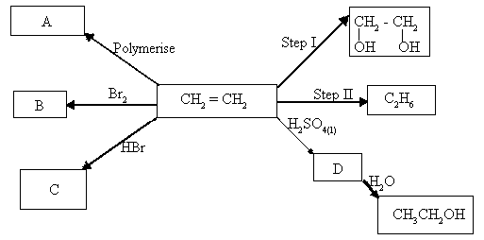

i) State the reagent and conditions necessary for step II to take place. (2marks) Reagent……………………………………………………………………………………………… Conditions……………………………………………………………………………………………………………………………………………………………………………………………….……………

ii) State one disadvantage for using polymer A over a long period of time. (1mark)
………………………………………………………………………………………………………………………………………………..………………………………………………………………………………….
iii) Name the reagent used in step I. (1mark)
………………………………………………………………………………………………………….
iv) Give the name of the type of reaction that take place in steps I and II, (2marks)
I……………………..…………………………………………………………………………………………
II……………………………………………………………………………………………………………….

v) Write the equation for the reaction that leads to the formation of substance C. (1mark)
………………………………………………………………………………………………………………………………………..………………………………………………………………………………………
vi) Name substances D and B. (1mk)
D…………………………………………………………………………………… …………………
B………………………………………………………………………………………………………

