Name: ……………………………………………………………………………………….Class: ………… Adm.No. ……………

CHEMISTRY
Paper 1
JULY 2019
Time: 2 hours

JULY 2019
Kenya Certificate of Secondary Education
CHEMISTRY
PAPER 1

INSTRUCTIONS TO CANDIDATES
- Answer ALL the questions in the spaces provided.
- Scientific calculators may be used.

MARKS SCORED

80
OUT OF

1. Name a method or a process that can be used to separate each of the following substances. (3mks)
(a) A mixture of petrol and diesel.
……………………………………………………………………………………………………………......
(b) Kerosene and water
………………………………………………………………………………………………………………..
(c) Food colouring ingredients in a sauce
………………………………………………………………………………………………………………..
2.The table below shows the formulae of elements P,Q,R and S.(not actual symbols) and their chlorides
Elements | P | Q | R | S
Formulae of chlorides | PCl | QCl₂ | RCl₃ | SCl₅
(a)State the group in which element Q belong. (1mk)
………………………………………………………………………………………………………………..
(b)Identify one element which is a non-metal. (1mk)
………………………………………………………………………………………………………………
(c)Write down the formulae of P oxide. (1mk)
………………………………………………………………………………………………………………
3. Hydrogen can be prepared by passing steam over heated Zinc powder as shown on the diagram below.

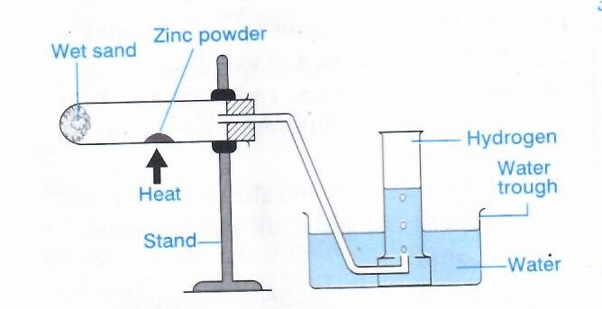
(a)Write down the chemical reaction that produces hydrogen gas. (1mk)
………………………………………………………………………………………………………………..
(b) Explain why hydrogen should be burned if not collected over water. (1mk)
………………………………………………………………………………………………………………..
(c) Give another metal that can be used instead of zinc. (1mk)
………………………………………………………………………………………………………………..
4. A piece of sodium metal was placed in a trough half filled with cold water. State three
observations that were made. (3mks)
………………………………………………………………………………………………………………………………………………………………………………………………………………………………………………………………………………………………………………………………………………………………………………………………………………………………………………………………
5. When 27.8g of hydrated Aluminum Oxide(Al₂O₃.XH₂O) was heated to a constant mass,20.6 of
Aluminium Oxide was obtained. Determine the value of X.(H=1.0,O=16,Al=27) (3mks)

6. (a)State Graham’s law of diffusion. (1mk)
……………………………………………………………………………………………………………………………………………………………………………………………………………………………….
(b) Methane diffuses through a porous plug at the rate of 8cm³S⁻¹.Calculate the rate at which gas P,with a
molecular of 28.44g will diffuse through the same material.(C=12,H=1.0) (2mks)

7. Carbon II Oxide gas was passed over heated copper II Oxide in a combustion tube.
(a) State an observation that was made in the combustion tube. (1mk)
………………………………………………………………………………………………………………..
(b) Write an equation for the reaction that’s taking place. (1mk)
………………………………………………………………………………………………………………..
(c) What characteristic of Carbon II Oxide is demonstrated from the equation? (1mk)
………………………………………………………………………………………………………………..
8.The apparatus below is used to investigate the action of sunlight on chlorine water.

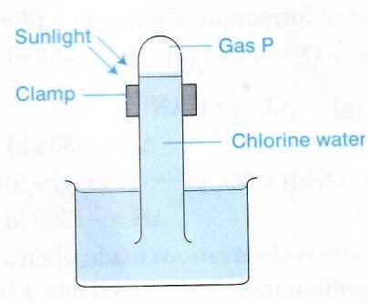
(a) Identify the gas labelled P. (1mk)
………………………………………………………………………………………………………………
(b) State and explain the observation that would be made if a blue litmus was dipped into the chlorine
water. (2mks)
………………………………………………………………………………………………………………………………………………………………………………………………………………………………………………………………………………………………………………………………………………………………………………………………………………………………………………………………
9.Observe the table below and use it to answer the questions that follows.

Element | Sodium | magnesium | Aluminium
Atomic radius(nm) | 1.90 | 1.60 | 1.32
(a)Explain the trend in the atomic radius across the period. (2mks)
………………………………………………………………………………………………………………………………………………………………………………………………………………………………
(b) Predict the the P.H of the solution of sodium Oxide. (1mk)
………………………………………………………………………………………………………………..
10.18cm³ of dilute suphuric (vi) acid require 25cm³ of 0.2M sodium hydroxide solution for complete
neutralization.
(a) Write the equation for the reaction that took place. (1mk)
………………………………………………………………………………………………………………..
(b) Calculate moles of sodium hydroxide required to neutralize the acid. (1mk)
………………………………………………………………………………………………………………
……………………………………………………………………………………………………………….
(c) Calculate the concentration of suphuric (vi) acid in moldm³. (1mk)
……………………………………………………………………………………………………………….
11.Excess zinc granules were added to a solution of Copper II sulphate in a beaker and stirred.
(a) Identify the observation that was made in the beaker after a while. (1mk)
………………………………………………………………………………………………………………..
(b) Giving a reason, identify the oxidizing species in the reaction. (2mks)
………………………………………………………………………………………………………………………………………………………………………………………………………………………………………………………………………………………………………………………………………………
12.Explain why a solution of hydrogen chloride gas in methylbenzene does not conduct electricity while
the solution of the same gas in water conducts. (2mks)
………………………………………………………………………………………………………………………………………………………………………………………………………………………………………………………………………………………………………………………………………………
13.The diagram below shows the solubility curves for sodium chloride and sodium carbonate.

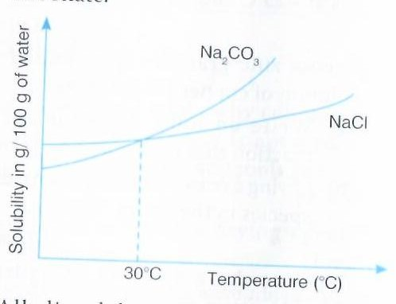
(a)Name a method that can be used to separate the two salts in solution. (1mk)
………………………………………………………………………………………………………………..
(b)Identify and explain crystals that would be separated from the solution during;
(i) the day at 40⁰c (1mk)
………………………………………………………………………………………………………………………………………………………………………………………………………………………………
(ii)the night at 20⁰c (1mk)
………………………………………………………………………………………………………………………………………………………………………………………………………………………………
14.Compound P reacted with chlorine in absence of light to form compound Q.the structural formulae of
compound Q is shown below.
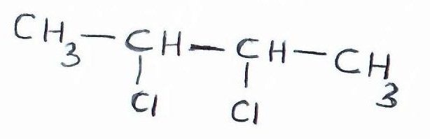
(a)Name and give the structural formula of compound P. (2mks)
………………………………………………………………………………………………………………………………………………………………………………………………………………………………………………………………………………………………………………………………………………
(b)Give the name of compound Q. (1mk)
……………………………………………………………………………………………………………….
15.Two gases,X2 and Y2, react to form a gaseous compound XY₃ according to the following equation.
X₂ +3Y₂ 2XY_{3(g)} ∆H= -44kJ
(a)Show the reaction on an energy level diagram. (3mks)

(b)State one way in which the yield of XY₃ can be increased. (1mk)
………………………………………………………………………………………………………………
16.Complete the following nuclear equations. (2mks)
$\begin{matrix}234 \\ 90\end{matrix}Th$ $\begin{matrix}234 \\ 91\end{matrix}p+ ______________$
$\begin{matrix}226 \\ 88\end{matrix}$Ra $\begin{matrix}222 \\ 86\end{matrix}Rn+______________$
17.State what would be observed if concentrated sulphuric (vi) acid was added to;
(a)Sugar crystals (1mk)
……………………………………………………………………………………………………………….
(b)Copper II sulphate crystals (1mk)
………………………………………………………………………………………………………………
(c)What property of concentrated suphuric (vi) acid is demonstrated by the two reactions above. (1mk)
……………………………………………………………………………………………………………….
18.The P.H values of the following solutions are;1.0,5.0,7.0 and 14.0.Match the PH values with correct
solution in the table below. (2mks)
Solutions |  | P.H values
Sodium chloride
Potassium hydroxide
Hydrochloric acid
Lemon juice
(b) Explain the meaning of term “liming” . (1mk)
………………………………………………………………………………………………………………..
19.A mixture of calcium hydroxide and Ammonium chloride was heated to produce gas P.
(a)Identify gas P. (1mk)
………………………………………………………………………………………………………………..
(b) Write an equation for the reaction that produces gas P. (1mk)
………………………………………………………………………………………………………………
(c)Draw a diagram to show a method that can be used to collect the gas P. (1mk)

20.The flow chart below shows the processes involved in extraction of Zinc metal.Study it and answer the questions that follows.
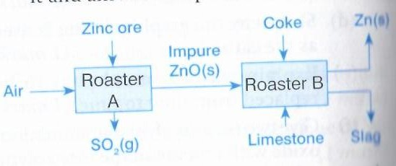
(a) Name the main ore used in the extraction of Zinc. (1mk)
………………………………………………………………………………………………………………..
(b)What’s the function of the limestone in roaster B.? (1mk)
………………………………………………………………………………………………………………..
(c)What do we call the process of coating an Iron metal with Zinc? (1mk)
………………………………………………………………………………………………………………..
21.Explain why sea water is not suitable for washing clothes. (2mks)
………………………………………………………………………………………………………………………………………………………………………………………………………………………………………………………………………………………………………………………………………………
22(a).A student reacted Lead II carbonate with dilute suphuric (vi) acid in order to prepare Lead II
Sulphate salt.Explain why he was unable to prepare the salt using the above reagents. (2mks)
……………………………………………………………………………………………………………………………………………………………………………………………………………………………………………………………………………………………………………………………………………………………………………………………………………………………………………………………….
(b)Give one other reagent he would use in place of Lead II carbonate. (1mk)
……………………………………………………………………………………………………………….
23. What do you understand by the term “Rusting”. (1mk)
………………………………………………………………………………………………………………………………………………………………………………………………………………………………
(b)State two similarities between rusting and combustion. (2mks)
……………………………………………………………………………………………………………………………………………………………………………………………………………………………………………………………………………………………………………………………………………....
24.Sodium chloride was accidentally mixed with lead II sulphate.Describe how Sodium chloride crystals
can be obtained. (2mks)
………………………………………………………………………………………………………………………………………………………………………………………………………………………………………………………………………………………………………………………………………………………………………………………………………………………………………………………………
25.Element T whose atomic number is 16 and mass number 32,combines with Oxygen whose atomic
number is 8.
(a)Determine the number of protons and neutrons in element T. (1mk)
………………………………………………………………………………………………………………
(b)Name the type of bond formed between T and Oxygen. (1mk)
………………………………………………………………………………………………………………..
(c)State the nature of solution formed when Oxide of T is bubbled through water. (1mk)
………………………………………………………………………………………………………………..
26.A piece of burning magnesium is lowered into a gas jar containing carbon (iv) Oxide .State and
Explain the observations made in the gas jar. (3mks)
………………………………………………………………………………………………………………………………………………………………………………………………………………………………………………………………………………………………………………………………………………………………………………………………………………………………………………………………………………………………………………………………………………………………………………
27.Students are normally advised to use a non-luminous flame when heating in the laboratory.
(a)How does a Bunsen burner produce a non-luminous flame? (1mk)
………………………………………………………………………………………………………………
(b)Why is the non-luminous flame preferred over the luminous flame? (1mk)
……………………………………………………………………………………………………………….
……………………………………………………………………………………………………………….
28.A current of 0.82A was passed through an aqueous solution of a salt of metal P for 5 hours.2.56g of
metal P were deposited.(r.m.m of P=52, 1Faraday=96500C)
(a)Calculate the number of faradays used. (1mk)
………………………………………………………………………………………………………………………………………………………………………………………………………………………………
(b)Determine the charge on the ion of metal P. (1mk)
………………………………………………………………………………………………………………
………………………………………………………………………………………………………………
(c)Write the equation for the formation of ion of P. (1mk)
……………………………………………………………………………………………………………….

