CHEMISTRY PAPER 1(THEORY PAPER)-MARKING SCHEME-TERM II 2019
1.a)fractional distillation
b)funnel separation
c)chromatography
2.a)group II
b)element S
c)P₂O
3.ZnO_{(s)} +H₂O_{(g)} H_{2(g)} +Zn_{(s)}
b)A mixture of hydrogen and air explodes
c)Magnesium,Iron,Lead or Cupper
4.The metal darts around the water surface
Melts into a silvery ball
Produces a hissing sound
5.mass of water= 27.8-20.6=7.2√1
Al2O3 | H2O
Moles 20.6/102 =0.202 | 7.2/18 =0.4
Mole ratio 0.0202/0.202 | 0.4/0.202
1 | 2
√1
X=2√1
6.Rate of a diffusion of a gas at constant pressure and temperature is inversely proportional to the square root of it’s density.
b) 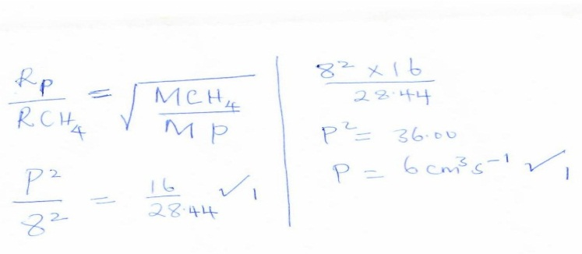
7.copper II Oxide (black) turns to brown (copper metal)
b) CO(g) +CuO (s) Cu(s) + CO₂(g)
c)reducing nature
8.a)Oxygen
b)Turns red then bleached;√1HOCl releases Oxygen atom into the dye decolourizing it√
9.a)atomic radii decreases;√across the period due to increase in nuclear charge/proton number which
create more attration of electrons
b)13-14
10.a) 2NaOH(aq) + H₂SO₄(aq) Na₂SO₄(aq)+ 2H₂O(l)
b) 0.2 moles--------1000 $\frac{0.2x25}{1000}√½$ =0.005moles√½
? --------- 25
c)mol of acids $\frac{0.005}{2}$ √½ = 0.0025mol-------------18 =$\frac{0.0025X1000}{18}$ =0.139M√½
? -------------- 1000
11.a)blue copper II sulphate faded√
b)Cu²⁺√ they gained electrons√
12.HCl gas in methylbenzene does not dissociate√ but in water it does√
13.a)fractional crystallization
b)Nacl√½ ,Na₂CO₃ is more soluble at high temperature√½
c)Na₂CO₃;when the temperature is low,they it is less soluble
14.a)But-2-ene √
H H
H-C-C=C-C- H
H H H H
b) 2,3-dichlorobutane
15
Axis-½ $×$2=1
Exothermic expression √1
Eqn and ∆H√1
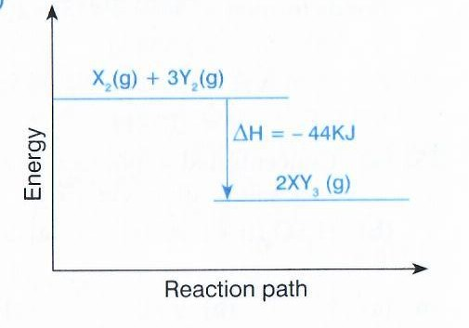
b).increasing the pressure√1 or
Lowering the temperature
17a).$\begin{matrix}0 \\ -1\end{matrix}$e- b)$\begin{matrix} 4 \\ 2\end{matrix}$ He
18. brown sugar turns to black mass
b)Blue copper II sulphate turns white
c)dehydrating agent
19.lemon juice 5.0√½
Sodium chloride 7.0√½
Potassium chloride 14.0√½
Hydrochloric acid 1.0√½
b)addition of calcium oxide or calcium hydroxide to soil to improve ph.
20.Ammonia/NH₃
b)Ca(OH)₂(aq) + 2NH₄Cl(s) CaCl₂(s) + 2H₂O(l) + 2NH₃(g)

c) 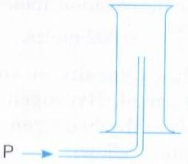
21.a)Zinc blende
b)reacts with the acidic impurities to form slag
c)galvanization
22.It contains sulphates of magnesium and calcium√;these form scum with soap leading to soap wastage.√
23.the reaction started but eventually stoped√;due to formation of an insoluble layer of lead sulphate
which prevents further reaction√
b).lead II nitrate
24.a).wearing out of Iron metal when it’s exposed to air and moisture/water or corrosion of Iron
metal√
Oxygen is used in both
Oxides are formed
There’s increase in mass
25.dissolve the mixture in water
Filter off the residue
Heat the filtrate to evaporate excess water
Cool to form crystals
26.a)32=16 +N
N=16 √½ P=16√½
b)Covalent
c) acidic
27.
White ash/solid is formed.√½
Black speck/solid/particles formed on the side of gas jar.√½

Magnesium burn to produce/release enough heat energy to decompose Carbon(IV) oxide gas to carbon√ and oxygen.Magnesium continues to burn in Oxygen forming white Magnesium Oxide solid/ash.√
28.When the air hole is open
b)It’s hotter than luminous
non smoky/sooty
29.
a)0.82 $×$ 5$×$ 60$×$ 60 =14760√½
$\frac{14760}{96500}$ =0.1529F√½
b)
2.65g---------0.1529f $\frac{0.1529x52}{2.65}$ √½ =3F√½
52g-----------?

c) P P³⁺ +3e-

