Name: …………………………………………………………………………….. Class: ………… Adm.No……………..
School: …………………………………………………………………………… Date: ………………………………………
233/1
CHEMISTRY
Paper 1
July 2019
Time: 2 hours
Kenya Certificate to Secondary Education
CHEMISTRY PAPER 1
TIME: 2 HOURS

INSTRUCTIONS TO CANDIDATES
- Write your name, admission number, date and school in the spaces provided.
- Answer all the questions in the spaces provided.
- All working must be clearly shown where necessary.
- Scientific calculators may be used.

1.Below is a table of 1stionization energies for elements A,B,C, and D which are metals.
Elements | A | B | C | D
Ionization energies Kjmol⁻¹ | 494 | 418 | 519 | 376
a) What is meant by 1st ionization energy? (1mk)

b) With an explanation, arrange the elements in order of increasing reactivities. (2mks)

2. A mixture consists of sulphur powder and iron filings.
(i) Describe how to obtain sulphur from the mixture using methylbenzene. (3 mks)

(ii) Is the mixture homogeneous or heterogeneous? Explain. (2 mks)

3. The catalytic oxidation of ammonia gas is done as per the set up below.
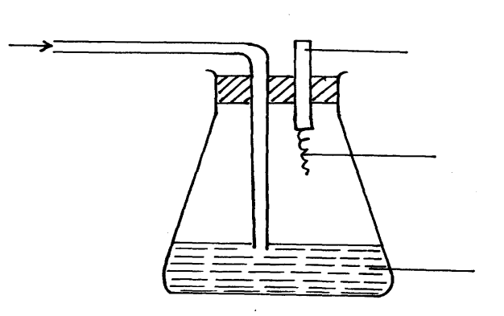
Oxygen
Glass rod

Platinum wire
Concentrated
Ammonia solution

a) Name the catalyst used in the above reaction. (1mk

b) After sometime, brown fumes are formed in the flask. Explain briefly how this observation occurs. (1mk)

c) Why does the metal catalyst stay red hot for some time? (1mk)

4. (a) Define hydration energy. (1 mark)

(b) Given that: the hydration energies of Ca²⁺ and Cl⁻ are -1891 kJ mol⁻¹ and -384 kJ mol⁻¹respectively,and that the lattice energy of calcium chloride is +2237 kJ mol⁻¹.Calculate the molar enthalpy change of solution of calcium chloride. (3 marks)

5. 36cm³ of a solution of potassium hydroxide requires 25cm³ of 0.5M sulphuric acid to neutralize it.
Calculate the concentration of alkali in g/dm³ (3mks

6. (a) Draw structural formulae of two isomers with molecular formula C₄H₈.
(2 mark

(b) Study the equation below and answer the questions that follow.
C₆H₁₄ + Cl₂ C₆H₁₃Cl + HCl
(i) State the condition under which this reaction occurs. (1 mark)

(ii) Give the general name of this type of reaction. (1 mark)

7. In an experiment , a student put equal volumes of mixture of ethanoic acid and in water and ethanoic acid in methlybenzene in two test-tubes as shown below. In each test tubeequal amounts of solid hydrogen carbonate were added.
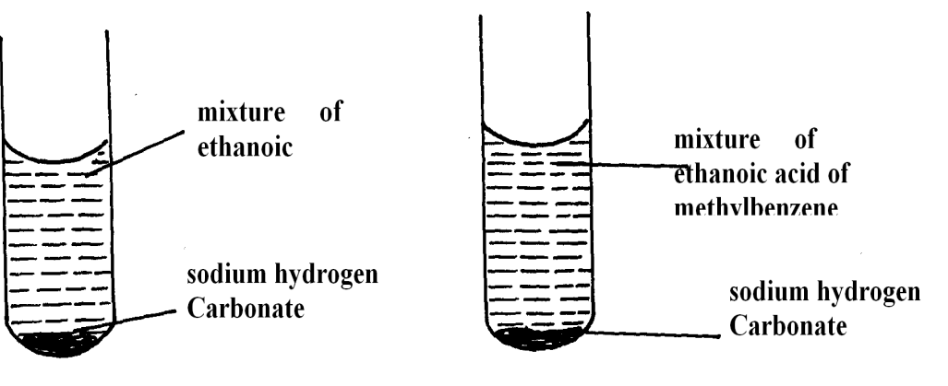

Mixture of ethanoic acid and methylbenzene
Mixture of ethanoic acid and water

Test tube 2
Test tube 1

a) State the observation which was made in each test-tube. (1mk)

b) Explain the observation in (a) above. (2mks)

8.a)Describe hardness of water. (1mk)
b) Explain how dilute hydrochloric acid can be used to determine the type of hardness in a sample of tap water. (1mk)

c) State one largescale uses of hardwater. (1mk)

9. The diagram below represents a set-up of apparatus used to collect a sample of a laboratory gas C.
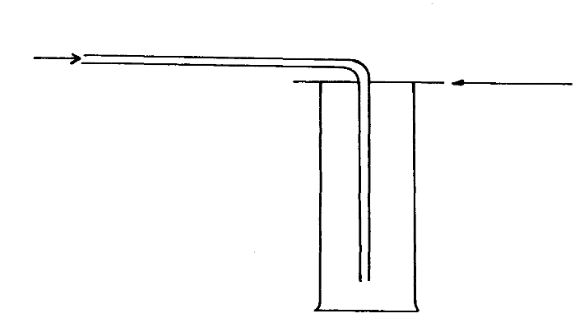
Gas C in
Card board
Gas jar

- Indicate in the diagram, the direction of the movements of gas C and air inside the gas jar. Give a reason for your answer. (2mks)

b) Name one laboratory gases that can be collected using the same method as gas C. (1mk)

10. When burning magnesium ribbon is put into a gas jar of carbon (IV) oxide gas, it continues to burn leaving behind white solid powder and black solid specks as residue write chemical equation for the reaction that produces.
i) The white solid powder. (1mk)

ii) Black solid specks. (1mk)

11. Study the table below and use it to answer the questions that follow. (The letters do not represent the actual symbols of the elements).
Element | Q | R | S | T | U
Atomic number | 5 | 20 | 3 | 18 | 5
Atomic mass | 10 | 40 | 7 | 40 | 11

(a ) select two letters that represent the same element? Give a reason. (2 marks)

(b)Give the number of neutrons in an atom of element S. (1 mark)

12. Dry carbon (II) oxide gas was passed over heated lead (II) oxide.
(a) Write an equation for the reaction. (1 mark)

(b)Give one industrial application of the above reaction. (1 mark)

(c)Name another gas that can be used in the above reaction. (1 mark)

13.a) State Boyle’s gas Law. (1mk)

b) A fixed mass of a gas has a volume of 250cm³ at 27ºC and 750mmHg pressure. Calculate the gas volume that the gas would occupy at 41ºC and 750mmHg pressure. (0º = 273k) (2mks)

14.(a) Proteins are obtained from amino acids monomers. Complete the equation below to show the polymer formed. (1 mark)
H₂NCH₂COOH + H₂NCHCH₃COOH ﴾HNCH₂CONHCHCH₃CO﴿ + 2H₂O
(b) Name the type of polymerization shown above. (1 mark)

15. The diagram below represents a laboratory experiment to investigate the reaction between hydrogen sulphide gas and an aqueous iron (II) chloride.
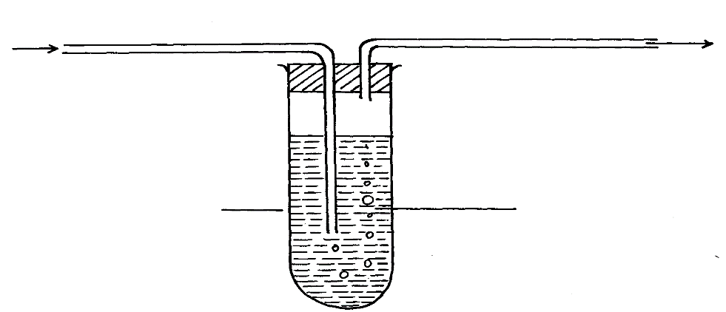
To fume chamber
Iron (III) chloride solution
Boiling tube.
Hydrogen sulphide gas

a)Write chemical equation for the reaction which takes place in the boiling tube. (1mk)

b) What adjustment need to be made in the above set-up if the laboratory does nothave a fume chamber.
(1mk)

c)Describe a laboratory chemical test for a sample of hydrogen sulphide gas. (1mk)

16. The set up below was used to prepare dry hydrogen gas. Study it and answer the questions that follow.
Cardboard
Hydrochloric
acid
Zinc granules
Liquid Y

(i) With a reason, identify the mistake in the set-up above. (1 mark)

(ii) What would be liquid Y? (1 mark)

(iii) Give two physical properties of hydrogen gas (1 mark)

17. Below are the bond dissociation energies of some elements.
Bond | Bond dissociation energy
C – C | 343 kJmo⁻¹
C – H | 414 kJmo⁻¹
H – H | 435 kJmo⁻¹
C(s)C(g) | 711 kJmo⁻¹

Use this information to calculate the heat of reaction for:-
2C_{(s)} + 3H_{2(g)} C₂H_{6(g)} ( 3 marks )

18. Ammonia gas was passed into water as shown below.

Ammonia
Gas

Water
(a)When a red litmus paper was dropped into the resulting solution; it turned blue.
Give a reason to this observation. ( 1 mark )

(b) What is the function of the funnel. (1mk)

19.Describe how you would obtain pure solid samples of each of the following components of a solid mixture containing ; Lead (II) chloride, Sodium carbonate and calcium sulphate. (3mk)

20.In preparation of oxygen gas a student used hydrogen peroxide and added a black solid and collected the gas over water.
a)What is the name of the black solid and what is its function. (1mk)

b)During collection of the gas, why should the first bubbles be allowed to escape. (1mk)

c)Give one main advantage of collecting a gas over water. (1mk)

21. Study the diagram below then use it to answer the questions that follow.
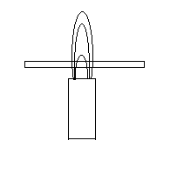
a)Draw the wooden splint at the end of experiment .If it was slipped the removed (1mk)

b)Explain the appearance of the wooden splint in a) above(2mks)

22. The compound A and B below are cleansing agents- Use it to answer the questions that follows.
A B
R- COO – Na⁺
R- O5O₃– Na⁺

(i) Identify cleaning agents A and B (1mk)

(ii) State two disadvantages of cleansing agent B over A. (2mks

23. Use dots and crosses diagram to draw bonds in : ( 3mks)
(a)Al₂Cl₆ (Al=13,Cl=17)

- Al₂O₃(Al=13,O=8)
24.a)Define the term oxidation state (1mk)

b)Calculate the oxidation states of manganese and chromium in:
i)MnO₂ (1mk)

ii)CrO⁻₄ (1mk)

25. The diagram below shows an experiment involving chlorine water.
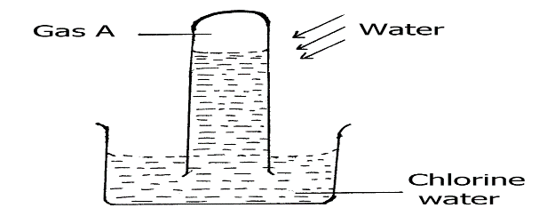

a) State and explain the observations made after 24 hours. (2 marks)

b) Write an equation to show the formation of gas A. (1mark)

c) State one use of chlorine gas. (1mark)

26. Starting with red roses ,describe:
a) how a solution containing the red pigment may be prepared.(2mks)

b) how the solution can be shown to be an indicator (1mk)

