AMUKURA PARISH JOINT EXAM 2021

CHEM PP2 MARKING SCHEME

1.(i) Noble gases √1

(ii) D2SO4 √1

(iii) (a) Y √1

(b) E √1

(iv) Ionic bond √1 – Because B reacts by losing an electron (s) which are gained by H. √1 accept transfer of electrons from a metal to non metal

(v) D//M √1 Any ½ mark each

(vi) Because E reacts by gaining an extra electron which reduces √1 the electrostatic

pull by the positive nucleus making the ionic radius increase. Or incoming electron causes increased repulsion wtte

(vii) At Period III Group IV

(viii) Because of the increase in the strength of the molecular bonds in the oxide of L as

compared to that of G. √1 w.t.t.e

(ix) C has a smaller atomic √1 radius than I because of the increase in the strength of the

Nucleur foce of attraction in C as the number of protons increase √1 w.t.t.e

(x) 1st ionization energies increases from J – L across the period due to addition of an

extra proton in the nucleus increasing the attraction of the valency electrons √

2 a) i) A solution that cannot dissolve any more of the solute at that particular temperature. ✓ 1mk

ii) Scientific technique used to separate substances due to their differences in their crystallization temperature. ✓ 1mk or w.t.t.e

b) i) on the scanned graph

ii) x=100g/100ml, y=40g/100ml

iii) 5oc

iv) type of hardness that cannot be removed by boiling

3. a) (i) Fractional distillation✓ 1mk

(ii) Argon//neon/xenon//krypton✓ 1mk

b) A Sulphur✓1mk

B Ammonia gas✓1mk

C sulphur (vi) oxide✓1mk

D Ammonium sulphate✓1mk

c) (i) Finely divided iron✓1mk

(ii) Vanadium (v) oxide✓1mk

(iii) The catalysts fasten✓1mk the Haber & contact processes by lowering the activation energy✓1mk of the reactions//the rate of production is increased.

d) (i) H2SO4(aq) + 2NH3(g) (NH4)2SO4(aq)✓1mk

(ii) Formula mass of (NH4)2SO4 = 2(14+4) + 32 + 4(16)

= 132grams✓ ½ mk

% of N = ✓1mk

= 21.212%✓ ½ mk

(iii) Use as a fertilizer✓1mk

4. a) I: The outlet delivery tube should not dip into the Zinc/dilute Sulphuric acid mixture in the round buttoned flask. ✓ 1mk

II: The use of heat is not required ✓ 1mk

b)

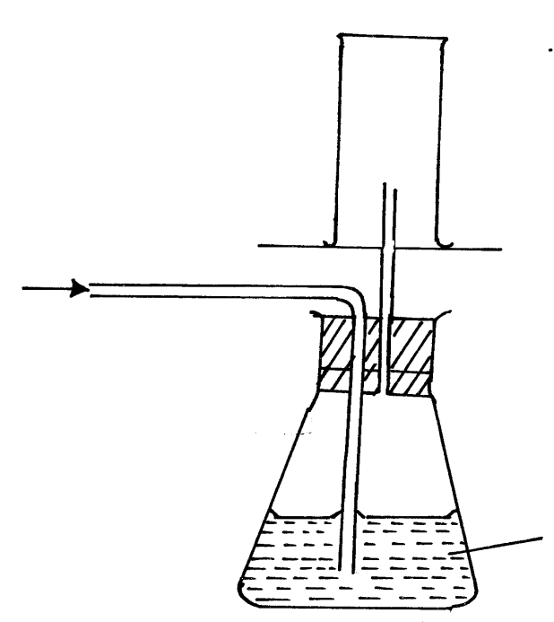

Dry H2(g)

✓ (way of collection) 1mk

Card board

Wet H2(g)

Conc H2SO4

✓ 1mk

c) i) It is denser than air✓1 mk

ii) H2(g) + ½ O2(g) ht H2O(g)✓ balancing½ mark

states ½ mark

d) Zn2(s) + H2SO4(aq) ZnSO4 (aq)+ H2(g) balancing ½ mk

states ½ mk

1vol 1 vol 1vol

 

Therefore, ✓1mk 



Or R = 65.4 ✓ 1mk

e) - H2(g) is used in balloons by meteorologists ✓1mk

- It is used as rocket fuel ✓ 1mk

5.

(a) Heating copper (ii) oxide √*1mk*

(b) Black solid would turn brown √*1mk*

(c) CuO(s) + CO (g) Cu(s) + Co2(g) √*1 ½ mk*

(d) 2CO (g) + O2(g) 2CO2(g) √*1 ½ mk*

(e) It is poisonous √*1mk*

(f) (i) Reducing agent - Carbon(ii) oxide √*1mk*

(ii) Oxidisingagent -Copper (ii) oxide √*1mk*

(g) Hydrogen / ammonia gas (Any one) √*1mk*

(h) There would be no observable change √*1mk.* This is because sodium is higher than carbon in the reactivity series and therefore has higher affinity of oxygen √*1mk*

6.

1. Concentrated sulphuric (vi) acid √*1mk*
2. It is denser than air √*1mk*
3. It turns red then white. *√1mk*

It turns white / it gets bleached √*1mk*

1. Cl2(g) + H2O(l) HOCl(aq)+ HCl(aq) √*1mk*
2. PCl3 √*1mk*

PCl5 √*1mk*

1. A yellow deposit of sulphur is formed / seen √*1mk*

Chlorine oxidizes sulphideions to solid sulphur √*1mk*

- Manufacture of hydrochloric acid √*1mk*

* Manufacture of bleaching agents such as chlorate used in the cotton and paper industries
* Chlorine is used in the treatment of water and sewage plants
* Manufacture of chloroform as an anaesthetic
* Manufacture of solvents such as trichloroethane

*Any one*

**7.**

1. A - Filtration √*1 ½ mk*

B - Absorption √*1 ½ mk*

M - Isolation of water √*1 ½ mk*

D - Cooling √*1 ½ mk*

1. Liquids – NaOH (aq) / KOH (aq) √*1mk*

Substance T – Ice / water √*1mk*

1. To increase surface area forcooling √*1 mk*
2. (i) Oxygen is used to remove impurities during steel making √*1 mk*

(ii) Is used in cutting and welding of metals √*1 mk*

1. 2H2O2(l) MnO2(S) 2H2O(l)+ O2(g) √*1 mk*
2. (i) R -Rusting occurred *√1 ½ mk* because of air and water being present √*½ mk*

S - No rusting *√½ mk* Water is absent √*½ mk*

T - No rusting √ *½ mk* Air is absent *√½ mk*

(ii) To prevent rusting *√1mk*

To increase aesthetic value of the metal