CONFIDENTIAL
CASPA AMUKURA PARISH
233/3
CHEMISTRY PRATICAL
CONFIDENTIAL INSTRUCTIONS TO SCHOOLS

In addition to fittings and apparatus found in a chemistry laboratory, each candidate will need the following.

Question one.
- Burette
- Pipette
- Filter Funnel
- Retort stand and clamp
- Conical flask, 250ml
- White tile
- Phenolphthalein indicator
- 100cm³ of Solution K, 0.1M hydrochloric acid
- 100cm³Solution L 2g per litre of sodium hydroxide.
- Solid N 0.5 g of an impure calcium carbonate, ( N is made by mixing CaCO₃ and Sodium Chloride in the ratio 4:1)
- An empty 250ml beaker

Question two and three
- Solid T sodium sulphite
- Solid J mixture of ammonium sulphate and hydrated zinc sulphate ratio 1:1
Access to
- Distilled water in wash bottle
- Barium chloride solution
- 2M hydrochloric acid
- Acidified potassium manganate vii
- Source of heating
- Barium nitrate
- 2M nitric v acid
- Lead ii nitrate
- 2M NaOH
- Aqueous ammonia solution
- Litmus papers

MARKING SCHEME

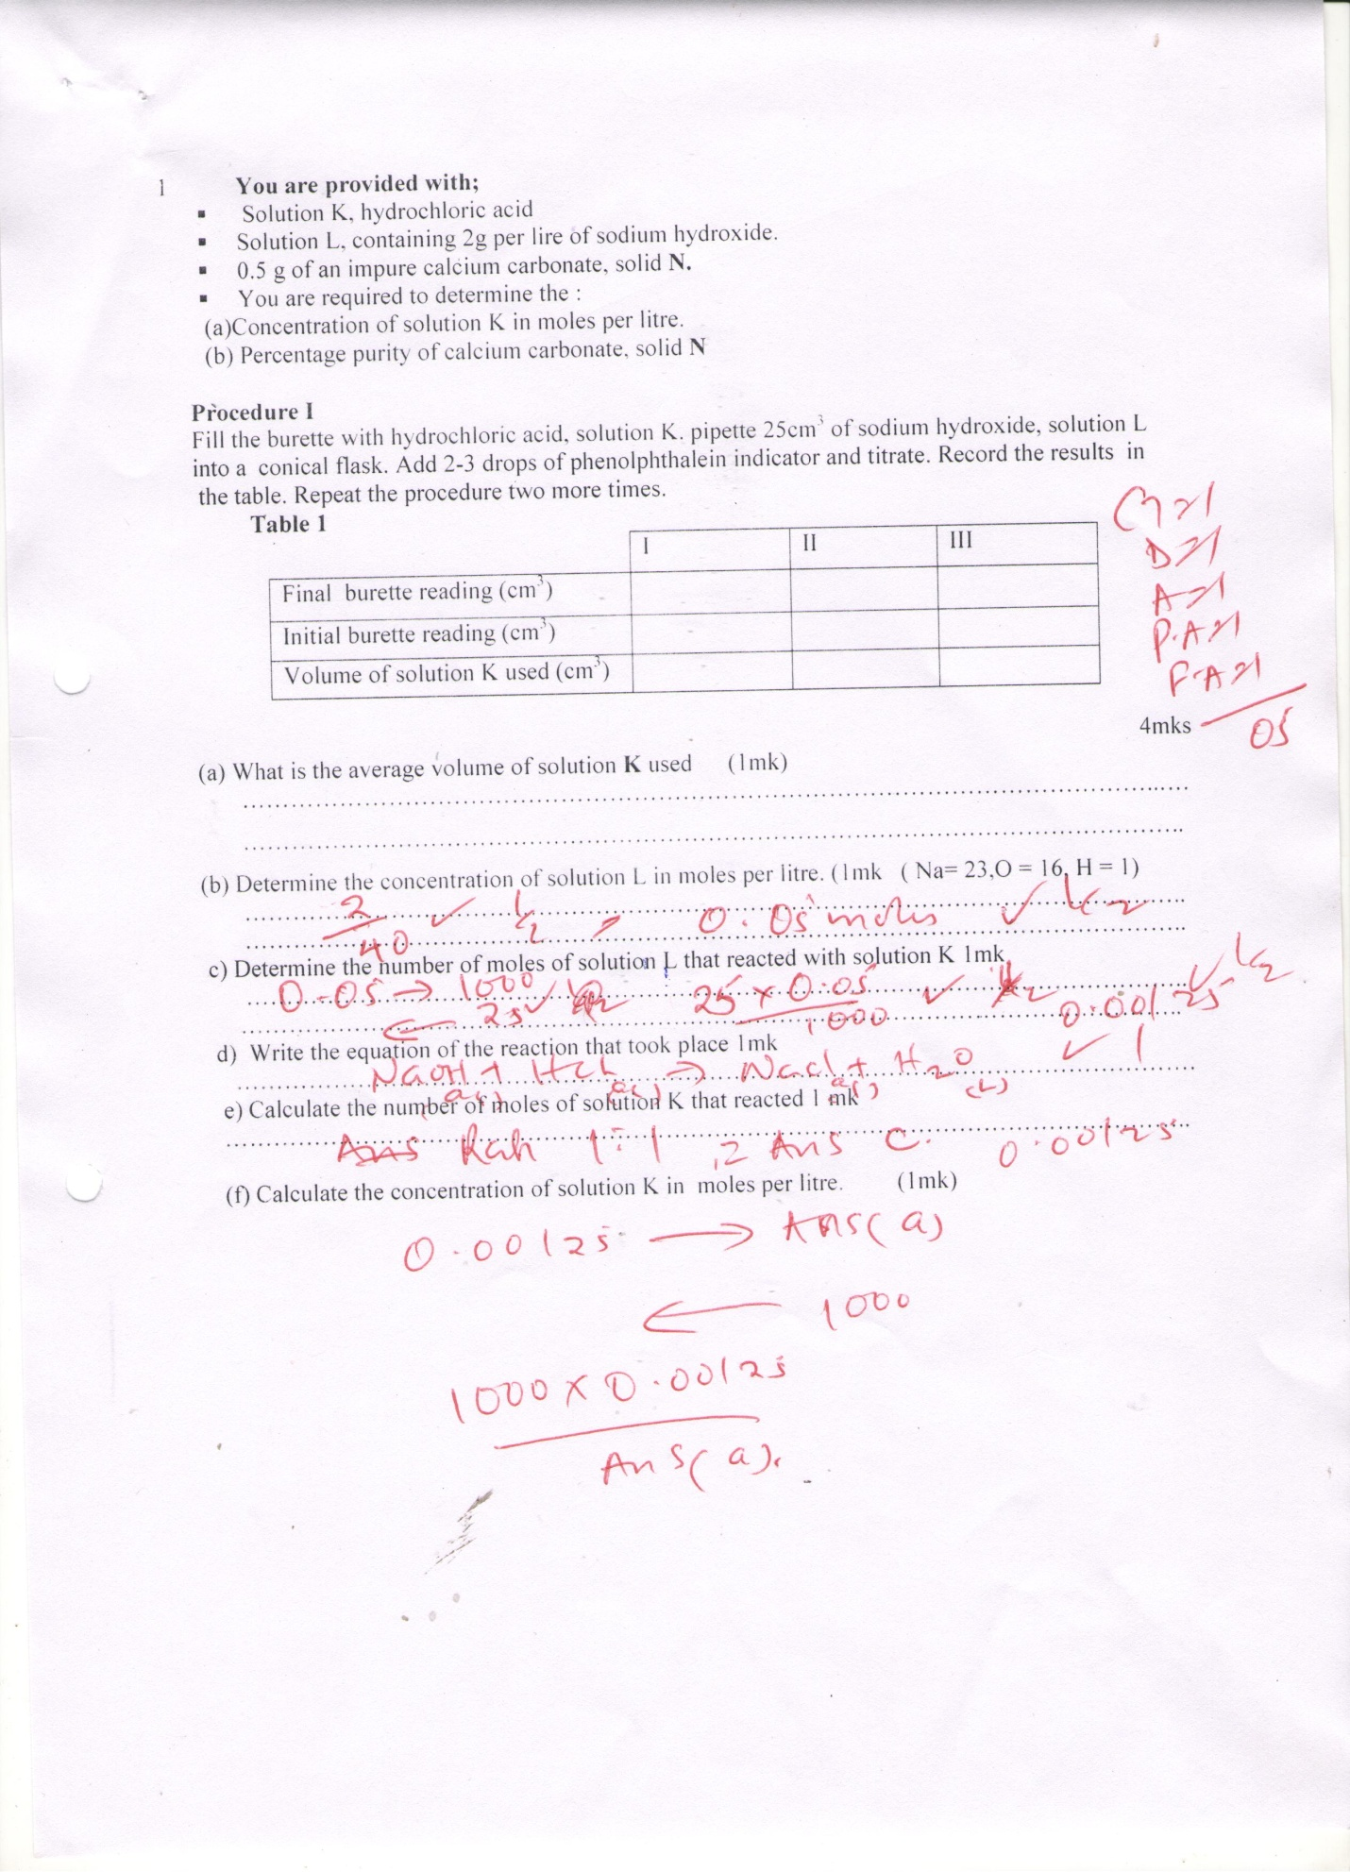
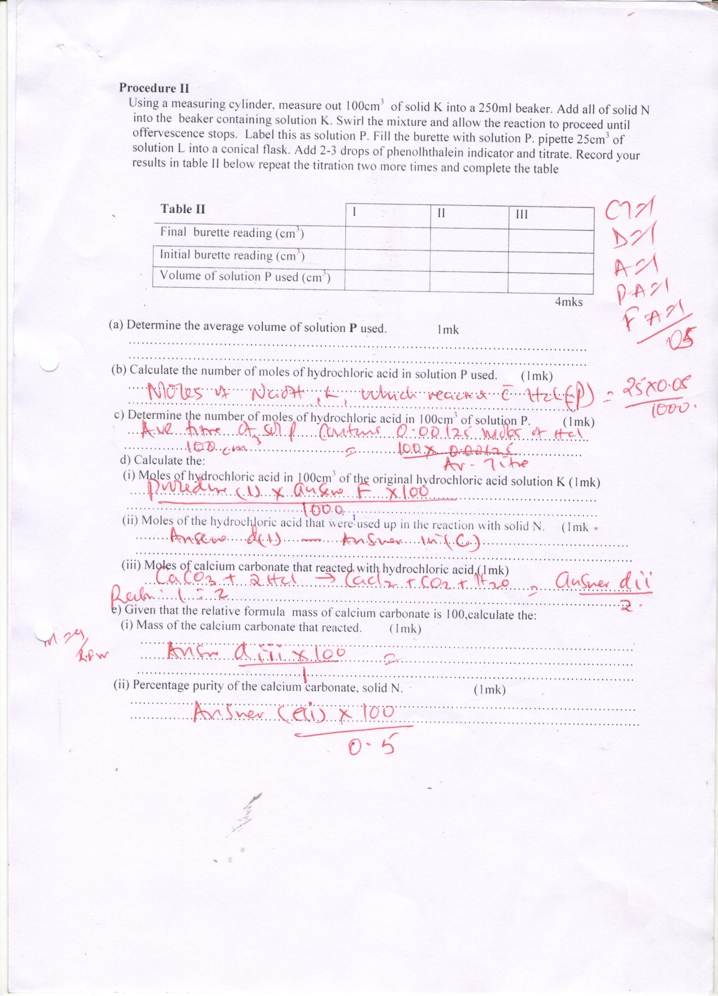
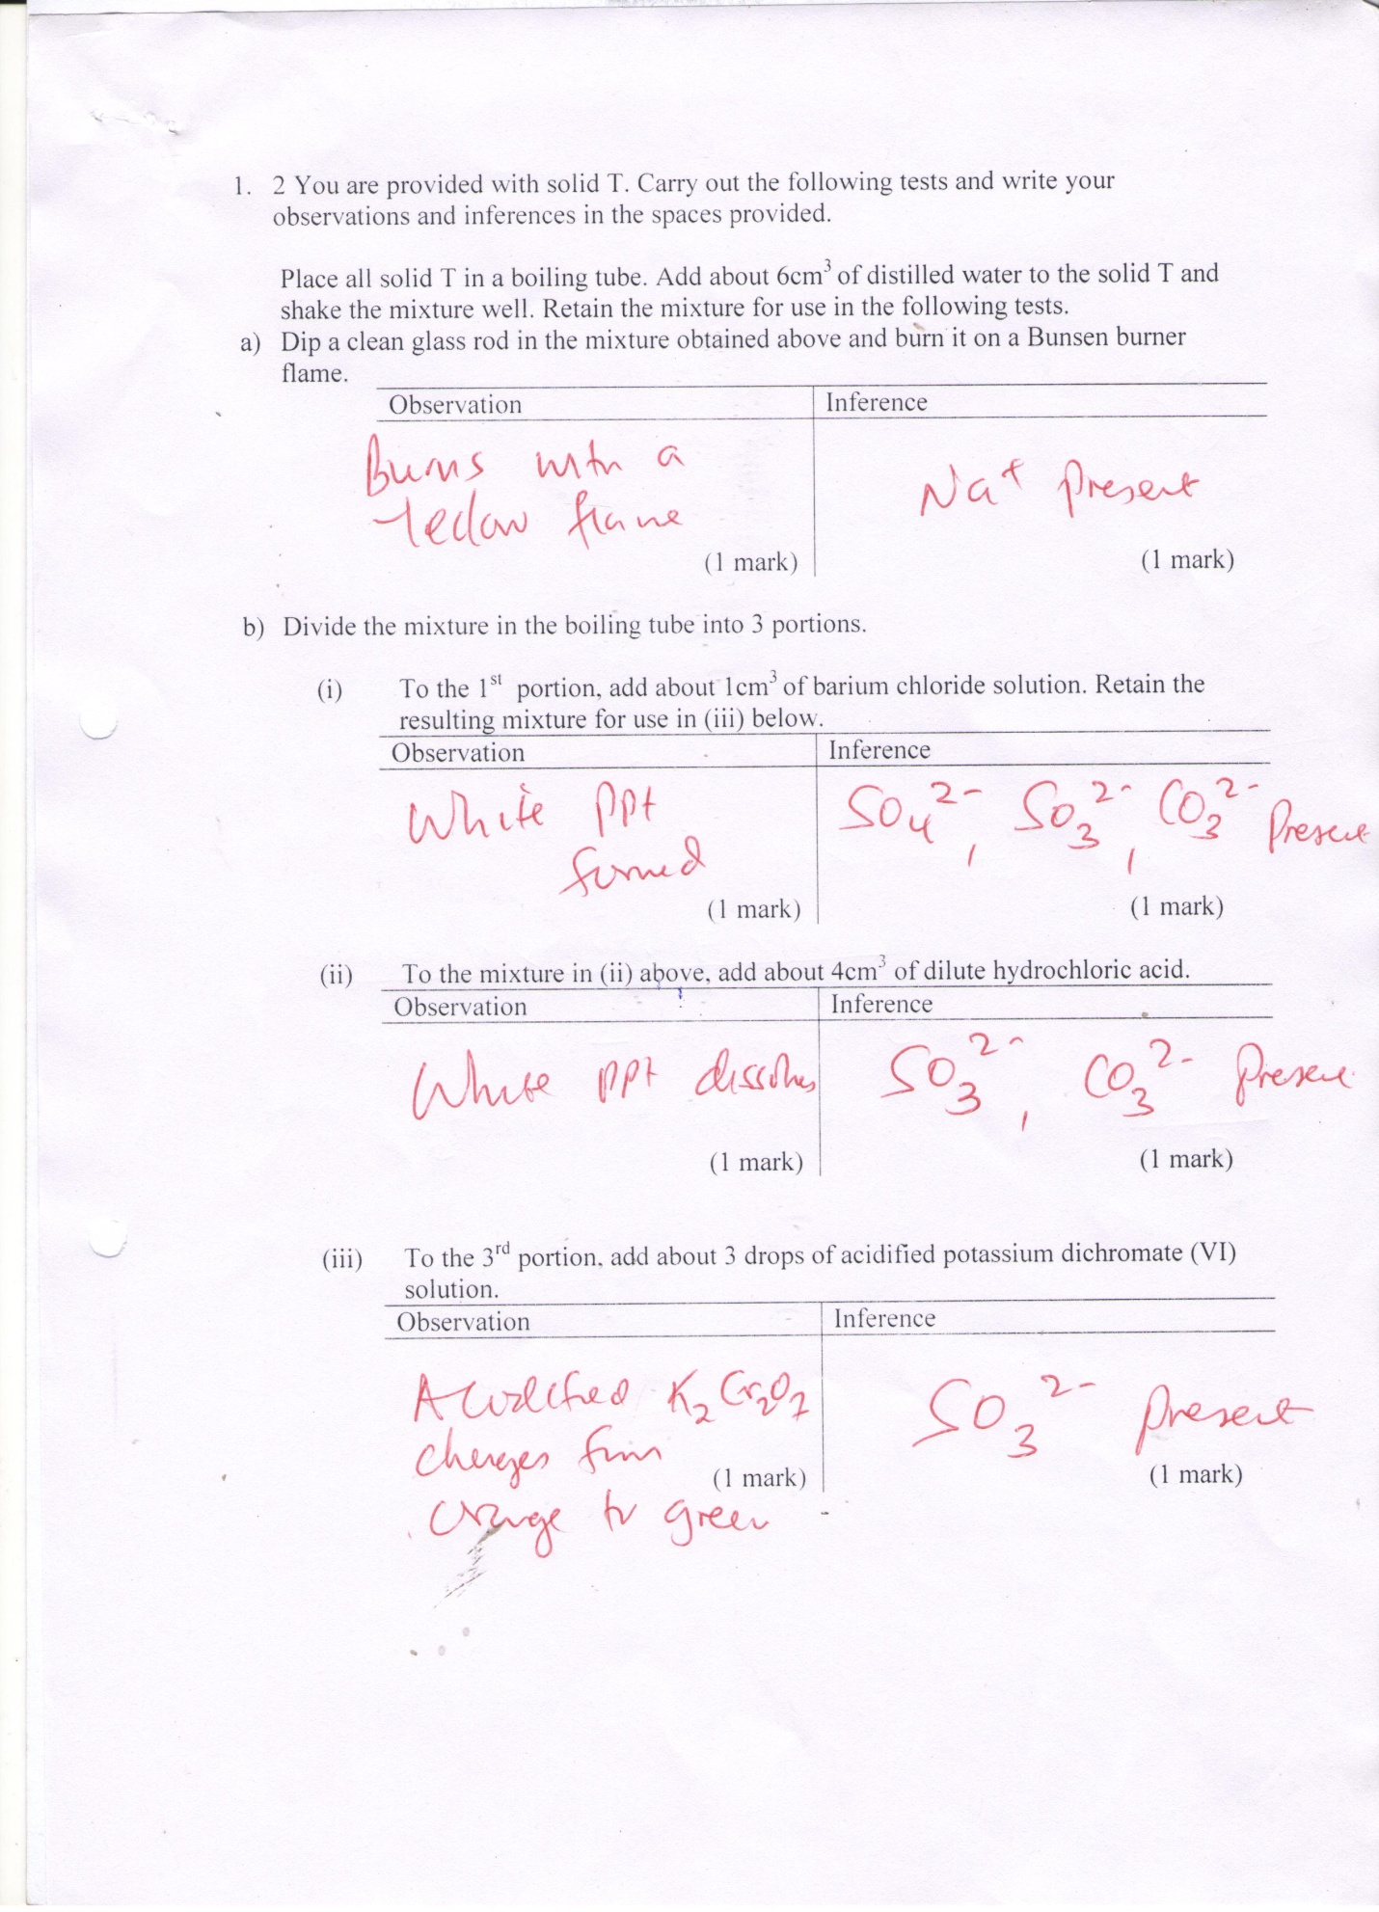
3.
a
Observation | Inference
A gas is given out which turns blue litmus paper red  (1 mark) | SO₄²⁻,CO₃²⁻ Present  (1 mark)
B(i)
Observation | Inference
White ppt is formed which dissolves in addition of exess.  (1 mark) | Al^{3+,}Zn^{2+,}pb²⁺ present  (1 mark)
(ii)
Observation | Inference
White ppt is formed which dissolves in addition of exess.  (1 mark) | Zn²⁺ present  (1 mark)
(iii)
Observation | Inference
White ppt is formed  (1 mark) | SO₄²⁻ present  (1 mark)
(iv)
Observation | Inference
White ppt is formed which does not dissolve on warming  (1 mark) | SO₄²⁻ present / SO₃²⁻absent  (1 mark)

