1. a) i) Alkali metals 🗸

b) i) G is more reactive 🗸 ½ since it looses one electron while J loses 2 electrons 🗸1/2

1. P is more reactive 🗸 ½ since P gains 1 electron while N gains 2 electrons 🗸 ½
2. K has longer radius than L 🗸 1 since Atomic radii decrease 🗸 ½ across the period

due to increase in nuclear charge as incoming electrons go to the same energy level 🗸 ½

1. Above 🗸 1
2. M.P decrease down the group 🗸 1due to increase in atomic 🗸 ½ sizes which weakens the inter atomic bonds 🗸½ .

f) KP3

g) Ionic / electrovalent

* 1. F is group 1 metal and O group 7 //
  2. F loses electrons , O gains W.T.T.E

h) – Arch welding

-Used in electric bulbs

1. H 2. 8. 8

N 2. 8. 8

2. a) i)Covalent bond type 1mk

Simple molecular 1mk

1. Expected to have ionic bond Because it is a compound of a metal (aluminum) and a non metal ( Chlorine) 🗸
2. AlCl3 Sublimes when heated🗸
3. Sodium Chloride solution
   * No effect on the blue litmus because the solution is neutral 1 ½

Aluminum Chloride solution

* + Blue litmus turns red because the solution is acidic due to hydrolysis of Al3+(aq) ion

1. MgO has much higher m.p than P4O10 because MgO has strong ionic bonds with giant ionic structure while P4O10 has simple molecular structure with weak van der waals forces. 2mks
2. Na2O(s) + H2O(l) 2NaOH(aq) 1mk

SiCl4 + 4H20(l)  H4Si 04(aq) + 4HCl(aq)1mk

***OR***

SiCl4(l) + 2H20(l) SiO2(s) + 4HCl(aq)

Al2Cl6 2mks

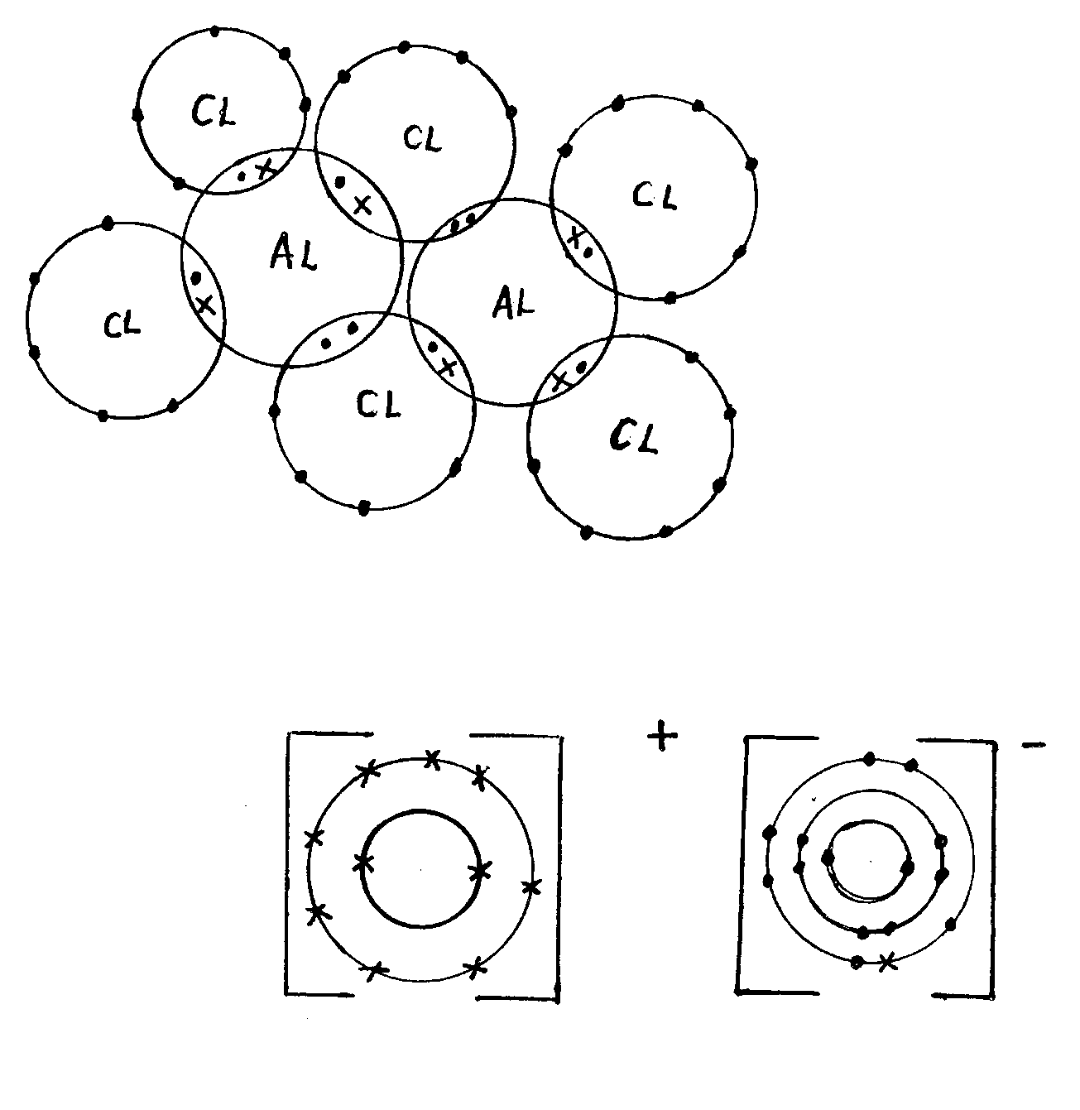

Electron 🗸

Diagrams🗸 2mks

NaCl

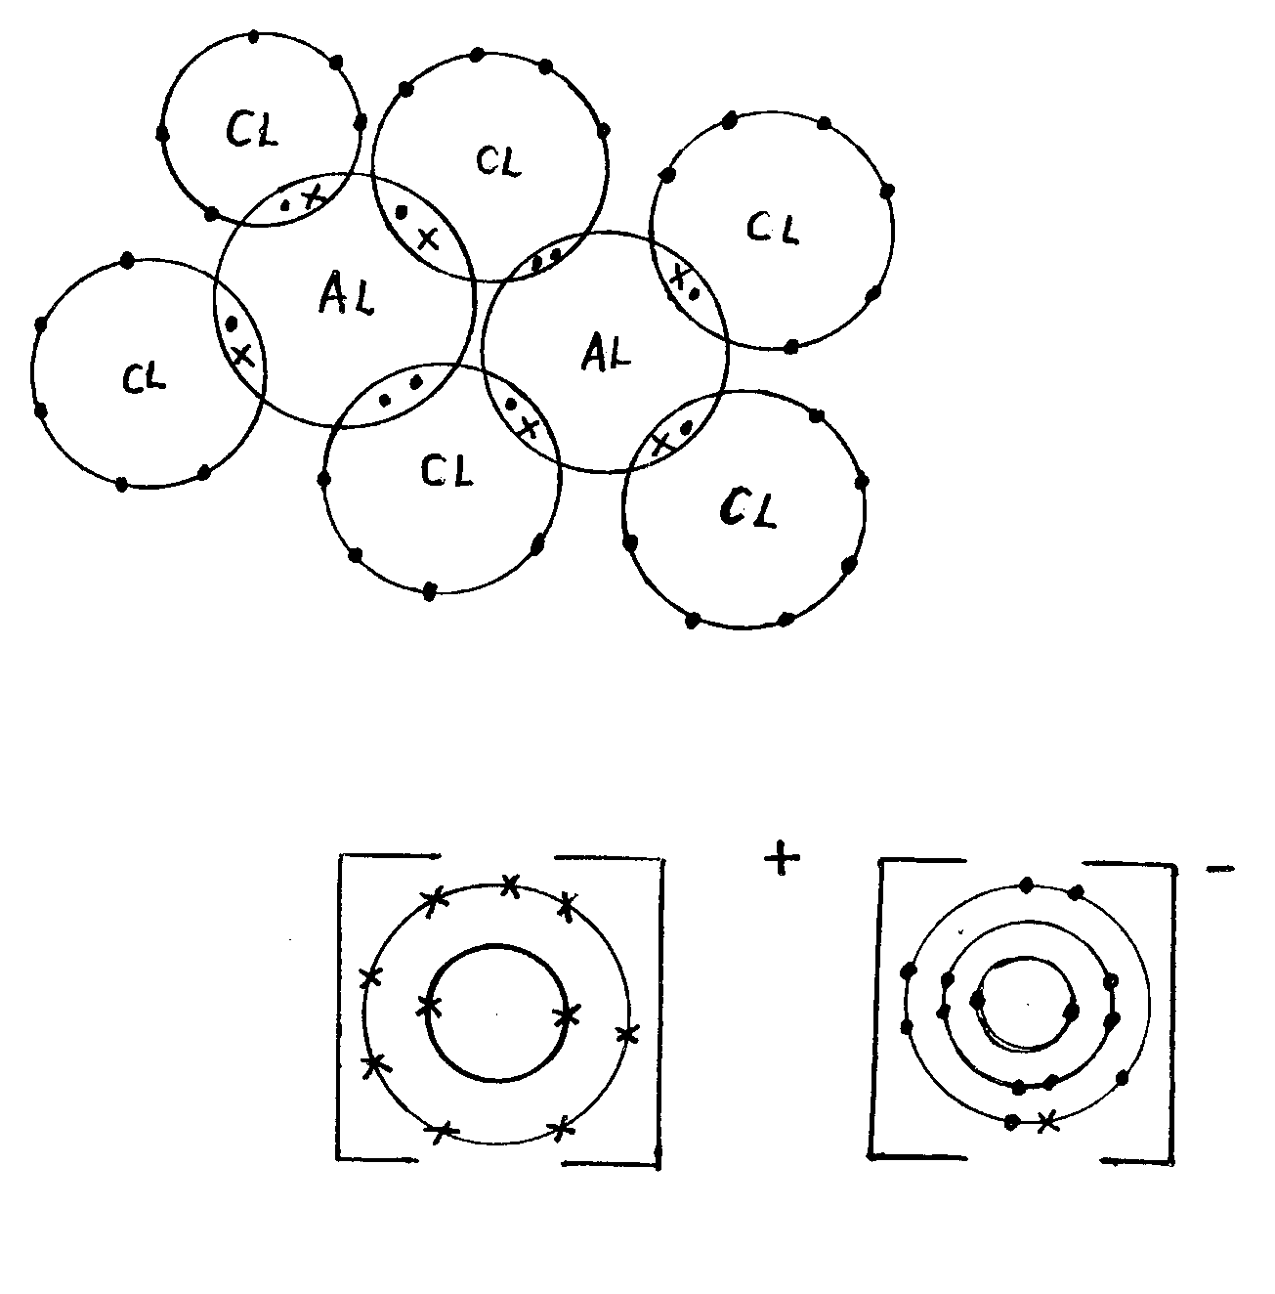

2mks

3. a) Alkynes✓1

b,i) H ⎯ C =C⎯H ✓1

⏐⏐

H H

1. I - Dehydration✓1

II - Hydrogenation✓1

III – Free radical substitution✓1

H H

⏐⏐

iii) H⎯C=C⎯H + HCL H⎯C⎯C⎯H

⏐⏐⏐⏐

H H H CL

OR

C2H4 (g) + HCL (g) CH3CH2CL✓1

Ignore the states

iv) 1 - Monochloroethane ✓1

v) (C2H3)n = 54

n = 54✓ ½

27n = 54

n = 2✓ ½

Molecular formula = C4H6✓1

H H

⏐ ⏐

vi) H⎯C≡C⎯C⎯C⎯H✓1

⏐⏐

H H

H H

⏐⏐

H⎯C⎯C≡C⎯C⎯H ✓1

⏐⏐

H H

4. a) (i) Fractional distillation✓ 1mk

(ii) Argon//neon//krypton✓ 1mk

b) A Sulphur✓1mk

B Ammonia gas✓1mk

C Conc. sulphuric acid//sulphur (vi) oxide✓1mk

D Ammonium sulphate✓1mk

c) (i) Finely divided iron✓1mk

(ii) Vanadium (v) oxide✓1mk

(iii) The catalysts fasten✓1mk the Haber & contact processes by lowering the atiration energy✓1mk of the reactions//the rate of production is increased.

d) (i) H2SO4(aq) + 2NH3(g) (NH4)2SO4(aq)✓1mk

(ii) Formula mass of (NH4)2SO4 = 2(14+4) + 32 + 4(16)

= 132grams✓ ½ mk

% of N = ✓1mk

= 21.212%✓ ½ mk

(iii) Use as a fertilizer✓1mk

TOTAL Question marks = 14 marks

5. a) I: The outlet delivery tube should not dip into the Zinc/dilute Sulphuric acid mixture in the round buttoned flask. ✓ 1mk

II: The use of heat is not required ✓ 1mk

b)

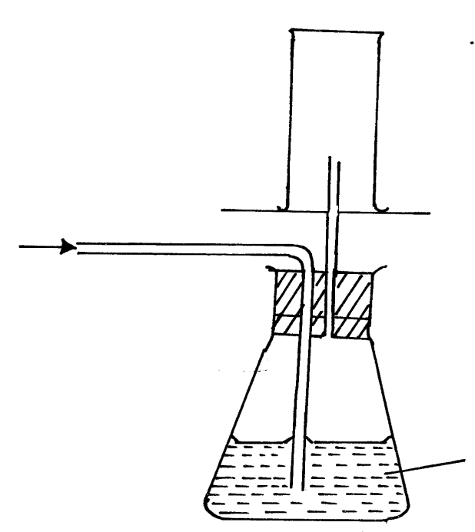

Dry H2(g)

✓ (way of collection) 1mk

Card board

Wet H2(g)

Conc H2SO4

✓ 1mk

c) i) It does not react with conc. H2SO4 ✓1 mk

ii) H2(g) + ½ O2(g) ht H2O(g)✓ balancing½ mark

states ½ mark

d) Zn2(s) + H2SO4(aq) ZnSO4 (aq)+ H2(g) balancing ½ mk

states ½ mk

1vol 1 vol 1vol

 

Therefore, ✓1mk 



Or R = 65.4 ✓ 1mk

e) - H2(g) is used in balloons by meteorologists ✓1mk

- It is used as rocket fuel ✓ 1mk

Note: Allow other correct answers.

6. a) i) A solution that cannot dissolve any more of the solute at that particular temperature. ✓ 1mk

ii) Scientific technique used to separate substances due to their differences in their crystallization temperature. ✓ 1mk or w.t.t.e

b) i)

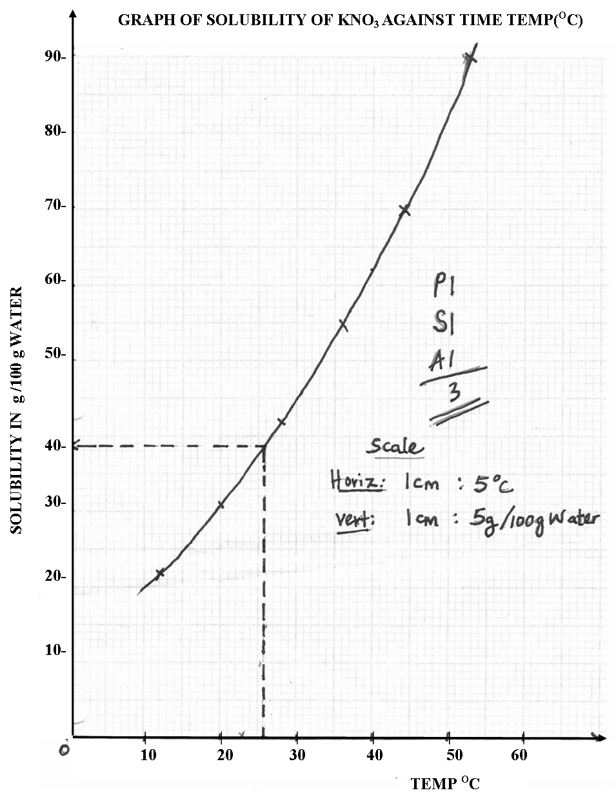

ii)

I: 38.5g/100g water 0.5. ✓ 1mk

II: 23.00C1.00c ✓ 1mk

III: Amount of solute added into water = 80.0g

Amount of solute dissolved (refer graph) = 62.0g✓1mk

Amount remained undissolved = 18.0g✓ 1mk

c) RFM of NaNO3 = 23 + 14 + 3(16) = 85

Solubility of NaNO3 at 150C (refer graph)  25g. ✓1mk

No of moles = ✓ 1mk

i.e. 100cm3 solvent = moles

100cm3 = ? (concentration)

= 2.941M✓1mk