Name________________________________________________Adm.No._________________
Class _____________________

FORM ONE
CHEMISTRY
TIME: 2 Hours

MWAKICAN JOINT EXAMINATION TEAM (MJET) TERM III 2019

Instructions to Candidates

(a) Write your name and admission number.
(b) Answer ALL the questions in this question paper.
(c) All your answers must be written in the spaces provided in this question paper.
(d) Students must answer all questions in English

FOR EXAMINER’S USE ONLY
QUESTIONS | MAXIMUM SCORE | CANDIDATES SCORE
1-27 | 100

INSTRUCTIONS
- Answer all the questions in the spaces provided

- State two advantages of apparatus made of glass in chemistry experiments. (2mks)

- In an experiment a student needs to measure out 36.50cm³ of a solution. Which piece of apparatus would measure this volume most accurately? (1mk)

- A wooden splint was slipped through a region of a particular flame in the laboratory and was burnt as shown in the diagram below.

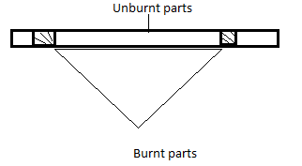

- Name the type of flame the wooden splint was slipped through. (1mk)

- Explain why the splint was burnt as shown above. (1mk)

- State one disadvantage of using the above type of flame in the laboratory. (1mk)

- A paper chromatography of a plant extract gave the following results.
Solvent | Number of spots
A | 5
B | 2
C | 3
D | 1

- Which solvent is the most suitable for purifying the extract? Explain. (2mks)

- State TWO physical properties on which chromatography as a method of separating coloured components of a mixture is based on. (2mks)

- Common salt was added to ice and then the melting point of ice was determined. What were the finding? Explain (2mks)

- Name the type of changes the substances given below undergo
Heat
- Solid wax Liquid wax. (1mk)

Heat
- Blue Copper (II) Sulphate White anhydrous Copper (II) Sulphate +
Water (1mk)

- State two differences between the table below (2mks)
Physical change | Chemical change
- a) What is atmospheric pollution? (1mk)

(b) Name one gaseous pollutant and one solid pollutant (2mks)

- a) State TWO conditions that accelerate rusting. (2mks)

(b) Give one advantage of rusting (1mk)

(c) State TWO ways in which rusting and combustion are similar. (2mks)

- Name TWO methods that can be used to prevent rusting. (2mks)

- a) Acids are said to be ‘corrosive’ what does this term mean? (1mk)

(b) Name three common mineral acids. (3mks)

(c) Name the acids found in
- human stomach (1mk)

- car batteries (1mk)

- lemon juice (1mk)

- making explosives (1mk)

- The set up below was used to react sodium metal with cold water.
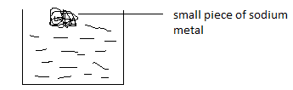

- Why does sodium metal float on water? (1mk)

- State two observations made when the piece of sodium was dropped into the water. (2mks)

- i) What would be observed if red and blue litmus papers were dropped into the resultant solution. Explain (2mks)

ii) Write a word equation for the reaction in (b) above. (1mk)

- State how sodium is stored in the laboratory and give a reason (2mks)

- State whether the following substances are compounds, elements or mixtures. (7mks)
- Air
- Rust
- Iron fillings
- Magnesium oxide
- Milk
- Sugar
- Margarine
- Name the elements present in the following compounds. (3mks)
Compound | Elements
- Sodium Chloride
- Copper (II) Oxide
- Lead Carbonate
- Metal P reacts with an oxide of metal Q but metal R does not. Metal P can remove oxygen from an oxide of S but metal Q cannot. Arrange the metals in order of their reactivity, starting with the most reactive. (2mks)

- A student added a colourless liquid to anhydrous Copper (II) Sulphate, which turned blue. He concluded that the liquid is pure water.
- Why is this conclusion wrong? (1mk)

- Which further test could he carry out to make this conclusion correct? (1mk)

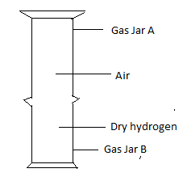
- A gas Jar B was full of dry hydrogen gas while gas Jar A was full of air.

- State the observation made when a burning splint was inserted in gas Jar A after sometime? (1mk)

- What conclusion can you make about the density of hydrogen gas? (1mk)

- A metal A reacts with steam to form an oxide B which is yellow when hot and white on cooling and liberates a gas C.
- Identify A, B and C. (3mks)
A –
B –
C –
- Write the word equation for the reaction of A and steam. (1mk)

- The following set-up was used to investigate the reaction of calcium with water.
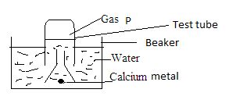

- Identify the colourless gas P. (1mk)

- Write a word equation for the reaction that takes place. (1mk)

- At the end of the reaction a few drops of phenolphthalein indicator were added to the resulting solution. State and explain the observations made. (2mks)

- State the observation that would be made when carbon (IV) oxide is bubbled into about 4cm3 of the resulting solution. (1mk)

- When fish are placed in water that has been boiled and allowed to cool, they die. Explain (1mk)

- Write word equations for the reactions of dilute hydrochloric acid with. (3mks)
- Magnesium

- Sodium Hydroxide

- Potassium Carbonate

- a) Name the solution and the catalyst used in the preparation of oxygen in the laboratory. (2mks)
Catalyst

Solution

- What is a Catalyst?

- Write a word equation for the reaction of the reagents you have named in (a) above. (1mk)

- State two uses of oxygen (2mks)

- The diagram below shows how gases P and Q were collected.
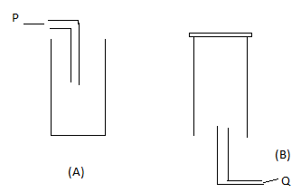

- Name the two methods shown above. (2mks)

- State the properties of P and Q that enable them to be collected using the methods shown above. (2mks)
P –

Q –

- The table below shows the PH values of solutions A,B,C, D and E.
Solution | A | B | C | D | E
PH | 6.5 | 2.0 | 8.5 | 10 | 7.0
- Which solution is likely to be
- Rain water (1mk)

- Wood ash (1mk)

- Sodium chloride (1mk)

- Tooth paste (1mk)

- Which solution will react with magnesium most vigorously? Give a reason. (2mks)

- a) What is a universal indicator? (1mk)

(b) State one disadvantage of an indicator extracted from flowers. (1mk)

- Write word equations for each of the following reactions. (4mks)
- Iron and sulphur
- Magnesium and Chlorine
- Lead and Oxygen
- Carbon and Oxygen
- A student arranged apparatus as shown below to prepare and collect dry hydrogen gas.

- Identify two mistakes in this set-up. (2mks)

- Name one metal that cannot be used in this experiment. Explain. (1mk)

- Name a suitable drying agent that can be used in this experiment. (1mk)

- Write a word equation for the reaction that takes place. (1mk)

- Give a reason why Nitric (V) acid cannot be used in this experiment as an acid. (1mk)

- Give one industrial use of Hydrogen gas. (1mk)

