**MWAKICAN JOINT EXAM TEAM (MJET) –TERM 1 2016**

**N AME ------------------------------------------------- INDEX NO---------------------------------**

**DATE_________________________ CANDIATES SIGNATURE _____________**

**CHEMISTRY**

**FORM 2**

**TIME: 2 1/2 HRS**

**INSTRUCTIONS:**

* **Answer all questions in the spaces provided.**
* **All working must be clearly shown.**

1. The following method shows a method used to protect iron nails from rusting.

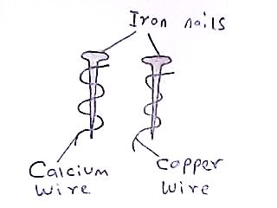

1. What is the chemical name for rust? (1mk)
2. Which nail will rust first? Explain. (2mks)
3. State one application of the reactivity series. (1mk)
4. a) State two types of liquid-liquid mixtures. (1mk)

b) A student mixed the following substances: iron fillings, ammonium

Chloride and sodium chloride salts. How could the student separate the

three substances. (3mks)

1. Element X can be represented as follows; 4019X.
2. What does figure 40 indicate? (1mk)
3. Write the electronic configuration of element X. (1mk)
4. Is element X a metal or a nonmetal? Explain. (2mks)
5. a) Give the name or the use of the following laboratory apparatus: (3mks)

|  |  |  |  |
| --- | --- | --- | --- |
| NAME | Stop watch | Wash bottle |  |
| USE |  |  | Crush substances |

b) Why is round bottomed flask preferred during heating of liquids than flat bottomed flask? (1mk)

1. Write the chemical formula of the following compounds. (3mks)
2. Ammonium nitrate
3. Sodium carbonate
4. Water
5. The following illustrations show various gas collection methods. Name the method and state one gas that can be collected by the method. (4mks)

A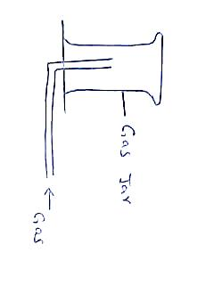 B

Method………………… Method…………………

Gas…………………….. Gas……………………..

1. a) What is drug abuse? (1mk)

b) State two effects of drug abuse to a person. (2mks)

1. The following is the periodic table of elements. Letters do not represent actual symbols.

|  |  |  |  |  |  |  |  |  |  |  |
| --- | --- | --- | --- | --- | --- | --- | --- | --- | --- | --- |
|  |  |  |  |  |  |  |  |  |  |  |
|  | A |  |  |  |  |  |  |  | P |  |
| S | Q | Y | | |  |  |  |  | T |  |
|  | Z |  | | | | | |

1. Use a cross (X) to indicate the position of sulphur on the table. (1mk)
2. Draw the structure of the most stable ion of element Q. (2mks)
3. Compare the atomic radius of element A and element Z. Explain your answer. (2mks)
4. What name is given to elements that occupies region Y in the periodic table? (1mk)
5. Element Z is a good conductor of electricity. Why is it a good conductor of electricity? (2mk)
6. What is the valency of element P? (1mk)
7. To which period does element A belong? (1mk)
8. Hydrogen may be grouped as group I or group VII element. Give reasons why it can be grouped as group I element. (1mk)
9. The following set up was set to study properties of hydrogen gas.



1. What property of hydrogen gas was being studied? (1mk)
2. State the observation made in the combustion tube? (1mk)
3. Write the chemical equation for the reaction that took place in the combustion tube. (2mks)
4. An element Q has three isotopes as follows;3618Q,3818Q and 4018Q with percentage abundances of 0.34% , 0.06% and 99.6%respectively. Calculate the relative atomic mass of element Q. (3mks)
5. The following diagram shows a wooden splint that was put across a non-luminous flame.



1. Explain the appearance of the wooden splint. (2mks)
2. Give one disadvantage of a luminous flame. (1mk)
3. State the change underwent by the following matter. (3mks)

|  |  |
| --- | --- |
| MATTER CHANGE | TYPE OF CHANGE |
| Melting of candle wax |  |
| Rusting of iron nails |  |
| Heating blue copper( ii)sulphate crystals to form white anhydrous copper(ii)sulphate |  |

1. a) What are Halogens? (1mk)
2. State one use of the following elements. (2mks)
3. Chlorine
4. Sodium
5. The following is a heating curve of a substance T.

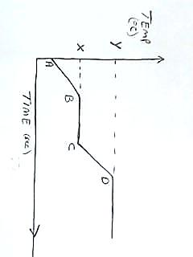

1. What name is given to temperature Y? (1mk)
2. What is the physical state of substance T between A and B? (1mk)
3. Is substance T pure or impure? Give reason for your answer. (2mks)
4. The following are Ph values of solutions A, B and C.

|  |  |
| --- | --- |
| Ph. | Solution |
| 1 | A |
| 8 | B |
| 7 | C |

1. Which solution represents: (2mks)
2. sodium hydroxide
3. Distilled water
4. Write a chemical equation for the reaction between magnesium metal and dilute hydrochloric acid. (2mks)
5. The following are the first and second ionization energies of calcium.

1stIonisation energy = 590 KJ/Mol

2ndIonisation energy = 1150KJ/Mol

Explain the difference in first and second ionization energies of calcium. (3mks)

1. The following set up shows the laboratory preparation of oxygen gas.



Liquid P

Manganese (IV) oxide

1. Identify liquid P. (1mk)
2. What is the use of Manganese (IV) oxide? (1mk)
3. State one use of oxygen gas. (1mk)
4. Fill and complete the following table of sub-atomic particles. (3mks)

|  |  |  |
| --- | --- | --- |
| SUB-ATOMIC PARTICLE | CHARGE | WHERE FOUND IN THE ATOM |
| protons |  |  |
|  |  | Outside the nuclear |
|  | neutral |  |

1. a) State the advantage of universal indicator over simple acid-base

Indicator. (1mk)

b) Why is plant extracts not the best type of indicator to use in the lab. (1mk)

1. State two types of organic acid. (2mk)
2. Arrange the following elements in order of their reactivity, starting from the least to most reactive element: potassium, hydrogen and calcium. (3mks)
3. The following diagram is a chromatogram developed by ink A and ink B.

|  |
| --- |
|  |
| **.**  **.**  **.** |
| A B C |

Chromatogram

Paper

1. Ink C is a mixture of ink A and B. On the paper indicate the chromatogram that would be developed by ink C. (3mks)