NAME …………………………….. Candidate’s Sign. ……..…
233 Date ………………………..
CHEMISTRY
TIME: 2 HOURS

MWAKICAN FORM 2 JOINT EVALUATION – 2016 TERM III

CHEMISTRY
PAPER – 233
TIME: 2 HRS

INSTRUCTIONS TO CANDIDATES
- Write your name and admission number in the spaces provided above.
- Sign and write the date of examination in the spaces provided.
- ANSWER ALL QUESTIONS IN THE SPACES PROVIDED.
- All working must be clearly shown where necessary.

FOR EXAMINER’S USE ONLY

QUESTIONS | MAXIMUM SCORE | CANDIDATE’S SCORE
1 - 28 | 100

- The electron arrangement of ions X³⁺ and Y²⁻ are 2.8 and 2.8.8 respectively.
- Write the electron arrangement of elements X and Y.
X - (1 mk)

Y - (1 mk)

- Write the formula of the compound that would be formed between element X and Y. (1 mk)

- Study the equation below;
Mg_{(s)} + ZnO_{(s)} MgO_{(s)} + Zn_{(s)}
- By use of arrows, indicate oxidation and reduction reactions in the equation. (2 mks)

- Name the reducing agent in the above reaction. (1 mk)

- Distinguish between the terms deliquescent and efflorescent salts. (2 mks)

- The table below shows PH value of different solutions.
Solution | A | B | C | D
PH | 14 | 7 | 2 | 11
- Which solution is likely to be sugar solution? (1 mk)

- Two of the solutions were found to react with both aluminium oxide and zinc oxide. Identify the two giving reasons. (2 mks)

- Identify the methods that are most appropriate to obtain. (3 mks)
- Oil from coconut

- Diesel from crude oil

- Sugar crystals from sugar solution

- An element Q has an electron arrangement of 2.8.5 (a) Identify the group and period to which it belongs.
Group - (1 mk)

Period - (1 mk)
(b) is element Q a metal or a non-metal? (1 mk)

- Carbon has two isotopes namely $\begin{matrix}14 \\ 6\end{matrix}C and \begin{matrix}12 \\ 6\end{matrix}C$. Calculate the relative abundance of these two isotopes if the relative atomic mass of carbon is 12.4. (3 mks)

- The diagram below shows how two gases, P and Q were collected.
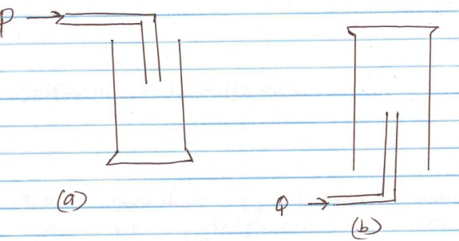

- Name the two methods shown above.
a - (1 mk)

b - (1 mk)

- State the property of Q that enables it to be collected as shown above. (1 mk)

- Give an example of a gas that is collected using the method shown in (b) above. (1 mk)

- State and explain the changes in mass that occur when the following substances are separately heated in open crucibles.
- Copper metal (1 ½ mk)

- Copper (ii) Nitrate (1 ½ mks)

- The structure of water molecule can be represented as shown below.
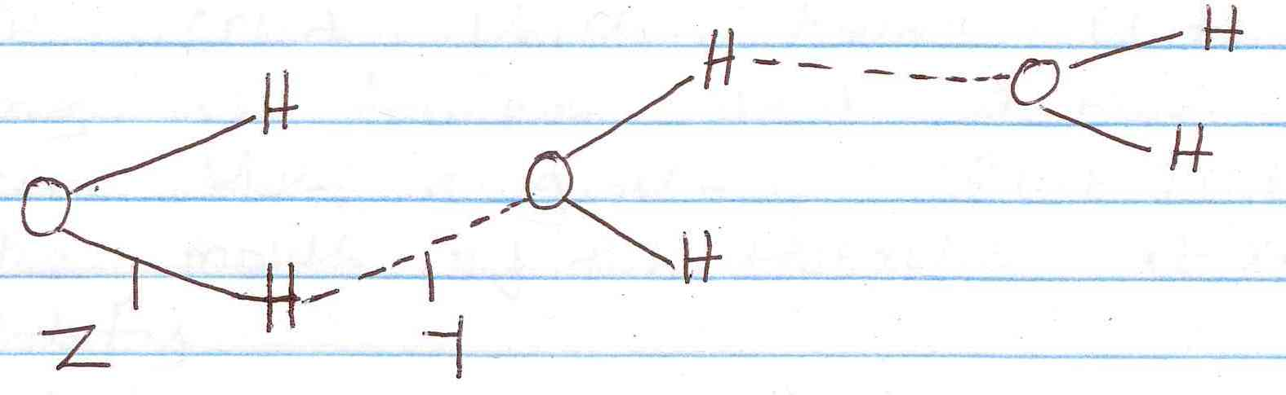

(a) Name the type of bonds represented by letters Y and Z.
Y – (1 mk)

Z - (1 mk)

- Element R has a valency of 2, element Q has a valency of 1 while element B has a valency of 3. Write the chemical formulae of their sulphates, phosphates and nitrates. (4½ mks)
Element | Sulphates | Phosphates | Nitrates
R
B
Q
- When a white solid X is heated, a yellow solid which turns white on cooling is formed and a brown gas is seen. When a glowing splint is placed at the mouth of the test-tube it relights.
- Identify;
- Solid X - (1 mk)

- The brown gas - (1 mk)

- Write an equation for the decomposition of solid X. (1 mk)

- Below is a structure of aluminium chloride.
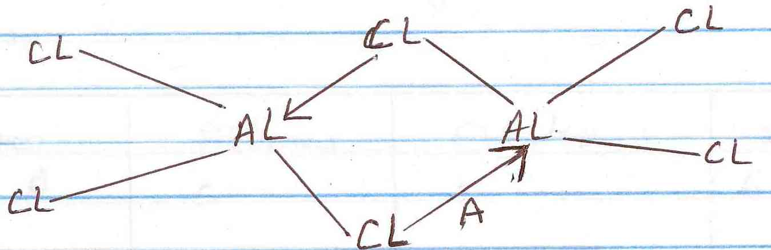

- Identify bond A. (1 mk)

- State the observations made when aluminium chloride solution is tested with blue and red litmus paper. Explain. (2 mks)

- Which particles conduct electricity in;
- Molten lead (ii) bromide (1 mk)

- Aqueous sodium chloride (1 mk)

- Graphite (1 mk)

- The following table gives the structures of the different atoms. Study it and answer the questions that follow. (A, B, C, D and E do not represent the actual symbols of the elements).
Atom | Protons | Electrons | Neutrons
A | 5 | 5 | 6
B | 9 | 9 | 10
C | 10 | 10 | 11
D | 15 | 15 | 16
E | 10 | 10 | 12
- What is the mass number of atom B? (1 mk)

- Which of the atoms has a mass number of 11? (1 mk)

- Which of the atoms represent isotopes of the same element. (1 mk)

- Study the following flow chart and answer the questions that follow.
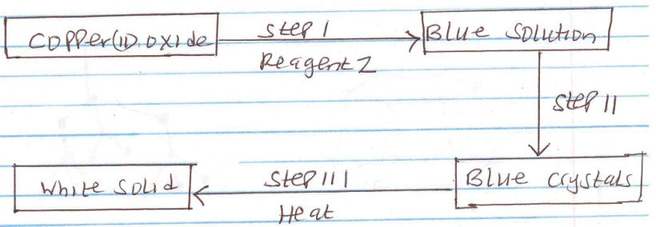

(a) (i) Identify reagent Z. (1 mk)

(ii) Identify the white solid. (1 mk)

(b) Write a chemical equation for the formation of the blue solution. (1 mk)

- State two properties that makes aluminium to be used in making of overhead electric cables. (2 mks)

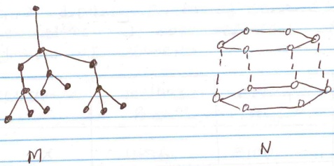
- The structures below represent two allotropes of carbon. Study them and answer the questions that follow

- Identify the allotropes labeled
M - (1/2 mks)

N - (1/2 mks)

- Explain in terms of structure and Bonding which of the two allotropes;
- Conducts electricity. (1 mk)

- Is used in making drilling equipments. (1 mk)

- (a) Name two conditions which accelerate rusting. (2 mks)

(b) State ONE method used for preventing rusting. (1 mk)

- The information below gives melting points of some substances. The letters do not represent the actual symbols of elements.
Substance | Melting point ⁰C | Boiling point ⁰C
X | 1536 | 3100
Y | 65 | 1115
Z | -40 | 361
P | -218 | -190
Q | 99 | 890
R | 116 | 445
- Identify any two substances that are solids at room temperature (25⁰C). (2 mks)

- Identify a substance that is a liquid at room temperature. (1 mk)

- Identify a substance that remains as a liquid over the widest range of temperature. (1 mk)

- (a) The following diagram shows how oxygen can be prepared and collected in the laboratory.
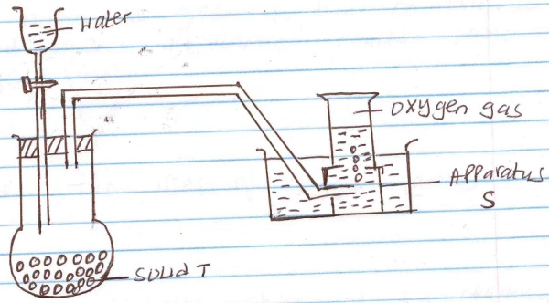

- Name;
I apparatus S - (1 mk)

II solid T - (1 mk)

- Why is it possible to collect oxygen as shown in the diagram? (1 mk)

- Explain why it is important NOT to collect any gas for the first few seconds of the experiment? (1 mk)

- Write an equation for the reaction that takes place. (1 mk)

(b) What name is given to the compounds formed when an element reacts with oxygen? (1 mk)

(c) State TWO uses of oxygen. (2 mks)

- Name the salts obtained by reacting;
- Zinc oxide with dilute sulphuric (vi) acid. (1 mk)

- Sodium carbonate with nitric acid. (1 mk)

- Potassium carbonate and dilute hydrochloric acid. (1 mk)

- (a) The table below shows properties of some substances.
Substance | Melting point (⁰C) | Boiling point (⁰C) | Electrical conductivity
 |  |  | Solid | Liquid
A | -112 | -107 | Poor | Poor
B | 801 | 1413 | Poor | Good
C | 97.5 | 880 | Good | Good
D | 44 | 280 | Poor | Poor
E | 1700 | 2200 | Poor | Poor
F | -110 | 46.3 | Poor | Poor
Select a substance which;
- Has a giant ionic structure. (1 mk)

- Is a metal (1 mk)

- Has a giant atomic structure. (1 mk)

(b) Using dots(.) and crosses (x) illustrate bonding in ammonia molecule (NH₃). (N=7, H=1) (2 mks)

- When a student was stung by a nettle plant, a teacher applied an aqueous solution of ammonia to the affected area of the skin and the student was relieved of the pain. Explain. (1 mk)

- (a) The information below is on four elements represented by letters P, Q, R and S. study it and answer the questions that follow. Q reacts with dilute acids but not with acids. S displaces P from its oxide and P reacts with cold water. Arrange the elements inorder of increasing reactivity. (1½ mks)

(b) State ONE reason why Helium is preffered to hydrogen in weather balloons. (1 mk)

- The set up below shows the reaction between dry chlorine gas and iron wool.
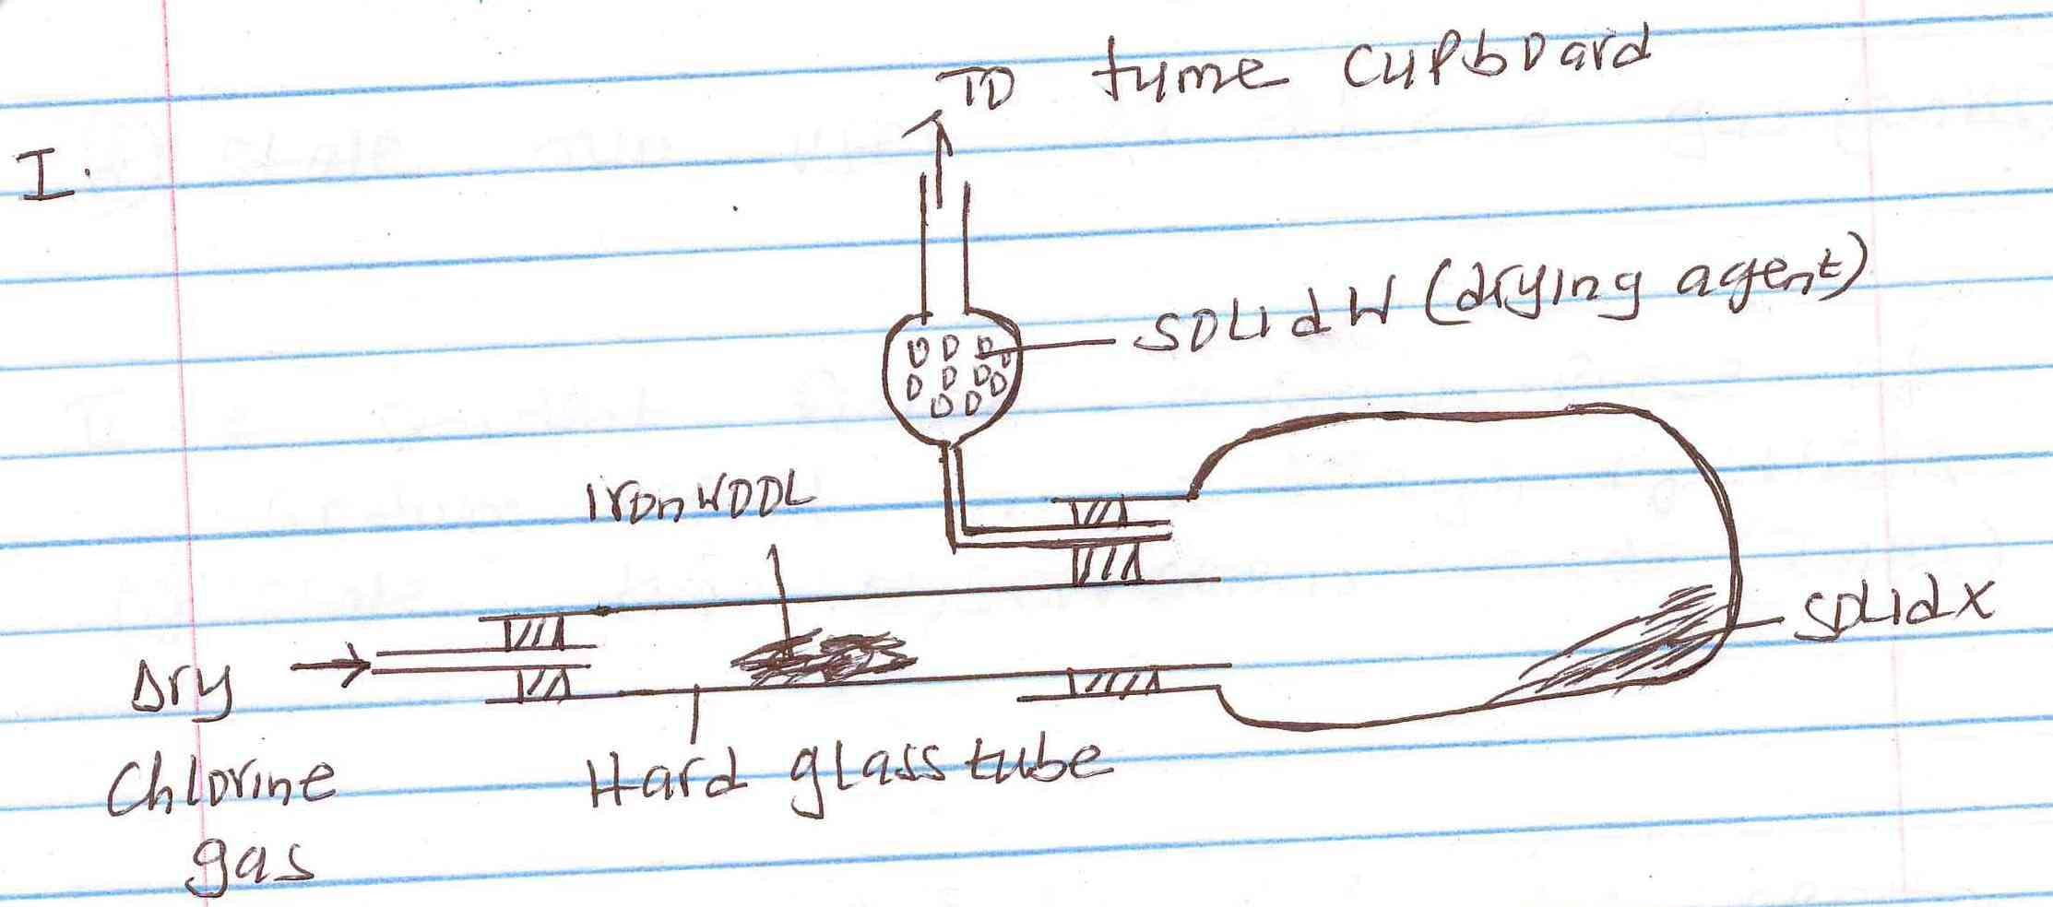

- Give one essential condition that is missing in the set up. (1 mk)

- Why is it not advisable to release excess chlorine gas in the atmosphere? (1 mk)

- Write a chemical equation for the formation of solid X. (1 mk)

- Name solid W and state why it is necessary. (2 mks)

- Give the formula of the product formed if iodine vapour is reacted with heated iron wool. (1 mk)

- State two uses of chlorine gas. (2 mks)

(ii) A student placed a small piece of sodium metal in a trough of water.
- State two observations made? (2 mks)

- Write a chemical equation for the reaction that took place. (1 mk)

- The products formed by action of heat on nitrates of elements A, B and C are shown below.
Nitrates | Products formed
A | Metal oxide + Nitrogen(iv)oxide + Oxygen
B | Metal + Oxygen + Nitrogen(iv)oxide
C | Metal nitrite + Oxygen
- (a) Arrange the metals inorder of increasing reactivity. (1 mk)

(b) Which element forms a soluble carbonate? (1 mk)

(c) Give an example of element B. (1 mk)

- (i) Write an equation to show the effect of heat on each of the following;
- Sodium hydrogen carbonate. (1 mk)

- Copper(ii)carbonate (1 mk)

- The graph below shows the curve obtained when water at 20⁰C was heated for 15 minutes.
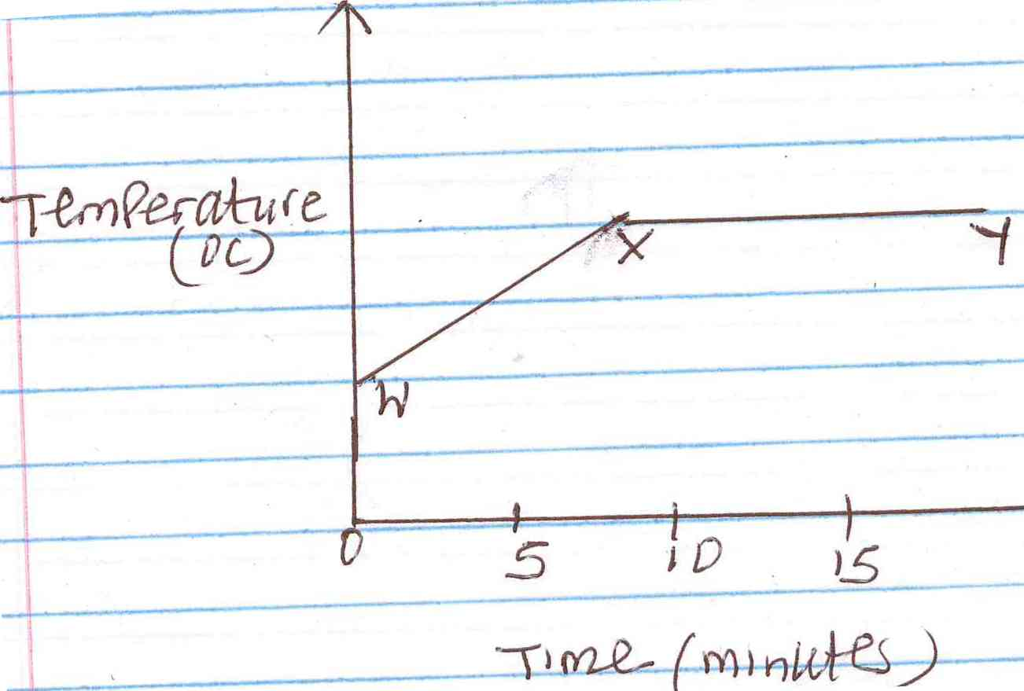

- What happens to water molecules between point W and X? (1 mk)

- In which part of the curve does change of state occur? (1 mk)

- Explain why the temperature does not rise between point X and Y. (1 mk)

- Which test would be used to check if water is pure? (1 mk)

