NAME ………………………………………….. ADM NUMBER…………………………..
SIGNATURE……………………………..
DATE..........................................................
233/2
CHEMISTRY
PAPER 2 (THEORY)
TIME: 2 HOURS
2ND TERM 2016.

MWAKICAN FORM 3 JOINT EXAMINATION – 2016

INSTRUCTIONS TO CANDIDATE
- Write your name and admission number in the spaces provided.
- Sign and write the date of examination in the spaces provided.
- Answer all the questions in the spaces provided.
- All working must be shown where necessary.
- Electronic calculators and Mathematics tables may used.

FOR EXAMINERS USE ONLY

Questions | Max score | Candidates score
 | 13
 | 10
 | 11
 | 14
 | 11
 | 10
 | 11
TOTAL | 80

QUESTIONS
- The grid below represents part of the periodic table, Study it and answer the questions that follow. The letters do not represent the actual symbols of the elements.

 | Y |  |  | C | D |  | E
F | G
 |  |  |  |  |  |  | H
- Name the elements (letters) that can form anions with a change of -1.Give reason for your answer. (2mks)

- What type of structure is formed by oxide of C. Explain. 2mks

- How does the reactivity of H compare with that of E. Explain. 2mks

- 1.3 g of Y reacts completely with 1.2dm³ of chlorine when reacted at S.T.P (Molar gas volume at s.tp=22.4dm³ ).
- Write a balanced chemical equation for the reaction between y and chlorine gas.(2mks)

- Determine the atomic mass of Y. 2mks

- What is the general name given to the group of elements Y and G belong.(1mk)

- Using dot(.) and crosses (x) draw a diagram to represent the compound formed when G and E react.(2mks)

- The set up was used by a student from Karia High School to prepare and collect dry hydrogen gas.

- Identify three mistakes in this set up and the solution.(3mks)

- Name liquid B 1mk

- Suggest a possible solid which can be used as solid N in the set up ;

- Name a suitable catalyst in this reaction.(1mk)

- Hydrogen produced can be passed over heated lead(II) oxide to determine one property of this gas.
- What property of hydrogen is determined in (e) above. 1mk

- Write down the chemical equation in (e) above. 1mk

- State two uses of Hydrogen gas. (2 mks)

- The diagram below shows Chromatograms for five different dye.
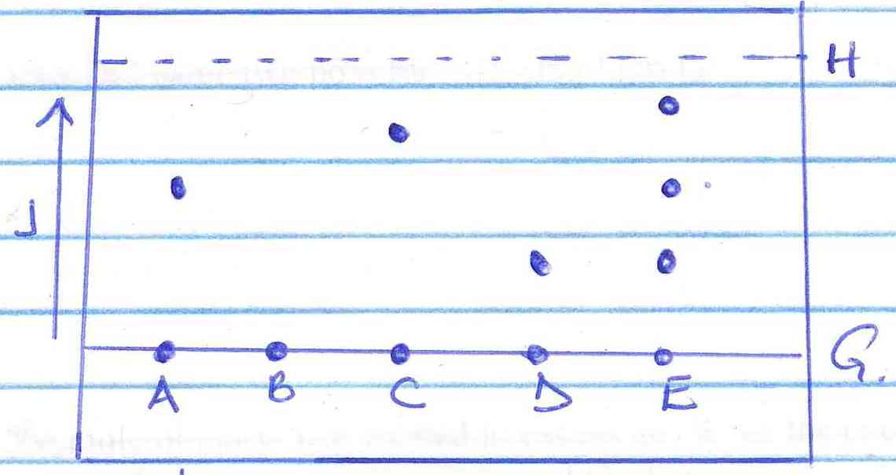

- Name the technique used to separate the dyes. (1 mk)

- What conditions are required to separate the chromatograms present in a dye. (2 mks)

- What is meant by the solvent front. Indicate its position in the diagram. (2 mks)

- Which chromatograms are present in dye E. (2 mks)

- Which dye is insoluble. Explain. (1 mk)

- Which dye is pure. Explain. (1 mk)

- Name two industrial application of chromatography. (2 mks)

- Use the flow chart below to answer the questions that follow.

R

- Name the process shown by the flow chart above. (1 mk)

- Name substances A

B

C

D

Gas x 5mks
- Name process (2 mks)
Q -

R -

- Write chemical equations for the reactions that take place.
- Step 4

- Step 7

- Name two substances that are recycled during the process. 2mks

- State two uses of sodium carbonate.(2mks)

- Study the scheme below and answer the questions that follow.
Substance Z

Excess Cl₂
Step (III)

Excess Cl₂
Step (VI)
Reagent B
160⁰C
Process Q
Step I
Step IV
Heat
Reagent A
CH₃CH₂OH
T
CH₂=CH₂
P
C₂H₆
C₂H₅COONa

Step (v)
Process W

Substance K and L

H
H

-C- C-

H
H
n

- State the homologous series in which T and P belong. (2 mks)
T-

P-
- Write chemical equation for complete combustion of T. 1mk

- Name process Q ……………………… (1 mk)

Process W (1 mk)

- Name the type of reaction that occurs in
Step I (1 mk)

Step III (1 mk)

Step VI (1 mk)

- Identify reagent B……………………………… (1 mk)

Reagent A…………………………………….. (1 mk)

- Write a chemical equation between reagent A and C₂H₅COONa. (1 mk)

- The diagram below represents a set up that can be used to prepare and collect nitrogen (iv) oxide.

- Write a chemical equation for the reaction that takes place in the boiling tube. (1 mk)

- Name gas x. (1 mk)

- What observations are made on final residue in the boiling after reaction on heating and cooling the residue. 1mk

- When a piece of burning magnesium is lowered into a gas jar containing nitrogen (IV) oxide it continues to burn.
- Explain the observation

- Write a chemical equation for the reaction.(1mk)

- What precaution should be taken when preparing nitrogen (IV) oxide gas, Explain. 1mk

- Explain why it is not advisable to use copper (II) nitrate instead of lead (II) nitrate. 1mk

- What property of nitrogen (IV)oxide makes it possible to be collected by the method above.(1mk)

- State one use of nitrogen(iv)oxide. (1 mk)

- During an experiment, sulphur (IV) oxide was found to diffuse through a porous material at a rate of 25.00cm³ per minute. When the experiment was repeated under the same conditions with another gas G.G was found to diffuse through the same porous material at a rate 26.26cm³ per minute.
- State Graham’s law of diffusion.(1mk)

- Determine the molecular mass of G.(O=16.0,S=32.0) (3 mks)

- The following table gives sample results from an experiment carried out to investigate the relationship between the volume of a fixed mass of gas with its temperatures.
Temp ⁰c | 0 | 20 | 40 | 60 | 80
Volume of the gas(cm³) | 140 | 150 | 160 | 170 | 180

- Plot a graph of volume (y-axis) against temperature (x-axis). Extrapolate the graph to intercept the x-axis. 3mks

- Identify the and state the law. 2mks

- Determine from the graph
- Volume of gas at 50 ⁰c. 1mk

- Temperature when the volume is 155cm³ 1mk

