NAME …………………………….. INDEX NO. ……..…
DATE ……………………………. CLASS ……………..
MWAKICAN FORM 3 JOINT EXAMINATION – 2016 TERM I

233/1
CHEMISTRY
PAPER 1
(THEORY)
TERM 1 2016 FORM THREE
2 HRS
INSTRUCTIONS TO CANDIDATES
- Write your name in the space provided.
- Answer all the questions in the spaces provided in the question paper.
- Mathematical tables and silent electronic calculators may be used.
- All working must be clearly shown where necessary.

QUESTIONS | MAXIMUM SCORE | CANDIDATE’S SCORE
1 – 29 | 80

- The electron arrangement of ions X³⁺ and Y²⁻ are 2.8 and 2.8.8 respectively.
- Write the electron arrangement of elements X and Y. (2 mks)
X - (1 mk)

Y - (1 mk)

- Write the formula of the compound that would be formed between element X and Y. (1 mk)

- Oxygen is obtained by fractional distillation of liquid air.
- Name two other gases obtained during this process. (2 mks)

- Give two commercial use of oxygen. (2 mks)

- (a) Explain why a burning magnesium ribbon continues to burn when placed in a gas jar containing carbon (iv) oxide gas but a burning splint is extinguished. (2 mks)

(b) Write an equation for the reaction that takes place in (a) above. (1 mk)

- Study the scheme below and then answer the questions that follow;
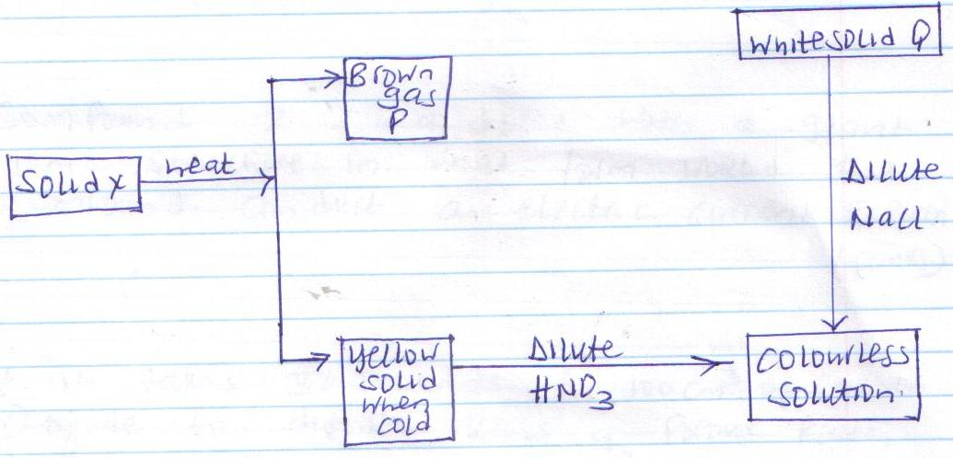

- Identify;
- Solid X. (1 mk)

- Yellow solid (1 mk)

- Write an ionic equation for the reaction between dilute sodium chloride and the colourless solution. (1 mk)

- (a) What are isotope? (1 mk)

(b) The R.A.M of element P is 63.5 it has two isotopes of masses 63 and 65 respectively. Determine the percentage abundance of each. (2 mks)

- Compound Z is a solid with a giant ionic structure in what form would the compound conduct an electric current. Explain. (2 mks)

- If it takes 30 seconds for 100cm³ of Carbon(iv)oxide to diffuse across a porous plate, how long will it take 150cm³ of nitrogen (iv) oxide to diffuse across the same plate under similar conditions? (C=12.0, N=14.0, O=16.0). (3 mks)

- (i) An oxide of an element Q was found to react with both HCl and NaOH. What property does the oxide exhibit? (1 mk)

(ii) Give two examples of oxides that behave like the oxide of Q. (2 mks)

- Use dot(and cross(x) diagrams to show the bonding in each of the following;
- Lithium oxide (Li=3, O=8) (1 mk)

- PH₄⁺ (P=15, H=1) (2 mks)

- Study the table below and answer the questions that follow.
Solid | Cold water | Hot water
P | Soluble | Soluble
Q | Insoluble | Insoluble
R | Insoluble | Soluble
Describe briefly how a pure sample of the solids can be obtained from a mixture of the three. (3 mks)

- 0.045 mole of a certain hydrocarbon gave on complete combustion 9.9 g of carbon(iv)oxide and 4.86g of water. Calculate its molecular formula. (C=12, H=1) (3 mks)

- Study the information below and use it to answer the questions that follow.
Ion | Electronic arrangement | Ionic radius
Na⁺ | 2.8 | 0.095
K⁺ | 2.8.8 | 0.133
Mg²⁺ | 2.8 | 0.065
Explain why the ionic radius of:
- K⁺ is greater than that of Na⁺. (1 mk)

- Mg²⁺ is smaller than that of Na⁺. (1 mk)

- Define the term ionization energy. (1 mk)

- When 34.8g of hydrated sodium carbonate Na₂CO₃.XH₂O were heated to a constant mass, 15.9g of anhydrous sodium carbonate (Na₂CO₃) were obtained. Calculate the value of X in the hydrated carbonate. (Na=23, O=16, C=12, H=1). (3 mks)

- When carbon (iv) oxide gas was passed through aqueous calcium hydroxide a white precipitate was formed.
- Write an equation for the reaction that took place. (1 mk)

- State and explain the changes that would occur when carbon (iv) oxide gas is bubbled through the white suspension. (2 mks)

- Some zinc sulphate crystals were heated to constant mass with the following results obtained.
Mass of crucible = 20.00 g
Mass of crucible and crystals = 25.74g
Mass of crucible and residue = 23.32 g
From the Data, calculate the value of X in the formula ZnSO₄.XH₂O. (Zn=65, S=32, O=16, H=1) (3 mks)

- Study the set up below and answer the questions that follow.
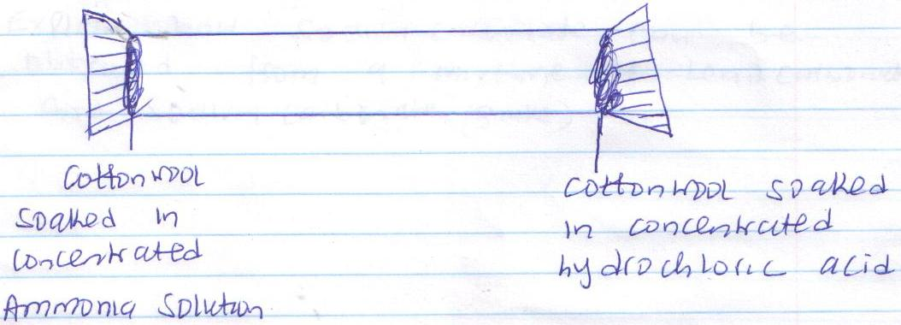

- What is the aim of the above experiment? (1 mk)

- State the observations made after sometime? (1 mk)

- Write an equation for the reaction taking place in the above set up. (1 mk)

- A compound has an empirical formula C₃H₆O and a relative formula mass of 116. Determine its molecular formula. (H=1.0, C=120, O=16.0) (2 mks)

- Explain how sodium carbonate can be obtained from a mixture of lead carbonate and sodium carbonate. (3 mks)

- A pure solid sample was heated and a graph of temperature against time obtained as shown below.
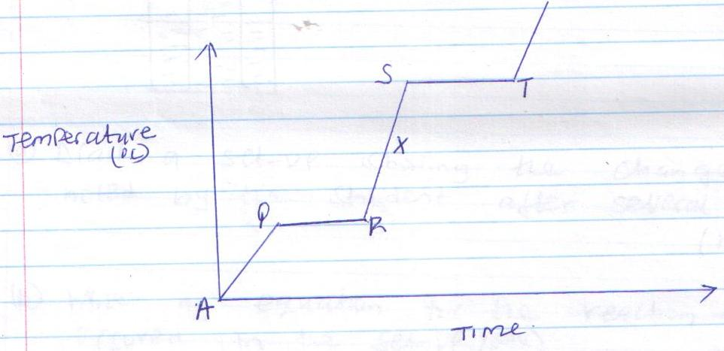

- Which regions on the curve represent the melting and boiling processes? (1 mk)

Melting (1/2 mk)

Boiling (1/2 mk)

- Explain why temperature remains constant at region ST. (1 mk)

- In which state of matter will the sample be at point X. (1 mk)

- A form two student used the set-up below to investigate the effect of sunlight on chlorine water.
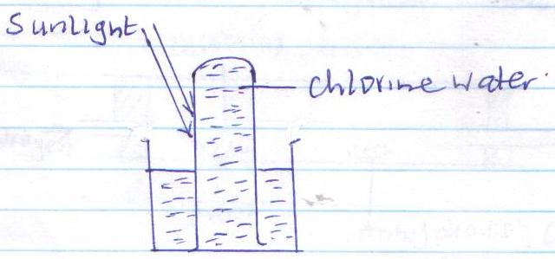

- Draw a set-up showing the change noted by the student after several hours. (1 mk)

- Write an equation for the reaction that occurred in the set-up. (1 mk)

- The table below shows the melting and boiling points of impure solid Q.
Substance | Melting point (0C) | Boiling point (0C)
 | 140-180 | 240-280
Identify the melting and boiling points of pure substance Q.
- Melting point (1 mk)

- Boiling point (1 mk)

- Study the diagram below;
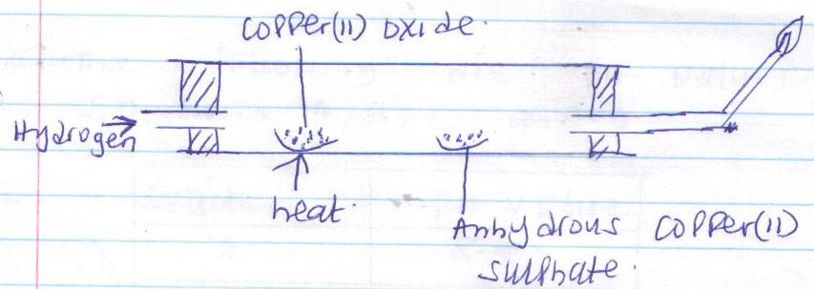

- State two observations made after sometime. (2 mks)

- Write one equation showing a reaction taking place in (a) above. (1 mk)

- Molten Zinc Chloride was electrolysed using graphite electrodes.
- State the observation made at the anode. (1 mk)

- Write equations for the reaction occurring at each of the electrode.
Cathode (1 mk)

Anode (1 mk)

- Describe how the following reagents would be used to prepare barium sulphate: solid sodium sulphate, distilled water, barium carbonate and dilute nitric(v)acid. (3 mks)

- The following are PH values of some solutions A, B, C and D.
Solution | PH value
A | 8.5
B | 4.5
C | 2.0
D | 12

- With the highest concentration of hydroxide ions. Explain. (2 mks)

- Which may be tooth paste. (1 mk)

- State two applications of electrolysis. (2 mks)

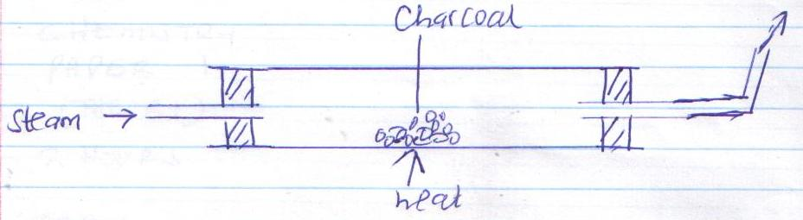
- When steam was passed over heated charcoal as shown in the diagram below a certain reaction took place.

- Write the equation for the reaction which took place. (1 mk)

- Name two uses of carbon (ii) oxide gas, which are also uses of hydrogen gas. (2 mks)

- (a) State the observation made when chlorine gas is bubbled through a solution of potassium iodide. (1 mk)

(b) Write an ionic equation for the reaction in (a) above. (1 mk)

- Give the reason why Helium is used in weather balloons. (1 mk)

