***NAME:****____________________________****INDEX NO:****_____________*

***SCHOOL:****________________________________****DATE****:___________*

***CHEMISTRY THEORY MARKING SCHEME***

***SEPT/OCTOBER 2021.***

***TIME: 2 HOURS.***

***KENYA CERTIFICATE OF SECONDARY EDUCATION***

***AMUKURA PARISH***

***FORM TWO***

***Instructions to Candidates.***

*a) Write your name, school and class in the spaces provided.*

*b) All working must be clearly shown.*

*c) Mathematical tables and electronic calculators may be used.*

*d) Answer all the questions.*

*Candidates must answer all questions in ENGLISH*

***FOR EXAMINER’S USE ONLY***

|  |  |  |
| --- | --- | --- |
| ***QUESTION*** | ***MAXIMUM SCORE*** | ***CANDIDATES SCORE*** |
| *1-14* | *80* |  |

1. **The diagrame bellow shows the heating curve of a pure substance.**

**Sturdy it and and answer the questions that follow**

** X z**

**time in minutes**

1. **What physical changes are taking place at points X and Z?(2mks)**

*x-solid to liquid*

*z-liquid to gas*

1. **Explain what happens to the melting point of the substance when sodium chloride is added. (2mks)**

*It lowers the melting because it act as an impurity*

1. **(a) State two differences between luminous flame and non-luminous flame (2mks)**

*Luminous produced when the airhole is completely closed while non-luminous produced when the air hole is completely opened*

*Luminous has four zones while non-luminous has three zones*

*Luminous is wavy while non-luminous is steady*

**(b)It is advisable to set a Bunsen burner to luminous flame prior to an experiment. Explain (2mks**

*To avoid burns,because luiminous flame can easily be seen because of its large bright yellow flame*

*To avoid wastage of gas*

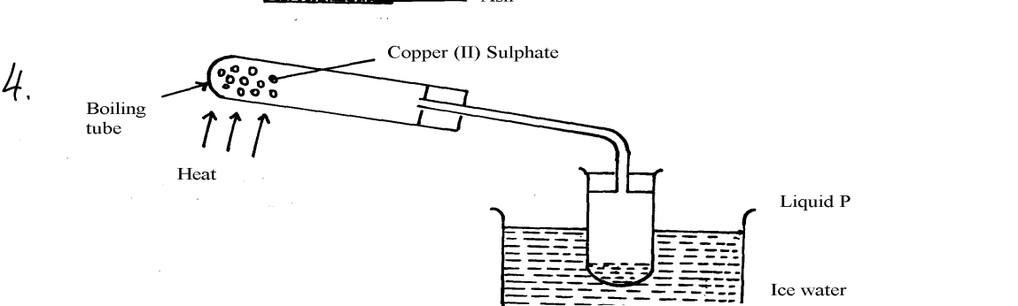**3. The apparatus below were used by a student to study the effect of heat on hydrated copper II sulphate.**

1. **Name liquid P (1mk)**

*water*

1. **What is the role of ice cold water (1mk)**

*To condense water vapour into colourless liquid water*

1. **What observation is made in the boiling tube (1mk)**

*Blue colour ofm hydrated copper II sulphate turns to white*.

**4. Given a mixture of lead (II) oxide, ammonium chloride and sodium chloride, describe how this mixture can be separated to obtain a sample of each (3mks)**

*Heat the mixture to sublime ammonium chloride*

*Add water to the remaining mixture and stir to allow sodium chloride to dissolve.*

*Filter to obtain lead II oxide as residue and sodium chloride as filtrate.*

*Evapourate the filtrate of sodium chloride by heating to crystals of sodium chloride.*

**5. (a) Flower extracts can be used as Acid-base indicators. Give two limitations of such indicators (2mks)**

*They cannot tell the strength of the acid and bases*

*They are not long lasting,easily decomposes.*

**(b) The diagram below shows spots of pure substances A, B, and C on chromatograph paper. Spot D is that of a mixture. After development A, B, and C were found to have moved 9cm3, 4cm3 and 7cm3. Respectively. D separated into two spots which have moved 7cm3 and 9cm3:-**

** On the diagram:-**

1. **Label the baseline and solvent front (2mks)**

As shown on the diagram.

1. **Show the position of all the spots after development (3mks)**

As shown on ther diagram.

**III Identify the substances present in mixture D (2mks**

*A and C*

**6. A beekeeper found that when stung by a bee, application of a little solution of sodium hydrogen carbonate helped to relieve the irritation of the affected area. Explain (2mks)**

*Sodium hydrogen carbonate is a base that neutralizes the acid from the bee sting hence leading to pain relieve.*

**7. Oxygen is obtained on large scale by the fractional distillation of air as shown on the flow chart** 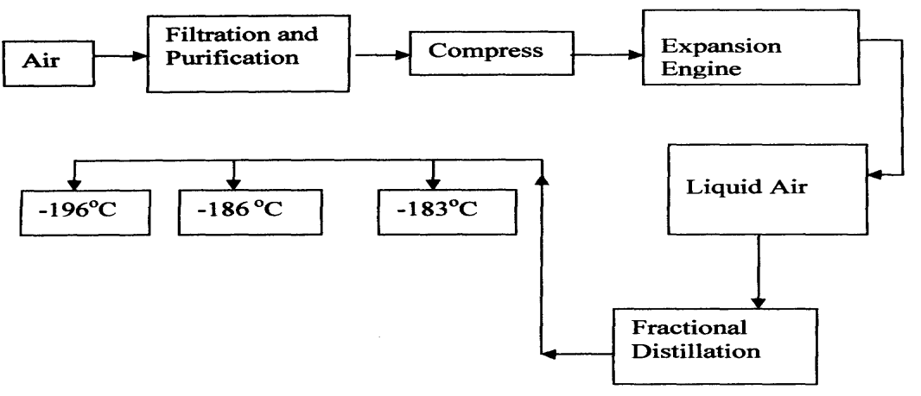

1. **Identify the substance that is removed at the filtration stage (1mk)**

*Dust particles.*

1. **Explain why Carbon (IV) oxide and water are removed before liquefaction of air (1mks)**

*Carbon IV oxide and water are part of impurities*.

1. **Identify the component that is collected at -186°C (1mk)**

*Rare gases/Argon/neon*

**8. Hydrogen can be prepared by reacting zinc with dilute hydrochloric acid.**

1. **Write an equation for the reaction.(1mk)**

$2HCL + Zn → ZnCl2 + H2$

1. **Name an appropriate drying agent for hydrogen gas. (1mk)**

*Concentrated sulphuric VI acid*

1. **Explain why copper metal cannot be used to prepare hydrogen gas.(2mks)**

*Copper metal is less reactive hence cannot displace hydrogen from hydrochloric acid*

1. **Hydrogen burns in oxygen to form an oxide.**
2. **Write an equation for the reaction. (1mk)**

$H2 + 1/2O2 → H2O$

1. **State two precautions that must be taken before the combustion begins and at the end of the combustion. (2mks)**

*Drying out of air from the apparatus to ensure that hydrogen burned is pure to avoid explosion*

*Excess hydrogen gas is burned because its mixture with oxygen is explosive when when heated.*

1. **Give two uses of hydrogen gas. (2mks)**

*Manufacture of ammonia*

*Used in weather ballons*

*Manufacture of HCL*

1. **Element Q reacts with dilute acids but not with cold water. Element R does not react with dilute acids. Elements S displaces element P from its oxide. P reacts with cold water. Arrange the four elements in order of their reactivity, starting with the most reactive. (3mks)**

*S P Q and P*

**9. In an experiment a gas jar containing some damp iron fillings was inverted in a water trough containing some water as shown in the diagram below. The set-up was left undisturbed for three days. Study it and answer the questions that follow**

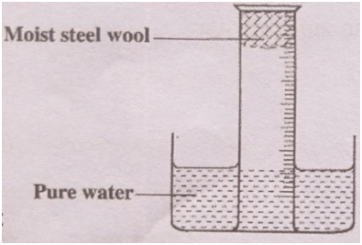

1. **Why were the iron filings moistened? (1mk)**

*To ensure that they stick on the wall of the gas jar*

1. **State and explain the observation made after three days (3mks)**

*Water level in the gas jar rose to occupy space left bt oxygen gas*

*Brown solid forms on the surface of iron fillings since rusting has taken place*

1. **State two conclusions made from the experiment. (2mks)**

*Oxygen is necessary for rusting to take place*

1. **Draw a labelled set-up of apparatus for the laboratory preparation of oxygen using Sodium Peroxide (3mks)**

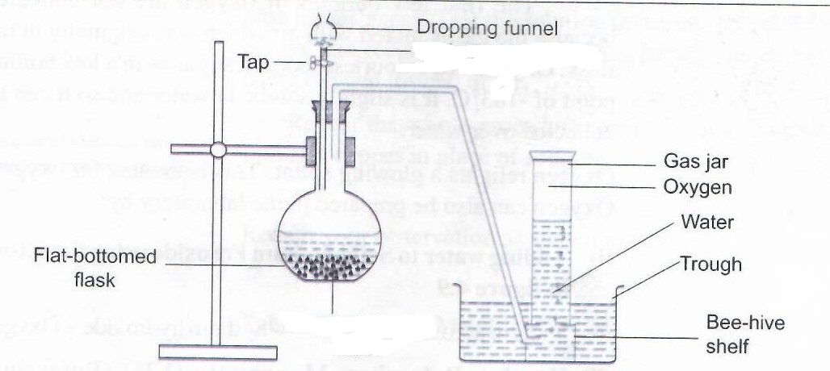

Water

Sodium Peroxide

1. **State two uses of oxygen(2mks)**

*Used in hospitals by patient with breathing difficulties.*

*Used in welding*

*Used by mountain climbers and sea divers.*

**10. (a) Element X is found in period 3 and group IV. It consists of two isotopes 28X and QX.**

**A sample of X was found to consist of 90% of 28X.If the relative atomic mass of X is 28.3, work out the number of neutrons in QX (3mks)**

**( 28 x 90 ) + (10x) = 28.3**

**100**

**2520 + 10x = 2830**

**10x = 310**

**x = 31**

**Neutrons = Mass no. - Atomic no.**

**31 - 14 = 17 neutrons**

1. **Draw the atomic structure of element X using Dots(.) or Crosses(X) diagram (1mk)**

**11.The grid below is part of the periodic table. The elements are not represented by their actual symbols. Use the information to answer the questions that follow**

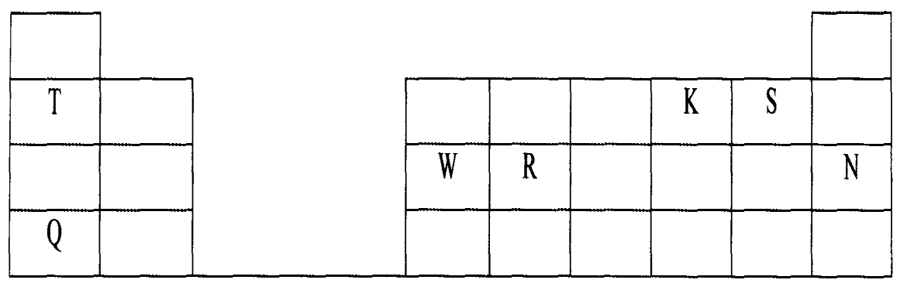

**i)Which is the most reactive**

**(I)Non — metal?(2mks).**

*S*

**Explain**

*Easily gains one electron to become stable*

**(II) Metal? (2mks)**

*Q*

**Explain**

*Easily losses an electron to become stable*

**ii)Name the family to which elements T and Q belongs.(1mk)**

*Alkali metals*

**iii)Write the formula of the compound formed when W reacts with S. (1mk)**

$WS3$

**iv) Explain why element N doesn’t form compounds with other elements. (2mks)**

*Its stable.*

*Its unreactive*

**v) Compare the atomic radii of T and Q. Explain.(2mks)**

*Q has a larger atomic radius than T ,because it has more occupied energy levels*

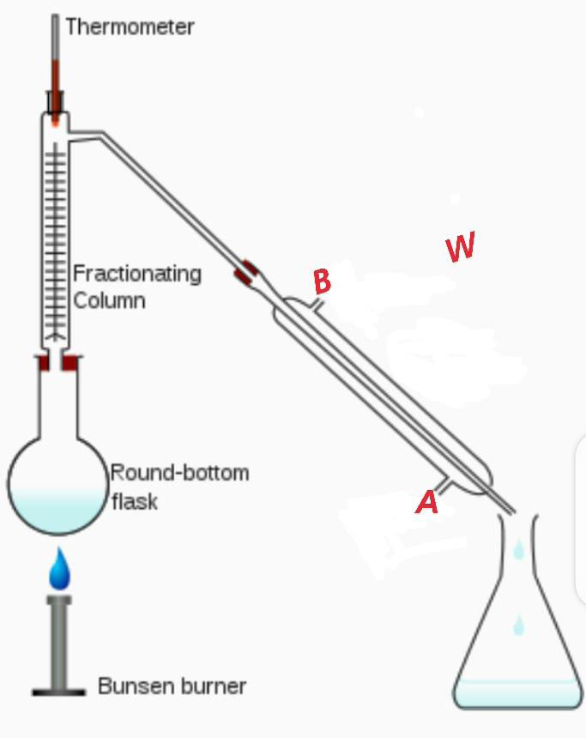**12. A student left some crushed fruit mixture with water for some days. He found the mixture had fermented. He concluded that the mixture was contaminated with water and ethanol with boiling point of 100oC and 78 oC respectively. The set-up of apparatus below are used to separate the mixture.**

1. **What is the purpose of the thermometer in the set-up?(1mk)**

*Recording of the temperature*

1. **which end of the apparatus W should tap water be connected?(1mk)**

*A.*

**iii. Name the apparatus W**

*Liebigs Condenser*

**iv. At Which liquid was collected as the first distillate? Explain (2mks)**

*Ethanol-has a lower boiling point hence easily distilled out faster than water*

1. **What is the name given to the above method of separating mixture?(1mk)**

*Fractional distillation*

1. **State two applications of the above method of separating mixtures (2mks)**

*Distillation of liquid air.*

*Distillation of crude oil.*

1. **What properties of the mixture make it possible for the component to be separated by the above methods? (2mks) .**

*Have closer but different boiling point*

*They are miscible*

**13. An oxide of element G has the formulae of G2O3.**

**a. State the valency of the element G(1mk)**

*3 valence electrons*

***b.* In which group of the periodic table is the element G. explain. (2mks)**

*Group III, because it has three valence electrons only*

**14. The atomic number of element P is 11 and that of Q is 8**

**a) Write down the possible formula of the compound formed between P and Q. (1mk)**

**P2Q**

**b) In which period does element P belong. Explain (2mks**

*Period 3, because it has three energy levels only*