Name:.................................................................................... Adm No:………………Class……...
Index No.: ........................................
Candidate’s Signature: .................
Date: ................................................

233/1
CHEMISTRY
Paper 1
THEORY
JULY 2019
Time: 2 hours

MOKASA II JOINT EVALUATION EXAMINATION
Kenya Certificate of Secondary Education
CHEMISTRY
Paper 1

Instructions to Candidates

- Write your name and index number in the spaces provided above.
- Sign and write the date of the examination paper.
- Answer ALL the questions in the spaces provided in the question paper.
- ALL working MUST be clearly shown where necessary.
- Mathematical tables and silent electronic calculators may be used.
- Candidates should check the paper to ascertain that all the pages are printed as indicated and that no questions are missing.

QUESTIONS | MARKS OUT OF 80
1 - 27
- (a) i. Draw the apparatus used in the laboratory for keeping substances free from moisture. (1 mark)

ii. Name the apparatus used in the laboratory for supporting crucibles on tripod stand while heating. ( 1 mark)
…………………………………………………………………………………………………..
(b) State two roles chemistry play in the society. ( 1 mark)
…………………………………………………………………………………………………..…………………………………………………………………………………………………..
- A sugar called raffinose was treated with dilute hydrochloric acid. The resulting solution W was analyzed to find out the sugars present using chromatography. The following chromatogram was obtained.
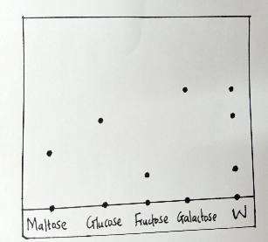
- Identify the sugars present in W. ( 1 ½ marks)
…………………………………………………………………………………………………..
- Which of the sugars is less sticky? Explain. ( 1 ½ marks)
………………………………………………………………………………………………….
- a. Describe how simple acid-base indicators can be obtained from flower petals. . (2 marks)
………………………………………………………………………………………………….
………………………………………………………………………………………………….
………………………………………………………………………………………………….
………………………………………………………………………………………………….
b. What is the disadvantage of using phenolphthalein indicator over other commercial indicators. ( 1 mark)
………………………………………………………………………………………………….
4. State and explain two observations made when a burning magnesium ribbon is lowered into a gas jar full of carbon (IV) oxide. ( 3 marks)
………………………………………………………………………………………………….
………………………………………………………………………………………………….
………………………………………………………………………………………………….
………………………………………………………………………………………………….
5. Draw a well labeled set-up of apparatus that can be used in the laboratory preparation of oxygen gas in the laboratory using sodium peroxide and water.
( 3 marks)

6. Potassium consists of three isotopes with mass numbers Y, 40 and 41 having relative abundances 93.1%, 0.01% and 6.89% respectively. Determine the value of Y given the atomic number of potassium is 19 and its relative atomic mass is 39.1379 . ( 2 marks)
………………………………………………………………………………………………….
………………………………………………………………………………………………….
………………………………………………………………………………………………….
7. a. Define the term ionization energy. ( 1 mark)
………………………………………………………………………………………………….
………………………………………………………………………………………………….
b. Using crosses (x ) to represent electrons, illustrate ion formation by an oxygen atom. ( 2 marks)

8. In an experiment to electrolyse a nitrate of element X in solution state using inert electrodes, 386 C of charge produced by passing a current of 0.2A increased the mass of the cathode by 0.128g. If the relative atomic mass of X is 64, determine the oxidation state in an ion of X. ( 1F= 96500C ) ( 2 marks)
………………………………………………………………………………………………….
………………………………………………………………………………………………….
………………………………………………………………………………………………….
9. 3 ZnO _{(s)} + 2 NH₃ _{(g)} 3 Zn _{(s)} + N₂ _{(g)} + 3 H₂O _{(l)}

In the equation above, identify with a reason the oxidizing agent and the reducing agent. ( 2 marks)
………………………………………………………………………………………………….
………………………………………………………………………………………………….

10. The grid below represents part of the periodic table. Study it and answer the questions that follow:
 |  |  |  |  | D
 |  |  |  |  | E | F | I
A |  |  |  |  |  | G
B | C

- Compare the reactivities of elements A and B with chlorine . ( 2 marks)
C

X
J
K
Y

M

U
Q

W

T

Z
C

X
J
K
Y

M

U
Q

W

T

Z
C

X
J
K
Y

M

U
Q

W

T

Z
C

X
J
K
Y

M

U
Q

W

T

Z
C

X
J
K
Y

M

U
Q

W

T

Z
C

X
J
K
Y

M

U
Q

W

T

Z

………………………………………………………………………………………………….
………………………………………………………………………………………………….
- State two uses of element I. ( 1 mark)
………………………………………………………………………………………………….
………………………………………………………………………………………………….
- Using dots and crosses to represent electrons, show bonding in a compound formed when C and I react. ( 1 mark)

11. Describe how you can prepare Barium sulphate salt starting with Barium Oxide. ( 3 marks)
………………………………………………………………………………………………….
………………………………………………………………………………………………….
………………………………………………………………………………………………….

12. Name the process by which:
a. Crystals of calcium chloride changes into solution when exposed in air overnight. . ( 1 mark)
………………………………………………………………………………………………….
b. The volume of concentrated sulphuric (VI) acid increases when left in an open beaker overnight. . ( 1 mark)
………………………………………………………………………………………………….

13. Study the diagram below for the electrolysis of molten Lead (II) bromide.
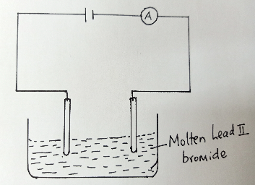

- Label the electrodes . ( 1 mark)
- Write an equation for the reaction taking place at the anode. ( 1 mark)

………………………………………………………………………………………………….
- Draw a well labeled diagram for a set-up that can be used to purify impure copper. ( 3 marks)

14. i. What do you understand by the term greenhouse effect? ( 1 mark)

………………………………………………………………………………………………….
………………………………………………………………………………………………….
ii. State two ways in which carbon (IV) oxide is released into the environment
. ( 1 mark)
………………………………………………………………………………………………….
………………………………………………………………………………………………….

15. Study the diagram below and use it to answer the questions that follow.

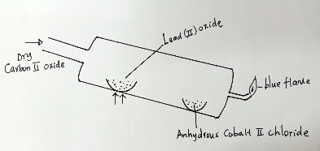

- State what is observed on the anhydrous cobalt (II) chloride. ( 1 mark)

………………………………………………………………………………………………….
- Write an equation for the reaction taking place in the combustion tube. ( 1 mark)

………………………………………………………………………………………………….
- State one industrial use of carbon (II) oxide. ( 1 mark)

………………………………………………………………………………………………….

16. i. State Graham’s Law of diffusion. ( 1 mark)

………………………………………………………………………………………………….
………………………………………………………………………………………………….
ii. 200 cm³ of oxygen gas took 90 seconds to diffuse through a porous plug. Determine the time taken by 300 cm³ of Sulphur (IV) oxide to diffuse through the same plug under the same conditions. ( O= 16, S = 32 ) . ( 3 marks)
………………………………………………………………………………………………….
………………………………………………………………………………………………….
………………………………………………………………………………………………….
………………………………………………………………………………………………….
17. Copper (II) nitrate was heated carefully and the gases produced passed over water. A colourless gas is collected over water.
i. Write an equation to show its decomposition. ( 1 mark)

………………………………………………………………………………………………….
ii. If 9.4g of the solid was heated, determine the volume of the gas collected at R.T.P. (3 marks)
( Cu= 64, N=14, O= 16 , molar gas volume at R.T.P = 24 dm³)

………………………………………………………………………………………………….
………………………………………………………………………………………………….
………………………………………………………………………………………………….

18. a. Draw the structural formula of the following:
i. Ethyne ( 1 mark)

ii. Ethane ( 1 mark)

b. Describe an experiment to distinguish between the compounds in (a) above. . ( 2 marks)
………………………………………………………………………………………………….
………………………………………………………………………………………………….
………………………………………………………………………………………………….

19. Study the diagram below for the preparation and collection of nitrogen (IV) oxide in the laboratory and use it to answer the questions that follow.

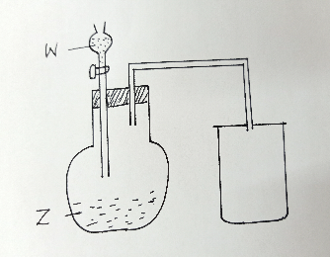

- Name substances W and Z. ( 2 marks)

W………………………………………………Z………………………………………………….
- Give a reason why the gas is collected as shown. ( 1 mark)

………………………………………………………………………………………………….
20. State and explain the observations made when moist blue litmus paper is dropped into a jar containing chlorine gas. ( 2 marks)

………………………………………………………………………………………………….
………………………………………………………………………………………………….
………………………………………………………………………………………………….
21. a. Given the reaction;
NH₄⁺ _{(aq)} + OH⁻ _{(aq)} NH_{3 (g)} + H₂O _{(l)}

Identify the acid in the backward reaction and give a reason for your answer. . (2 marks)
………………………………………………………………………………………………….
………………………………………………………………………………………………….
b. State two advantages of hard water. ( 1 mark)
………………………………………………………………………………………………….
………………………………………………………………………………………………….
22. i. Define the term solubility. ( 1 mark)
………………………………………………………………………………………………….
………………………………………………………………………………………………….
ii. Use the information below to calculate the solubility of sodium nitrate.
Mass of evaporating dish = 15.10g
Mass of evaporating dish and salt = 20.10g
Mass of evaporating dish and solution = 40.10g ( 2 marks)
………………………………………………………………………………………………….
………………………………………………………………………………………………….
………………………………………………………………………………………………….
23. 100 cm³ of 2M copper (II) sulphate at 20 ⁰C is reacted with 3 grams of magnesium ribbon. The temperature of the resulting solution was found to be 26 ⁰C.
( density of solution is 1 g/cm3, c= 4.2kJ/Kg/K, Mg=24 )

- Determine the molar enthalpy change for the reaction. ( 3 marks)
………………………………………………………………………………………………….
………………………………………………………………………………………………….
………………………………………………………………………………………………….
………………………………………………………………………………………………….

- Draw an energy level diagram for representing the reaction (2 marks)

24. Curves A below was obtained when marble chips were reacted with dilute hydrochloric acid and carbon (IV) oxide produced.

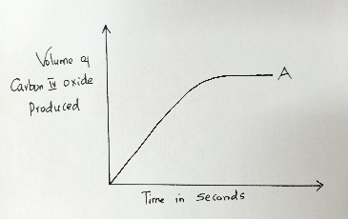
- On the same graph, sketch a curve that would be obtained if powdered calcium carbonate was used and labeled as B (1 mark)
- Explain the difference in the two curves. ( 2 marks)

………………………………………………………………………………………………….
………………………………………………………………………………………………….
25. Give two uses of zinc metal. ( 2 marks)
………………………………………………………………………………………………….
………………………………………………………………………………………………….
26. a. Identify the substances represented below;

- ( 1 mark)

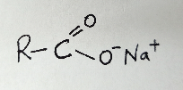

- ( 1 mark)
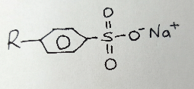
- Name the polymer shown below. ( 1 mark)

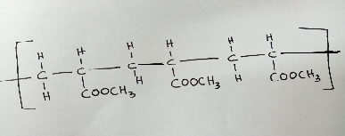

- If the polymer in (b) above has a molar mass of 8600, how many monomers are present in it? ( 2 marks)
………………………………………………………………………………………………….
………………………………………………………………………………………………….
………………………………………………………………………………………………….

- Draw a repeating unit of the polymer. ( 1 mark)

27. i. The activity of a radioactive isotope decreased from 1024 counts per second to 128 counts per second in 75 days. Determine the half-life of the isotope. ( 2 marks)

………………………………………………………………………………………………….
………………………………………………………………………………………………….
………………………………………………………………………………………………….

- State two dangers associated with radioactivity. ( 2 marks)
………………………………………………………………………………………………….
………………………………………………………………………………………………….

