Kenya certificate of secondary education 2019
233/1 CHEMISTRY -Paper 1
END TERM 1 2019 TIME :2 hours

Name …………………………………………….……… Index Number…………………/………

Signature ………………….…...……….. Date ……………/…………/……………

INSTRUCTIONS TO CANDIDATES
  - Write your name and index number in the spaces provided

  - Sign and write the date of examination in the spaces provided
  - Answer ALL questions in the spaces provided
  - Mathematical table and electronic calculators may be used.
  - ALL working MUST be shown clearly where necessary
  - This paper consists of 14 printed pages. Candidates should check the question paper to ensure that all pages are printed as indicated and no questions are missing
FOR EXAMINERS USE ONLY

QUESTION | MAXIMUM SCORE | CANDIDATE’S SCORES
1 – 28 | 80

Chemistry 1
2019

Turn over

- a) Distinguish between ionization energy andelectronaffinity. (2 marks)
………………………………………………………………………………………………………………………………………………………………………………………………………………………………
…………………………………………………………………………………………………………….
(b) The atomic number of Q and R are 9 and 17 respectively. Compare the electron affinity of Q and . Explain. (1 mark)
………………………………………………………………………………………………………………………………………………………………………………………………………………………………
- The relative atomic mass of an element is 10.28, it has two isotopes ¹⁰ R and ¹¹R.
5 5
Calculate the relative percentage abundance ofeachisotope. (3marks)
………………………………………………………………………………………………………………………………………………………………………………………………………………………………
………………………………………………………………………………………………………………………………………………………………………………………………………………………………
- Describe how solid Aluminum chloride can be separated from a solid mixture of sodium chloride and ammoniumchloride. (3 marks)
………………………………………………………………………………………………………………………………………………………………………………………………………………………………
………………………………………………………………………………………………………………………………………………………………………………………………………………………………

- The number of protons and neutrons of atoms W, X, Y and Z are shown in the tablebelow.
Atom | No. of protons | No. of neutrons
W | 6 | 6
X | 12 | 12
Y | 6 | 8
Z | 17 | 20
  - Write down the electronic configurationofX. (1 marks)
………………………………………………………………………………………………………………………………………………………………………………………………………………………………

  - (i) Which one of the atoms is of an element in group (VII) of the periodictable .(1mk)
………………………………………………………………………………………………………………

(ii) Name the type of bond which is formed when X andZreacts. (1 mark)
………………………………………………………………………………………………………………

- Sulphur exists in two crystallineforms
  - Name one crystalline formofsulphur. (1 mark)

………………………………………………………………………………………………………………

  - Give any two usesofsulphur. (2 marks)
………………………………………………………………………………………………………………………………………………………………………………………………………………………………
- An experiment was set as shownbelow
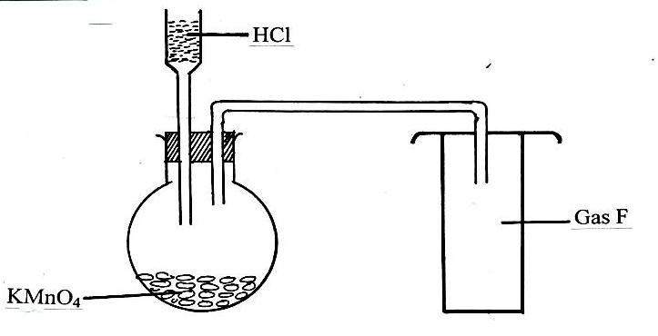

  - Name thegasF (1 mark)

………………………………………………………………………………………………………………
  - State one physical characteristic ofgasF. (1 mark)
………………………………………………………………………………………………………………………………………………………………………………………………………………………………

(c ) What would be observed if a litmus paper was put in a solution ofgasF. (1 mark)
………………………………………………………………………………………………………………………………………………………………………………………………………………………………

- Below is a list ofoxides.

MgO, N₂O, K₂O, CaO and Al₂O₃

From the above list select
  - Aneutraloxide. (1 mark)

………………………………………………………………………………………………………………
  - An oxide that can react with both potassium hydroxide and dilutehydrochloricacid.(1 mark)

………………………………………………………………………………………………………………
(c ) What property is exhibited by the reaction inb above. (1 mark)

………………………………………………………………………………………………………………

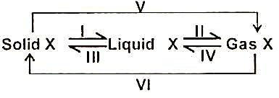
- a) The figure below shows some changes in state for a substance X. Study the diagram and answer thequestions.

Each of the changes can be speeded up by heating or by cooling. Which changes are speeded up by cooling and which onesbyheating.(2marks)
………………………………………………………………………………………………………………………………………………………………………………………………………………………………

- In an experiment, rods of metal X, Y, Z were cleaned with sand paper and placed in a beaker containing water. Another set of rods was also placed in a beaker containing dilute acid. After placing the rods in the two liquids, bubbles of gas were seen around some of the rods as shown in the diagrambelow.

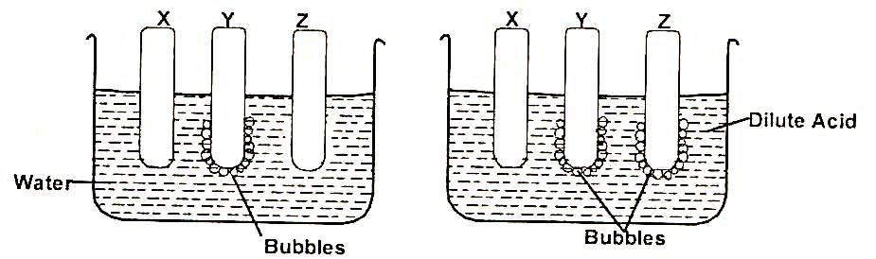
  - Why is it necessary to clean the rods with sand paper before dipping them intotheliquid. (1mark)
………………………………………………….
  - Arrange the three metals in order of their reactivity starting with themostreactive. (2 marks)
………………………………………………………………………………………………………………………………………………………………………………………………………………………………
- Study the table below and use it to answer the question thatfollow
Solution | PH
A | 3.5
B | 14
C | 8.5

- In which of the solution will phenolphthalein indicatorbecolourless. (1mark)

……………………………………………

- Which of the solutions could be used to relieve heartburn?Explain. (2marks)
…………………………………………………………………………………………………………………………………………………………………………………………………………………………

- a) Why is air considered as a mixture rather than acompound ? (1mark)
………………………………………………………………………………………………………………………………………………………………………………………………………………………………
- State one similarity between rusting and combustionofiron. (1mark)

………………………………………………………………………………………………………………

- Explain why iron nails rust faster in sodium chloride solution than intapwater. (1mark)

……………………………………………………………………………………………………………

- The apparatus shown below was used to investigate the effect of carbon II oxide on copper II oxide.

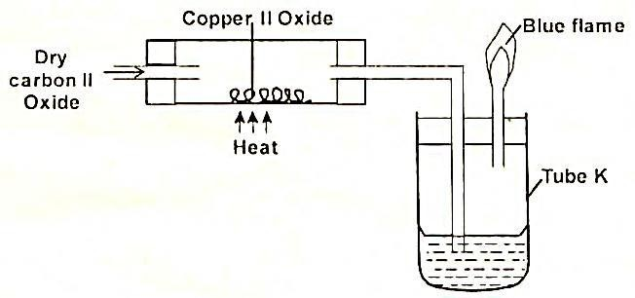

- State the observation that was made in the combustion tube by the end of the experiment.
(1 mark)
………………………………………………………………………………………………………..

b) Write an equation for the reaction that took place in the combustion tube. (1mark)
………………………………………………………………………………………………………..

c) Why is it necessary to burn gas coming out of tube K ? (1mark)
………………………………………………………………………………………………………..

- a) What is airpollution? (1mark)
………………………………………………………………………………………………………..

b) State four gaseous substances present inunpollutedair. (2marks)
………………………………………………………………………………………………………..
………………………………………………………………………………………………………..

- The table below shows properties of some chlorides. Study it and answer the questions thatfollow.
Chloride | Mp(°C) | BP (°C) | Electrical conductivity in aqueous solution | PH of solution
Al | - | 183 | Good | 3
Na | 860 | 1420 | Good | 7
P | 32 | 75 | Good | 3
H | -146 | -29 | Good | 1

- Explain the high melting and boiling points ofsodiumchloride. (1mark)
………………………………………………………………………………………………………..

- Write an equation for the reaction between PC15andwater. (1mark)
………………………………………………………………………………………………………..

- Draw the dot (•) and cross (x) diagram to show bondinginNaCl. (1 mark)
………………………………………………………………………………………………………..

- Excess Concetrated Sulphuric Vi acid with pieces of dry wood as shown

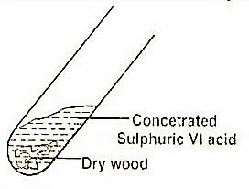

- State the observation made inthetube. (1mark)
………………………………………………………………………………………………………..
………………………………………………………………………………………………………..

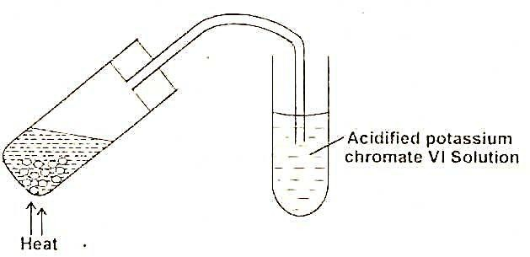
- Whenthereactionwascomplete,the mixture washeatedgently,thenstronglyandsetupadjustedasshownbelow.
State and explain the observation made on acidified potassium chromateVIsolution. (2marks)
………………………………………………………………………………………………………..
………………………………………………………………………………………………………..

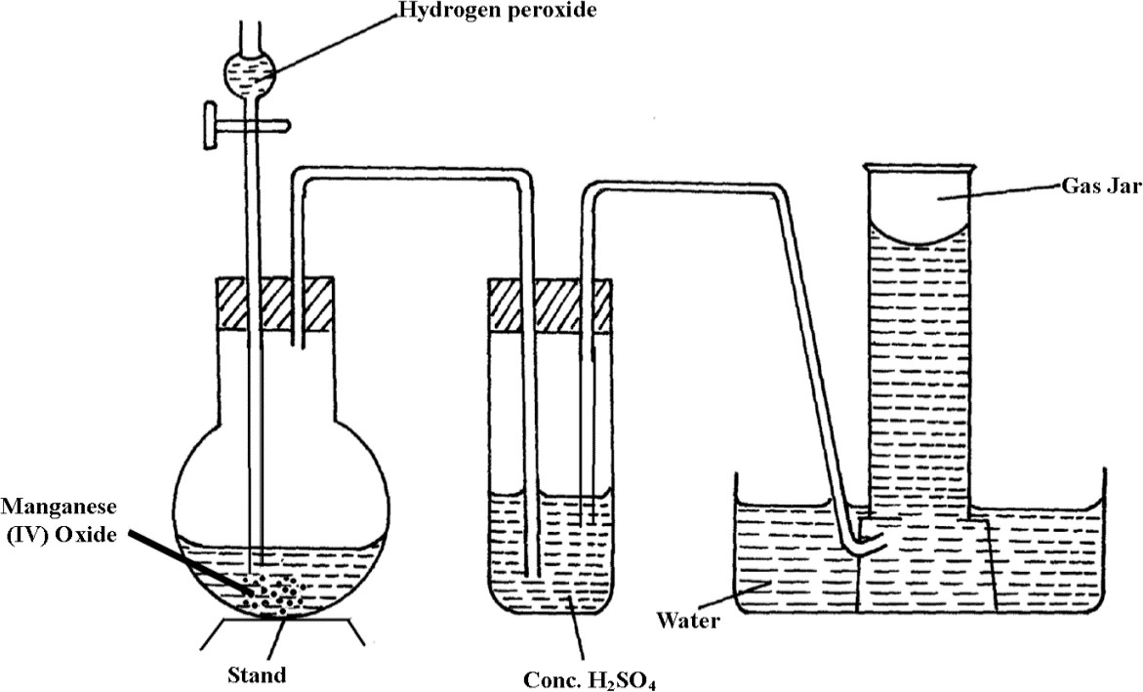
- The diagram below shows the set-up that can be used to prepare and collect oxygen gas. Study it and answer the questions thatfollow.

- Identify two mistakes from the diagram which must be corrected for one to collect dryoxygen gas. (2marks)
………………………………………………………………………………………………………..
………………………………………………………………………………………………………..

- What property of oxygen gas makes it possible to be collectedoverwater. (1mark)
………………………………………………………………………………………………………..
………………………………………………………………………………………………………..

- When a grey powder P, which has no action on cold water, is placed into a salt solution of Q, a brown solid R isdeposited. The blue solution of Q, fades giving way to a greensolution.
- Name the type of reaction thattakesplace. (1 mark)
………………………………………………………………………………………………………..
………………………………………………………………………………………………………..
- Identify solids Pand R (1 marks)
………………………………………………………………………………………………………..
………………………………………………………………………………………………………..

- Write an equation for the reaction leading to formation of thebrownsolid. (1mark)
………………………………………………………………………………………………………..
………………………………………………………………………………………………………..
- Calculate the number of molecules of water of crystallization in oxalic acid crystals, H₂C₂O₄. xH₂O, from the following data:5g of the crystals were made up to 250cm³ of this solution required 15.9cm³ of 0.5M sodium hydroxide to neutralize it. (H=1, C=12, 0 16,H₂0= 18) (3marks)
………………………………………………………………………………………………………..
………………………………………………………………………………………………………..
………………………………………………………………………………………………………..
………………………………………………………………………………………………………..

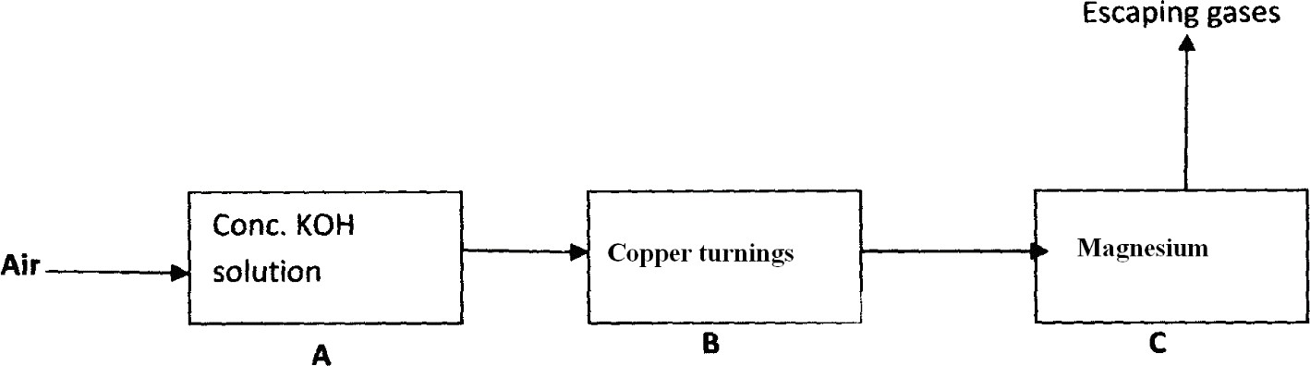
- Air is passed through several reagents as shown in the flow diagrambelow

Name one gas which escapes from chamber C. Give a reason foryouranswer (3marks)
………………………………………………………………………………………………………..
………………………………………………………………………………………………………..
………………………………………………………………………………………………………..
………………………………………………………………………………………………………..

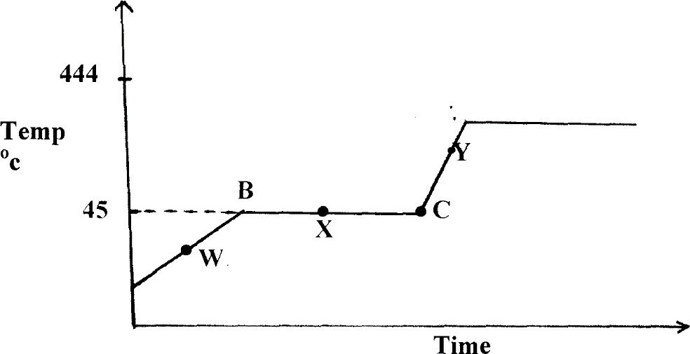
- The diagram below shows the heating curve of a pure substance. Study it and answer the questions thatfollow.
  - What are the physical states of the substances at points WandY. (2marks)
W………………………………………………………………………………………………………..
Y……………………………………………………………………………………………………..
  - Explain why the temperature remains constant between points Band C. (2marks)
………………………………………………………………………………………………………..
………………………………………………………………………………………………………..
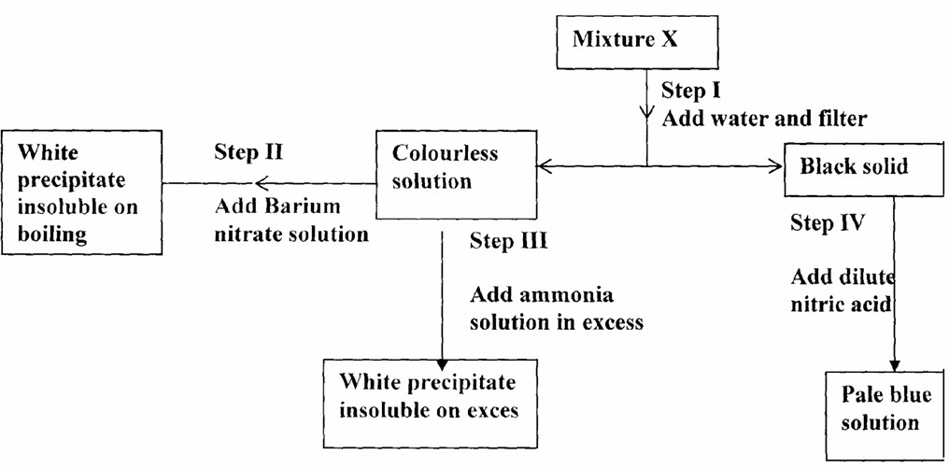
- Study the chart below and answer the questions thatfollow.

  - Name:
- Cations present inmixtureX. (1mark)
………………………………………………………………………………………………………..

- Anions present inthesolution. (1mark)
………………………………………………………………………………………………………..

  - Write an equation to show how the white precipitate in step IIIisformed. (1mark)

………………………………………………………………………………………………………..

- When solid Zinc carbonate was added to a solution of hydrogen chloride in methylbenzene, there was no observable change. On addition of some water to the mixture there was effervescence. Explaintheseobservations. (2mark
………………………………………………………………………………………………………..
………………………………………………………………………………………………………..

- (a) State the law of combining volumesof gases. (1 mark)
………………………………………………………………………………………………………..
………………………………………………………………………………………………………..
(b) What volume of methane would remain if a burner containing 40cm³ of methane burns in 40cm³ of enclosed air (assuming that oxygen is 20%ofair)? (2 marks)
………………………………………………………………………………………………………..
………………………………………………………………………………………………………..
- The molecular formula of compound T is C₃H₈O. T reacts with acidified potassium manganate (VII) to form another compound U whose formula C₃H₆O₂. T also reacts with sodium metal to produce hydrogen gas and T is neutral tolitmus.
  - Suggest the homologous series to whichT belongs. (1mark)
………………………………………………………………………………………………………..
………………………………………………………………………………………………………..
  - Name the type of reaction leading to the formation of U in the reactiondescribedabove. (1mark)
………………………………………………………………………………………………………..
………………………………………………………………………………………………………..
  - Write the structural formulaofU. (1mark)
………………………………………………………………………………………………………..
……………………………………………………………………………………………………..
- (a) StateBoyle’slaw.(1mark)
………………………………………………………………………………………………………..
………………………………………………………………………………………………………..

(b) 60cm³ of oxygen gas diffused through a porous hole in 50 seconds. How long will it take 80cm³ of sulphur (IV) oxide to diffuse through the same hole under the same conditions
(S = 32, O=16). (2marks)
………………………………………………………………………………………………………..
………………………………………………………………………………………………………..
………………………………………………………………………………………………………..
………………………………………………………………………………………………………..

- Whensulphurisheatedinaboilingtubeintheabsenceofair,theyellowcrystals meltintoagoldenyellowmobileliquidat 113°C. The liquid turns into a dark brown viscous mass at 180°C. At 400°C the brown liquid becomes less viscous and flows easily. Explaintheseobservations. (3marks)
……………………………………………………………………………………………………..
……………………………………………………………………………………………………..
………………………………………………………………………………………………………..
………………………………………………………………………………………………………..
- In an experiment soap solution was used against 3 separate samples of water. Each sample was later boiled and soapadded. Each water sample was 1000cm³. The results are tabulatedbelow.

Volume of soap used to form lather | Sample
 | I | II | III
Before boiling (cm³) | 27 | 3 | 10.6
After boiling (cm³) | 27 | 3 | 3

  - Which sample was likely to be softwater? Explain. (2 marks)
………………………………………………………………………………………………………..
………………………………………………………………………………………………………..
  - State the cause of change in volume of soap used to form lather insampleIII. (1 mark)
………………………………………………………………………………………………………..
………………………………………………………………………………………………………..

THIS IS THE LAST PRINTED PAGE

