LARI SUB COUNTY EXAMINATION
CHEMISTRY PAPER 1 (233/1)
PAPER 1
July 2019
MARKING SCHEME
1. – Does not corrodereadily (not reactive) Reject if mention of rusting
- Light or lower density
- Resistant to chemical corrosion
-Ductile Any two (2mks)
2. –Add water to the mixture and stir to dissolve sodium chloride. Filter to obtain sodium chloride as the filtrate and copper (II) oxide as the residue Heat the filtrate to saturation then cool it down to obtain sodium chloride crystals. half a mark each in correct sequence maximum (3mks)
3. a) (i) Dilute nitric acid
(ii) Lead (II) Sulphate (accept lead sulphate)
b) Pb(OH)_{2(s)} + 2OH⁻_{(aq)} – [Pb(OH)₄]²⁻_{(aq)}
4. a) K⁺ has a larger number of energy levels (three) than Na⁺ with greater shielding effect in K⁺ than Na⁺ accept ionic radius increases down the group reason/explanation.
b) Both have two energy levels but effective nuclear charge is greater in Mg²⁺ than Na⁺ since Mg²⁺ has +2 charge where’s Na⁺ has +1 charge. or
Mg2+ is formed by loss of two electrons with a stronger nucleur charge and attraction to the outer electrons. Na+ is formed by loss of one electron with a weaker nucleur charge and attraction to the outer electrons.
5. (i) SO_{2(g)} + NO_{2(g)} SO_{3(g)} + NO_{(g)}
+4 +4 +6 +2 or show the calculations of oxidation numbers. Half a mark for the correct calculation of the oxidation number. (1mk)
Oxidation number of S increases from +4 to +6 while Nitrogen decreases from +4 to +2 (1mk)
(ii) SO_{2(g)} the oxidation number of Sulphur in it is increased from +4 to +6
6. Precipitation /crystals are formed because the solubility of the salt decreases with increase in temperature (2mks)
7. In Paraffin : NO effervescence
In ethanol: Effervescence of a colourless gas 1mk each total (2mks)
8. KOH_{(aq)} + HNO_{3(aq)} KNO_{3(aq)} + H₂O_{(l)}
R.F.M of KOH = 56½
Moles of HNO₃ = 50 x 2 = 0.1½
1000
Mole ratio is 1:1½
Hence moles of KOH in 50cm³ = 0.1
In 100cm³ is 0.2 moles½
Mass of X = 0.2 x 56 = 11.2g½ (3mks)
9. (a) General rise in global temperature due to accumulation of green house gases
(b) Global warming, Change in weather pattens, Melting of ice in polar regions, Elnino rains, Lanina weather Pattens or any other correct ( accept any two correct use)
10. (a) C_{(s)} + H₂O_{(g)} CO_{(g)} + H_{2(g)} Well balanced ½mark correct state symbols ½ mark
(b) Fuel, Reducing agent in extraction of less reactive metals from their oxides

11. Rate of diffusion of O₂
Rate of diffusion of O₂ = Molecular mass of CH₄
Rate of diffusion of CH₄ Molecular mass of O₂
RFM O₂ = 32; RFM CH₄ = 16.
Rate of diffusion of O₂ = 100 cm³ ½
4 sec
Rate of diffusion of CH₄ = 200 cm³ ½
t sec
100/4 cm³ / sec = 16
200/t cm³/sec 32 1 = 5.66secs

12. a) Butane
b) Hardening of oil to fats /manufacture of margarine
13. Yield increases Yield of methanol is endothermic . Increase in temperature shifts equilibrium to the right favors the forward reaction/ yield of methanol
14. –Add excess copper (II) oxide to dilute sulphuric acid in a glass beaker, ½ stir the mixture½ and heat to complete the reaction½ , filter to remove unreacted copper (II) oxide, ½ heat ½ the filtrate to saturation, then cool the saturated solution to obtain crystals of copper (II) sulphate ½maximum (3mks)
14. a) 83
b) P 50% P 25%P 12.5%P 6.25% P
4 Half – lifes 112 days
1 half- life ?
(¼ x 112days) = 28days
16. a) Calcium: 2.8.8.2
Beryllium 2.2
b) Calcium has a larger number of energy levels with a weaker nuclear charge and attraction to the outer electrons hence easier to remove them during chemical reaction. Beryllium has a smaller atom with stronger nuclear charge and attraction to the outer electrons hence strongly held by the nucleus, not easily released during chemical reactions
17. Oxygen exists as desrete smaller molecules (O₂) with a smaller surface area for formation of fewer van der waals forces between themwhile sulphur exist as a larger molecule with S₈ rings and chains which are bulky with a larger surface area for formation of larger number of van der Waals forces
18. Mass of water = 94.5 – 51.3 = 43.2½
Rmm Ba(OH)₂ = 171½
Rmm of water = 18
Ba(OH). XH₂O
51.3 H₂O
171 43.2½
18
0.3 = 1 24 = 8
0.3 0.3
E. F = Ba(OH)₂ . 8H₂O.
19. a) (i) Concentrated Hydrochloric acid
(ii) Concentrated sulphuric (VI) acid
b) No heat Dropping funnel has no tap/stem of the thistle funnel is too short Gas jar is corked Any two correct (2marks)
20 (a) (N), (L), (K), (M) (1mks)
(b) 1st ionization Energy reject ionization energy alone.
21. a) (i) NH₃
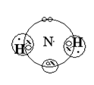

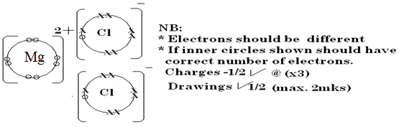
(ii) MgCl₂

b) It has an ion pair of electronics which it uses to form a dative bond with hydrogen ions
22. a) Heat energy produced or consumed when one mole of a compound is formed from its elements under standard conditions.
H₄ = (3X – 286) + 2(⁻394) + 277
= -858 + - 788 + 277
= -1369KJ /mole penalize for wrong or no units/ penalize for mol instead of mole
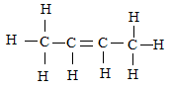
23. a)

must be open structure with clear double bond

b) Alkenes
c) 2,3- dichlorobutane

24. a) X_{(s)} + Cl_{2(g)} XCl_{(s)}
b) Carry out the experiment in a working fume chamber/cupboard to minimize inhaling Chorine
gas which is poisonous when inhaled reject is poisonous alone
Zinc used to coat the iron surface reacts with oxygen to form an oxide coating
25. a) The chloride ions are more concentrated in the solution than hydroxide ions hence chloride ions are discharged at the anode with preference to hydroxide ions.
b) Hydrogen gas
a) They have two valence electrons to conduct while group one have one valence electrons
b) In solid lead bromide ions are not free but in molten lead bromide the ions are not free
26. a) Ca(OH)_{2(aq)} + CO_{2(g)} CaCO_{3(s)}
b) White precipitate due to formation of insoluble calcium carbonate
27. a) – Sodium chloride (rock salt)
Reject - Chile saltpeter (Sodium nitrate)
- Glauber’s salt ( sodium sulphate)
b) - Used in sodium vapour lambs
-Used in street light
- Preparation of tetraethyl lead
- Manufacture of sodium peroxide
- Alloyed with potassium and used as a coolant in nuclear reactors Any two 1 mark each
Reject - Making of table salt
28. a) Sodium hydride reject sodium hydroxide
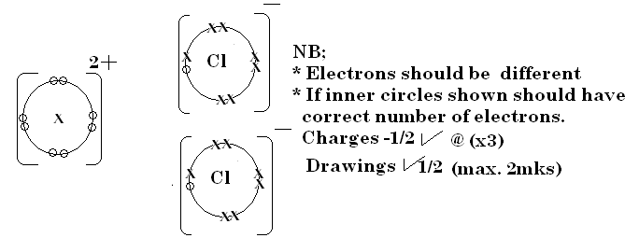
b)Na is more electropositive than H hence losses its valence electrons more easily to form Na⁺ than hydrogen. Hydrogen being more electronegative gains the electron to form H⁻

28. a) 2 C_{(s)} + O_{2(g)} 2CO_{(g)}
CuO_{(s)} + CO_{(g)} Cu_{(s)} + CO_{2(g)}
b) Lime water turn white. CO_{2(g)} is produced from reduction of CuO_{(s)} turn the limewater white as it react with it to produce CaCO₃ (white)

